CS542200 Parallel Programming

Homework 2: Mandelbrot Set

Due: Mon Nov 16 11:59, 2020

# Goal

In this assignment, you are asked to parallelize the sequential *Mandelbrot Set* program, and learn the following skills:

* Get familiar with thread programming using Pthread and OpenMP.
* Combine process and thread to implement a hybrid parallelism solution .
* Understand the importance of load balance.

# Problem Description

The *Mandelbrot Set* is a set of complex numbers that are quasi-stable when computed by iterating the function:

$$Z_{k}=\{C, k=0 Z_{k-1}^{2}+C, k≥1$$

* *C* is some complex number: $C=a+bi$
* $Z_{k}$ is the $k_{th}$ iteration of the complex number
* if $\left|Z_{k}\right|≤2$ for any *k*, *C* belongs to the *Mandelbrot Set*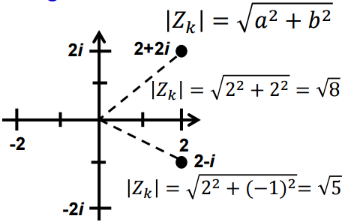

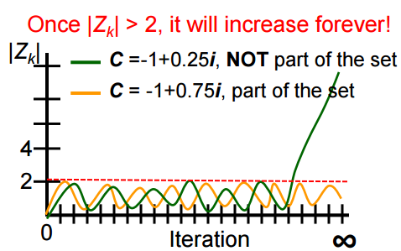

What exact is the *Mandelbrot Set*?

* It is fractal: An object that display self-similarity at various scale; magnifying a fractal reveals small-scale details similar to the larger-scale characteristics
* After plotting the *Mandelbrot Set* determined by thousands of iterations:



For more information, please refer to lecture notes.

# Input / Output Format

## Input specification

The input parameters are specified from the command line. There are no input files.

Your programs should accept the following srun command:

|  |
| --- |
| srun -n $procs -c $t ./exe $out $iter $x0 $x1 $y0 $y1 $w $h |

For example, the image in Sec2. is created by:

|  |
| --- |
| srun -n1 -c1 ./hw2seq out.png 10000 -2 2 -2 2 800 800 |

The meanings of the arguments are:

* $procs – int; [1, 48]; number of processes. Always 1 for the Pthread version.
* $t – int; [1, 12]; number of threads per process. (technically, this is the number of CPUs you can use per process; you are allowed to use more or fewer threads)
* $out – string; the path to the output file.
* $iter – int; [1, 2×108]; number of iterations. (the largest int is around 2.1×109)
* $x0 – double; [-10, 10]; inclusive lower bound of the real axis.
* $x1 – double; [-10, 10]; non-inclusive upper bound of the real axis.
* $y0 – double; [-10, 10]; inclusive lower bound of the imaginary axis.
* $y1 – double; [-10, 10]; non-inclusive upper bound of the imaginary axis.
* $w – int; [1, 16000]; number of points in the x-axis for output.
* $h – int; [1, 16000]; number of points in the y-axis for output.

## Output specification

Your programs should produce a PNG image at $out, visualizing the *Mandelbrot Set* in the given range.

We provide a sequential version to show how the pixels are rendered.

Example 1: srun ./exe $out $iter -2 2 -2 2 400 400

x axis:[-2 2), 400 pints = {-2, -1.99, -1.98, … 1.98, 1.99}



Example 2: srun ./exe $out $iter 0 2 -2 2 800 400



# Working Items

In this assignment, you are asked to parallelize the sequential *Mandelbrot Set* program by implementing the following two versions:

1. pthread: Single node shared memory programming using Pthread

* This program only needs to be run on a single node.

1. hybrid: Multi-node hybrid parallelism programming using MPI + OpenMP

* This program must be run across multiple nodes.
* MPI processes are used to balance tasks among nodes, and OpenMP threads are used to perform computations.
* Pthread library could also be used to create additional threads for communications.

**Requirements:**

* **Must follow the input/output file format and execution command line arguments specifications described in Section 3.**
* **No mathematical optimization is permitted.** That means the computations must be performed on each and every pixel.

# Report

Your report must contain the following contents, and you can add more as you like.

1. **Title, name, student ID**
2. **Implementation**

Explain your implementations, especially in the following aspects:

* How you implement each of requested versions, especially for the hybrid parallelism.
* How do you partition the task?
* What technique do you use to reduce execution time and increase scalability?
* Other efforts you made in your program

1. **Experiment & Analysis**

Explain how and why you do these experiments? Explain how you collect those measurements? Show the result of your experiments in plots, and explain your observations.

* 1. **Methodology**
     1. **System Spec** (If you run your experiments on your own machine)

Please specify the system spec by providing the CPU, RAM, storage and network (Ethernet / InfiniBand) information of the system.

* + 1. **Performance Metrics**

How do you measure computing time of your programs? How do you compute the values in the plots?

* 1. **Plots: Scalability & Load Balancing**
     1. Conduct **strong scalability** experiments, and plot the speedup. The plot must contain at least 4 different scales (number of processes, threads) for both single node and multi-node environments.
     2. Design your own experiments to show how **balance** it is in each of your experiments by plots.
     3. Make sure your plots are properly labeled and formatted.
     4. You are recommended to choose a proper problem size to ensure the experiment results are accurate and meaningful.
  2. **Discussion** (must base on the results in the plots)
     1. Compare and discuss the **scalability** of your implementations.
     2. Compare and discuss the **load balance** of your implementations.
  3. **Others**
* You are strongly encouraged to conduct more experiments and analysis of your implementations.

1. **Experience & Conclusion**

* Your conclusion of this assignment.
* What have you learned from this assignment?
* What difficulties did you encounter in this assignment?
* If you have any feedback, please write it here. Such as comments for improving the spec of this assignment, etc.

# grading

1. **[50%] Correctness** (pthread version: 15%, hybrid version: 35%)

* We will use several test cases to test your implementations. You get full points for an implementation if you passed all the test cases, no points for it otherwise.
* For each test case, your implementation will be considered correct if:
* Your implementation produced a valid PNG image.
* At least **99.8%** of the pixels in your output image are identical to the corresponding pixel produced by the sequential version.
* The **execution time** of your implementation is **shorter** than:
  + the execution time of the sequential version + 30 seconds

1. **[15%] Performance** (pthread version: 5%, hybrid version: 10%)

* We will use several different test cases (denoted *C*) to run your code.
* Your performance score will be given by:
$$\sum{}S\left(C\right)×\frac{T_{best}(C)}{T_{yours}(C)}$$

* *C* is a test case: the set of input parameters excluding parallelism settings. e.g. $x0, $x1, $y0, $y1, $w, $h.
* $S(C)$ is the score allocated to the test case.
* $T_{best}(C)$ is the shortest execution time of all students for the test case, excluding incorrect implementations.
* $T_{yours}(C)$ is your shortest execution time of {pthread, hybrid} for the test case, excluding incorrect implementations.
$\sum{}S\left(C\right)=15$

* Visit <http://apollo.cs.nthu.edu.tw/scoreboard/hw2> for **preliminary** results.

1. **[25%] Report**

* Grading is based on your evaluation, discussion and writing. If you want to get more points, design or conduct more experiments to analyze your implementation.

1. **[10%] Demo**
   1. Explain your implementations.
   2. Explain the key results and findings from your report.
   3. (Optional) Your extra efforts. (Why do you deserve a higher score?)
2. **Policy**
3. **0 point will be given to cheater** (even copying code from the Internet).
4. **No late submissions after deadline will be accepted.**

# Submission & Reminder

Upload these files to apollo31, and place them under ~/homework/hw2/:

* hw2a.c (pthread version)
* hw2b.c (hybrid version)
* Makefile

Upload this file to iLMS:

* report.pdf

Note:

1. Refer to /home/pp20/share/hw2 on apollo for the sequential version of *Mandelbrot* *Set*, Makefile and test cases.
2. You can also write your code in C++ by submitting *.cc files.
3. Your Makefile must be able to build the corresponding targets of the implementations: pthread, hybrid. If you’re unsure how to write a Makefile, you can use the provided example Makefile as-is.
4. **Self-checking scripts** are provided to verify the correctness of your code. Type the following commands under your source code directory for testing: **hw2a-judge** for pthread version, **hw2b-judge** for hybrid version.
5. Your submission time for your source code will be based on the time on apollo31 and your submission time for your report will be based on iLMS.
6. Resources are limited, start your work ASAP. Do not leave it until the last day!
7. **A scoreboard system will be available for you to checkout the current ranking of your implementation**.   
   Go to <http://apollo.cs.nthu.edu.tw/scoreboard/hw2> to check scoreboard.