Parallel Programming hw4-2 ----Blocked Folyd-Warshall ( Multi-GPU)

學號：109062639 姓名：葉哲欣

**Implementation:**

想法：將data 分為2區塊 ，GPU採取同時運算，確保自己負責的區塊資料正確性。

建立2個data大小的matrix(dev_dist[0],dev_dist[1])並且複製dist的data，每個GPU 在自己對應 到的dev_dist做運算

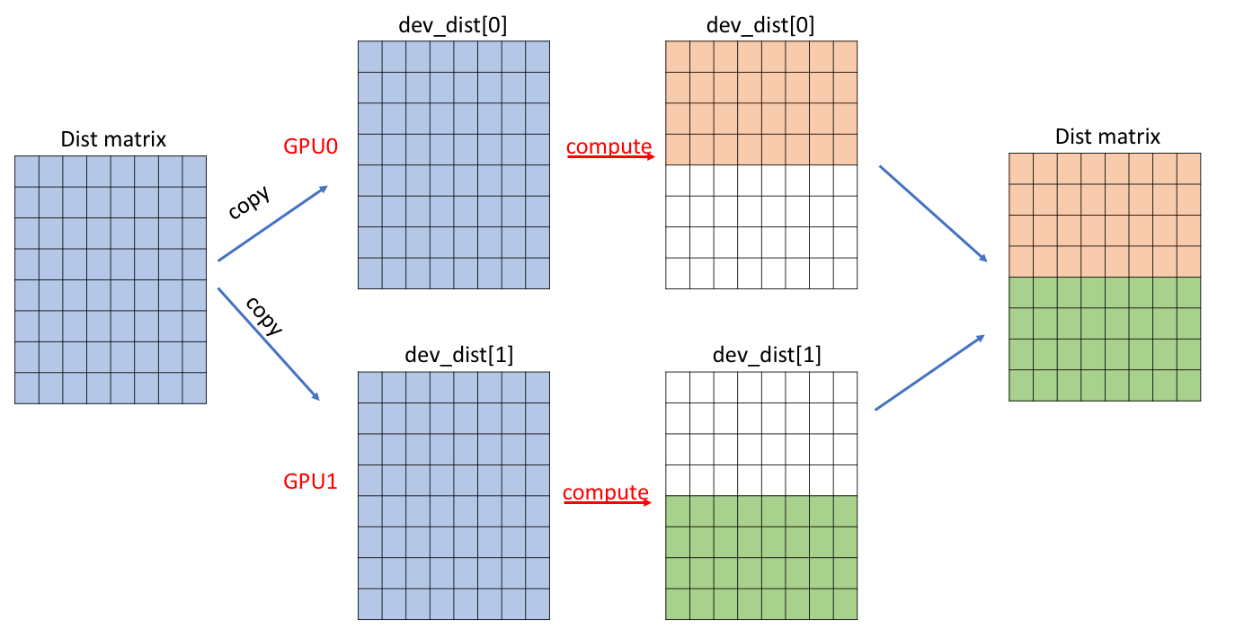

由於phase1,phase2所使用到的block數量較少，較快執行完成,故讓每個GPU運算完整的  
 dev_dist

Phase3:

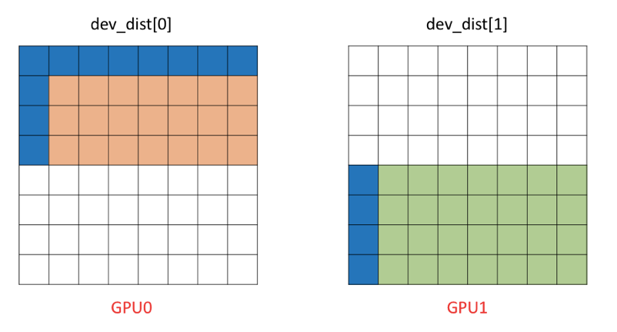

每個round各GPU 需運算一個(ceil(round,num_gpu))*(round-1)個block(藍色+紅色)

故phase3所需thread及block：

dim3 ThreadPerBlock(k,k)

dim3 BlockPerGrid(ceil(round,num_gpu),round)

執行每一個round,兩GPU各自執行Phase1,Phase2,Phase3 但要如何確保資料正確性？

方法：

執行第r-th round

若r < ceil(Round,num_gpu)時

將dev_dist[0] 第 r -row的所有block memcopy 到 dev_dist[1]相對應位置

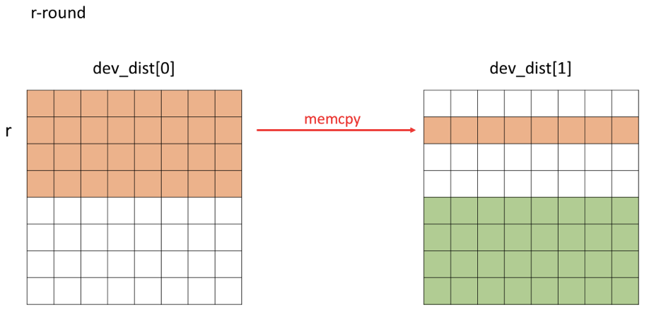

若r >=ceil(Round,num_gpu)時

將dev_dist[1] 第 r -row的所有block memcopy 到 dev_dist[0]相對應位置

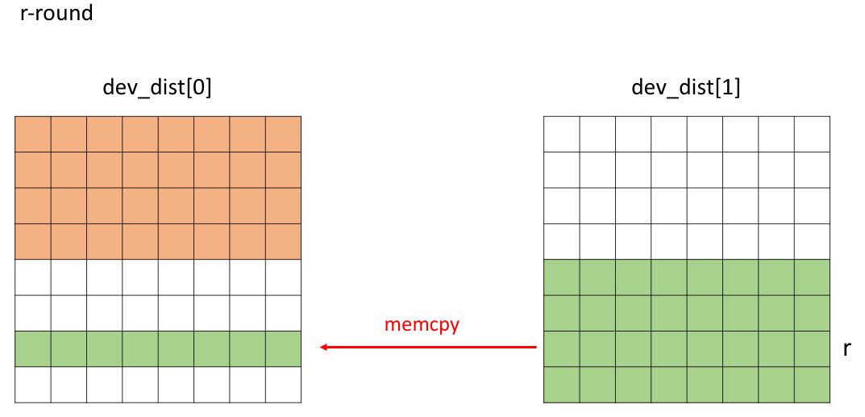

**Profiling Results**

Occupancy

|  |  |  |  |
| --- | --- | --- | --- |
| **GPU1** | | **GPU2** | |
| **kernel** | **Achieved occupancy(avg.)** | **kernel** | **Achieved occupancy(avg.)** |
| Phase1 | 0.495939 | Phase1 | 0.495970 |
| Phase2 | 0.858472 | Phase2 | 0.861369 |
| **Phase3** | **0.887581** | **Phase3** | **0.889586** |

sm efficiency

|  |  |  |  |
| --- | --- | --- | --- |
| **GPU1** | | **GPU2** | |
| **kernel** | **sm efficiency** | **kernel** | **sm efficiency** |
| Phase1 | 3.68% | Phase1 | 3.69% |
| Phase2 | 66.89% | Phase2 | 67.72% |
| **Phase3** | **91.91%** | **Phase3** | **92.03%s** |

Share memory load/store throughput

|  |  |  |  |  |  |  |
| --- | --- | --- | --- | --- | --- | --- |
| **GPU1** | | | **GPU2** | | | |
| **kernel** | **Load throughput** | **Store throughput** | **kernel** | **Load throughput** | **Store throughput** |
| Phase1 | 52.744GB/s | 17.948GB/s | Phase1 | 53.059GB/s | 18.056GB/s |
| Phase2 | 1284.0GB/s | 672.14GB/s | Phase2 | 1280.9GB/s | 670.50GB/s |
| **Phase3** | **2503.0GB/s** | **104.29GB/s** | **Phase3** | **2482.4GB/s** | **108.74GB/s** |

Global load/store throughput

|  |  |  |  |  |  |  |
| --- | --- | --- | --- | --- | --- | --- |
| **GPU1** | | | **GPU2** | | | |
| **kernel** | **Load throughput** | **Store throughput** | **kernel** | **Load throughput** | **Store throughput** |
| Phase1 | 659.33MB/s | 659.33MB/s | Phase1 | 663.27MB/s | 663.27MB/s |
| Phase2 | 47.552GB/s | 23.581GB/s | Phase2 | 47.436GB/s | 23.523GB/s |
| **Phase3** | **185.20GB/s** | **62.280GB/s** | **Phase3** | **186.87GB/s** | **61.765GB/s** |

**Experiment and Analysis**

**System Spec:** hades server

**Time distribution:**

採用 nvprof來查詢 kernel compute 以及memry htd,dth time

使用omp_get_wtime()來紀錄I/O time

*nvpro會測到兩個gpu的時間加總，故compute and memory copy time 要除2

(b)Weak Scalability

|  |  |  |
| --- | --- | --- |
|  | **#GPU:2** | **#GPU:1** |
| **Test case** | **cost time(s)** | **cost time(s)** |
| **p35k1** | 59.600828 | 106.844367 |
| **P34k1** | 54.333784 | 89.929763 |
| **P33k1** | 36.412536 | 80.288615 |
| **P32k1** | 33.388332 | 71.838691 |
| **P31k1** | 44.56218 | 69.112767 |

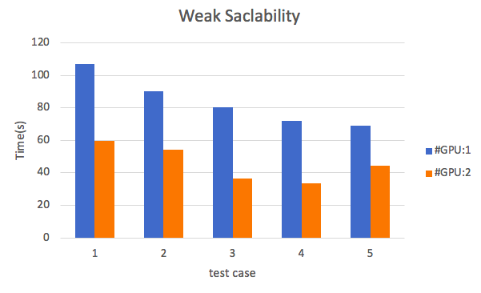

#GPU1:one gpu compute time

#GPU2:two gpu compute time

(c.)Time distribution

|  |  |  |  |  |
| --- | --- | --- | --- | --- |
| **Test case** | **Computing time(s)** | **copy time(s)** | **I/O time(s)** | **communication(s)** |
| **p35k1** | 46.59345 | 25.2605 | 7.374005 | 2.094 |
| **P34k1** | 41.94735 | 22.70815 | 6.626022 | 1.9675 |
| **P33k1** | 28.35855 | 15.06925 | 5.783509 | 1.859 |
| **P32k1** | 25.08395 | 13.6616 | 5.887422 | 1.723 |
| **P31k1** | 23.391 | 12.4346 | 5.883014 | 1.528 |

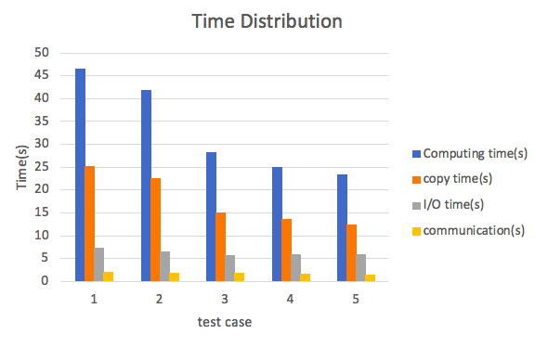

**Optimization :**

1. memory copy2D：使用memcpy2D 來加速存取時間
2. cudaHostalloc:使用pinned memory 來減少gpu取得host data時間

**Experiment and Analysis**

從這次作業我學到如何運用cuda來做multi-gpu的運算，來加速程式運算。

如何將dist拆成2塊平行化，並且利用不同的技巧來減少資料傳輸，複製的時間。本次作業困難點就是data該如何分割給2個gpu實作，並且只傳輸少部分的data 給其他gpu平行運算，運算完後再合併data。另外也學習到使用不同的memcpy 和 allocate 機制來大幅改善效能