Research Compendium practice

Chih-Fu Yeh1,✉

01 December, 2021

Text of abstract

1 Stanford University

✉ Correspondence: [Chih-Fu Yeh <[yehcf@stanford.edu](mailto:yehcf@stanford.edu)>](mailto:yehcf@stanford.edu)

Keywords: keyword 1; keyword 2; keyword 3

Highlights: These are the highlights.

# 1 Introduction

This is a replication of figure 2A from1 (Fig. 4.1)

# 2 Background

# 3 Methods

# 4 Results

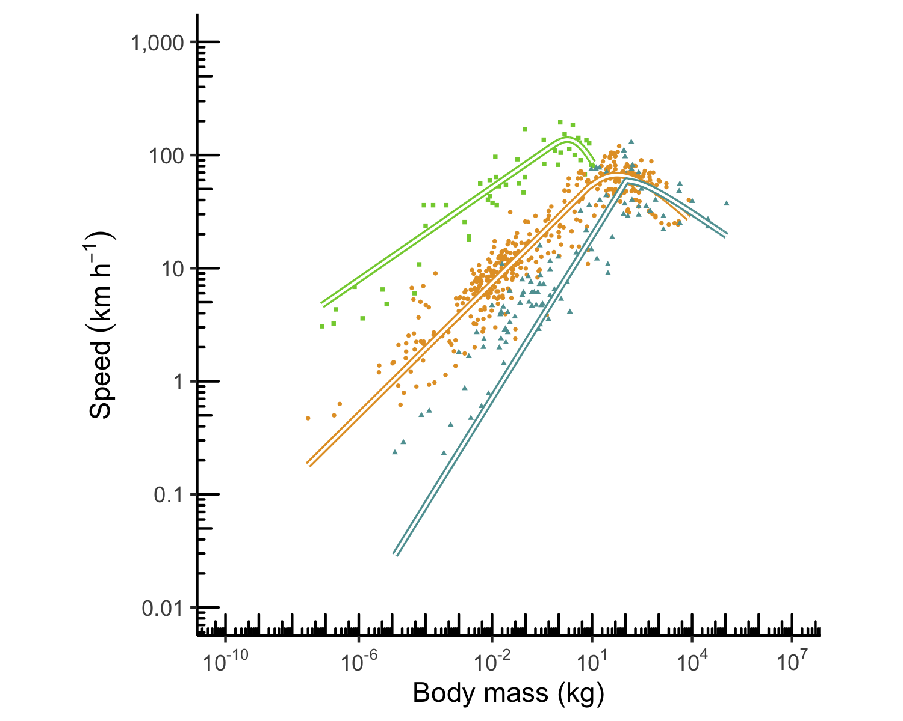

Figure 4.1: Replication of figure 2a from1

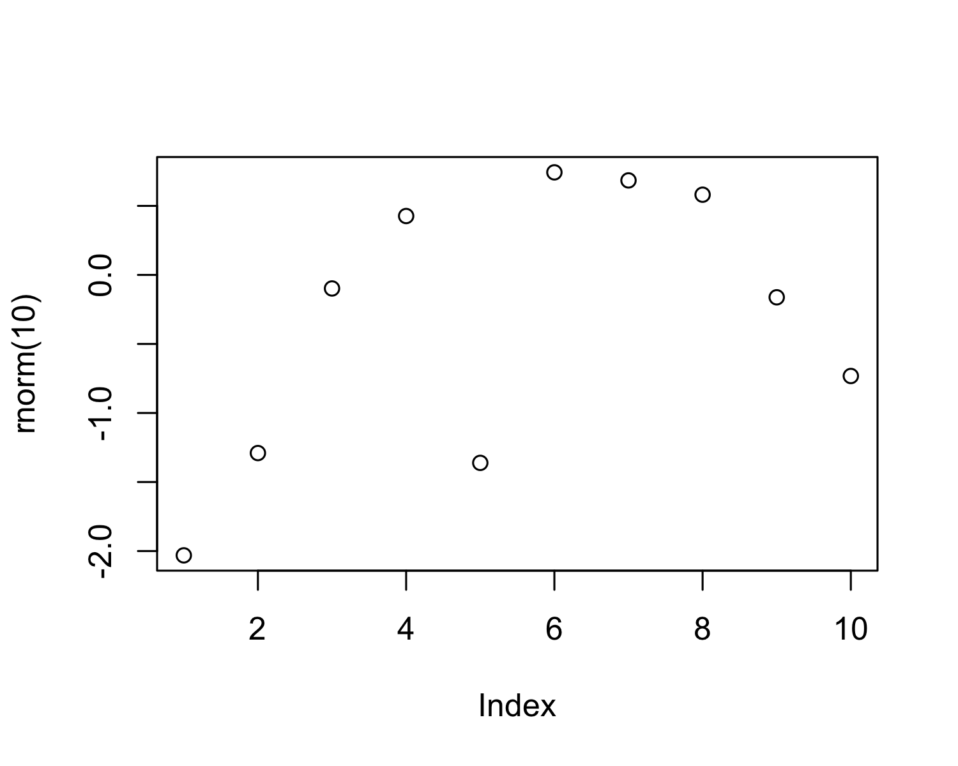

Figure 4.2: A plot of random numbers

Figure 4.2 shows how we can have a caption and cross-reference for a plot

Here is an example of inline code 3.14 in the middle of a sentence.

# 5 Discussion

# 6 Conclusion

# 7 Acknowledgements

# 8 References

1. Hirt, M. R., Jetz, W., Rall, B. C. & Brose, U. [A general scaling law reveals why the largest animals are not the fastest](https://doi.org/10.1038/s41559-017-0241-4). *Nature Ecology & Evolution* **1**, 1116–1122 (2017).

### 8.0.1 Colophon

This report was generated on 2021-12-01 11:22:40 using the following computational environment and dependencies:

#> ─ Session info 🏘️ 📜 ✍🏿 ─────────────────────────────────────────────────  
#> hash: houses, scroll, writing hand: dark skin tone  
#>   
#> setting value  
#> version R version 4.0.3 (2020-10-10)  
#> os macOS Catalina 10.15.7  
#> system x86_64, darwin17.0  
#> ui X11  
#> language (EN)  
#> collate en_US.UTF-8  
#> ctype en_US.UTF-8  
#> tz America/Los_Angeles  
#> date 2021-12-01  
#> pandoc 2.16.2 @ /usr/local/bin/ (via rmarkdown)  
#>   
#> ─ Packages ───────────────────────────────────────────────────────────────────  
#> package * version date (UTC) lib source  
#> assertthat 0.2.1 2019-03-21 [1] CRAN (R 4.0.2)  
#> bookdown 0.24 2021-09-02 [1] CRAN (R 4.0.2)  
#> cachem 1.0.6 2021-08-19 [1] CRAN (R 4.0.2)  
#> callr 3.7.0 2021-04-20 [1] CRAN (R 4.0.2)  
#> cli 3.1.0 2021-10-27 [1] CRAN (R 4.0.2)  
#> colorspace 2.0-0 2020-11-11 [1] CRAN (R 4.0.2)  
#> crayon 1.4.2 2021-10-29 [1] CRAN (R 4.0.2)  
#> DBI 1.1.1 2021-01-15 [1] CRAN (R 4.0.2)  
#> desc 1.4.0 2021-09-28 [1] CRAN (R 4.0.2)  
#> devtools 2.4.2 2021-06-07 [1] CRAN (R 4.0.2)  
#> digest 0.6.28 2021-09-23 [1] CRAN (R 4.0.2)  
#> dplyr * 1.0.7 2021-06-18 [1] CRAN (R 4.0.2)  
#> ellipsis 0.3.2 2021-04-29 [1] CRAN (R 4.0.2)  
#> evaluate 0.14 2019-05-28 [1] CRAN (R 4.0.1)  
#> fansi 0.5.0 2021-05-25 [1] CRAN (R 4.0.2)  
#> farver 2.0.3 2020-01-16 [1] CRAN (R 4.0.2)  
#> fastmap 1.1.0 2021-01-25 [1] CRAN (R 4.0.2)  
#> fs 1.5.0 2020-07-31 [1] CRAN (R 4.0.2)  
#> generics 0.1.0 2020-10-31 [1] CRAN (R 4.0.2)  
#> ggplot2 * 3.3.3 2020-12-30 [1] CRAN (R 4.0.2)  
#> glue 1.5.0 2021-11-07 [1] CRAN (R 4.0.2)  
#> gtable 0.3.0 2019-03-25 [1] CRAN (R 4.0.2)  
#> highr 0.9 2021-04-16 [1] CRAN (R 4.0.2)  
#> htmltools 0.5.2 2021-08-25 [1] CRAN (R 4.0.2)  
#> knitr 1.36 2021-09-29 [1] CRAN (R 4.0.2)  
#> lifecycle 1.0.1 2021-09-24 [1] CRAN (R 4.0.2)  
#> magrittr 2.0.1 2020-11-17 [1] CRAN (R 4.0.2)  
#> maxspeed * 0.0.0.9000 2021-12-01 [1] local  
#> memoise 2.0.1 2021-11-26 [1] CRAN (R 4.0.2)  
#> munsell 0.5.0 2018-06-12 [1] CRAN (R 4.0.2)  
#> pillar 1.6.4 2021-10-18 [1] CRAN (R 4.0.2)  
#> pkgbuild 1.2.0 2020-12-15 [1] CRAN (R 4.0.2)  
#> pkgconfig 2.0.3 2019-09-22 [1] CRAN (R 4.0.2)  
#> pkgload 1.2.3 2021-10-13 [1] CRAN (R 4.0.2)  
#> prettyunits 1.1.1 2020-01-24 [1] CRAN (R 4.0.2)  
#> processx 3.5.2 2021-04-30 [1] CRAN (R 4.0.2)  
#> ps 1.6.0 2021-02-28 [1] CRAN (R 4.0.2)  
#> purrr 0.3.4 2020-04-17 [1] CRAN (R 4.0.2)  
#> R6 2.5.1 2021-08-19 [1] CRAN (R 4.0.2)  
#> remotes 2.4.1 2021-09-29 [1] CRAN (R 4.0.2)  
#> rlang 0.4.12 2021-10-18 [1] CRAN (R 4.0.2)  
#> rmarkdown 2.11 2021-09-14 [1] CRAN (R 4.0.2)  
#> rprojroot 2.0.2 2020-11-15 [1] CRAN (R 4.0.2)  
#> rstudioapi 0.13 2020-11-12 [1] CRAN (R 4.0.2)  
#> scales 1.1.1 2020-05-11 [1] CRAN (R 4.0.2)  
#> sessioninfo 1.2.1 2021-11-02 [1] CRAN (R 4.0.2)  
#> stringi 1.7.6 2021-11-29 [1] CRAN (R 4.0.3)  
#> stringr 1.4.0 2019-02-10 [1] CRAN (R 4.0.2)  
#> testthat 3.1.0 2021-10-04 [1] CRAN (R 4.0.2)  
#> tibble 3.1.6 2021-11-07 [1] CRAN (R 4.0.2)  
#> tidyselect 1.1.0 2020-05-11 [1] CRAN (R 4.0.2)  
#> usethis 2.1.3 2021-10-27 [1] CRAN (R 4.0.2)  
#> utf8 1.2.2 2021-07-24 [1] CRAN (R 4.0.2)  
#> vctrs 0.3.8 2021-04-29 [1] CRAN (R 4.0.2)  
#> withr 2.4.2 2021-04-18 [1] CRAN (R 4.0.3)  
#> xfun 0.28 2021-11-04 [1] CRAN (R 4.0.2)  
#> yaml 2.2.1 2020-02-01 [1] CRAN (R 4.0.2)  
#>   
#> [1] /Library/Frameworks/R.framework/Versions/4.0/Resources/library  
#>   
#> ──────────────────────────────────────────────────────────────────────────────

The current Git commit details are:

#> Local: main /Users/ChihFu/Desktop/maxspeed  
#> Remote: main @ origin (https://github.com/yehchihfu/maxspeed.git)  
#> Head: [03aa972] 2021-12-01: Create nature.csl