TUTORIAL: HOW TO RUN A NODE FOR WINDOWS

**1. Download a Docker on Your Computer and Install it.**

* Download Link : <http://dockr.ly/3aLDIfZ>
* Recommended: ***Docker Version 2.5.0.1***

***A lower version of the Docker is recommended before you can run a node on your windows. your node will get an error when you run it, the Docker with the higher isn’t advisable for now. So, my advice is download the lower version. That there is no error when you run the node.***

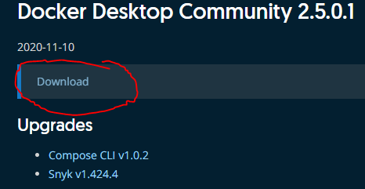

* Install the Docker *(Is needed to run the node)*

***Setup your Docker properly. Download the package requirements before you open it. It is not difficult to install just only follow the guide. Ensure there is no problem with your Docker before you run a node. because the Docker will serve as the brain of your node to run the node properly and without problems.***

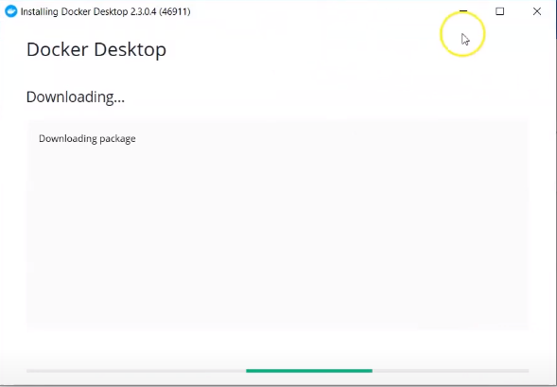

**2. Download Concordium Node and Client software**

* Download Link : <https://bit.ly/3jwtt2U>
* Extract the files

***Download the concordium-node on its official website. Lock updated your concordium before installing it on your pc. the latest version of the concordium-node is now 0.4.11. you can click the link above to take the automatic download.***

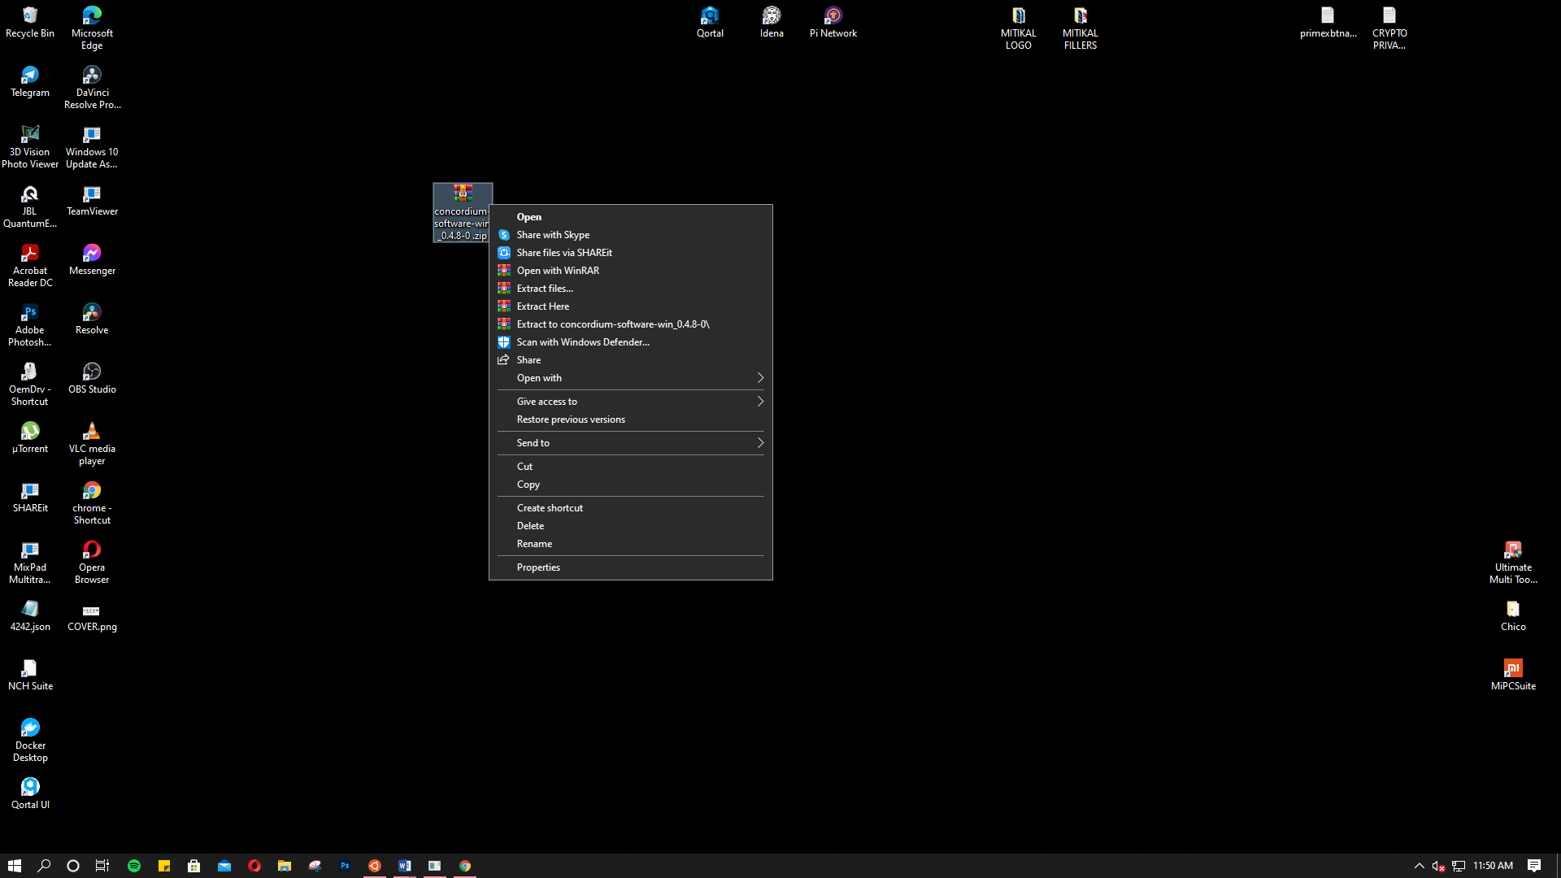

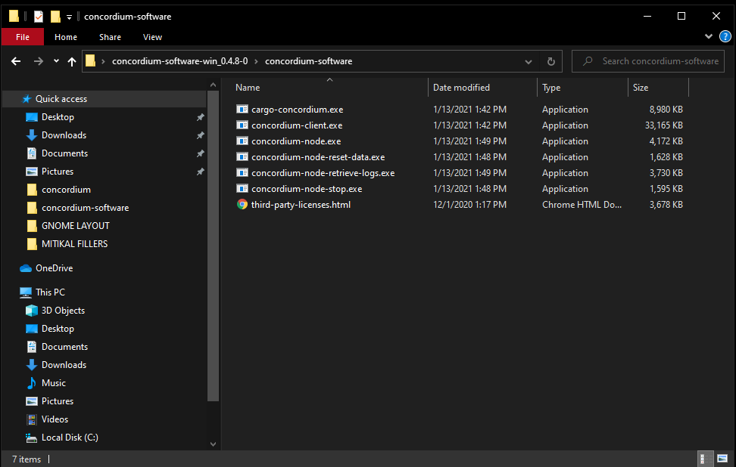

*Note: Put the folder of concordium-software in one destination folder thereby, you can quickly access or easy find.*

**3. Now, Open Your Docker Application to Start it Running in Background**

Just wait until the Docker is running, When the Docker starts you go to your search box and type *Windows PowerShell*

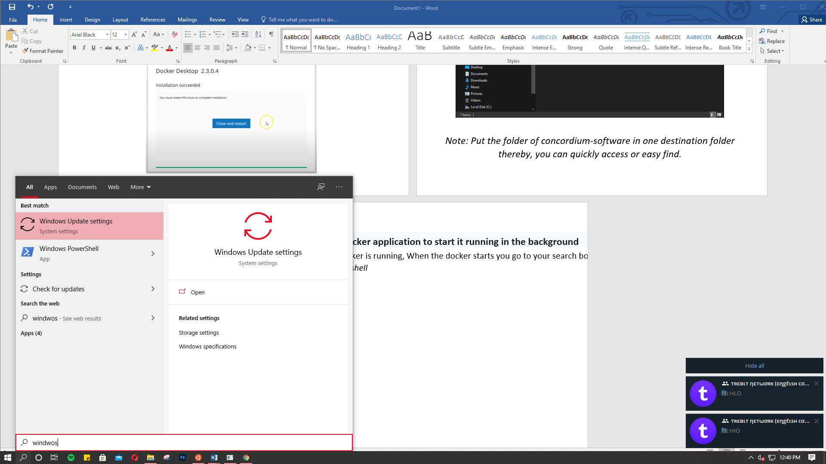

* Just open it and run.
* We run nodes on windows, also need Windows PowerShell. This will be our funnel to open the concordium-node.

It looks like when the PowerShell is open

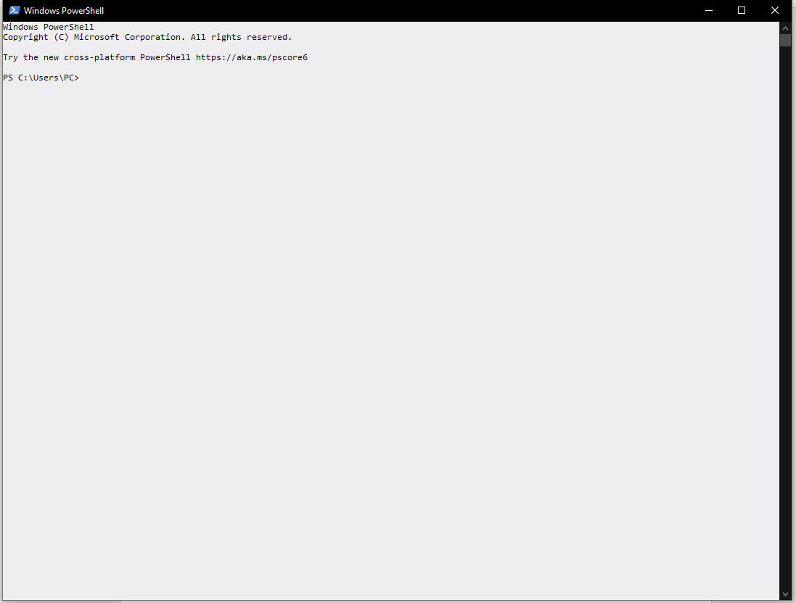



* In my case the folder of my concordium -software I put in the documents. So, go there and click the search box.
* After Click on search box just wait for it to be highlighted then right click and copy.
* You need to take the path where your Concordium-software is located.

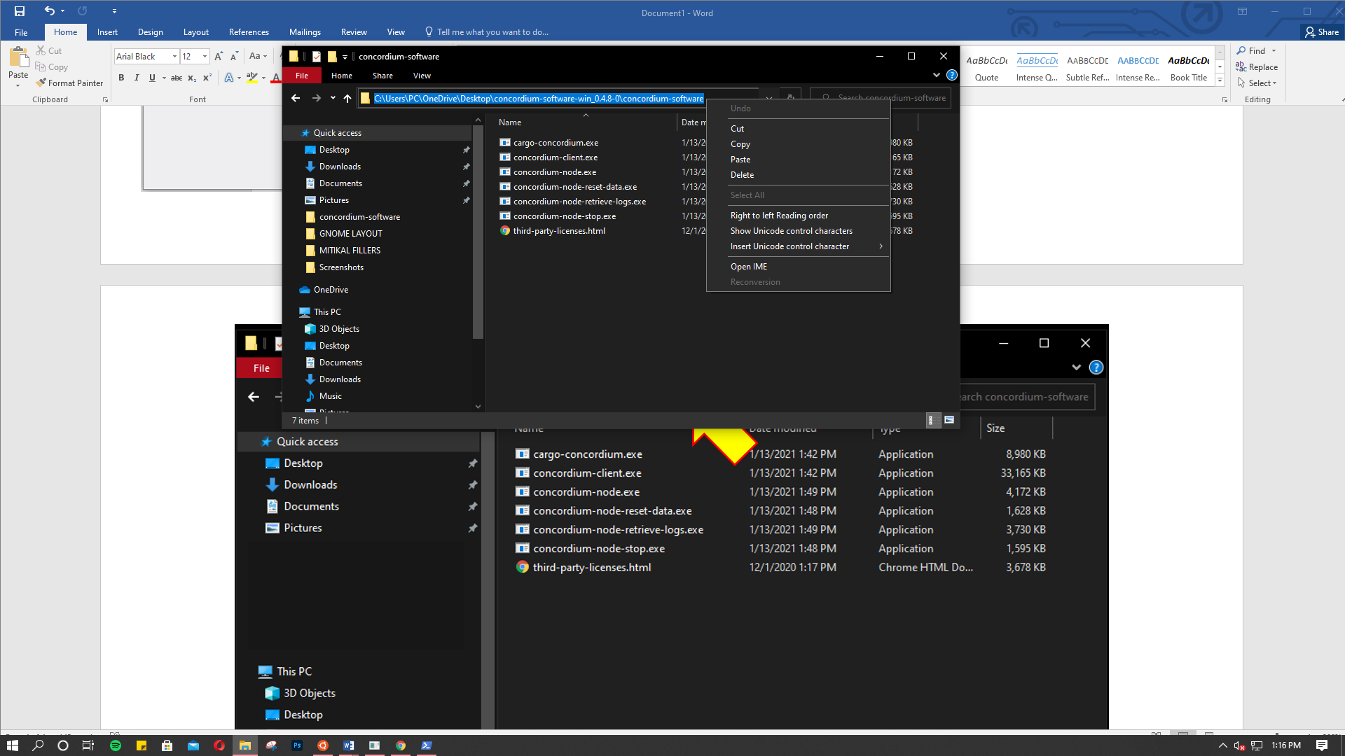

Go back to Windows PowerShell and type :

cd \Users\PC\OneDrive\Documents\concordium-software\ Then Enter.

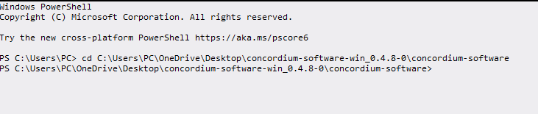

Note: Please Change the path name with your path name.

*Note: You can go directly to the folder of Concordium-software. And look for -Concordium-node.exe and wait for it to run. But, there's a probably you have encounter error. So better use Windows PowerShell to run concordium-node.exe properly.*

**4. Setup and Create Your New Node.**

Now we open the concordium-node.exe to setup the node

* In PowerShell. Just paste ./concordium-node.exe then enter.
* now your node start running and create your node with your desire name.

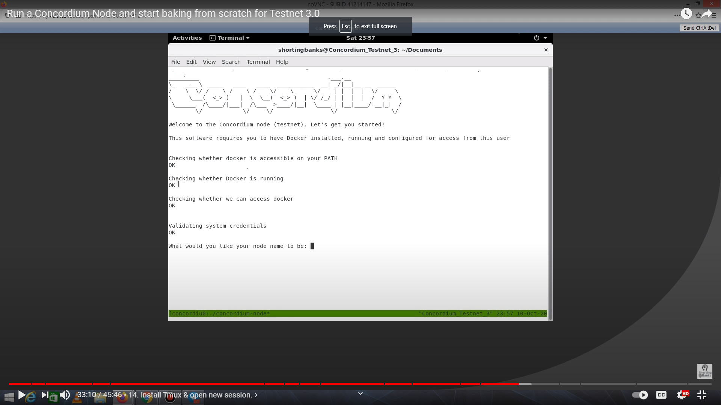

Markcarillo

* Make sure you have enter node name before you proceed the next step

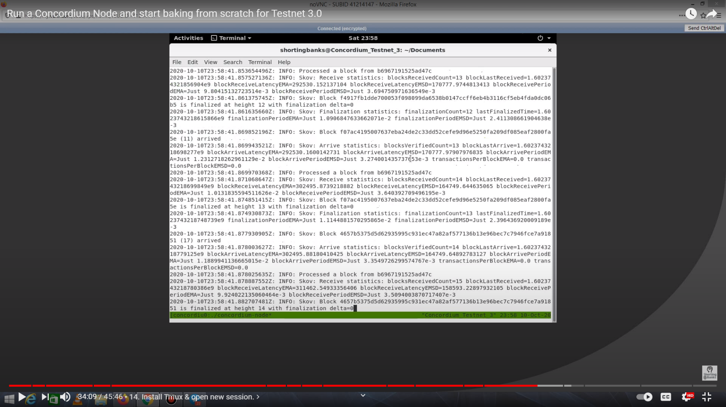

***Observe the node when runs smoothly and no visible error or unfavorable. as can be seen in the picture that it is really well processed***

* After running a node, you can check it from dashboard.

By clicking this link : <https://dashboard.testnet.concordium.com>

* Find your name in the list.
* When your name appears on the public dashboard you are successful in running your own node.
* Just wait for your blocks until fully synchronized.
* It takes up to 24 hours. It depends on your internet connection.

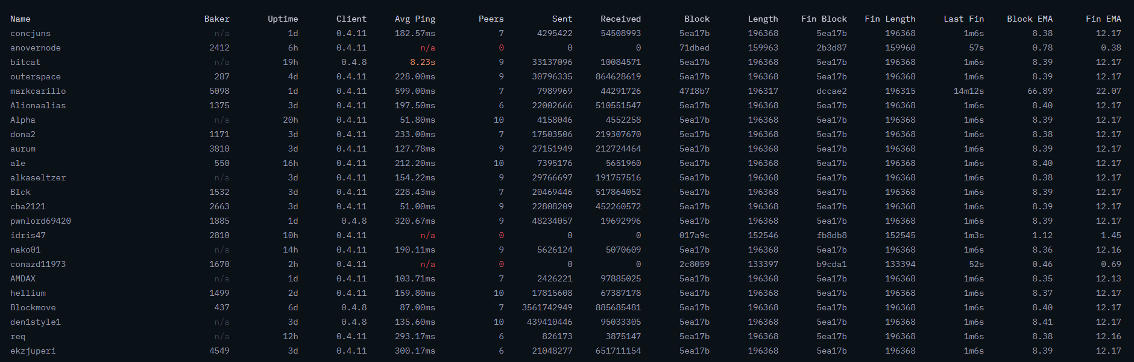

*I added. If incase you to stop running your node just go to powershell again and type ./concordium-node-stop.exe*

*After the finalization of the blocks of your node. You can now add your baker account to your node account. I will make separate article tutorial how to put baker account in node account.*

**5. Proper Way to Stop the Node**

* If you want to turn off your node go to your Concordium-software folder and find Concordium-node-stop.exe just open it and wait for your running node to stop.
* Other way is open PowerShell type cd \Users\PC\OneDrive\Documents\concordium-software Then Enter. Just type ./concordium-node-stop.exe.

**6. Reconnecting the Node**

* If you are trying reconnect again your node. this the simple tips. Open again the PowerShell then just type cd \Users\PC\OneDrive\Documents\concordium-software

And type ./concordium-node-exe --no-block-state-import Press Enter.

* The node is starting to run again. Just wait for it to recover and finalize the blocks again.

*Running a node in windows has a big disadvantage unlike running a node through a VPS or Virtual Private Server that can even turn off the computer and laptop while still running your node. the only advantage of running nodes to windows is that it is easy to set up even one day when you study it you can easily understand and do it right on your own computer.*

**TAKE NOTE:**

Thank you so much for reading my article about “How to run a node” Hope you learn a lot and I am glad to be able to serve you by it very simple tutorial. Thank you and God bless!