

Banking System



Yehia Tarek

Eslam Tayseer

Mohammed Mostafa

Youssef Waleed

Moaz Mohammed Haytham

Karim Sabry

***Introduction: -***

A Banking software system is the domain we are working on. The system is based on an incrementsl development process model to make that software designed specifically for Banks.

***Functional Requirements: -***

* Insert ATM card
* Validate ATM card
* Enter Product task
* Enter pin
* Validate pin
* Validate for account type if the task is banking

***Nonfunctional Requirements:-***

Performance Requirements: -

* Error message should be displayed at least 6 seconds.
* If there is no response from the bank after a request within a minute, the card is rejected with an error message
* The ATM dispenses money if and only if the withdraw from the account is proceeded and accepted by the bank.
* Each bank may be processing transaction from several ATM’s at the same time
* Response time for different operations should not exceed 3 seconds

***Accounting Requirement: -***

* Customer shouldn’t withdraw more than 50% of balance
* No one rather than the owner of the account should have access to it
* High encryption of data
* Loans shouldn’t exceed 75% of the amount of money in balance.
* Online accounts should have password rather than the pin code on the card.

***Loaners:***

1. Service Provided:

* Show Interest
* Notify about deadline
* Provide balance details
* Provide contact information

1. Data Provided:

* Personal Information
* The value of the mortgage
* The period required to payback

1. Event Provided:

* Normal: -
* Validate User
* Check password
* Select service
* Exception: -
* Timeout
* Unavailable service
* Retard penalty to pay it

***Accounting Staff:***

1. Services Provided:

* Cash Counting
* Calculating expenses
* Managing and reviewing contracts for companies

1. Data Provided:

* Customer’s Orders
* Contracts information and terms
* Calculation of expenses and benefits

1. Events Provided

* Normal: -
* Balance Updates
* Communication with the domain
* Open/Close accounts
* Exceptions: -
* Absence of essential information
* Incomplete expenses and balance of account information

***Depositors:***

1. Services Provided:

* Show balance details
* Withdraw money
* Transfer credit

1. Data provided:

* Value of deposit
* Money to be withdrawn
* Credit to be transferred

1. Event Provided

* Normal: -
* Withdraw credit
* Request pin
* Select service
* Ask customer service
* Close balance
* Exceptions: -
* Not enough credit
* Stolen credit
* Lost password
* Incapability to validate account information

***Use Case Diagram:***

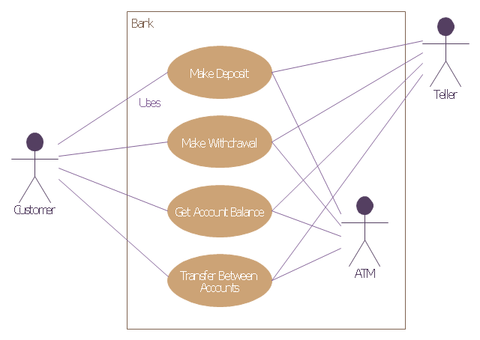

***Class Diagram:***

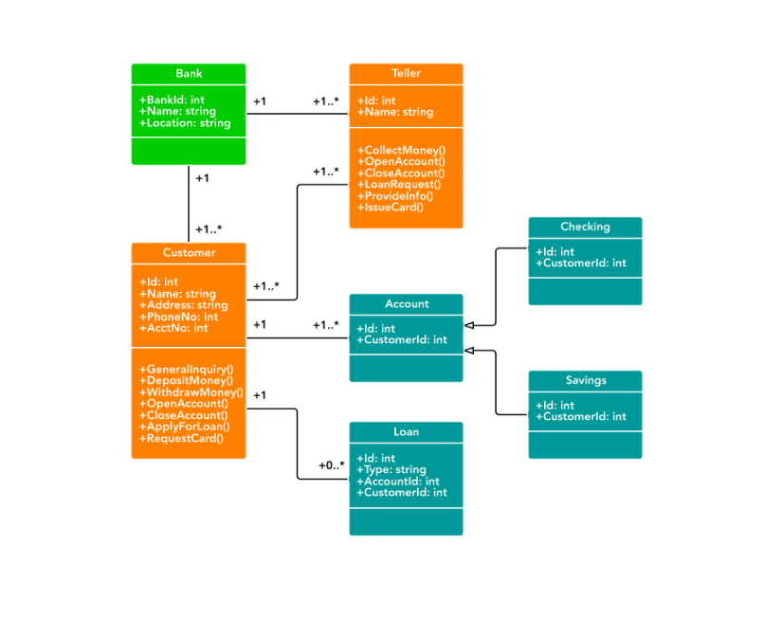

***Sequence Diagram for Withdrawal/Deposit:***

