

Africathone

Supply Chain System For Eco-Friendly
Resources

1.0 Introduction

Supply chain system using blockhain system to ensure the organizations use eco-friendly systems .Blockchain gives suppliers, manufacturers, distributors, and retailers the ability to create a physical-digital link between commodities or goods and their corresponding identities on blockchain. When both the origins and the entire chain of custody of a commodity are verified on a blockchain, it creates a more transparent, trustworthy network.

1.1 App Scenario
1- All the Eco-friendly materials producers and/or clean resources producers have an account on our Blockchain (ex: Factory producing Eco-friendly materials, Renewable energy stations…,etc. )
2- Using all the information that we already have on them will help us determine to what extend their clients are using Eco-friendly materials or clean or renewable energy relative to their production (the clients production).
3- Thus, we are able to determine the exact amount of the Eco-friendly material that the clients use in their own production. And according to this information we can give them a score that will help in encouraging them in using more Eco-friendly products (the higher the score the higher they use Eco-friendly material)
The main advantage of using blockchain is: the determination of the score is given in a transparent way, we are sure of the exact amount each client uses and by knowing this detailed information we can better optimize our efforts and cost in enhancing an Eco-friendly system on start-ups level as well as on the grand companies level.

1.2.1 What blockchain we will use?

We will use IOTA Blockchain, IOTA is The first open-source distributed ledger that is being built to power the future of the Internet of Things with feeless microtransactions and data integrity for machines.

IOTA white paper:
https://assets.ctfassets.net/r1dr6vzfxhev/2t4uxvsIqk0EUau6g2sw0g/45eae33637ca92f85dd9f4a3a218e1ec/iota1_4_3.pdf

1.2.2 Why using it?

The importance of micropayments will increase in the rapidly developing IoT industry, and paying a fee that is larger than the amount of value being transferred is not logical. Furthermore, it is not easy to get rid of fees in the blockchain infrastructure since they serve as an incentive for the creators of blocks. This leads to another issue with existing cryptocurrency technology, namely the heterogeneous nature of the system.
1-No Fees.
2-No hard limit on transactions.
3-Un-Forkable.
4-Removes the dichotomy between the transaction authenticator and transaction makers.

1.2.3 How it work?
Blockchain: Linked List
Tangle: Directed Acyclical Graph
Instead pf blocks that hold multiple transactions, each transaction is another node in graph.
In general, a tangle-based cryptocurrency works in the following way. Instead of the global blockchain, there is a DAG that we call the tangle. The transactions issued by nodes constitute the site set of the tangle graph, which is the ledger for storing transactions. The edge set of the tangle is obtained in the following way: when a new transaction arrives, it must approve two previous transactions. these approvals are represented by directed edges, as shown in Figure 12 . If there is not a directed edge between transaction A and transaction B, but there is a directed path of length at least two from A to B, we say that A indirectly approves B. There is also the “genesis” transaction, which is approved either directly or indirectly by all other transactions (Figure 2). The genesis is described in the following way. In the beginning of the tangle, there was an address with a balance that contained all of the tokens. The genesis transaction sent these tokens to several other “founder” addresses. Let us stress that all of the tokens were created in the genesis transaction. No tokens will be created in the future, and there will be no mining in the sense that miners receive monetary rewards “out of thin air

1.3 Project Architecture

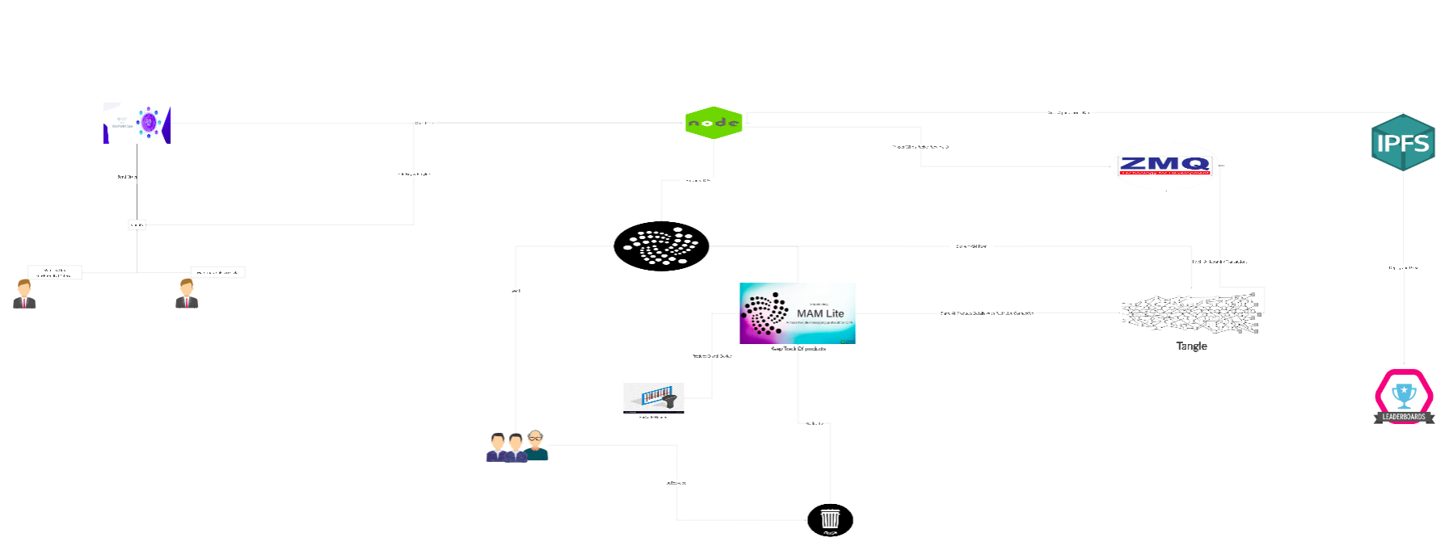

Find architect more clean using this link:https://app.creately.com/diagram/jws9tcnv1/view

2.0.0 Our Plan For The Project
All resources we found it useful to build our project and tools we are planing for devops and the architect of our system.

2.0.1 DevOps
1- For Agile we will use Taiga Software
2- Github for version control and deployment.
3- For production we will use the tangle node
2.0.2 IOTA resources and similar projects
https://docs.iota.org/docs/getting-started/0.1/introduction/what-is-dlt https://www.youtube.com/watch?v=MsaPA3U4ung&list=PLmL13yqb6OxdIf6CQMHf7hUcDZBbxHyza https://iota101.info/Allchapters_javascript.ipynb.html https://blog.florence.chat/tutorial-how-to-build-a-completely-free-dapp-11a4ddf5959c https://www.youtube.com/watch?v=nMCLCrLZJXE&list=PLL5pYVd8AWtRNi6NIPckfbBKQ22OIrmEB https://assets.ctfassets.net/r1dr6vzfxhev/2t4uxvsIqk0EUau6g2sw0g/45eae33637ca92f85dd9f4a3a218e1ec/iota1_4_3.pdf

3.2 DevOps and Back-end resources

https://www.atlassian.com/git/tutorials/comparing-workflows

https://blog.mwaysolutions.com/2014/06/05/10-best-practices-for-better-restful-api/

https://swagger.io/blog/api-design/api-design-best-practices/

https://taiga.io/

https://www.atlassian.com/blog/add-ons/5-real-life-examples-beautiful-technical-documentation

