

Student Name: Yehia Tarek

Submitted To: Sahib Sethi

Mentored By: Manish Podival

Report:
Survey the technology landscape

Agenda

Technologies I am interested in.

My Resources

My Dashboard

Twitter Account people I followed

Technologies I am interested in:-

1- Blockchain:

a)Etherum
b) hyperledger
c) IOTA

2-Back-end nodejs

3-Front-end:

a)JavaScript
b)Flutter
c)React
d)Bootstrap

My Resources:-

1- Email subscriptions
2- Meduim(https://medium.com/@yehiatarek67)
3-Twitter (https://twitter.com/YehiaTa78724367)
4-Freedly (https://medium.com/@yehiatarek67)

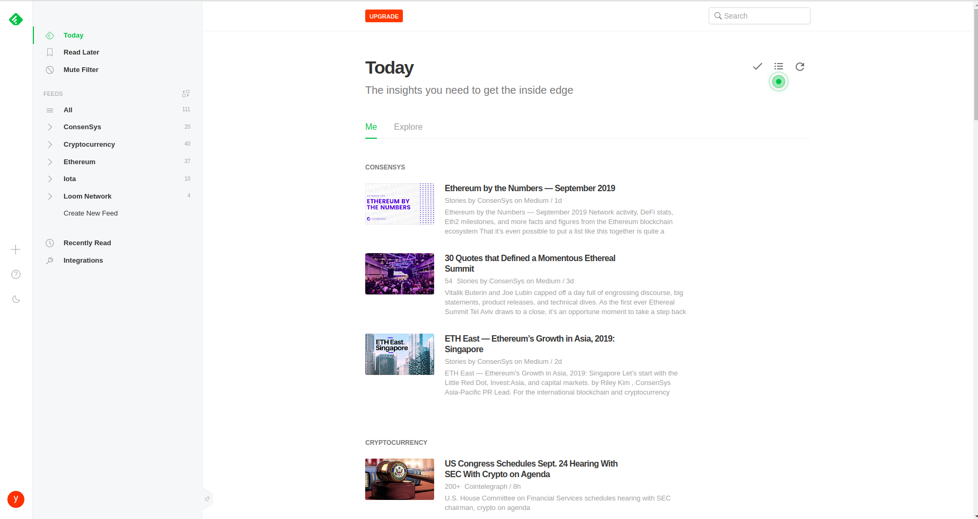

My Dashboard

Visit: https://feedly.com/i/my

Twitter Account people I followed

Visit: https://twitter.com/YehiaTa78724367/)

https://medium.com/northcoders/8-javascript-experts-you-must-follow-on-twitter-b3293fb14ab5

