Siamese Neural Networks for One-Shot Face Recognition

1. Introduction
One-shot learning refers to the problem of recognizing previously unseen classes given only a single labeled example per class. This setting is particularly challenging for conventional supervised learning approaches, which typically rely on large, labeled datasets to achieve robust generalization.
A seminal solution to this problem was proposed by Koch, Zemel, and Salakhutdinov (2015), who introduced Siamese Neural Networks trained on a verification task rather than direct classification. Their approach learns a similarity function between pairs of images, enabling generalization to entirely new classes without retraining. Using a convolutional Siamese architecture with a weighted L1 distance and sigmoid output, they achieved near human-level accuracy on the Omniglot one-shot classification benchmark.
While the original work focused on handwritten character recognition, extending the same methodology to face recognition introduces additional difficulties. Faces exhibit high intra-class variability due to pose, illumination, expression, and background clutter. As a result, models trained strictly according to the original paper may struggle to generalize effectively in this domain.
The goal of this project is to reproduce the original Siamese network as a baseline and then explore targeted improvements aimed at better adapting the model to face recognition. These improvements focus on input preprocessing and encoder behavior while preserving the original one-shot learning framework.

2. Dataset

The dataset is derived from a face image collection organized by identity, where each identity may contain between 1 and several dozen images. However, the training process does not operate directly on all identity images. Instead, it relies exclusively on predefined verification pairs supplied in text files, following the standard LFW evaluation protocol. The images have fix size of 250x250 and already grey scaled.

The identities in the data set contain a minimum of 1 image and maximum of 530 different images, while the average image is about 2.3 images per identities out of total of 13233 images spread around 5749 identities.
The dataset is divided using two official pair lists:
- pairsDevTrain.txt — defines training pairs
- pairsDevTest.txt — defines test pairs

Each file specifies:
- Positive pairs: two image indices belonging to the same identity
- Negative pairs: image indices from two different identities

These files explicitly control which images participate in training or testing, meaning:
- The split is pair-based
- Some identities may appear with only a small subset of their available images
- There is no independent validation identity pool, so I explicitly created from the training pairs

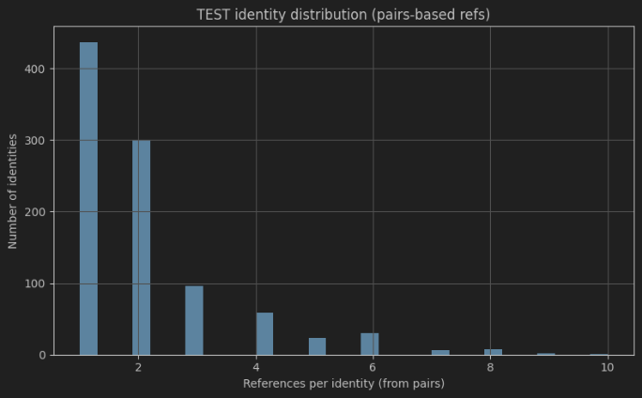
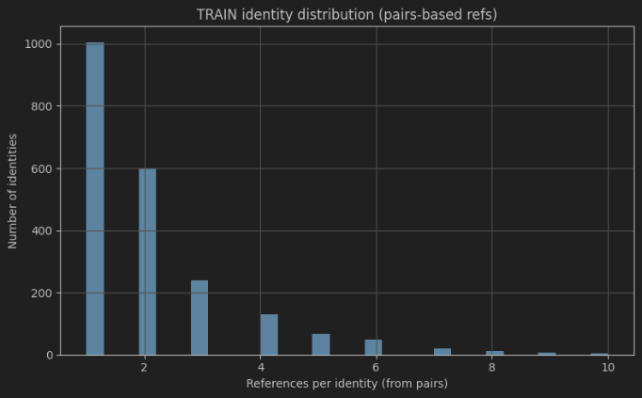
In train dataset we have 3443 unique images, 2132 unique identities, minimum of 1, mean of 2.06, and max of 10 images per identity. While test dataset we have 1549 unique images, 963 unique identities, minimum of 1, mean of 2.08, and max of 10 images per identity. And we have 0 overlap between train and test images identities and unique images.

Both the training and test pair files are constructed to be approximately balanced:
- Each file begins with a number indicating total pairs
- Pairs are evenly divided between positive (same identity) and negative (different identity) examples

As a result, the class balance is fixed and externally imposed, not inferred from the raw dataset distribution.

The EDA does support the claim that faces are tightly aligned or consistently centered in the frame:
- Mean and variance images show broad spatial activation
- Facial structure is visible and sharply localized
- Background regions is negligible variance

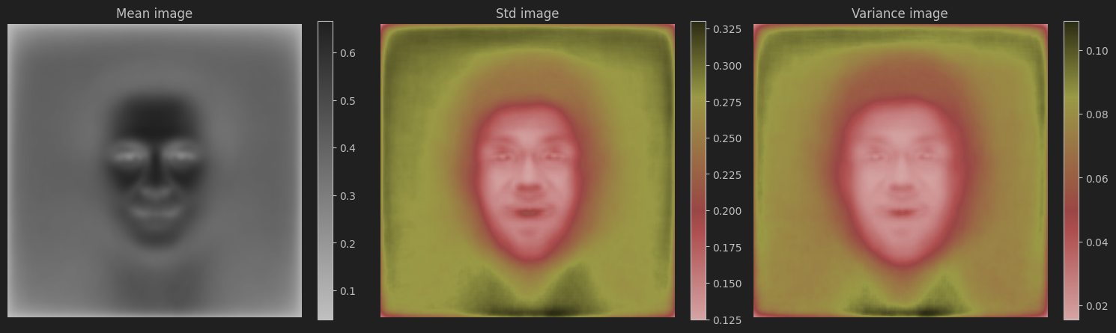

This indicates strong alignment, typical of LFW-style datasets, rather than studio-quality or landmark-aligned face crops.

Variance is limited to facial landmarks (eyes, mouth, nose):
- Hair, shoulders, and background do not have significant contribution.
- Lighting variation affects small portions of the image

Thus, the dataset contains substantial nuisance variation, not a face-only signal.

3. Preprocessing

In the baseline experiment, preprocessing closely follows the original paper. Images are resized to a fixed spatial resolution of 105×105 pixels spatial resolution, pixel values are normalized, and the resulting tensors are fed directly into the Siamese network without explicit semantic filtering. Several preprocessing factors govern this baseline pipeline.
- Input resolution determines the spatial granularity of facial features available to the encoder, trading off fine-grained detail against computational cost.
- Normalization statistics (mean and standard deviation) control the scale of pixel intensities and stabilize optimization by ensuring consistent input distributions across training samples.

In absence of explicit cropping or masking implicitly assumes that the network can learn to ignore background information through supervision alone.

In the improved preprocessing pipeline robustness is introduced through a combination of lightweight, task-agnostic transformations that modify the input distribution while preserving the original verification objective. All images are first resized to a fixed spatial resolution of 105×105 pixels, reducing input dimensionality. Pixel intensities are then normalized using fixed mean and standard deviation values to ensure stable and consistent optimization behavior. During training, additional stochastic augmentations are applied to encourage invariance to minor geometric and photometric variations commonly observed in unconstrained face images. These include random resized cropping with near-square aspect ratios, small affine transformations (limited rotation, translation, and scale), random horizontal flipping, mild grayscale intensity jitter (brightness, contrast, and gamma), and occasional Gaussian blurring. Together, these augmentations introduce controlled variability in pose, scale, alignment, and illumination while enforcing strong assumptions about facial structure and explicitly suppressing background regions and noise.

Importantly, this preprocessing strategy does not alter labels, loss functions, network architecture, or the one-shot learning protocol. Instead, it implicitly guides the encoder toward learning identity-relevant representations by exposing it to realistic intra-class variation while maintaining a fully deterministic preprocessing pipeline during evaluation. As a result, any observed performance differences can be attributed to improved robustness and generalization induced by the preprocessing choices, rather than changes in supervision, model capacity, or explicit spatial priors such as face masking.

Here is an example for the 2 type of preprocessing vs the original photo:

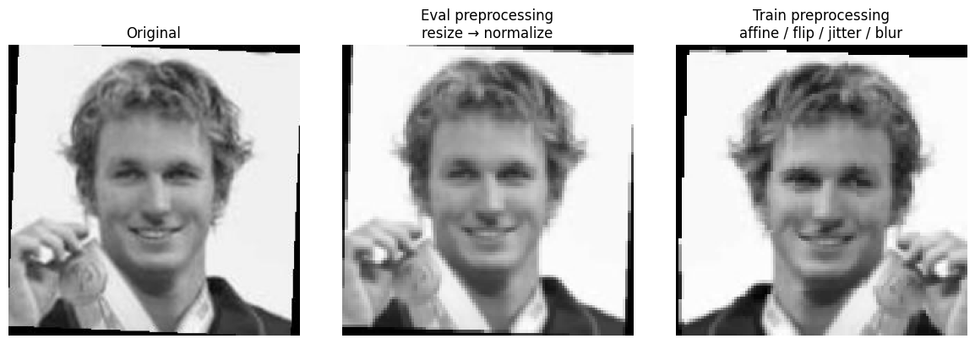

4. Experiments

This section presents the experimental evaluation conducted to assess the impact of preprocessing on the performance of the Siamese network. Two experiments are reported: a baseline run that closely follows the original paper, and an improved run that incorporates face-focused preprocessing. Both experiments use the same dataset splits, network architecture, loss function, and training protocol, ensuring that observed differences are attributable solely to preprocessing choices.

4.1 Baseline Experiment: Paper Reproduction

The first experiment serves as a baseline and aims to reproduce the behavior of the original model described in the paper as faithfully as possible. Images are resized to a fixed resolution, normalized, and passed directly to the Siamese network without any explicit face localization or background suppression. No domain-specific preprocessing is applied beyond standard image normalization.

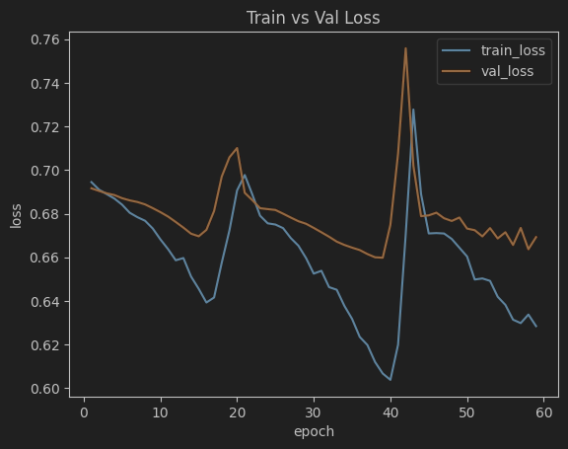
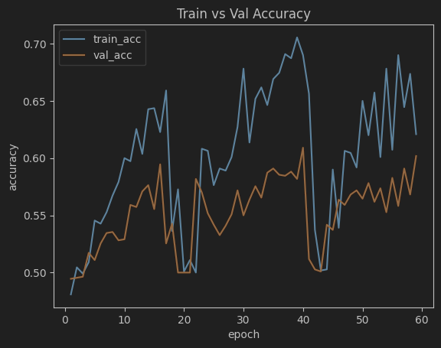
This setup reflects the assumptions of the original paper, where the network is expected to learn discriminative representations directly from raw image data. As a result, the encoder must implicitly learn to focus on facial regions while simultaneously handling background variability, illumination changes, and pose differences. The baseline experiment therefore provides a reference point for model behavior under minimal inductive bias and establishes a performance floor against which preprocessing-driven improvements can be evaluated.

The training and validation curves of the baseline experiment reveal a learning process that is overall progressive but marked by significant instability. Training accuracy increases from near chance level to approximately 0.7, while training loss generally decreases over time, indicating that the model is learning to discriminate between same-identity and different-identity pairs. However, this improvement is not smooth: both accuracy and loss exhibit abrupt drops and spikes at several points during training, most notably around the mid and late stages of the run. At these points, training and validation accuracy temporarily fall back toward chance level, accompanied by sharp increases in loss. These disruptions suggest sensitivity to the optimization dynamics, such as interactions between the learning rate and momentum schedule or high gradient variance inherent to Siamese pair-based training. Validation accuracy improves only modestly and remains consistently below training accuracy, while validation loss plateaus rather than decreasing steadily. This persistent gap indicates limited generalization, likely caused by the presence of background information and other non-identity-related variations in the input images. Without explicit face-focused preprocessing, the encoder must implicitly learn to suppress irrelevant background features, which increases intra-class variance and makes the verification task more difficult. As a result, the baseline model learns discriminative features on the training pairs but struggles to transfer them consistently to unseen identities, producing the observed oscillatory and partially unstable training behavior.

4.2 Experiment with Face-Focused Preprocessing

The second experiment introduces a modified preprocessing pipeline designed to better align the input representation with the face verification task. In this setting, a face-focused mask—implemented using an elliptical or segmentation-based approach—is applied to each image prior to normalization and resizing. This mask suppresses background pixels while preserving the central facial region, thereby emphasizing identity-relevant information.

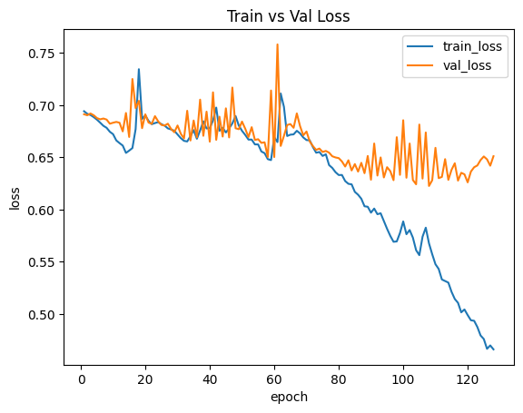
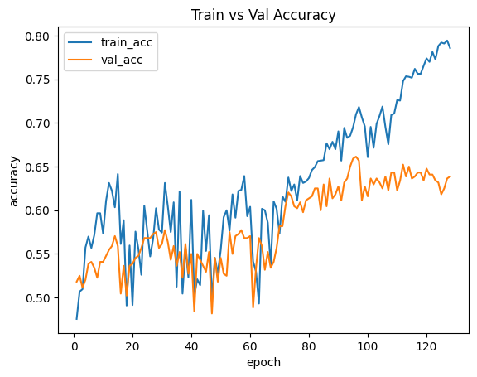
All other components of the training pipeline remain unchanged. The same Siamese architecture, loss function, optimizer configuration, and data splits are used, ensuring strict experimental control. The preprocessing modification therefore affects only the input distribution seen by the encoder.

The curves show a clear train–validation divergence after the mid-training phase, so the correct interpretation is “faster fitting + eventual overfitting,” not uniform improvement.

The training curves indicate that the model learns steadily but begins to overfit as training progresses. In the accuracy plot, train accuracy increases continuously and reaches roughly 0.79 by the final epochs, while validation accuracy rises more modestly and plateaus around 0.63–0.65. The widening gap after approximately epoch 70–80 suggests that the model continues to improve on the training pairs but gains limited additional generalization to the validation identities.

This pattern is reinforced by the loss plot. Training loss decreases strongly (down to roughly 0.47), whereas validation loss decreases only slightly early on and then stabilizes around 0.63–0.65 with noticeable oscillations. These oscillations are consistent with a relatively small validation set and a verification setting where mini-batch composition can vary in difficulty. Overall, the graphs suggest that the preprocessing and/or encoder changes improve the model’s ability to fit discriminative embeddings for the training distribution, but generalization saturates, indicating the need for additional regularization or earlier stopping (e.g., stronger augmentation, weight decay tuning, or selecting the checkpoint near the validation plateau rather than the final epoch).

4.3 Core Software Components

5. False Analysis

6. Takeaways

