Introduction: 1

Section A: 1

**1.1 Data Type Objects:** 1

**1.2 Operations:** 1

Section B: 4

**2.1 Data Type Objects:** 4

**2.2 Operations:** 4

**2.2.1 DENTAL_OFFICE** 4

**2.2.2 PATIENT** 5

**2.2.3 TOOTH** 5

**2.2.4 OPERATION** 5

**2.5 Design Issue** 6

**2.7 ADT Diagram** 6

# **Introduction:**

This is the document for TOOl_RENTAL ADT and DENTAL_OFFICE ADT. There will be some BON diagrams for reader to easily understand the logic behind the code, and this document will focus on the design idea for each class involved in both ADTs.

# **Section A:**

1. **TOOL_RENTAL ADT:**

### **1.1 Data Type Objects:**

inventory : LINKED_LIST[TOOL_DESC]

rented : LINKED_LIST[RENTAL_DESC]

under_repair : LINKED_LIST[REPAIR_DESC]

to_rent : LINKED_LIST[TOOL_DESC]

### **1.2 Operations:**

>> new_shop(new_tools: LINKED_LIST[TOOL_DESC]; min_tool_count: INTEGER)

-- Set up a tool rental shop, there is a minimum of 100 tools initially available for rent.

-- Require: min_tool_count >= 100

-- Ensure: inventory.count = min_tool_count and

number_rented_tools = 0 and

number_under_repair_tools = 0

>> size_of_inventory --> INTEGER

--- The number of tools in the inventory; i.e. owned by the shop.

--- Require: NONE

--- Ensure: Result := inventory.count

>> number_rented_tools --> INTEGER

--- The number of tools that are rented out

--- Require: NONE

--- Ensure: Result := rented.count

>> number_under_repair_tools --> INTEGER

--- The number of tools under repair.

--- Require: NONE

--- Ensure: Result := under_repair.count

>> dispose_of(tool: TOOL_DESC)

--- Remove a tool from the shop. It is no longer rentable or repairable.

--- It is no longer owned by the shop.

--- Require: valid_tool: tool /= void

exist_inventory: in_inventory(tool)

not_exist_rented: not in_rented(tool)

--- Ensure: not_exist_inventory: not in_inventory(tool)

decreased_inventory_size: size_of_inventory = (old size_of_inventory - 1)

>> buy (new_tool : TOOL_DESC)

--- Buy a new tool, which is, upon purchase, immediately available for rent.

--- Require: valid_tool: new_tool /= void

not_exist_inventory: not in_inventory(new_tool)

brand_new: new_tool.repair_count = 0

--- Ensure

exist_in_inventory: in_inventory(new_tool)

increased_inventory_size: size_of_inventory = (old size_of_inventory + 1)

increased_to_rent: to_rent.count = (old to_rent.count + 1)

>> start_repair_process (tool : TOOL_DESC)

--- The tool cannot be rented until it is repaired.

--- require

valid_tool: tool /= void

exist_in_inventory: in_inventory(tool)

exist_in_to_rent: in_to_rent(tool)

not_exist_in_rented: not in_rented(tool)

not_exist_in_repair: not in_repair(tool)

--- ensure

exist_in_inventory: in_inventory(tool)

not_exist_in_rented: not in_rented(tool)

exist_in_repair: in_repair(tool)

not_exist_to_rent: not in_to_rent(tool)

increased_under_repair_size: number_under_repair_tools = (old number_under_repair_tools + 1)

decreased_number_rented: to_rent.count = (old to_rent.count - 1)

>> to make this section more meaningful, please refer to listing of code, there are more supported

>> routines and contracts

* 1. **Operation Interactions:**

There are many interactions when writing the contracts, mostly between the contract support routines and actual operations in TOOL_RENTAL.

For example, when writing:

>> rent(tool: TOOL_DESC)

--- the preconditions are basically checking the proper location in which the tool should be before the

--- rental occurs. There is a supported routines called in_rented to make sure this tool to be rented is

--- not in the existing rented list, since the whole system follow the mutual exclusive mechanism,

--- which means, for all tool or rental or repair tools, it is not possible that the tool will be in two or

--- more lists at the same time.

--- Meanwhile, in_rented uses the quantifier that I wrote in order to traverse the corresponded list.

--- And the predicate we use same_tool is doing the existence checking.

* 1. **Axioms / ADT Invariant:**

total_inventory_equation:

to_rent.count = (size_of_inventory - number_rented_tools - number_under_repair_tools)

rented list intersect repair list = void ^ rented list intersect to rent = void

repair list intersect rented list = void ^ repair list intersect to rent = void

to rent list intersect repair list = void ^ to rent list intersect rented list = void

all list elements are in the inventory

* 1. **Design Issue:**

Since the whole system follow the mutual exclusive mechanism, which means, for all tool or rental or repair tools, it is not possible that the tool will be in two or more lists at the same time. Hence, the contract design idea is basically focusing on the list elements checking to follow the rules.

* 1. **ADT Diagram for TOOL_RENTAL**

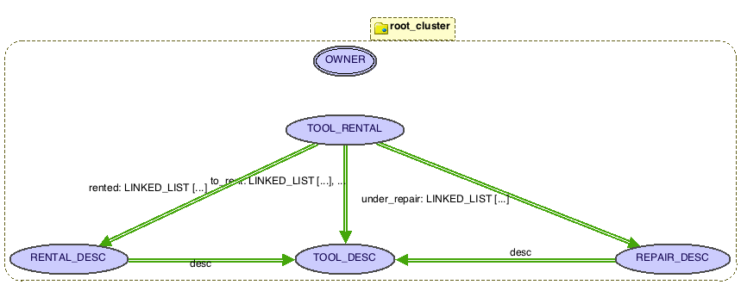

# **Section B:**

1. **DENTAL_OFFICE ADT:**

### **2.1 Data Type Objects:**

Imported: NONE

Exported: DENTAL_OFFICE

Hidden: PATIENT, TOOTH, OPERATION

### **2.2 Operations:**

#### **2.2.1 DENTAL_OFFICE**

>> make

--- initialize the dental office which contains a list of patients

>> get_root_canal_patients_list --> LINKED_LIST[PATIENT]

--- Query the existing patient list to get the patients who have had root canal

--- Require: patient_list /= void

--- Ensure: for all patients in the Result list, they all have had root canal operation

>> number_of_teeth_extraction(start_Date, end_Date: DATE): INTEGER

--- return the number of extractions done in the period of time

--- Require: start_Date is less than end_Date

--- Ensure: Result := #{t: TOOTH | t in Patients_LIST :: t.operations.has(extraction) ^ t.operation.date is between start_Date and end_Date }

>> get_operations_from_all(start_Date, end_Date: DATE): LINKED_LIST[OPERATION]

--- all operations performed on male/female patients

--- Require: start_Date is less than end_Date

--- Ensure: Result := list of operations that perform on any of tooth of each patients in ---- the dental_office

>> some support routines and agent to traverse the patient list, please refer to source >> code for detail

#### **2.2.2 PATIENT**

>> make(address: STRING; bod: DATE)

--- Initialize the patient with address, birth of date and the list of his/her teeth

>> had_root_canal : BOOLEAN

--- routine to determine if the patient has had root canal

--- require teeth /= void

--- ensure Result = there_exists_teeth(agent has_root_canal_tooth_in_p(?))

>> had_extraction: BOOLEAN

--- require teeth /= void

--- ensure Result = there_exists_teeth(agent has_extraction_tooth_in_p(?))

#### **2.2.3 TOOTH**

>> has_root_canal_tooth: BOOLEAN

--- Return True if this tooth has had root canal

--- Require: True

--- Ensure: Result := there_exists1_operation(agent is_root_canal(?))

>> has_extraction_tooth: BOOLEAN

--- Return True if this tooth has been extracted

--- Require: True

--- Ensure: Result := there_exists1_operation(agent is_extraction(?))

>> get_extraction_op: OPERATION

--- Return the operation object for query in dental_office to get the date of that

--- operation

--- Require: True

--- Ensure: Result := find_operation(agent is_extraction(?))

>> Some other support routines please refer to the source code in the end of report

#### **2.2.4 OPERATION**

>> make(date: DATE; type: INTEGER)

--- Initialize the operation object that has date and operation type

--- for operation type, 0 is filling, 2 is extraction, and 1 for root canal

* 1. **Operation Interactions:**

In this DENTAL_OFFICE implementation, the operation interactions among classes are basically the support routines interaction, that is, traversing every element among patient list or tooth list with a patient class.

* 1. **Axioms / ADT Invariant**

-- If this tooth got extracted then current is set to void, this idea

-- will be applied to patient class to check if any one of the tooth

-- is extracted, if yes, then the tooth is set to void and no more

-- operations can be done

extracted: there_exists1_operation(agent is_extraction(?)) implies Current = void

-- make sure that the count for root canal operation is at most one

at_most_1_root_canal: count_exists_operation(agent is_root_canal(?)) <= 1

### **2.5 Design Issue**

Design the DENTAL_OFFFICE require a good understanding of classes relationships. Since this system is mainly dealing with the problem of list traversal and query the list elements, hence, in the design process, we need some support routines to accomplish these tasks. In Eiffel, this can be done with the idea of agent and tuple features.

* 1. **Sample Query Usage**

In DENTAL_OFFICE, for example, we want to instantiate it within the START class.

E.g:

office: DENTAL_OFFICE

office. get_root_canal_patients_list

--- this will return a list of patients who have had root_canal

### **2.7 ADT Diagram**

