****报表地址：****

**http://192.25.103.250:8080/XYBI/ReportServer?reportlet=%5B5f00%5D%5B53d1%5D%5B6d4b%5D%5B8bd5%5D%2F%5B7ecf%5D%5B7eaa%5D%5B4e1a%5D%5B52a1%5D%5B4f53%5D%5B5916%5D%5B4ea7%5D%5B54c1%5D%5B6708%5D%5B62a5%5D.cpt&fr_check_url=TueJun1911:08:02CST2018&id=14e8084e-464c-45aa-8d39-53473b4fe0f4**

****问题****  
测试经纪业务体外产品月报的取数源表和目标表的数据保持同步且一致。

****设计****  
编写SQL脚本，测试目标表的相关字段在跑完存储过程后是否和源表的汇总数据保持一致。

****测试过程及结果****

-- 保有金额_期末

--保有金额_月日均

--保有金额_年日均

--销售金额_月累计

--赎回金额_月累计

--销售金额_年累计

--赎回金额_年累计

select SUM(RETAIN_AMT_FINAL)

,sum(RETAIN_AMT_MDA)

,sum(RETAIN_AMT_YDA)

,sum(SALE_AMT_MTD)

,sum(REDP_AMT_MTD)

,sum(SALE_AMT_YTD)

,sum(REDP_AMT_YTD)

from DM.T_BRKBIS_OUTMARK_PROD_M

WHERE YEAR_MTH = '201805'

UNION ALL

SELECT SUM(T1.QMBYJE)

,sum(BYJE_YRJ)

,sum(BYJE_NRJ)

,sum(XSJE_M)

,sum(SHJE_M)

,sum(XSJE_Y)

,sum(SHJE_Y)

FROM DBA.T_DDW_TWCP_M T1

WHERE T1.NIAN = '2018' AND T1.YUE = '05'

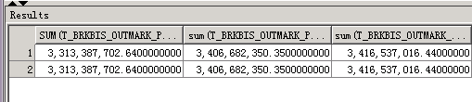

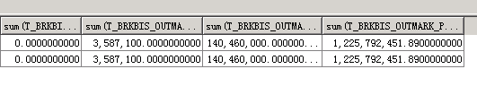

-- 帆软报表表样

