****报表地址：****

**http://192.25.103.250:8080/XYBI/ReportServer?reportlet=%5B5f00%5D%5B53d1%5D%5B6d4b%5D%5B8bd5%5D%2F%5B7ecf%5D%5B7eaa%5D%5B4e1a%5D%5B52a1%5D%5B671f%5D%5B8d27%5DIB%5B6708%5D%5B62a5%5D.cpt&fr_check_url=TueJun1910:54:53CST2018&id=14e8084e-464c-45aa-8d39-53473b4fe0f4**

****问题****  
测试经纪业务期货IB月报的取数源表和目标表的数据保持同步且一致。

****设计****  
编写SQL脚本，测试目标表的相关字段在跑完存储过程后是否和源表的汇总数据保持一致。

****测试过程及结果****

-- 测试客户数总数是否合理

-- 客户数

select SUM(CUST_NUM) from DM.T_BRKBIS_FUTR_IB_M WHERE YEAR_MTH = '201805'

UNION ALL

SELECT COUNT(T1.KHH) FROM DBA.T_DDW_IBYWMX T1 WHERE T1.NIAN = '2018' AND T1.YUE = '05'

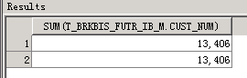

-- IB资产_期末

select SUM(IB_AST_FINAL) from DM.T_BRKBIS_FUTR_IB_M WHERE YEAR_MTH = '201805'

UNION ALL

SELECT SUM(T1.QMQY) FROM DBA.T_DDW_IBYWMX T1 WHERE T1.NIAN = '2018' AND T1.YUE = '05'

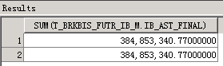

-- IB资产_月日均

select SUM(IB_AST_MDA) from DM.T_BRKBIS_FUTR_IB_M WHERE YEAR_MTH = '201805'

UNION ALL

SELECT SUM(T1.RJQY) FROM DBA.T_DDW_IBYWMX T1 WHERE T1.NIAN = '2018' AND T1.YUE = '05'

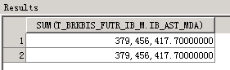

-- 净留存手续费_月累计

select SUM(NET_RETAN_CHAG_MTD) from DM.T_BRKBIS_FUTR_IB_M WHERE YEAR_MTH = '201805'

UNION ALL

SELECT SUM(T1.JLCSXF) FROM DBA.T_DDW_IBYWMX T1 WHERE T1.NIAN = '2018' AND T1.YUE = '05'

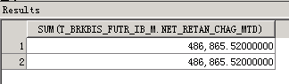

-- 帆软报表表样

