****报表地址：****

**http://192.25.103.250:8080/XYBI/ReportServer?reportlet=%5B5f00%5D%5B53d1%5D%5B6d4b%5D%5B8bd5%5D%2F%5B7ecf%5D%5B7eaa%5D%5B4e1a%5D%5B52a1%5D%5B80a1%5D%5B7968%5D%5B8d28%5D%5B62bc%5D%5B5408%5D%5B540c%5D%5B660e%5D%5B7ec6%5D%5B6708%5D%5B62a5%5D.cpt&fr_check_url=FriJun2213:30:34CST2018&id=23192148-97ac-4384-a113-85a49138f541**

****问题****  
测试经纪业务股票质押明细月报的取数源表和目标表的数据保持同步且一致。

****设计****  
编写SQL脚本，测试目标表的相关字段在跑完存储过程后是否和源表的汇总数据保持一致。

****测试过程及结果****

--股票质押总资产_期末

--股票质押余额_期末

--股票质押总资产_月日均

--股票质押余额_月日均

--股票质押总资产_年日均

--股票质押余额_年日均

select

sum(GUAR_SECU_MVAL_FINAL)

,sum(STKPLG_FIN_BAL_FINAL)

,sum(GUAR_SECU_MVAL_MDA)

,sum(STKPLG_FIN_BAL_MDA)

,sum(GUAR_SECU_MVAL_YDA)

,sum(STKPLG_FIN_BAL_YDA)

from DM.T_AST_EMPCUS_STKPLG_M_D

where YEAR = '2018' AND MTH = '05'

union all

select

sum(STKPLG_TOTAST_FINAL)

,sum(STKPLG_BAL_FINAL)

,sum(STKPLG_TOTAST_MDA)

,sum(STKPLG_BAL_MDA)

,sum(STKPLG_TOTAST_YDA)

,sum(STKPLG_BAL_YDA)

from DM.T_BRKBIS_STKPLG_CTR_DTL_M

where year_mth = '201805';

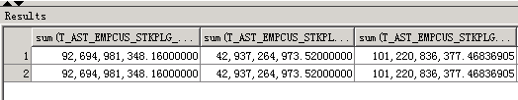

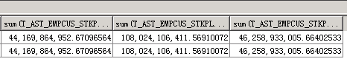

-- 帆软报表表样

