****报表地址：****

**http**

****问题****  
测试经纪业务融资融券月报的取数源表和目标表的数据保持同步且一致。

****设计****  
编写SQL脚本，测试目标表的相关字段在跑完存储过程后是否和源表的汇总数据保持一致。

****测试过程及结果****

-- 测试客户数总数是否合理

-- 经纪业务约定购回的客户的总人数

select

count(distinct CUST_ID)

FROM DM.T_AST_EMPCUS_APPTBUYB_M_D T1

where T1.YEAR = '2018' AND T1.MTH = '05';

-- 3,485,851人

-- 经纪业务约定购回客户中客户状态不为 “正常”的客户数

select count(1)

FROM DM.T_PUB_CUST T1 where CUST_ID in

(select distinct cust_id from DM.T_AST_EMPCUS_APPTBUYB_M_D)

and T1.CUST_STAT_NAME <> '正常'

and T1.YEAR = '2018' AND T1.MTH = '05';

--220,011人

--目标表汇总的客户总数

select

sum(cust_num)

from DM.T_BRKBIS_APPTBUYB_M

where YEAR_MTH='201805'

--3,265,840人

--结论：3485851-220011=3265840，说明客户数合理

--股票质押总资产_期末

--股票质押净资产_期末

--股票质押余额_期末

--自营融出方余额_期末

--资管融出方余额_期末

--小额融出方余额_期末

--股票质押总资产_月日均

--股票质押净资产_月日均

--股票质押余额_月日均

--自营融出方余额_月日均

--资管融出方余额_月日均

--小额融出方余额_月日均

--股票质押总资产_年日均

--股票质押净资产_年日均

--股票质押余额_年日均

--自营融出方余额_年日均

--资管融出方余额_年日均

--小额融出方余额_年日均

select sum(STKPLG_TOTAST_FINAL)

,sum(STKPLG_BAL_FINAL)

,sum(PROP_FINOS_BAL_FINAL)

,sum(ASSM_FINOS_BAL_FINAL)

,sum(MINO_AMT_FINOS_BAL_FINAL)

,sum(STKPLG_TOTAST_MDA)

,sum(STKPLG_BAL_MDA)

,sum(PROP_FINOS_BAL_MDA)

,sum(ASSM_FINOS_BAL_MDA)

,sum(MINO_AMT_FINOS_BAL_MDA)

,sum(STKPLG_TOTAST_YDA)

,sum(STKPLG_BAL_YDA)

,sum(PROP_FINOS_BAL_YDA)

,sum(ASSM_FINOS_BAL_YDA)

,sum(MINO_AMT_FINOS_BAL_YDA)

from DM.T_BRKBIS_STKPLG_AGGR_M

WHERE YEAR_MTH = '201805'

UNION ALL

SELECT sum(GUAR_SECU_MVAL_FINAL)

,sum(STKPLG_FIN_BAL_FINAL)

,sum(PROP_FINAC_OUT_SIDE_BAL_FINAL)

,sum(ASSM_FINAC_OUT_SIDE_BAL_FINAL)

,sum(SM_LOAN_FINAC_OUT_BAL_FINAL)

,sum(GUAR_SECU_MVAL_MDA)

,sum(STKPLG_FIN_BAL_MDA)

,sum(PROP_FINAC_OUT_SIDE_BAL_MDA)

,sum(ASSM_FINAC_OUT_SIDE_BAL_MDA)

,sum(SM_LOAN_FINAC_OUT_BAL_MDA)

,sum(GUAR_SECU_MVAL_YDA)

,sum(STKPLG_FIN_BAL_YDA)

,sum(PROP_FINAC_OUT_SIDE_BAL_YDA)

,sum(ASSM_FINAC_OUT_SIDE_BAL_YDA)

,sum(SM_LOAN_FINAC_OUT_BAL_YDA)

FROM DM.T_AST_EMPCUS_STKPLG_M_D T1

WHERE T1.YEAR = '2018' AND T1.MTH = '05'

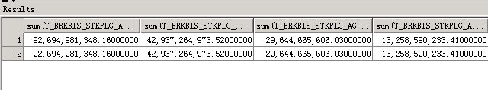

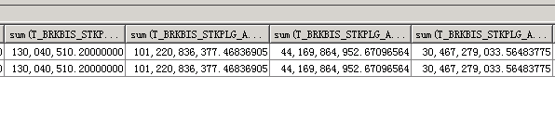

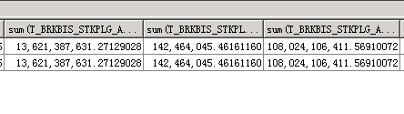

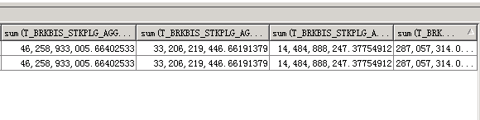

--源数据和目标表对比：约定购回余额_年日均

select

sum(APPTBUYB_BAL_YDA)

from DM.T_BRKBIS_APPTBUYB_M

where YEAR_MTH='201805'

union all

select

sum(T1.APPTBUYB_BAL_YDA)

FROM DM.T_AST_EMPCUS_APPTBUYB_M_D T1

where T1.YEAR = '2018' AND T1.MTH = '05';

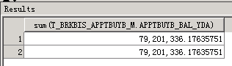

--源数据和目标表对比：约定购回净佣金_月累计

select sum(APPTBUYB_NET_CMS_MTD)

from DM.T_BRKBIS_APPTBUYB_M

where YEAR_MTH='201805'

union all

select sum(T1.APPTBUYB_NET_CMS_MTD)

from DM.T_EVT_EMPCUS_CRED_INCM_M_D T1

where T1.YEAR = '2018' AND T1.MTH = '05';

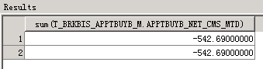

--源数据和目标表对比：约定购回实收利息_月累计

select sum(APPTBUYB_PAIDINT_MTD)

from DM.T_BRKBIS_APPTBUYB_M

where YEAR_MTH='201805'

union all

select sum(T1.APPTBUYB_PAIDINT_MTD)

from DM.T_EVT_EMPCUS_CRED_INCM_M_D T1

where T1.YEAR = '2018' AND T1.MTH = '05';

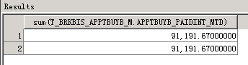

--源数据和目标表对比：约定购回净佣金_年累计

select sum(APPTBUYB_NET_CMS_YTD)

from DM.T_BRKBIS_APPTBUYB_M

where YEAR_MTH='201805'

union all

select sum(T1.APPTBUYB_NET_CMS_YTD)

from DM.T_EVT_EMPCUS_CRED_INCM_M_D T1

where T1.YEAR = '2018' AND T1.MTH = '05';

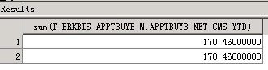

--源数据和目标表对比：约定购回实收利息_年累计

select sum(APPTBUYB_PAIDINT_YTD)

from DM.T_BRKBIS_APPTBUYB_M

where YEAR_MTH='201805'

union all

select sum(T1.APPTBUYB_PAIDINT_YTD)

from DM.T_EVT_EMPCUS_CRED_INCM_M_D T1

where T1.YEAR = '2018' AND T1.MTH = '05';

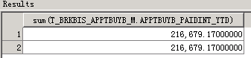

-- 帆软报表表样

