****报表地址：****

**http://192.25.103.250:8080/XYBI/ReportServer?reportlet=%5B5f00%5D%5B53d1%5D%5B6d4b%5D%5B8bd5%5D%2F%5B7ecf%5D%5B7eaa%5D%5B4e1a%5D%5B52a1%5D%5B878d%5D%5B8d44%5D%5B878d%5D%5B5238%5D%5B6708%5D%5B62a5%5D.cpt&fr_check_url=TueJun1910:44:30CST2018&id=14e8084e-464c-45aa-8d39-53473b4fe0f4**

****问题****  
测试经纪业务融资融券月报的取数源表和目标表的数据保持同步且一致。

****设计****  
编写SQL脚本，测试目标表的相关字段在跑完存储过程后是否和源表的汇总数据保持一致。

****测试过程及结果****

-- 测试客户数总数是否合理

-- 经纪业务融资融券的客户的总人数

select

count(distinct CUST_ID)

FROM DM.T_AST_EMPCUS_CREDIT_M_D T1

where T1.YEAR = '2018' AND T1.MTH = '05';

-- 3,485,851人

-- 经纪业务约定购回客户中客户状态不为 “正常”的客户数

select count(1)

FROM DM.T_PUB_CUST T1 where CUST_ID in

(select distinct cust_id from DM.T_AST_EMPCUS_CREDIT_M_D)

and T1.CUST_STAT_NAME <> '正常'

and T1.YEAR = '2018' AND T1.MTH = '05';

--220,011人

--目标表汇总的客户总数

select

sum(cust_num)

from DM.P_BRKBIS_CREDIT_M

where YEAR_MTH='201805'

--3,265,840人

--结论：3485851-220011=3265840，说明客户数合理

-- 目标表融资融券有效户数

select sum(CREDIT_EFF_HOUS) from dm.T_BRKBIS_CREDIT_M

-- 36400.00人

-- PUB_CUST表融资融券有效户数

select count(1)

FROM (SELECT

T1.YEAR

,T1.MTH

,T1.CUST_ID

,T1.CUST_STAT_NAME AS 客户状态

,CASE WHEN T1.TE_OACT_DT>=T2.NATRE_DAY_MTHBEG THEN 1 ELSE 0 END AS 是否月新增

,CASE WHEN T1.TE_OACT_DT>=T2.NATRE_DAY_YEARBGN THEN 1 ELSE 0 END AS 是否年新增

,COALESCE(T1.IF_VLD,0) AS 是否有效

,COALESCE(T4.IF_SPCA_ACCT,0) AS 是否特殊账户

,COALESCE(T1.IF_PROD_NEW_CUST,0) AS 是否产品新客户

,T1.CUST_TYPE_NAME AS 客户类型

,COALESCE(T3.IF_CREDIT_CUST,0) AS 是否融资融券客户

,COALESCE(T3.IF_CREDIT_EFF_CUST,0) AS 是否融资融券有效客户

,CASE WHEN T3.IF_CREDIT_CUST=1 AND T3.CREDIT_OPEN_DT>=T2.NATRE_DAY_MTHBEG THEN 1 ELSE 0 END AS 是否融资融券月新增

,CASE WHEN T3.IF_CREDIT_CUST=1 AND T3.CREDIT_OPEN_DT>=T2.NATRE_DAY_YEARBGN THEN 1 ELSE 0 END AS 是否融资融券年新增

,CASE WHEN T3.IF_CREDIT_CUST=1 AND T3.CREDIT_EFF_ACT_DT>=T2.NATRE_DAY_MTHBEG THEN 1 ELSE 0 END AS 是否融资融券月新增有效户

,CASE WHEN T3.IF_CREDIT_CUST=1 AND T3.CREDIT_EFF_ACT_DT>=T2.NATRE_DAY_YEARBGN THEN 1 ELSE 0 END AS 是否融资融券年新增有效户

,T3.CREDIT_CRED_QUO AS 融资融券授信额度

,T3.APPTBUYB_CRED_QUO AS 约定购回授信额度

,T3.STKPLG_CRED_QUO AS 股票质押授信额度

,CASE

WHEN COALESCE(T5.TOT_AST_MDA,0)<100 THEN '00-100以下'

WHEN COALESCE(T5.TOT_AST_MDA,0) >= 100 AND COALESCE(T5.TOT_AST_MDA,0)<1000 THEN '01-100_1000'

WHEN COALESCE(T5.TOT_AST_MDA,0) >= 1000 AND COALESCE(T5.TOT_AST_MDA,0)<2000 THEN '02-1000_2000'

WHEN COALESCE(T5.TOT_AST_MDA,0) >= 2000 AND COALESCE(T5.TOT_AST_MDA,0)<5000 THEN '03-2000_5000'

WHEN COALESCE(T5.TOT_AST_MDA,0) >= 5000 AND COALESCE(T5.TOT_AST_MDA,0)<10000 THEN '04-5000_1W'

WHEN COALESCE(T5.TOT_AST_MDA,0) >= 10000 AND COALESCE(T5.TOT_AST_MDA,0)<50000 THEN '05-1W_5W'

WHEN COALESCE(T5.TOT_AST_MDA,0) >= 50000 AND COALESCE(T5.TOT_AST_MDA,0)<100000 THEN '06-5W_10W'

WHEN COALESCE(T5.TOT_AST_MDA,0) >= 100000 AND COALESCE(T5.TOT_AST_MDA,0)<200000 THEN '1-10W_20W'

WHEN COALESCE(T5.TOT_AST_MDA,0) >= 200000 AND COALESCE(T5.TOT_AST_MDA,0)<500000 THEN '2-20W_50W'

WHEN COALESCE(T5.TOT_AST_MDA,0) >= 500000 AND COALESCE(T5.TOT_AST_MDA,0)<1000000 THEN '3-50W_100W'

WHEN COALESCE(T5.TOT_AST_MDA,0) >= 1000000 AND COALESCE(T5.TOT_AST_MDA,0)<2000000 THEN '4-100W_200W'

WHEN COALESCE(T5.TOT_AST_MDA,0) >= 2000000 AND COALESCE(T5.TOT_AST_MDA,0)<3000000 THEN '5-200W_300W'

WHEN COALESCE(T5.TOT_AST_MDA,0) >= 3000000 AND COALESCE(T5.TOT_AST_MDA,0)<5000000 THEN '6-300W_500W'

WHEN COALESCE(T5.TOT_AST_MDA,0) >= 5000000 AND COALESCE(T5.TOT_AST_MDA,0)<10000000 THEN '7-500W_1000W'

WHEN COALESCE(T5.TOT_AST_MDA,0) >= 10000000 AND COALESCE(T5.TOT_AST_MDA,0)<30000000 THEN '8-1000W_3000W'

WHEN COALESCE(T5.TOT_AST_MDA,0) >= 30000000 THEN '9-大于3000W'

END AS 资产段

FROM DM.T_PUB_CUST T1

LEFT JOIN DM.T_PUB_DATE_M T2 ON T1.YEAR=T2.YEAR AND T1.MTH=T2.MTH

LEFT JOIN DM.T_PUB_CUST_LIMIT_M_D T3 ON T1.YEAR=T3.YEAR AND T1.MTH=T3.MTH AND T1.CUST_ID=T3.CUST_ID

LEFT JOIN DM.T_ACC_CPTL_ACC T4 ON T1.YEAR=T4.YEAR AND T1.MTH=T4.MTH AND T1.MAIN_CPTL_ACCT=T4.CPTL_ACCT

LEFT JOIN DM.T_AST_ODI_M_D T5 ON T1.YEAR=T5.YEAR AND T1.MTH=T5.MTH AND T1.CUST_ID=T5.CUST_ID

WHERE T1.YEAR = '2018'

AND T1.MTH = '05'

--AND 资产段 IS NOT NULL

) T1

where CUST_ID in

(select distinct cust_id from DM.T_AST_EMPCUS_CREDIT_M_D)

and T1.客户状态 = '正常'

and T1.YEAR = '2018' AND T1.MTH = '05'

and t1.是否融资融券客户 = 1 and T1.是否融资融券有效客户 = 1

-- 36400

--源数据和目标表对比：融资融券授信额度

-- 目标表融资融券授信额度

select sum(CREDIT_CRED_QUO) from dm.T_BRKBIS_CREDIT_M where year_mth= '201805'

UNION ALL

-- DM.T_PUB_CUST_LIMIT_M_D融资融券授信额度

select sum(融资融券授信额度)

FROM (SELECT

T1.YEAR

,T1.MTH

,T1.CUST_ID

,T1.CREDIT_CRED_QUO AS 融资融券授信额度

from DM.T_PUB_CUST_LIMIT_M_D T1

WHERE T1.YEAR = '2018'

AND T1.MTH = '05'

) T1

where CUST_ID in

(select distinct cust_id from DM.T_AST_EMPCUS_CREDIT_M_D)

and T1.YEAR = '2018' AND T1.MTH = '05'

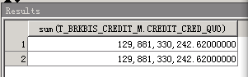

-- 融资融券总资产_期末

select sum(CREDIT_TOTAST_FINAL)

from dm.T_BRKBIS_CREDIT_M

where year_mth= '201805'

UNION ALL

select

sum(T1.TOT_AST_FINAL)

FROM DM.T_AST_EMPCUS_CREDIT_M_D T1

where T1.YEAR = '2018' AND T1.MTH = '05';

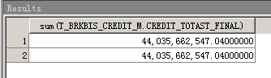

-- 源数据和目标表对比：融资融券净资产_期末

select sum(CREDIT_NET_AST_FINAL)

from dm.T_BRKBIS_CREDIT_M

where year_mth= '201805'

UNION ALL

select

sum(T1.NET_AST_FINAL)

FROM DM.T_AST_EMPCUS_CREDIT_M_D T1

where T1.YEAR = '2018' AND T1.MTH = '05';

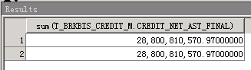

-- 源数据和目标表对比： 融资融券总负债_期末

select sum(CREDIT_TOT_LIAB_FINAL)

from dm.T_BRKBIS_CREDIT_M

where year_mth= '201805'

UNION ALL

select

sum(T1.TOT_LIAB_FINAL)

FROM DM.T_AST_EMPCUS_CREDIT_M_D T1

where T1.YEAR = '2018' AND T1.MTH = '05';

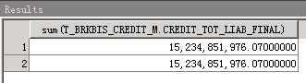

-- 源数据和目标表对比： 融资融券余额_期末

select sum(CREDIT_BAL_FINAL)

from dm.T_BRKBIS_CREDIT_M

where year_mth= '201805'

UNION ALL

select

sum(T1.CREDIT_BAL_FINAL)

FROM DM.T_AST_EMPCUS_ODI_M_D T1

where T1.YEAR = '2018' AND T1.MTH = '05';

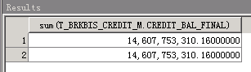

-- 源数据和目标表对比： 融资融券信用保证金_期末

select sum(CRED_MARG_FINAL)

from dm.T_BRKBIS_CREDIT_M

where year_mth= '201805'

UNION ALL

select

sum(T1.CRED_MARG_FINAL)

FROM DM.T_AST_EMPCUS_CREDIT_M_D T1

where T1.YEAR = '2018' AND T1.MTH = '05';

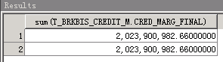

-- 源数据和目标表对比： 融资融券总资产_月日均

select sum(CREDIT_TOTAST_MDA)

from dm.T_BRKBIS_CREDIT_M

where year_mth= '201805'

UNION ALL

select

sum(T1.TOT_AST_MDA)

FROM DM.T_AST_EMPCUS_CREDIT_M_D T1

where T1.YEAR = '2018' AND T1.MTH = '05';

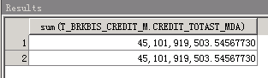

-- 源数据和目标表对比： 融资融券净资产_月日均

select sum(CREDIT_NET_AST_MDA)

from dm.T_BRKBIS_CREDIT_M

where year_mth= '201805'

UNION ALL

select

sum(T1.NET_AST_MDA)

FROM DM.T_AST_EMPCUS_CREDIT_M_D T1

where T1.YEAR = '2018' AND T1.MTH = '05';

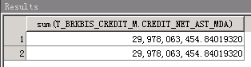

-- 源数据和目标表对比： 融资融券总负债_月日均

select sum(CREDIT_TOT_LIAB_MDA)

from dm.T_BRKBIS_CREDIT_M

where year_mth= '201805'

UNION ALL

select

sum(T1.TOT_LIAB_MDA)

FROM DM.T_AST_EMPCUS_CREDIT_M_D T1

where T1.YEAR = '2018' AND T1.MTH = '05';

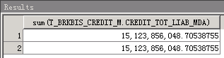

-- 源数据和目标表对比： 融资融券余额_月日均

select sum(CREDIT_BAL_MDA)

from dm.T_BRKBIS_CREDIT_M

where year_mth= '201805'

UNION ALL

select

sum(T1.CREDIT_BAL_MDA)

FROM DM.T_AST_EMPCUS_ODI_M_D T1

where T1.YEAR = '2018' AND T1.MTH = '05';

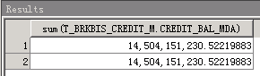

-- 源数据和目标表对比：

--融资融券信用保证金_月日均

--总资产_年日均

--净资产_年日均

--总负债_年日均

select sum(CRED_MARG_MDA),

sum(CREDIT_TOTAST_YDA),

sum(CREDIT_NET_AST_YDA),

sum(CREDIT_TOT_LIAB_YDA)

from dm.T_BRKBIS_CREDIT_M

where year_mth= '201805'

UNION ALL

select

sum(CRED_MARG_MDA)

,sum(TOT_AST_YDA)

,sum(NET_AST_YDA)

,sum(TOT_LIAB_YDA)

FROM DM.T_AST_EMPCUS_CREDIT_M_D T1

where T1.YEAR = '2018' AND T1.MTH = '05';

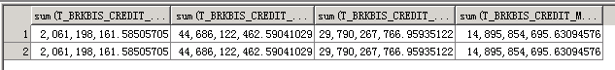

-- 源数据和目标表对比： 融资融券余额_年日均

select sum(CREDIT_BAL_YDA)

from dm.T_BRKBIS_CREDIT_M

where year_mth= '201805'

UNION ALL

select

sum(T1.CREDIT_BAL_YDA)

FROM DM.T_AST_EMPCUS_ODI_M_D T1

where T1.YEAR = '2018' AND T1.MTH = '05';

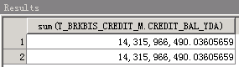

-- 源数据和目标表对比：

--融资融券信用保证金_年日均

select sum(CRED_MARG_YDA)

from dm.T_BRKBIS_CREDIT_M

where year_mth= '201805'

UNION ALL

select

sum(CRED_MARG_YDA)

FROM DM.T_AST_EMPCUS_CREDIT_M_D T1

where T1.YEAR = '2018' AND T1.MTH = '05';

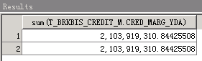

-- 源数据和目标表对比：

--融资买入金额_月累计

--融券卖出金额_月累计

--融资卖出金额_月累计

--融券买入金额_月累计

--融资买入金额_年累计

--融券卖出金额_年累计

--融资卖出金额_年累计

--融券买入金额_年累计

--融资融券交易量_普通_月累计

--融资融券交易量_信用_月累计

--融资融券交易量_普通_年累计

--融资融券交易量_信用_年累计

select sum(CCB_MTD)

,sum(CSS_MTD)

,sum(FIN_SELL_MTD)

,sum(CRDT_STK_BUYIN_MTD)

,sum(CCB_YTD)

,sum(CSS_YTD)

,sum(FIN_SELL_YTD)

,sum(CRDT_STK_BUYIN_YTD)

,sum(CREDIT_TRD_QTY_ODI_MTD)

,sum(CREDIT_TRD_QTY_CRED_MTD)

,sum(CREDIT_TRD_QTY_ODI_YTD)

,sum(CREDIT_TRD_QTY_CRED_YTD)

from dm.T_BRKBIS_CREDIT_M

where year_mth= '201805'

UNION ALL

select

sum(T1.CCB_AMT_MTD)

,sum(CSS_AMT_MTD)

,sum(FIN_SELL_AMT_MTD)

,sum(CRDT_STK_BUYIN_AMT_MTD)

,sum(CCB_AMT_YTD)

,sum(CSS_AMT_YTD)

,sum(FIN_SELL_AMT_YTD)

,sum(CRDT_STK_BUYIN_AMT_YTD)

,sum(CREDIT_TRD_QTY_MTD)

,sum(CREDIT_TRD_QTY_MTD)

,sum(CREDIT_TRD_QTY_YTD)

,sum(CREDIT_TRD_QTY_YTD)

FROM DM.T_EVT_EMPCUS_ODI_TRD_M_D T1

where T1.YEAR = '2018' AND T1.MTH = '05';

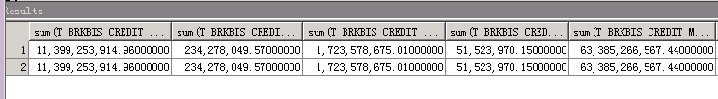

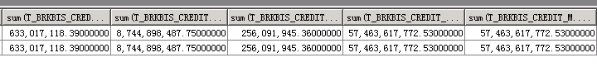

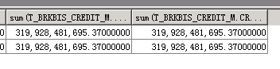

-- 源数据和目标表对比：

--融资融券净佣金_普通_月累计

--融资融券净佣金_信用_月累计

--融资融券净佣金_普通_年累计

--融资融券净佣金_信用_年累计

--融资融券应收利息_月累计

--融资融券实收利息_月累计

--融资融券资金成本_月累计

--融资融券保证金利差收入_月累计

--融资融券应收利息_年累计

--融资融券实收利息_年累计

--融资融券资金成本_年累计

--融资融券保证金利差收入_年累计

select sum(CREDIT_NET_CMS_ODI_MTD)

,sum(CREDIT_NET_CMS_CRED_MTD)

,sum(CREDIT_NET_CMS_ODI_YTD)

,sum(CREDIT_NET_CMS_CRED_YTD)

,sum(CREDIT_RECE_INT_MTD)

,sum(CREDIT_PAIDINT_MTD)

,sum(CREDIT_CPTL_COST_MTD)

,sum(CREDIT_MARG_SPR_INCM_MTD)

,sum(CREDIT_RECE_INT_YTD)

,sum(CREDIT_PAIDINT_YTD)

,sum(CREDIT_CPTL_COST_YTD)

,sum(CREDIT_MARG_SPR_INCM_YTD)

from dm.T_BRKBIS_CREDIT_M

where year_mth= '201805'

UNION ALL

select

sum(CREDIT_ODI_NET_CMS_MTD)

,sum(CREDIT_CRED_NET_CMS_MTD)

,sum(CREDIT_ODI_NET_CMS_YTD)

,sum(CREDIT_CRED_NET_CMS_YTD)

,sum(FIN_RECE_INT_MTD)

,sum(FIN_PAIDINT_MTD)

,sum(CREDIT_CPTL_COST_MTD)

,sum(CREDIT_MARG_SPR_INCM_MTD)

,sum(FIN_RECE_INT_YTD)

,sum(FIN_PAIDINT_YTD)

,sum(CREDIT_CPTL_COST_YTD)

,sum(CREDIT_MARG_SPR_INCM_YTD)

FROM DM.T_EVT_EMPCUS_CRED_INCM_M_D T1

where T1.YEAR = '2018' AND T1.MTH = '05';

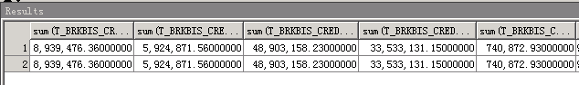

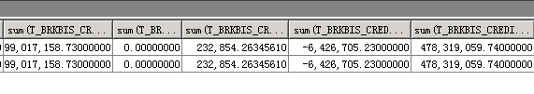

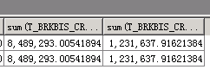

-- 帆软报表表样

