****问题****  
在存储过程 dba.p_ddw_xy_jjzb_yyb_m_d执行结束后，dba.t_ddw_xy_jjzb_yyb_m_d的表各个业务指标的汇总值是否同取数源DBA.T_DDW_XY_JJZB_D的业务指标汇总值保持同步或者在特定过滤条件和计算规则下合理存在。

****设计****  
编写SQL脚本，测试年/月的累计指标是否保持同步，其中，测试用例的数据日期为20170531

****测试代码方案****-- 测试年日均份额_场外、年日均份额_场内、年日均市值_场外、年日均市值_场内（所有测试结果因为数据类型长度问题，会有精度差异，可以忽略）

select round(sum(QMFE_CW_D),2) from DBA.T_DDW_XY_JJZB_D A

where A.RQ BETWEEN 20170101 AND 20170531

union all

select round(sum(RJFE_CW_Y)*151,2) from dba.t_ddw_xy_jjzb_yyb_m_d

where rq=20170531

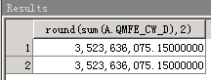

select round(sum(QMFE_CN_D),2) from DBA.T_DDW_XY_JJZB_D A

where A.RQ BETWEEN 20170101 AND 20170531

union all

select round(sum(RJFE_CN_Y)*151,2) from dba.t_ddw_xy_jjzb_yyb_m_d

where rq=20170531

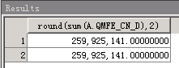

select round(sum(QMSZ_CW_D),3) from DBA.T_DDW_XY_JJZB_D A

where A.RQ BETWEEN 20170101 AND 20170531

union all

select round(sum(RJSZ_CW_Y)*151,3) from dba.t_ddw_xy_jjzb_yyb_m_d

where rq=20170531

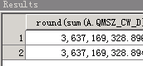

select round(sum(QMSZ_CN_D),4) from DBA.T_DDW_XY_JJZB_D A

where A.RQ BETWEEN 20170101 AND 20170531

union all

select round(sum(RJSZ_CN_Y)*151,4) from dba.t_ddw_xy_jjzb_yyb_m_d

where rq=20170531

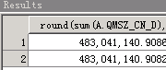

--月日均份额_场外

select sum(QMFE_CW_D) from DBA.T_DDW_XY_JJZB_D A

where A.RQ BETWEEN 20170501 AND 20170531

union all

select sum(RJFE_CW_M)*31 from dba.t_ddw_xy_jjzb_yyb_m_d

where rq=20170531

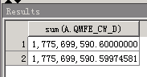

--月末份额_场外

select sum(QMFE_CW_D) from DBA.T_DDW_XY_JJZB_D A

where A.RQ = 20170531

union all

select sum(QMFE_CW_M) from dba.t_ddw_xy_jjzb_yyb_m_d

where rq=20170531

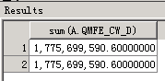

--年累计场内金额_交易买

select sum(CNJE_JYMR_D) from DBA.T_DDW_XY_JJZB_D A

where A.RQ BETWEEN 20170101 AND 20170531

union all

select sum(CNJE_JYMR_Y) from dba.t_ddw_xy_jjzb_yyb_m_d

where rq=20170531

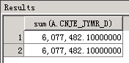

--年累计场内金额_认购确认

select sum(CNJE_RGQR_D) from DBA.T_DDW_XY_JJZB_D A

where A.RQ BETWEEN 20170101 AND 20170531

union all

select sum(CNJE_RGQR_Y) from dba.t_ddw_xy_jjzb_yyb_m_d

where rq=20170531

--年累计场外金额_定时定额投资确认

select sum(CWJE_DSDETZQR_D) from DBA.T_DDW_XY_JJZB_D A

where A.RQ BETWEEN 20170101 AND 20170531

union all

select sum(CWJE_DSDETZQR_Y) from dba.t_ddw_xy_jjzb_yyb_m_d

where rq=20170531

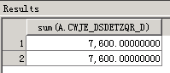

--月累计场内金额_交易买

select sum(CNJE_JYMR_D) from DBA.T_DDW_XY_JJZB_D A

where A.RQ BETWEEN 20170501 AND 20170531

union all

select sum(CNJE_JYMR_M) from dba.t_ddw_xy_jjzb_yyb_m_d

where rq=20170531

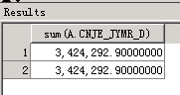

--月累计场外金额_定时定额投资确认

select sum(CWJE_DSDETZQR_D) from DBA.T_DDW_XY_JJZB_D A

where A.RQ BETWEEN 20170501 AND 20170531

union all

select sum(CWJE_DSDETZQR_M) from dba.t_ddw_xy_jjzb_yyb_m_d

where rq=20170531

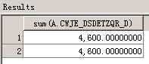

--年累计场内手续费_交易卖

select sum(CNSXF_JYMC_D) from DBA.T_DDW_XY_JJZB_D A

where A.RQ BETWEEN 20170101 AND 20170531

union all

select sum(CNSXF_JYMC_Y) from dba.t_ddw_xy_jjzb_yyb_m_d

where rq=20170531

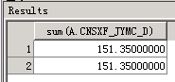

--月累计场内手续费_交易买

select sum(CNSXF_JYMR_D) from DBA.T_DDW_XY_JJZB_D A

where A.RQ BETWEEN 20170501 AND 20170531

union all

select sum(CNSXF_JYMR_M) from dba.t_ddw_xy_jjzb_yyb_m_d

where rq=20170531

--股票换购

select sum(HG_JE_M),sum(HG_SXF_M),sum(HG_JE_Y),sum(HG_SXF_Y) from dba.t_ddw_xy_jjzb_yyb_m_d where rq=20170531

union all

select sum(hg_je_m),sum(hg_sxf_m),max(hg_je_y),max(hg_sxf_y) from DBA.T_DDW_XY_JJZB_m

