2.1  
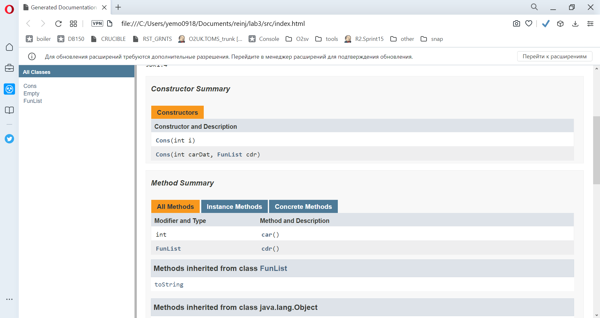

2.2

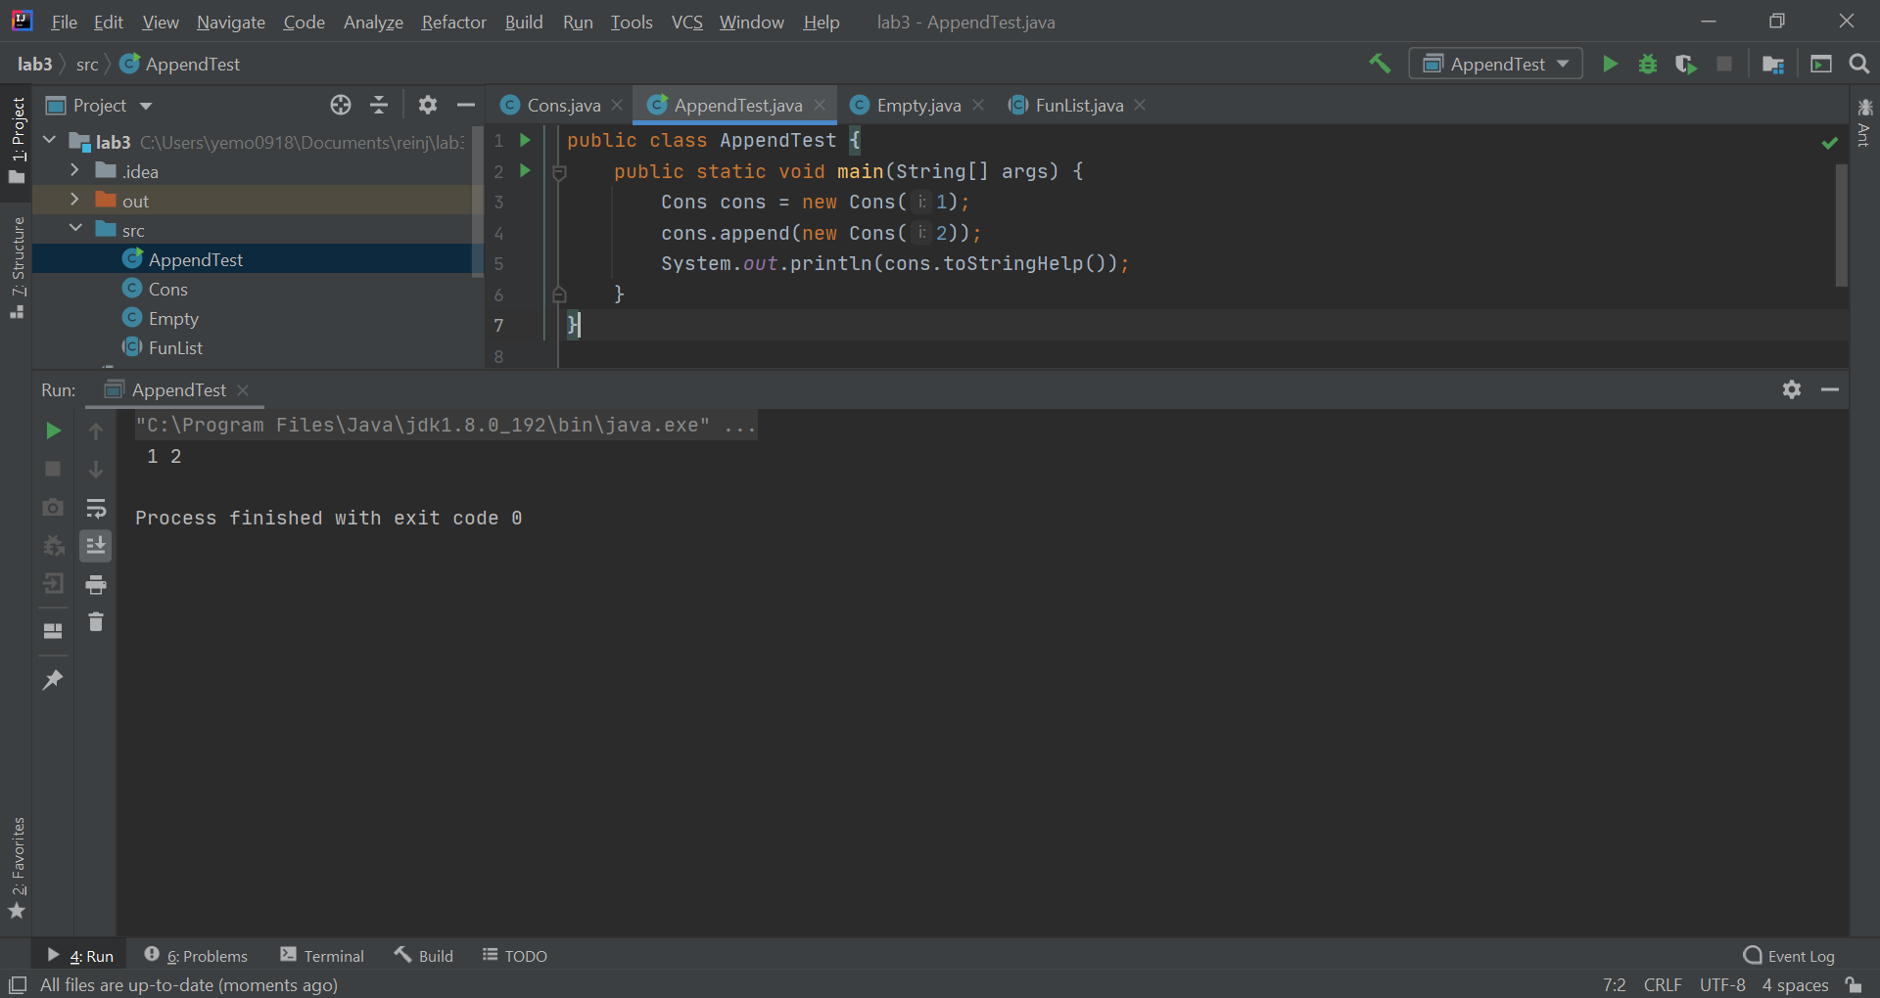

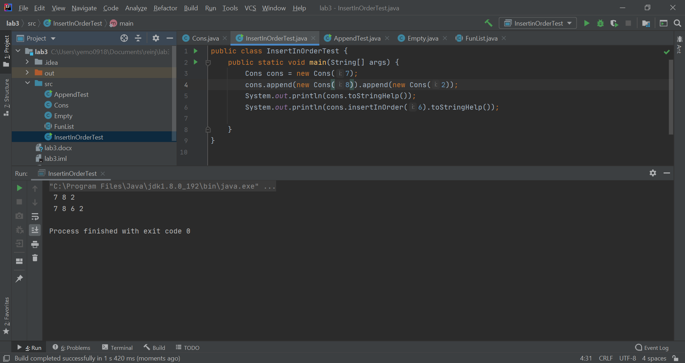

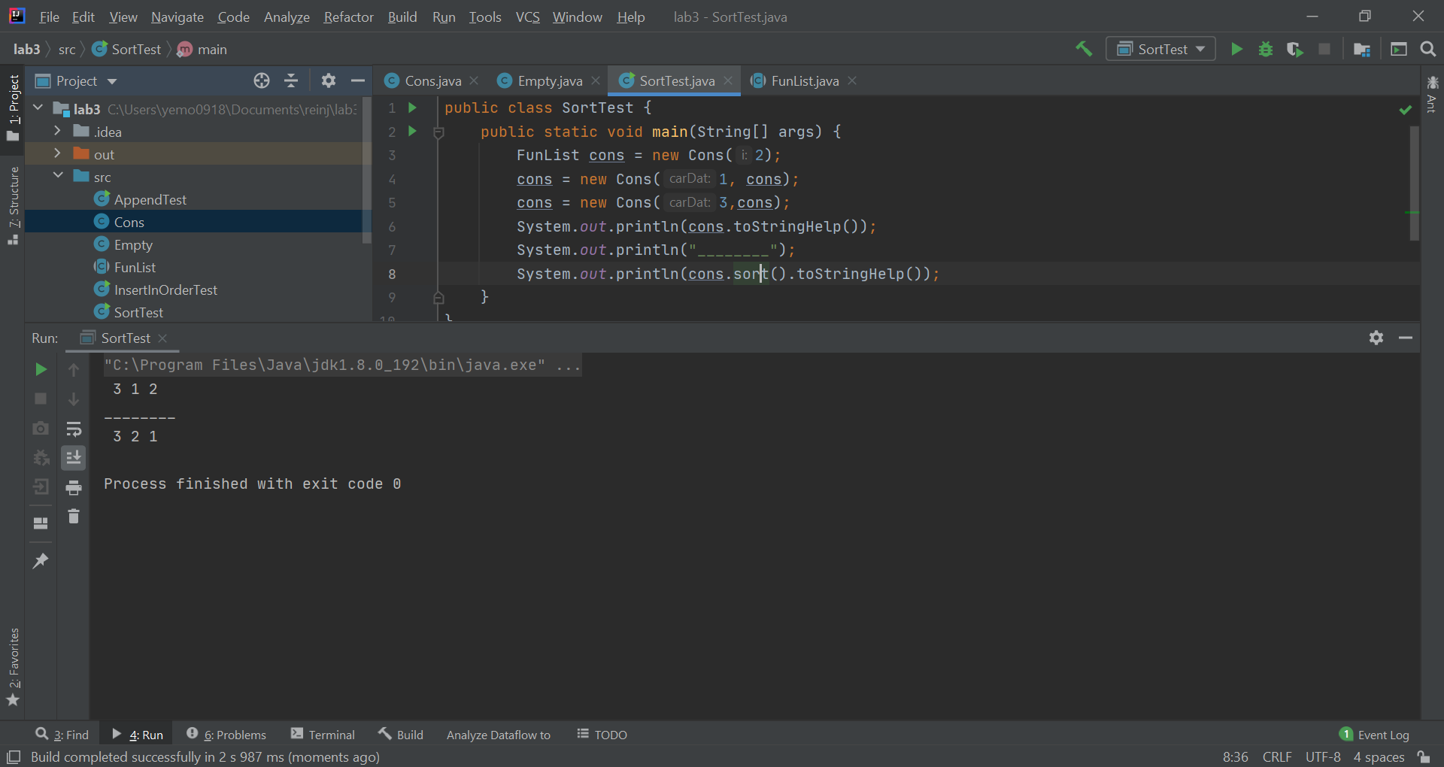

import java.util.Collections;  
import java.util.LinkedList;  
  
*/**  
 * Mimics fundamental function cons for constructs  
 * memory objects which hold two values or pointers to values  
 *  
 \** ***@author*** *Vyacheslav Moskalenko  
 \** ***@since*** *JDK1.4  
 */*public class Cons extends FunList {  
 private int _dat;  
 private FunList _cdr;  
  
 public Cons(int carDat, FunList cdr) {  
 _dat = carDat;  
 _cdr = cdr;  
 }  
  
 */**  
 \** ***@param*** *i a left side (head) of the list.  
 */* public Cons(int i) {  
 _dat = i;  
 _cdr = Empty.*uniqueInstanse*();  
 }  
  
 */**  
 \** ***@return*** *the first int in the list object  
 */* public int car() {  
 return _dat;  
 }  
  
 */**  
 \** ***@return*** *the tail (all but the first element) of the list object  
 */* public FunList cdr() {  
 return _cdr;  
 }  
  
 @Override  
 public FunList append(FunList other) {  
 if(this._cdr instanceof Empty){  
 return new Cons(this._dat, other);  
 }  
 return new Cons(this._dat, this._cdr.append(other));  
 }  
  
 @Override  
 public FunList insertInOrder(int i) {  
 if(_dat<=i) {  
 return new Cons(i, this);  
 }else{  
 return new Cons(_dat, _cdr.insertInOrder(i));  
 }  
  
 }  
  
 @Override  
 public FunList sort() {  
 return _cdr.sort()  
 .insertInOrder(_dat);  
 }  
  
 */**  
 \** ***@return*** *a String description of the list object  
 */* String toStringHelp() {  
 return " " + _dat + _cdr.toStringHelp();  
 }  
}

*/**  
* Mimics functional empty list.  
\** ***@author*** *Vyacheslav Moskalenko  
\** ***@since*** *JDK1.4  
*/*public class Empty extends FunList{  
  
private static Empty *EMPTY* = new Empty();  
  
*/**  
\** ***@return*** *single instance of class  
 */*public static Empty uniqueInstanse(){  
 return *EMPTY*;  
}  
  
private Empty(){}  
  
*/**  
\** ***@return*** *nothing now  
 */*public int car(){  
throw new java.util.NoSuchElementException("car requires a non Empty Funlist");  
}  
  
*/**  
\** ***@return*** *nothing now  
 */*public FunList cdr(){  
throw new java.util.NoSuchElementException("cdr requires a non Empty Funlist");  
}  
  
 public FunList append(FunList other) {  
 return new Cons(this.car(), other);  
 }  
  
  
 public FunList insertInOrder(int i) {  
 return new Cons(i);  
 }  
  
  
 public FunList sort() {  
 return this;  
 }  
  
  
  
 */**  
\** ***@return*** *empty string  
 */*String toStringHelp(){  
return "";  
}  
  
  
}

*/**  
 * Mimics functional lists.  
 *  
 \** ***@author*** *Moskalenko Vyacheslav  
 \** ***@since*** *JDK1.4  
 */*public abstract class FunList {  
 */**  
 \** ***@return*** *the first int in the list object  
 */* public abstract int car();  
  
 */**  
 \** ***@return*** *the tail (all but the first element) of the list object  
 */* public abstract FunList cdr();  
  
 */**  
 * NOTE: toString () method is NOT abstract. It calls, toStringHelp() , an abstract method.  
 * It represents what we call an "invariant" behavior for <code>FunList</code>.  
 * It is an example of the "Template Method Pattern". A "template method" is a method that  
 * makes calls to at least one abstract method in its own class.  
 */* public String toString() {  
 return "(" + toStringHelp() + " ) ";  
 }  
  
 */**  
 \** ***@return*** *some FunList  
 */* public abstract FunList append(FunList other);  
  
 public abstract FunList insertInOrder(int i);  
  
 public abstract FunList sort();  
  
  
 */**  
 \** ***@return*** *a String description of the list object  
 */* abstract String toStringHelp();  
}