電通二甲微處理器實驗 實驗結報

實驗名稱 | Lab01-Blink
組別 | 18 | 組員 | 許景俊、衡上鈞

- 實驗目的
Ans： 使用 circuits.io 模擬 Arduino UNO 電路及程式
繪製電路圖
觀察 Arduino UNO 之輸出
學習將程式碼及實驗報告上傳至 Github

- 實驗步驟
- 填寫分組表單
- 啓動 Arduino IDE, 載入 Blink 程式碼
- 至 circuits.io 註冊帳號，啟動 Arduino 模擬器
- 接上 LED 電路
- 修改程式，將 LED 輸出改為 Pin 9
- 觀察 LED 之閃爍間隔
- 修改程式, 使 LED 閃爍間隔分別增加為 2 倍及 ½ 倍, 重新量測並截圖
- 畫出電路圖

- 程式碼
/*
Blink
Turns on an LED on for one second, then off for one second, repeatedly.

Most Arduinos have an on-board LED you can control. On the Uno and
Leonardo, it is attached to digital pin 13. If you're unsure what
pin the on-board LED is connected to on your Arduino model, check
the documentation at http://arduino.cc

This example code is in the public domain.

modified 8 May 2014
by Scott Fitzgerald
*/

// the setup function runs once when you press reset or power the board
void setup() {
// initialize digital pin 13 as an output.
pinMode(13, OUTPUT);
}

// the loop function runs over and over again forever
void loop() {
digitalWrite(13, HIGH); // turn the LED on (HIGH is the voltage level)
delay(1000); // wait for a second
digitalWrite(13, LOW); // turn the LED off by making the voltage LOW
delay(1000); // wait for a second
}

- 實驗結果及分析
結果：因為這次的Arduino還沒拿到，所以改用模擬的方式做實驗。而這次的實驗我們也成功使用circuits.io 模擬出 Arduino UNO 電路，也了解了Github的上傳及修改。

- 心得討論
第一次接觸Arduino這個東西，有點陌生…帶點緊張。還好最後的實驗結果是成功的，希望下次的實驗也能如此的順利(PS.第一次打實驗結報，有點緊張，別在意)

- 修正電路圖
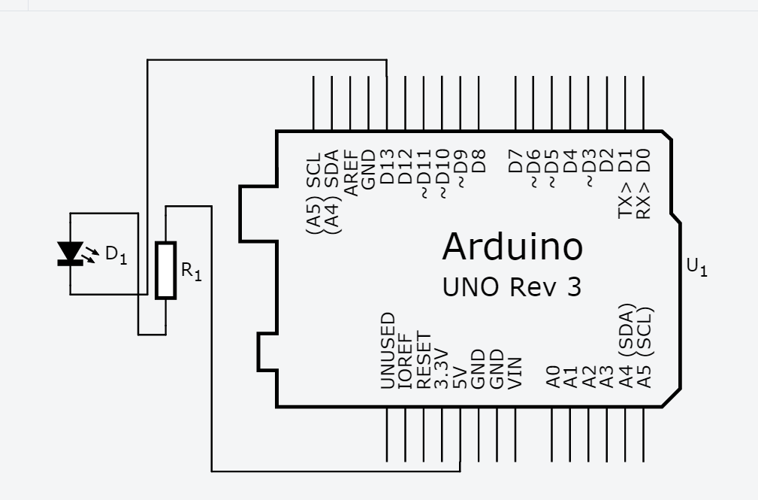
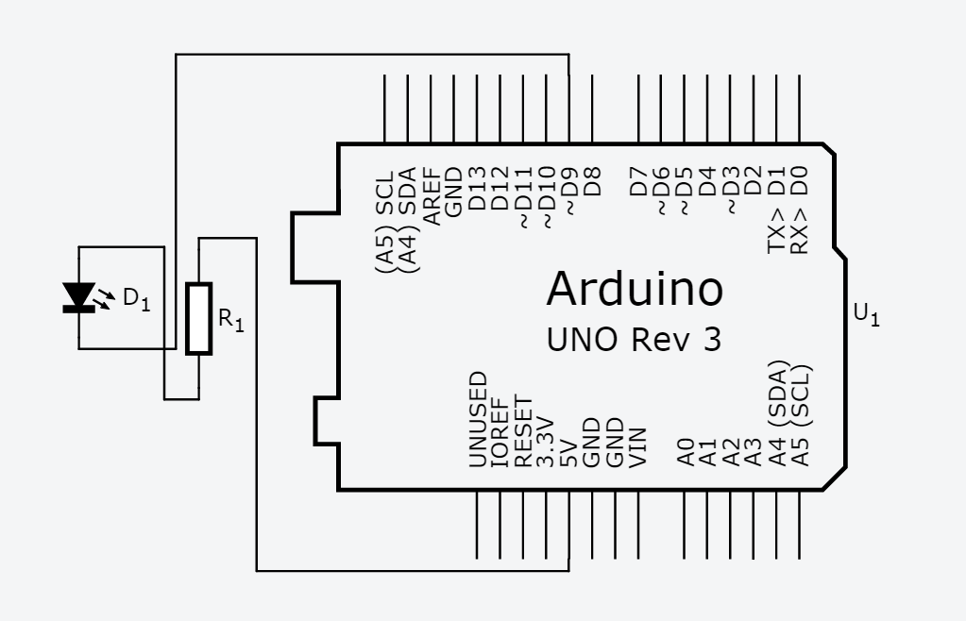
- 修正程式碼
/*
Blink
Turns on an LED on for one second, then off for one second, repeatedly.

Most Arduinos have an on-board LED you can control. On the Uno and
Leonardo, it is attached to digital pin 13. If you're unsure what
pin the on-board LED is connected to on your Arduino model, check
the documentation at http://arduino.cc

This example code is in the public domain.

modified 8 May 2014
by Scott Fitzgerald
*/

// the setup function runs once when you press reset or power the board
void setup() {
// initialize digital pin 9 as an output.
pinMode(9, OUTPUT);
}

// the loop function runs over and over again forever
void loop() {
digitalWrite(9, HIGH); // turn the LED on (HIGH is the voltage level)
delay(500); // wait for a second
digitalWrite(9, LOW); // turn the LED off by making the voltage LOW
delay(500); // wait for a second
}

