**Project Name**

**Present USB tree connected to devise**

An application used to present USB & Hub teww , built with React, NodeJs & Express.

**Project Status**

Initial quick and dirty (with bug presenting device name)

**Project Screen Shot(s)**

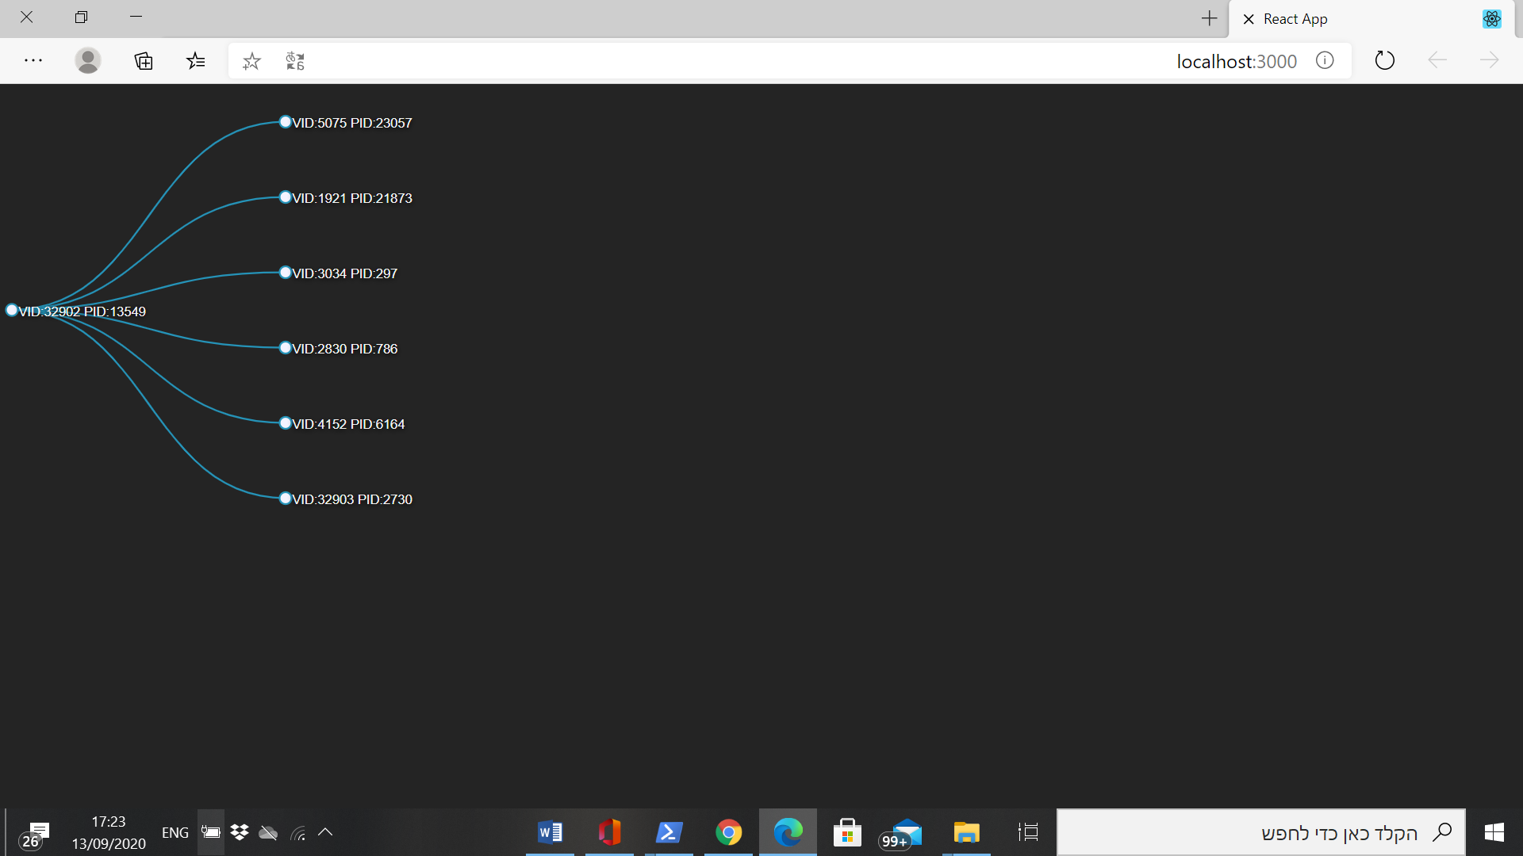

**Short demo – Video file exist in the documentation directory**

**Installation and Setup Instructions**

**Before running the Server you should install the right libusb for your Os.**

**Please follow the instruction using this link:**

[**https://github.com/tessel/node-usb**](https://github.com/tessel/node-usb)

**Install nodejs**

**https://github.com/yehudada/MCETest/api**

**Install Client**

**https://github.com/yehudada/MCETest/client**

**2. Start the server**

**3. Start the client**

**Reflection**

This was a 2 days long project built. I learn quickly basic react and nodejs using tutorials to solve the and write an implementation plan for ready for production app .