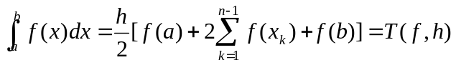， 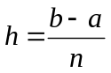
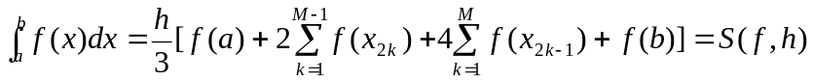，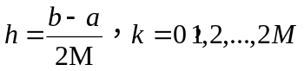

>>> def funint(x):
y=1.0/(1+x**2)
return y

>>> funint(0)
1.0
>>> funint(1)
0.5
>>> import numpy as np
>>> from math import *

>>> def compi(n):
h=1.0/n
s=funint(0)
for i in range(1,n):
s=s+2*funint(i*h)
s=s+funint(1)
s=s*h/2
s=4*s
print('pi=',s)

>>>compi(10)
pi= 3.1399259889071587
>>>compi(100)
pi= 3.141575986923129
>>>compi(1000)
pi= 3.1415924869231246
compi(10000)
pi= 3.14159265192314
>>>compi(100000)
pi= 3.1415926535731526
>>>compi(1000000)
pi= 3.1415926535897927
>>>compi(10000000)
pi= 3.141592653589987
>>>compi(100000000)
pi= 3.1415926535902257 12 significant digits

π=3.14159 26535 89793 23846 26433 83279 50288 41971 69399 37510 58209 74944 5923078164 062...
>>> def compsimpson(m):
h=1.0/(2*m)
s=funint(0)
for k in range(1,m):
s=s+2*funint(2*k*h)
for j in range(1,m+1):
s=s+4*funint((2*j-1)*h)
s=s+funint(1)
s=s*h/3
s=4*s
print('pi=',s)
>>>compsimpson(10)
pi= 3.1415926529697855
def compsimpson(100)
SyntaxError: invalid syntax
compsimpson(100)
pi= 3.141592653589792
compsimpson(1000)
pi= 3.141592653589789
compsimpson(10000)
pi= 3.1415926535897998
compsimpson(100000)
pi= 3.1415926535897754
compsimpson(1000000)
pi= 3.1415926535897465

Find the factorial of the interger N (计算正整数N的阶乘：)
>>> def fact(n):
if n==1:
return 1
return n*fact(n-1)
>>> fact(3)
6
Find the fibonacci series 斐波那契数列：
>>> def fibo(n):
if n <= 1:
return n
else:
return(fibo(n-1) + fibo(n-2))
>>> fibo(1)
1
>>> fibo(2)
1
>>> fibo(3)
2
>>> fibo(4)
3
>>> fibo(5)
5
>>> fibo(6)
8

Recursive composite trapezoidal rule (递归算法）

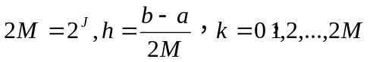

def recurTrap(j):
if j == 0:
return (funint(0)+funint(1))/2
else:
h=1.0/2**j
s=0
for k in range(1,2**(j-1)+1):
s=s+funint((2*k-1)*h)
s=s*h
return(recurTrap(j-1)/2 + s)

>>> 4*recurTrap(8)
3.1415901104582833
>>> 4*recurTrap(10)
3.141592494644073
3>>> 4*recurTrap(15)
3.141592653434568
>>> 3.14159265358979323846
3.141592653589793
>>> 4*recurTrap(20)
3.1415926535896626
>>> 4*recurTrap(25)
3.1415926535897247
>>>4*recurTrap(30)
3.1415926535895817

T(0)
T(1) | *
T(2) | * | *
T(3) | * | * | *
T(4) | * | * | * | *
T(5) | * | * | * | * | *

