5. Find the parabola 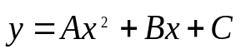that passes through the points (1,4), (2,7) and (3,14) and show the graph of the parabola and the points.

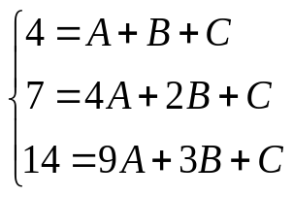
>> A=[1,1,1;4,2,1;9,3,1]

A =

1 1 1
4 2 1
9 3 1

>> b=[4;7;14]
b = 4
7
14

>> x=A\b

x = 2.0000
-3.0000
5.0000
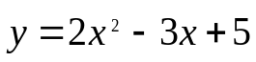
X=[1,2,3], Y=[4,7,14]
>> X=[1,2,3]

X =

1 2 3

>> Y=[4,7,14]

Y =

4 7 14

>> plot(X,Y,'*')
>> t=1:0.1:3

t = 1 至 12 列
1.0000 1.1000 1.2000 1.3000 1.4000 1.5000 1.6000 1.7000 1.8000 1.9000 2.0000 2.1000

13 至 21 列

2.2000 2.3000 2.4000 2.5000 2.6000 2.7000 2.8000 2.9000 3.0000

>> u=t

u = 1 至 12 列
1.0000 1.1000 1.2000 1.3000 1.4000 1.5000 1.6000 1.7000 1.8000 1.9000 2.0000 2.1000

13 至 21 列

2.2000 2.3000 2.4000 2.5000 2.6000 2.7000 2.8000 2.9000 3.0000

>> for i=1:21
u(i)=2*t(i)^2-3*t(i)+5;
end
>> u

u =

1 至 12 列

4.0000 4.1200 4.2800 4.4800 4.7200 5.0000 5.3200 5.6800 6.0800 6.5200 7.0000 7.5200

13 至 21 列

8.0800 8.6800 9.3200 10.0000 10.7200 11.4800 12.2800 13.1200 14.0000

>> hold on
>> plot(t,u)
>> 