1：Design two nonlinear algebraic equations (degree at least 5 , with no less than 3 zeros) and find all their zeros (error less than 0.001),show ， your result and Matlab or Python code.

2：（1） Find the numerical solution of the following nonlinear equations using iteration method and Newton method respectively and show your analysis of error by using norms of vector and matrix and demonstrate your computer code：
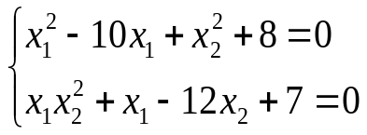
（2）Find the numerical solution of the following nonlinear equations using iteration method and Newton method respectively and show your analysis of error by using norms of vector and matrix and demonstrate your computer code：
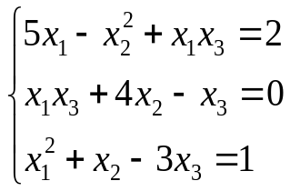

3：(1)Generate matrix A（50*50）and vector b（50*1) by using random number，and solve the linear system AX=b by using Gaussian partial pivoting elimination algorithm.
(2)Randomly generate 3 diagonal matrices (30 * 30), and use Jacobi iteration and Gauss Seidel iteration to solve them respectively. The error of the solution in terms of norm is required to be less than 1/1000.
4： Use appropriate polynomial interpolation to approximate the following ellipse.
(1)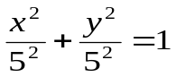
(2)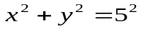

5：我国古代数学著作《九章算数》记载的线性方程组如下：
今有上禾三秉,中禾二秉,下禾一秉,实三十九斗；上禾二秉,中禾三秉,下禾一秉,实三十四斗；上禾一秉,中禾二秉,下禾三秉,实二十六斗；问上、中、下禾实一秉各几何?
查阅九章算术记载的此问题的解法是什么？指出相当于今天的什么方法。

