举例（预测人口），某地区2010-2020人口数据：
X 2010 2011 2012 2013 2014 2015 2016 2017 2018 2019 2020
Y 3.9 5.3 7.2 9.6 12.9 17.1 23.2 31.4 38.6 50.2 63.0
散点图趋势
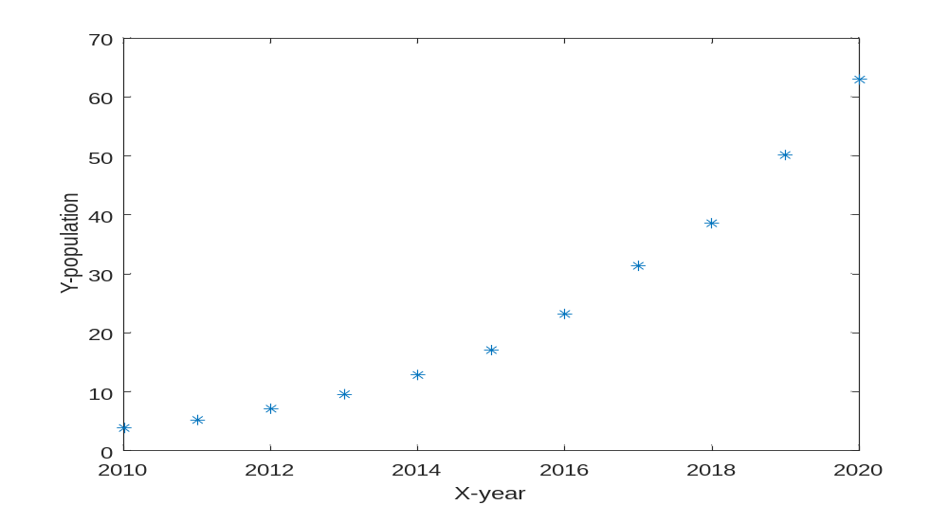
Linear fitting：
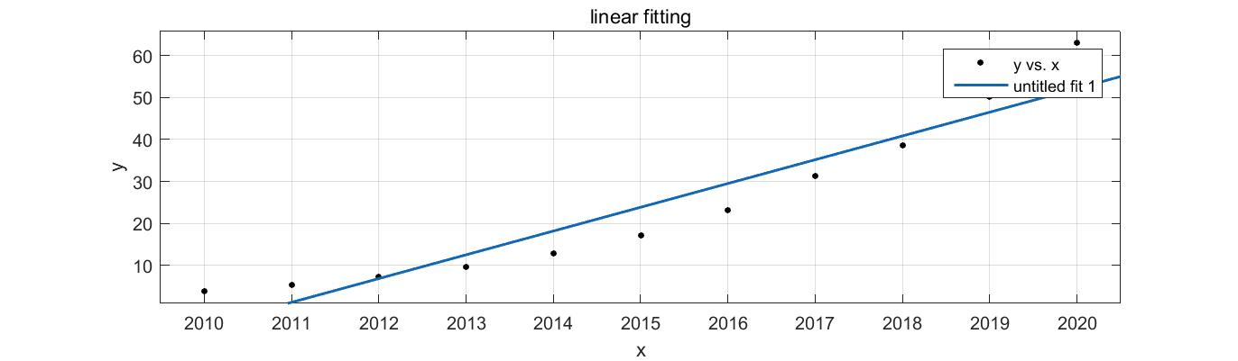
Linear model Poly1:
f(x) = p1*x + p2
Coefficients (with 95% confidence bounds):（置信区间）
p1 = 5.665 (4.303, 7.028)
p2 = -1.139e+04 (-1.414e+04, -8646)

Goodness of fit: （拟合优度）
SSE: 359.2 （sum of square errors 误差平方和）
R-square: 0.9077 可决系数
Adjusted R-square: 0.8974 调整后的可决系数

RMSE: 6.317 均方根误差

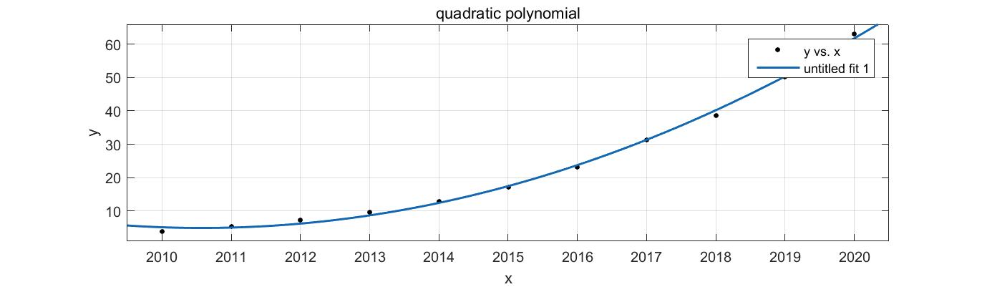
Linear model Poly2:
f(x) = p1*x^2 + p2*x + p3
Coefficients (with 95% confidence bounds):
p1 = 0.6396 (0.5602, 0.7191)
p2 = -2572 (-2892, -2252)
p3 = 2.586e+06 (2.263e+06, 2.908e+06)

Goodness of fit:
SSE: 8.149
R-square: 0.9979
Adjusted R-square: 0.9974
RMSE: 1.009

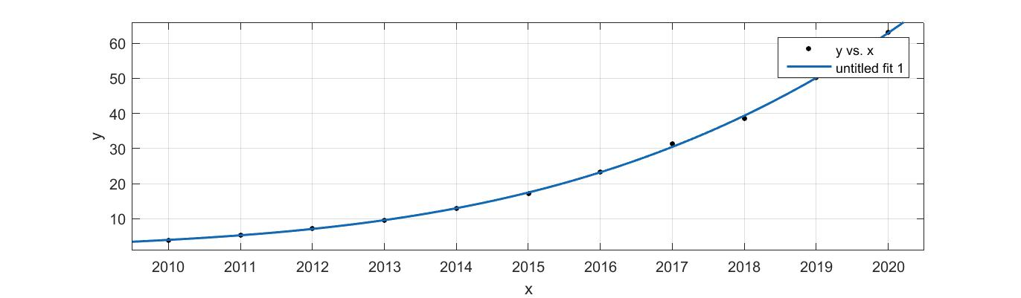
Linear model Poly3:
f(x) = p1*x^3 + p2*x^2 + p3*x + p4
Coefficients (with 95% confidence bounds):
p1 = 0.03248 (0.01795, 0.04701)
p2 = -195.7 (-283.5, -107.9)
p3 = 3.93e+05 (2.161e+05, 5.7e+05)
p4 = -2.631e+08 (-3.82e+08, -1.443e+08)

Goodness of fit:
SSE: 1.632
R-square: 0.9996
Adjusted R-square: 0.9994
RMSE: 0.4829

How to understand the goodness of fitting?
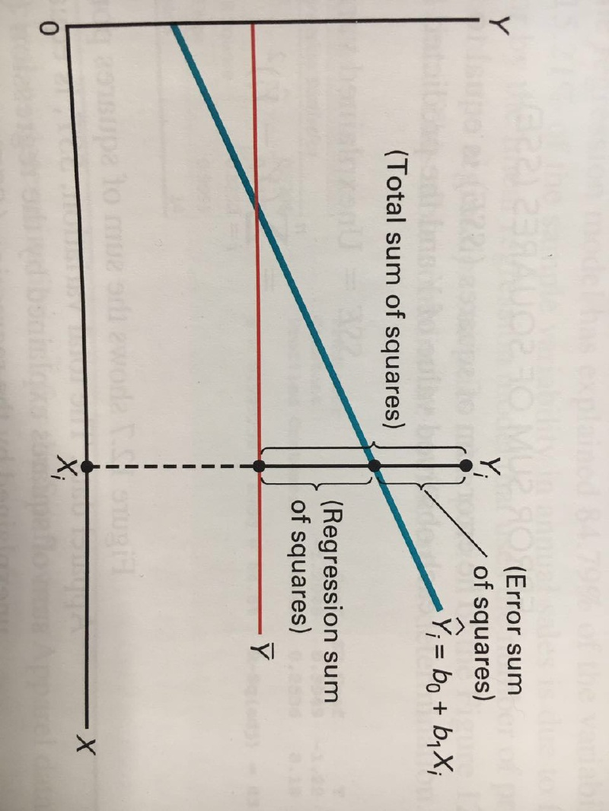
See more at: https://www.cnblogs.com/ykit/p/12501816.html
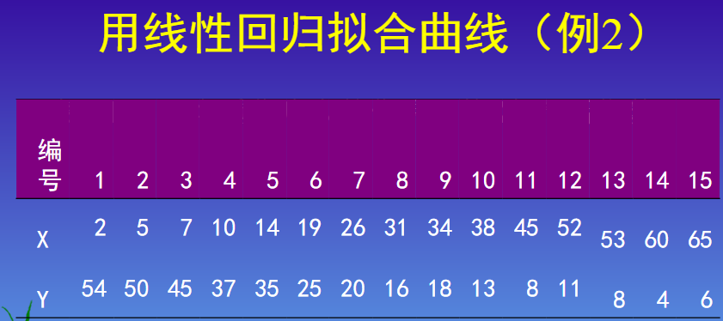
Home work:

X: 住院天数， Y 预后指数， 选择合适曲线拟合Y=F(X).

X 2010 2011 2012 2013 2014 2015 2016 2017 2018 2019 2020
Y 3.9 5.3 7.2 9.6 12.9 17.1 23.2 31.4 38.6 50.2 63.0

Python multi variate linear regression:

>>import pandas as pd #配置读入数据表格 环境
>>import numpy as np #配置数值计算环境
>>df = pd.read_excel("E:/boston_house.xls") #读取存放于E盘的Boston房价数据
>>df1=pd.read_excel("E:/boston_house.xls").values
>>x=df1[0:100,0:13] #截取0-99行，0--12列
>>print(x.shape) #检查x维数
>>y=df1[0:100,13:14] ##截取13列

>>from sklearn.linear_model import LinearRegression
>>regr = LinearRegression()
>>regr.fit(x,y)

>>import statsmodels.api as sm #配置评估模型环境

>>x2 =sm.add_constant(x)
>>est = sm.OLS(y,x2).fit()
>>print(est.summary()) #评估模型

#以下观察房价与氢氧化氮浓度的关联
>>import matplotlib.pyplot as plt
>>x5=df1[0:100,4:5] #氢氧化氮浓度
>>regr.fit(x5,y)
>>plt.scatter(x5,y)
>>plt.plot(x5,regr.predict(x5),color='red')
>>plt.show()

Homework: 