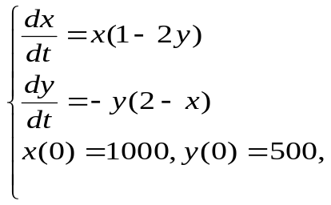
And this system can solved by ODE45:

function df=foxfun(t,Y)
df=[Y(1)*(2-Y(2));
-Y(2)*(1-0.1*Y(1))];
end
[t,Y]=ode45(@foxfun,[0,100],[1000,2]) plot(t,Y(:,1),'*');hold on;plot(t,Y(:,2),'o')

