- Fill in the following blanks
- let 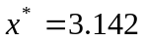be an approximation to 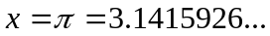,then 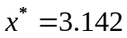 retains significant digits. The relative error of is .
- Use Simpson numerical integral rule
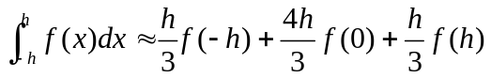
to compute 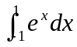 = .。
- Let 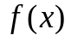 satisfies the conditions in the following table:
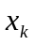 | 0 | 1 | 2
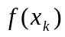 | 1 | 2 | 4
（1）Find the corresponding divided differences and fill in the blanks without (*)
 | 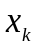 | 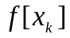 | 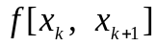 | 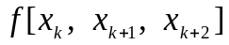
0 |  |  | *** | ***
1 |  |  |  | ***
2
- Find the Lagrange interpolation polynomial which satisfies
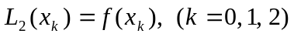
and Newton interpolation polynomial which satisfies
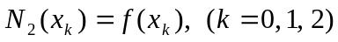.
- Consider the following linear system
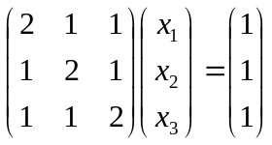
- Find the Jacobi iteration algorithm and Gauss-Seidel
- Given the initial value 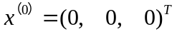,find 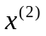by using Gauss-Seidel iteration algorithm.

- Find the solution to the following linear system by using column pivoting Gaussian elimination method.

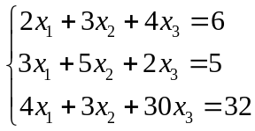
- Give Newton method and find the approximation to the root of 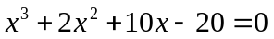 which is close to 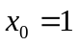.Fill in the following table with your iteration results.

 | 0 | 1 | 2 | 3
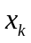 | 1

- Find the numerical solution to the following ODE by using Euler method（let step size h=0.1） 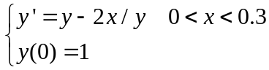.

- Fill “Artificial Intelligence”, “Machine Learning”, “Neural Networks”，“Deep learning” in the following circles。

- Consider the following 2-dimentional image A_{6×6}, and the convolution kernel B_{6×6}, and C_{3×3}

2 | 2 | 2 | 3 | 3 | 3
0 | 0 | 0 | 0 | 4 | 0
0 | 0 | 0 | 4 | 0 | 0
0 | 0 | 4 | 0 | 0 | 0
0 | 4 | 0 | 0 | 0 | 0
3 | 3 | 3 | 2 | 2 | 2
1 | 1 | 1
0 | 0 | 0
0 | 0 | 0

Find the convolution of A with B and A with C respectively.

0 | 0 | 2
0 | 2 | 0
2 | 0 | 0

- Given the following data D regarding flu cases, generate the decision tree by using decision tree classification algorithm. Find the entropy of D, conditional entropy and the information gain of each attribute in the table.
Case | Headache | Muscle pain | Temperature | Flu
1 | yes | yes | normal | no
2 | yes | yes | high | yes
3 | yes | yes | very high | yes
4 | no | yes | normal | no
5 | no | no | high | no
6 | no | yes | very-high | yes

Entropy(D)=
Entropy(D|Headache)=
Entropy(D|Muscle pain)=
Entropy(D|Temperature)=
Information-Gain(Headache)=
Information-Gain(Muscle pain)=
Information-Gain(Headache)=
- Given the following data D regarding flu cases,
Case | Headache | Muscle pain | Temperature | Flu
1 | yes | yes | normal | no
2 | yes | yes | high | yes
3 | yes | yes | very high | yes
4 | no | yes | normal | no
5 | no | no | high | no
6 | no | yes | very-high | yes
Suppose the new case is（Headache=yes、Muscle pain=no、Temperature=normal），use Naive Bayesian Classification Algorithm to judge whether the case has influenza, Flu=?

- Consider the following BP Nerual Network where the activation function for the first hidden layer is 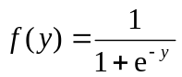and the activation function for the output layer is 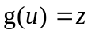。
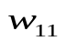
x₁
y₁ h₁
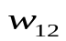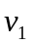
u
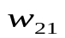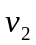
z
x₂
y₂ h₂
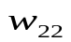

Find the formula to compute the following variable,
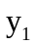= 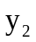=
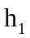= 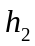=
=

- List the machine learning algorithms which are widely used in AI.

