BP 神经网络用于regression:
1.具体应用实例。根据表1，预测序号15的跳高成绩。表1 国内男子跳高运动员各项素质指标
序号 | 跳高成绩(m) | 30m行进跑(s) | 立定三级跳远(m) | 助跑摸高(m) | 助跑4—6步跳高(m) | 负重深蹲杠铃(kg) | 杠铃半蹲系数 | 100  (s) | 抓举  (kg)
1 | 2.24 | 3.2 | 9.6 | 3.45 | 2.15 | 140 | 2.8 | 11.0 | 50
2 | 2.33 | 3.2 | 10.3 | 3.75 | 2.2 | 120 | 3.4 | 10.9 | 70
3 | 2.24 | 3.0 | 9.0 | 3.5 | 2.2 | 140 | 3.5 | 11.4 | 50
4 | 2.32 | 3.2 | 10.3 | 3.65 | 2.2 | 150 | 2.8 | 10.8 | 80
5 | 2.2 | 3.2 | 10.1 | 3.5 | 2 | 80 | 1.5 | 11.3 | 50
6 | 2.27 | 3.4 | 10.0 | 3.4 | 2.15 | 130 | 3.2 | 11.5 | 60
7 | 2.2 | 3.2 | 9.6 | 3.55 | 2.1 | 130 | 3.5 | 11.8 | 65
8 | 2.26 | 3.0 | 9.0 | 3.5 | 2.1 | 100 | 1.8 | 11.3 | 40
9 | 2.2 | 3.2 | 9.6 | 3.55 | 2.1 | 130 | 3.5 | 11.8 | 65
10 | 2.24 | 3.2 | 9.2 | 3.5 | 2.1 | 140 | 2.5 | 11.0 | 50
11 | 2.24 | 3.2 | 9.5 | 3.4 | 2.15 | 115 | 2.8 | 11.9 | 50
12 | 2.2 | 3.9 | 9.0 | 3.1 | 2.0 | 80 | 2.2 | 13.0 | 50
13 | 2.2 | 3.1 | 9.5 | 3.6 | 2.1 | 90 | 2.7 | 11.1 | 70
14 | 2.35 | 3.2 | 9.7 | 3.45 | 2.15 | 130 | 4.6 | 10.85 | 70
15 | ? | 3.0 | 9.3 | 3.3 | 2.05 | 100 | 2.8 | 11.2 | 50

4.4 (序号15)跳高成绩预测
4.4.1 数据整理
将前14组国内男子跳高运动员各项素质指标作为输入，即（30m行进跑，立定三级跳远，助跑摸高，助跑4-6步跳高，负重深蹲杠铃，杠铃半蹲系数，100m，抓举），将对应的跳高成绩作为输出。

数据集：（注意：每一列是一组输入数据，行数代表输入层神经元个数，列数输入训练集组数）
P=[3.2 3.2 3 3.2 3.2 3.4 3.2 3 3.2 3.2 3.2 3.9 3.1 3.2;
9.6 10.3 9 10.3 10.1 10 9.6 9 9.6 9.2 9.5 9 9.5 9.7;
3.45 3.75 3.5 3.65 3.5 3.4 3.55 3.5 3.55 3.5 3.4 3.1 3.6 3.45;
2.15 2.2 2.2 2.2 2 2.15 2.14 2.1 2.1 2.1 2.15 2 2.1 2.15;
140 120 140 150 80 130 130 100 130 140 115 80 90 130;
2.8 3.4 3.5 2.8 1.5 3.2 3.5 1.8 3.5 2.5 2.8 2.2 2.7 4.6;
11 10.9 11.4 10.8 11.3 11.5 11.8 11.3 11.8 11 11.9 13 11.1 10.85;
50 70 50 80 50 60 65 40 65 50 50 50 70 70];

T=[2.24 2.33 2.24 2.32 2.2 2.27 2.2 2.26 2.2 2.24 2.24 2.2 2.2 2.35];

BP网络模型

网络结构示意图如下：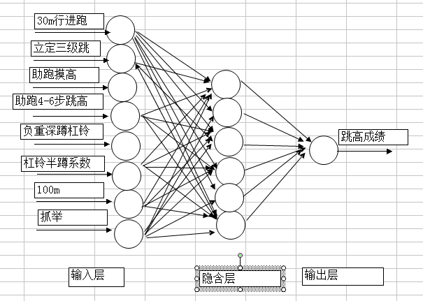

4.4.2.2.2 激活函数(传递函数）的选取

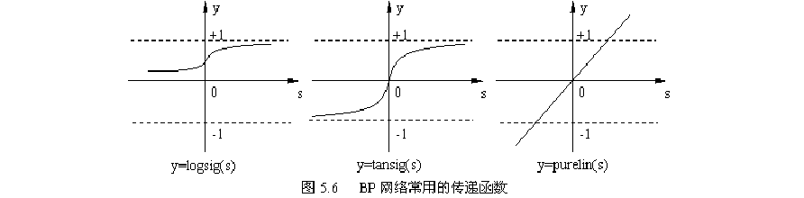
BP神经网络通常采用Sigmoid可微函数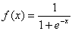和线性函数作为网络的激励函数。本文选择S型正切函数tansig作为隐层神经元的激励函数。而由于网络的输出归一到[ -1, 1]范围内, 因此预测模型选取S 型对数函数tansig作为输出层神经元的激励函数。

P=[3.2 3.2 3 3.2 3.2 3.4 3.2 3 3.2 3.2 3.2 3.9 3.1 3.2;
9.6 10.3 9 10.3 10.1 10 9.6 9 9.6 9.2 9.5 9 9.5 9.7;
3.45 3.75 3.5 3.65 3.5 3.4 3.55 3.5 3.55 3.5 3.4 3.1 3.6 3.45;
2.15 2.2 2.2 2.2 2 2.15 2.14 2.1 2.1 2.1 2.15 2 2.1 2.15;
140 120 140 150 80 130 130 100 130 140 115 80 90 130;
2.8 3.4 3.5 2.8 1.5 3.2 3.5 1.8 3.5 2.5 2.8 2.2 2.7 4.6;
11 10.9 11.4 10.8 11.3 11.5 11.8 11.3 11.8 11 11.9 13 11.1 10.85;
50 70 50 80 50 60 65 40 65 50 50 50 70 70];

>> T=[2.24 2.33 2.24 2.32 2.2 2.27 2.2 2.26 2.2 2.24 2.24 2.2 2.2 2.35]

>> minmax(P)

ans =

3.0000 3.9000
9.0000 10.3000
3.1000 3.7500
2.0000 2.2000
80.0000 150.0000
1.5000 4.6000
T=[2.24,2.33,2.24,2.32,2.2,2.27,2.2,2.26,2.2,2.24,2.24,2.2,2.2,2.35]

搭建网络：
>> net = newff(minmax(P),[6,1],{'tansig','purelin'},'trainrp')

警告: NEWFF used in an obsolete way.
> In nnerr.obs_use (line 17)
In newff>create_network (line 126)
In newff (line 101)
See help for NEWFF to update calls to the new argument list.
net =
Neural Network

name: 'Custom Neural Network'
userdata: (your custom info)

dimensions:

numInputs: 1
numLayers: 2
numOutputs: 1
numInputDelays: 0
numLayerDelays: 0
numFeedbackDelays: 0
numWeightElements: 61
sampleTime: 1

connections:

biasConnect: [1; 1]
inputConnect: [1; 0]
layerConnect: [0 0; 1 0]
outputConnect: [0 1]

subobjects:

input: Equivalent to inputs{1}
output: Equivalent to outputs{2}

inputs: {1x1 cell array of 1 input}
layers: {2x1 cell array of 2 layers}
outputs: {1x2 cell array of 1 output}
biases: {2x1 cell array of 2 biases}
inputWeights: {2x1 cell array of 1 weight}
layerWeights: {2x2 cell array of 1 weight}

functions:

adaptFcn: 'adaptwb'
adaptParam: (none)
derivFcn: 'defaultderiv'
divideFcn: (none)
divideParam: (none)
divideMode: 'sample'
initFcn: 'initlay'
performFcn: 'mse'
performParam: .regularization, .normalization
plotFcns: {'plotperform', plottrainstate,
plotregression}
plotParams: {1x3 cell array of 3 params}
trainFcn: 'trainrp'
trainParam: .showWindow, .showCommandLine, .show, .epochs,
.time, .goal, .min_grad, .max_fail, .delta0,
.delt_inc, .delt_dec, .deltamax

weight and bias values:

IW: {2x1 cell} containing 1 input weight matrix
LW: {2x2 cell} containing 1 layer weight matrix
b: {2x1 cell} containing 2 bias vectors

methods:

adapt: Learn while in continuous use
configure: Configure inputs & outputs
gensim: Generate Simulink model
init: Initialize weights & biases
perform: Calculate performance
sim: Evaluate network outputs given inputs
train: Train network with examples
view: View diagram
unconfigure: Unconfigure inputs & outputs

evaluate: outputs = net(inputs)
Neural Network

name: 'Custom Neural Network'
userdata: (your custom info)

dimensions:

numInputs: 1
numLayers: 2
numOutputs: 1
numInputDelays: 0
numLayerDelays: 0
numFeedbackDelays: 0
numWeightElements: 81
sampleTime: 1

connections:

biasConnect: [1; 1]
inputConnect: [1; 0]
layerConnect: [0 0; 1 0]
outputConnect: [0 1]

subobjects:

input: Equivalent to inputs{1}
output: Equivalent to outputs{2}

inputs: {1x1 cell array of 1 input}
layers: {2x1 cell array of 2 layers}
outputs: {1x2 cell array of 1 output}
biases: {2x1 cell array of 2 biases}
inputWeights: {2x1 cell array of 1 weight}
layerWeights: {2x2 cell array of 1 weight}

训练网络：
>> net.trainParam.show=50;
net.trainParam.lr=0.05;
net.trainParam.epochs=3000;
net.trainParam.goal=1e-5;
[net,tr]=train(net,P,T)

net =

Neural Network

name: 'Custom Neural Network'
userdata: (your custom info)

dimensions:

numInputs: 1
numLayers: 2
numOutputs: 1
numInputDelays: 0
numLayerDelays: 0
numFeedbackDelays: 0
numWeightElements: 81
sampleTime: 1

connections:

biasConnect: [1; 1]
inputConnect: [1; 0]
layerConnect: [0 0; 1 0]
outputConnect: [0 1]

subobjects:

input: Equivalent to inputs{1}
output: Equivalent to outputs{2}

inputs: {1x1 cell array of 1 input}
layers: {2x1 cell array of 2 layers}
outputs: {1x2 cell array of 1 output}
biases: {2x1 cell array of 2 biases}
inputWeights: {2x1 cell array of 1 weight}
layerWeights: {2x2 cell array of 1 weight}

functions:

adaptFcn: 'adaptwb'
adaptParam: (none)
derivFcn: 'defaultderiv'
divideFcn: (none)
divideParam: (none)
divideMode: 'sample'
initFcn: 'initlay'
performFcn: 'mse'
performParam: .regularization, .normalization
plotFcns: {'plotperform', plottrainstate,
plotregression}
plotParams: {1x3 cell array of 3 params}
trainFcn: 'trainrp'
trainParam: .showWindow, .showCommandLine, .show, .epochs,
.time, .goal, .min_grad, .max_fail, .delta0,
.delt_inc, .delt_dec, .deltamax, .lr

weight and bias values:

IW: {2x1 cell} containing 1 input weight matrix
LW: {2x2 cell} containing 1 layer weight matrix
b: {2x1 cell} containing 2 bias vectors

methods:

adapt: Learn while in continuous use
configure: Configure inputs & outputs
gensim: Generate Simulink model
init: Initialize weights & biases

>> sim(net,P)-T

ans =

1 至 10 列

0.0028 -0.0108 0.0193 0.0138 0.0007 -0.0317 0.0399 -0.0287 0.0306 0.0001

11 至 14 列

-0.0063 -0.0019 -0.0079 -0.0213

>> a=[3.0 9.3 3.3 2.05 100 2.8 11.2 50]'

a =

3.0000
9.3000
3.3000
2.0500
100.0000
2.8000
11.2000
50.0000

>> sim(net,a)

ans =

2.2493
BP神经网络用于classification:
>> 本文以Fisher的Iris数据集作为神经网络程序的测试数据集。Iris数据集可以在http://en.wikipedia.org/wiki/Iris_flower_data_set 找到。这里简要介绍一下Iris数据集：
有一批Iris花，已知这批Iris花可分为3个品种，现需要对其进行分类。不同品种的Iris花的花萼长度、花萼宽度、花瓣长度、花瓣宽度会有差异。我们现有一批已知品种的Iris花的花萼长度、花萼宽度、花瓣长度、花瓣宽度的数据。一种解决方法是用已有的数据训练一个神经网络用作分类器。
总数共150条：
5.7 4.4 1.5 0.4 1
5.4 3.9 1.3 0.4 1
5.1 3.5 1.4 0.3 1
5.7 3.8 1.7 0.3 1
5.1 3.8 1.5 0.3 1
5.4 3.4 1.7 0.2 1
5.1 3.7 1.5 0.4 1
4.6 3.6 1 0.2 1
5.1 3.3 1.7 0.5 1
4.8 3.4 1.9 0.2 1
7 3.2 4.7 1.4 2
6.4 3.2 4.5 1.5 2
6.9 3.1 4.9 1.5 2
5.5 2.3 4 1.3 2
6.5 2.8 4.6 1.5 2
5.7 2.8 4.5 1.3 2
6.3 3.3 4.7 1.6 2
4.9 2.4 3.3 1 2
6.6 2.9 4.6 1.3 2
5.2 2.7 3.9 1.4 2
5.7 2.8 4.1 1.3 2
6.3 3.3 6 2.5 3
5.8 2.7 5.1 1.9 3
7.1 3 5.9 2.1 3
6.3 2.9 5.6 1.8 3
6.5 3 5.8 2.2 3
7.6 3 6.6 2.1 3
4.9 2.5 4.5 1.7 3
7.3 2.9 6.3 1.8 3
6.7 2.5 5.8 1.8 3
7.2 3.6 6.1 2.5 3
6.5 3.2 5.1 2 3
6.4 2.7 5.3 1.9 3
6.8 3 5.5 2.1 3
5.7 2.5 5 2 3
5.8 2.8 5.1 2.4 3
6.4 3.2 5.3 2.3 3
6.5 3 5.5 1.8 3
7.7 3.8 6.7 2.2 3
7.7 2.6 6.9 2.3 3
6 2.2 5 1.5 3
6.9 3.2 5.7 2.3 3
5.6 2.8 4.9 2 3
7.7 2.8 6.7 2 3
6.3 2.7 4.9 1.8 3
6.7 3.3 5.7 2.1 3
7.2 3.2 6 1.8 3
6.2 2.8 4.8 1.8 3
6.1 3 4.9 1.8 3
6.4 2.8 5.6 2.1 3
选取100条作为训练集：

>> net=newff(minmax(X),[6,1],{'tansig','purelin'},'trainrp') #搭建网络,隐层一6个神经元+隐层二1个神经元,

>> net.trainParam.show=50; #设置训练参数

net.trainParam.lr=0.05;
net.trainParam.epochs=300;
net.trainParam.goal=1e-5;

>> [net,tr]=train(net,X,T) #训练网络

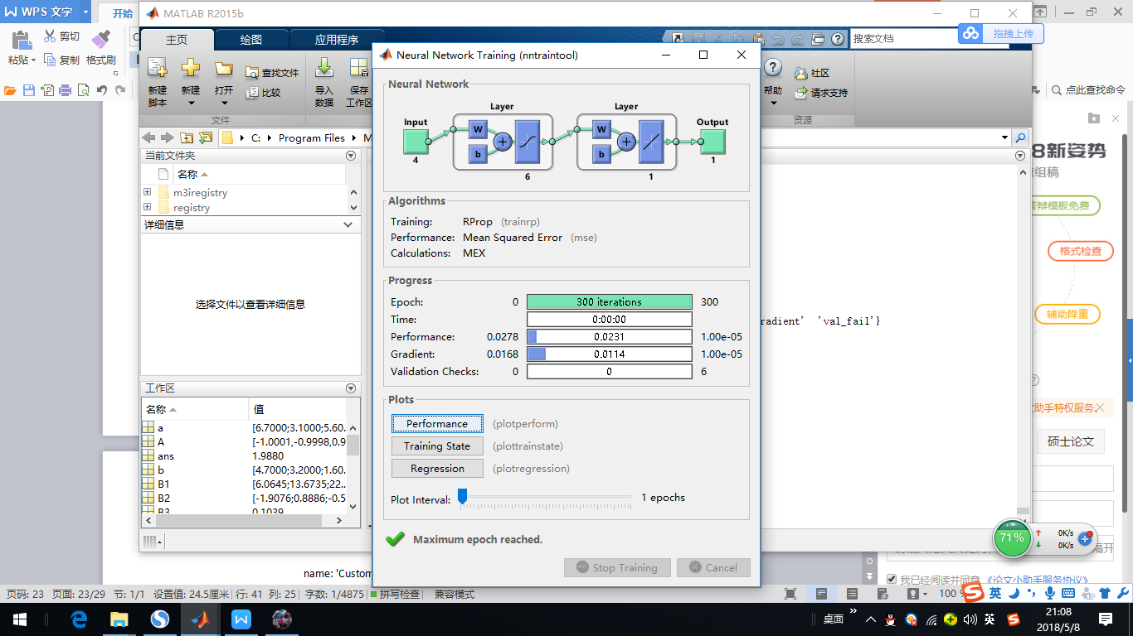

>> sim(net,X)-T # 查看训练精度

>> a = # 输入新样本

5.5000
2.6000
3.7000
1.2000

>> sim(net,a) # 利用网络给新样本分类

ans =

1.9181

b =

5.2000
2.5000
4.8000
1.7000

>> sim(net,b)

ans =

2.8528

c=[4.5 3.1 1.4 0.2]'

c =

4.5000
3.1000
1.4000
0.2000

>> sim(net,c)

ans =

1.0477

作业：神经网络分类器
性别 身高（英尺） 体重（磅） 脚掌（英寸）
男 6 180 12
男 5.92 190 11
男 5.58 170 12
男 5.92 165 10
女 5 100 6
女 5.5 150 8
女 5.42 130 7
女 5.75 150 9
已知某人身高6英尺、体重130磅，脚掌8英寸，请问该人是男是女？

X =

6.0000 5.9200 5.5800 5.9200 5.0000 5.5000 5.4200 5.7500
180.0000 190.0000 170.0000 165.0000 100.0000 150.0000 130.0000 150.0000
12.0000 11.0000 12.0000 10.0000 6.0000 8.0000 7.0000 9.0000

>> T

T =

1 1 1 1 2 2 2 2

>> net=newff(minmax(X),[6,1],{'tansig','purelin'},'trainrp')
警告: NEWFF used in an obsolete way.
> In nnerr.obs_use (line 17)
In newff>create_network (line 126)
In newff (line 101)
See help for NEWFF to update calls to the new argument list.

net =

Neural Network

name: 'Custom Neural Network'

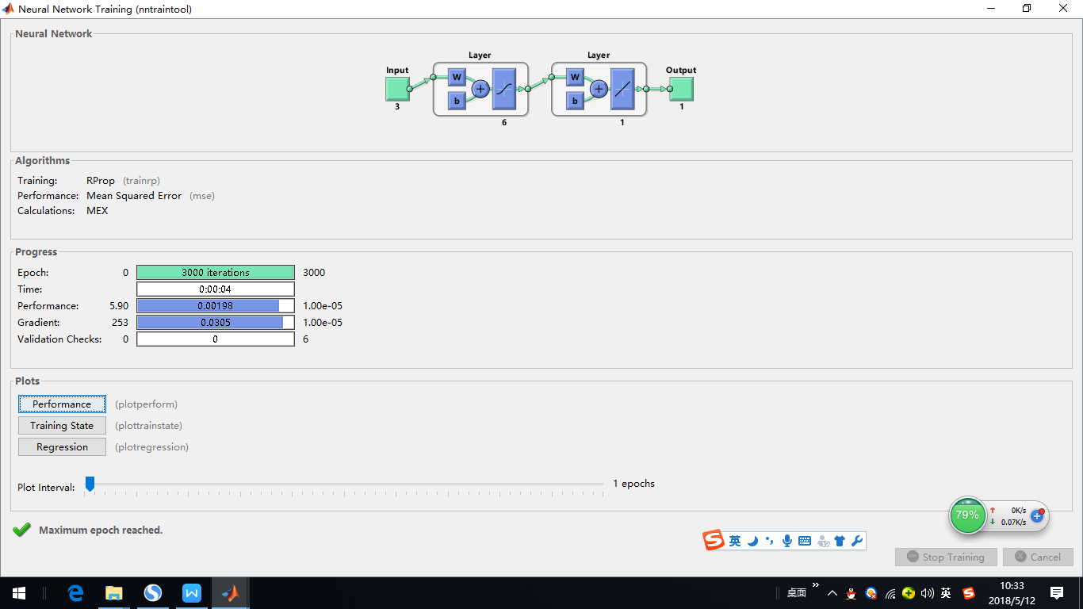

>> w1=net.iw{1,1} w1 =

-0.5040 0.0043 -0.8413
-3.0099 0.0399 0.3314
-2.3240 -0.0402 0.4535
3.7767 -0.0058 0.5615
-2.6417 -0.0332 -0.5263
2.8877 0.0455 -0.1480

>> theta1=net.b{1}

theta1 =
12.2581
9.3175
15.0370
-24.4727
22.5560
-18.6017

>> w2=net.lw{2,1}

w2 =

-0.4803 0.6001 -0.1372 0.8213 -0.6363 -0.4724

>> theta2=net.b{2}

theta2 =

-0.7089

>> net.trainParam.show=50;
net.trainParam.lr=0.05;
net.trainParam.epochs=3000;
net.trainParam.goal=1e-5;
[net,tr]=train(net,X,T)

net =

Neural Network

name: 'Custom Neural Network'
userdata: (your custom info)

evaluate: outputs = net(inputs)

tr =

trainFcn: 'trainrp'
trainParam: [1x1 struct]
performFcn: 'mse'
performParam: [1x1 struct]
derivFcn: 'defaultderiv'
divideFcn: 'dividetrain'
divideMode: 'sample'
divideParam: [1x1 struct]

>> sim(net,X)

ans = 0.9781 0.9791 0.9790 1.0798 2.0230 2.0199 2.0230 1.9185

>> sim(net,X)-T

ans =

-0.0219 -0.0209 -0.0210 0.0798 0.0230 0.0199 0.0230 -0.0815

>> #输入新样本
a =

6
130
8

>> sim(net,a) #新样本分类

ans =

2.0189

作业：已知某人身高5.8英尺、体重132磅，脚掌7.5英寸，请问该人是男是女？

BP neural network 的Python 实现：

使用scikit-learn，可以很快搭建一个神经网络。用scikit-learn中自带的数据集来实现一个神经网络：
>>from sklearn.datasets import load_iris # 加载数据集
>>from sklearn.neural_network import MLPClassifier # 加载neural network
>>from sklearn.model_selection import train_test_split # 加载数据分割器
>>iris_data=load_iris() # 导入鸢尾花数据集
>>X_train, X_test, y_train, y_test = train_test_split(iris_data['data'], iris_data['target'], test_size=0.25, random_state=1) # 拆分数据集 测试集占25%
# 以下搭建neural network 两个隐层一层4个神经元，一层2个神经元
>>mlp = MLPClassifier(solver='lbfgs', hidden_layer_sizes=[4, 2], random_state=0)
>>mlp.fit(X_train, y_train) # 利用拆分数据训练neural network
>>score = mlp.score(X_test, y_test) # 评估模型
执行结果：
>>> from sklearn.datasets import load_iris
>>> from sklearn.neural_network import MLPClassifier
>>> from sklearn.model_selection import train_test_split
>>> iris_data=load_iris()
>>> X_train,X_test,y_train,y_test=train_test_split(iris_data['data'],iris_data['target'],test_size=0.25,random_state=1)
>>> mlp=MLPClassifier(solver='lbfgs',hidden_layer_sizes=[4,2],random_state=0)
>>> mlp.fit(X_train,y_train)
MLPClassifier(hidden_layer_sizes=[4, 2], random_state=0, solver='lbfgs')
>>> score=mlp.score(X_test,y_test)
>>> print(score)
0.9210526315789473
可以分类单个样本：
>>> import numpy as np
>>> x=np.array([[2.0,3.3,4.1,3.0]])
>>> x
array([[2. , 3.3, 4.1, 3. ]])
>>> mlp.predict(x)
array([2])
>>>

作业：鸢尾花数据集选取100个作为数据集，另外50个作为测试集，搭建神经网络。

