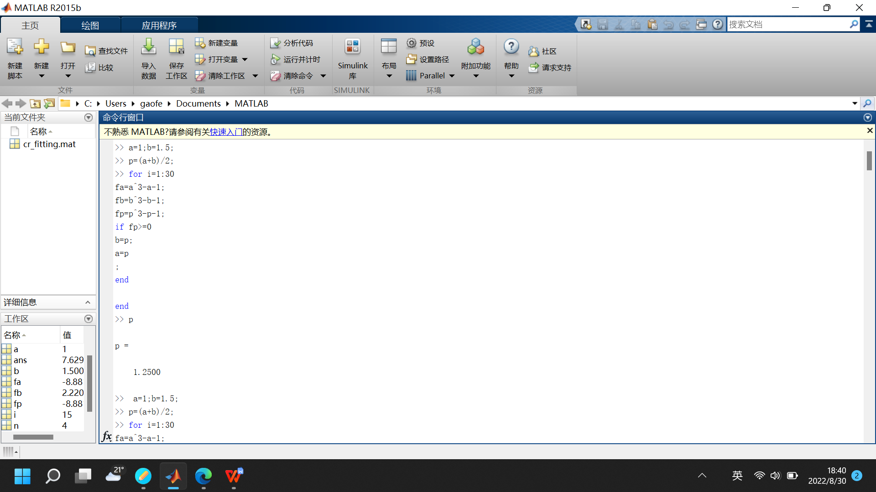
Ex2.1: Find the zero of 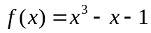 in [1,1.5].

>> a=1; b=1.5; p=(a+b)/2;
>> for i=1:1000
fa=a^3-a-1;
fb=b^3-b-1;
fp=p^3-p-1;
if fa*fp<0
b=p;p=(a+b)/2;
else a=p;p=(a+b)/2;
end
end
>> p

p =

1.3247

>> fp=p^3-p-1
fp =
-8.8818e-16

Ex2.1: Find the zero of in [1,1.5] to the accuracy 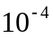.
for i=n:15
abs((b-a)/2^n)
end
0.1250
0.0625
0.0313
0.0156
0.0078
0.0039
0.0020
9.7656e-04
4.8828e-04
2.4414e-04
1.2207e-04
6.1035e-05
3.0518e-05
1.5259e-05
7.6294e-06
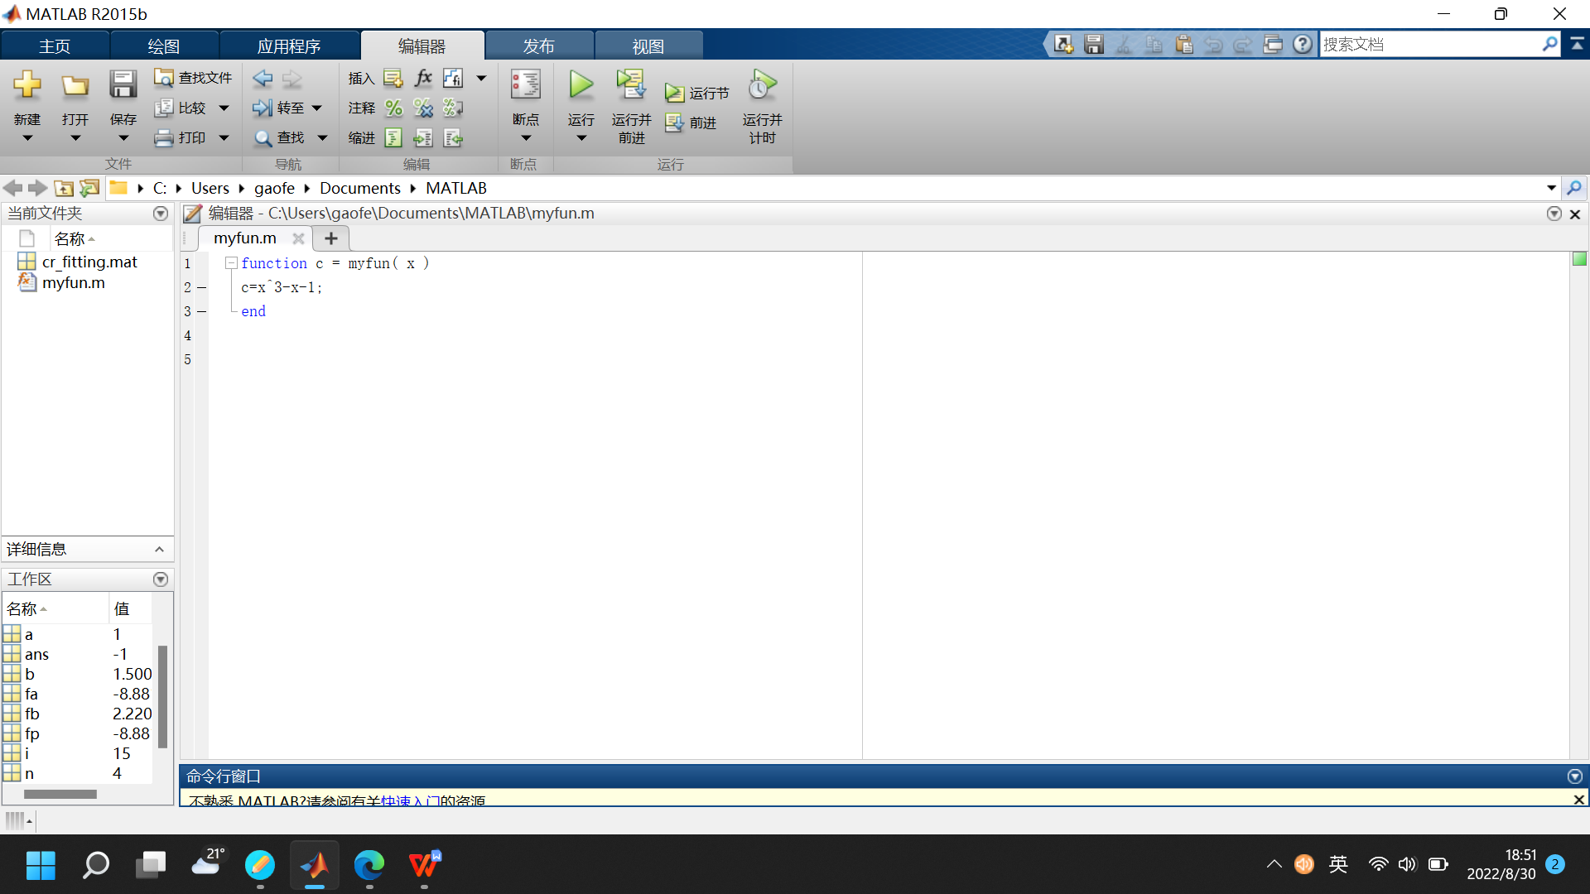
function c = myfun( x )
c=x^3-x-1;
End

>> a=1; b=1.5; p=(a+b)/2;
>> for i=1:1000
fa=a^3-a-1;
fb=b^3-b-1;
fp=p^3-p-1;
if fa*fp<0
b=p;p=(a+b)/2;
else a=p;p=(a+b)/2;
end
end

Click the following link to see the demonstration of Newton’s method for finding the simple root of equations.
https://blog.csdn.net/qq_31442743/article/details/80590640

