- Show that  has at least one zero in the given interval.
- 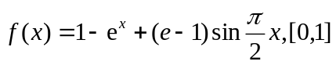
Proof: It can be easily verified that is continuous in the interval  and 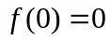 and 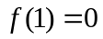.
So, from Rolle Mean Value Theorem we conclude that there exists one zero 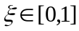 such that 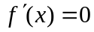.

- Find the 4-th Taylor polynomial for 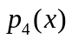 for the function 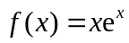at the point 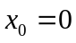
(b) approximate 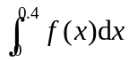 by using 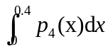
Solution: The Taylor polynomial for is as follows,
and we can also get
So we have
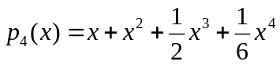.
Therefore,
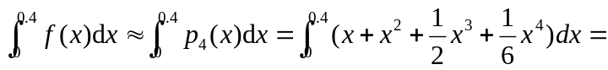 0.104874666666667

(exact value: 0.104905181415238,
Matlab code, >> 0.4^2/2+0.4^3/3+0.4^4/8+0.4^5/30 )
(c) Find the upper bound for the error 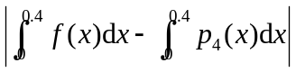
Solution: From Taylor Theorem, we have
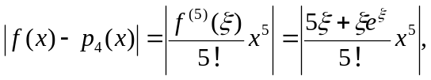where 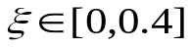
Therefore,
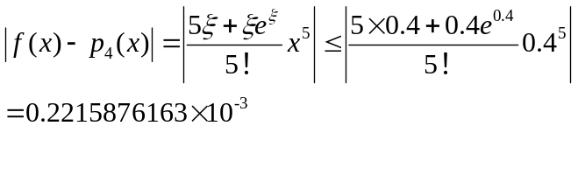
- Perform the following computation
- Exactly, (ii) using 3-digit chopping arithmetic, (iii) using 3-digit rounding arithmetic , and compute the relative errors in part (ii) and part (iii)
(b) 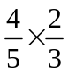
Solution: (i) =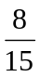
- Since 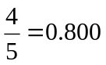, 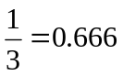, so we have 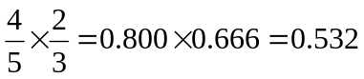
- Since , 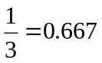, so we have
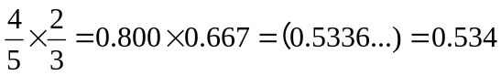
The relative errors in part (ii) is as follows
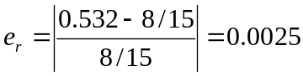
9 The following approximations are obtained by rounding arithmetic, Determine how many significant digits they have respectively.

(a)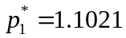 (b)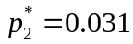 (c)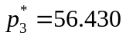 (d)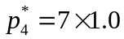
Solution : (a) 5 (b) 2 (c) 5 (d) 2

