Problem 1
(1)Use Theorem 2.2 to show that 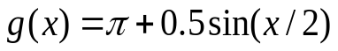
has a unique fixed point on the interval 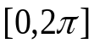;
- Use the fixed point iteration to find the approximation to the fixed point that is accurate to within 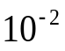.

Problem 2:
Use Newton method to get the approximations to the following numbers respectively (accurate to within 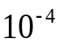) and show your Matlab or Python code.
