Problem 1
(1)Use Theorem 2.2 to show that 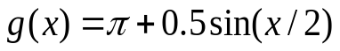
has a unique fixed point on the interval 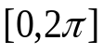;
- Use the fixed point iteration to find the approximation to the fixed point that is accurate to within 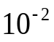.

>> p=zeros(1,20)

p =

0 0 0 0 0 0 0 0 0 0 0 0 0 0 0 0 0 0 0 0

>> p(1)=pi

p =

3.1416 0 0 0 0 0 0 0 0 0 0 0 0 0 0 0 0 0 0 0

>> for i=1:19
p(i+1)=pi+0.5*sin(p(i)/2);
end
>> p

p =

3.1416 3.6416 3.6260 3.6270 3.6269 3.6269 3.6269 3.6269 3.6269 3.6269 3.6269 3.6269 3.6269 3.6269 3.6269 3.6269 3.6269 3.6269 3.6269 3.6269

>> format long
>> p
3.141592653589793 3.641592653589793 3.626048864445115 3.626995622438735 3.626938794225417 3.626942208351095 3.626942003248299 3.626942015569841
3.626942014829625 3.626942014874094 3.626942014871422 3.626942014871583 3.626942014871573 3.626942014871573 3.626942014871573 3.626942014871573
3.626942014871573 3.626942014871573 3.626942014871573 3.626942014871573

>> format short

>> for n=1:10
error=k^n/(1-k)*abs((p(2)-p(1)))
end
error =
0.1667
error =
0.0417
error =
0.0104
error =

0.0026
error =
6.5104e-04
error =
1.6276e-04
error =
4.0690e-05
error =
1.0173e-05
error =
2.5431e-06
error =
6.3578e-07

Problem 2:
Use Newton method to get the approximations to the following numbers respectively (accurate to within 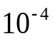) and show your Matlab or Python code.
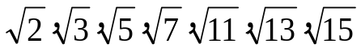

>> P=ones(1,20); P(1)=4;

>> for i=1:19
p(i+1)=0.5*(p(i)+13/p(i))
end

p =
4.000000000000000 3.625000000000000 3.605603448275862 3.605551275841457 3.605551275463990 3.605551275463990 3.605551275463990 3.605551275463990
3.605551275463990 3.605551275463990 3.605551275463990 3.605551275463990 3.605551275463990 3.605551275463990 3.605551275463990 3.605551275463990
3.605551275463990 3.605551275463990 3.605551275463990 3.605551275463990

>> sqrt(13)

ans =

3.605551275463989

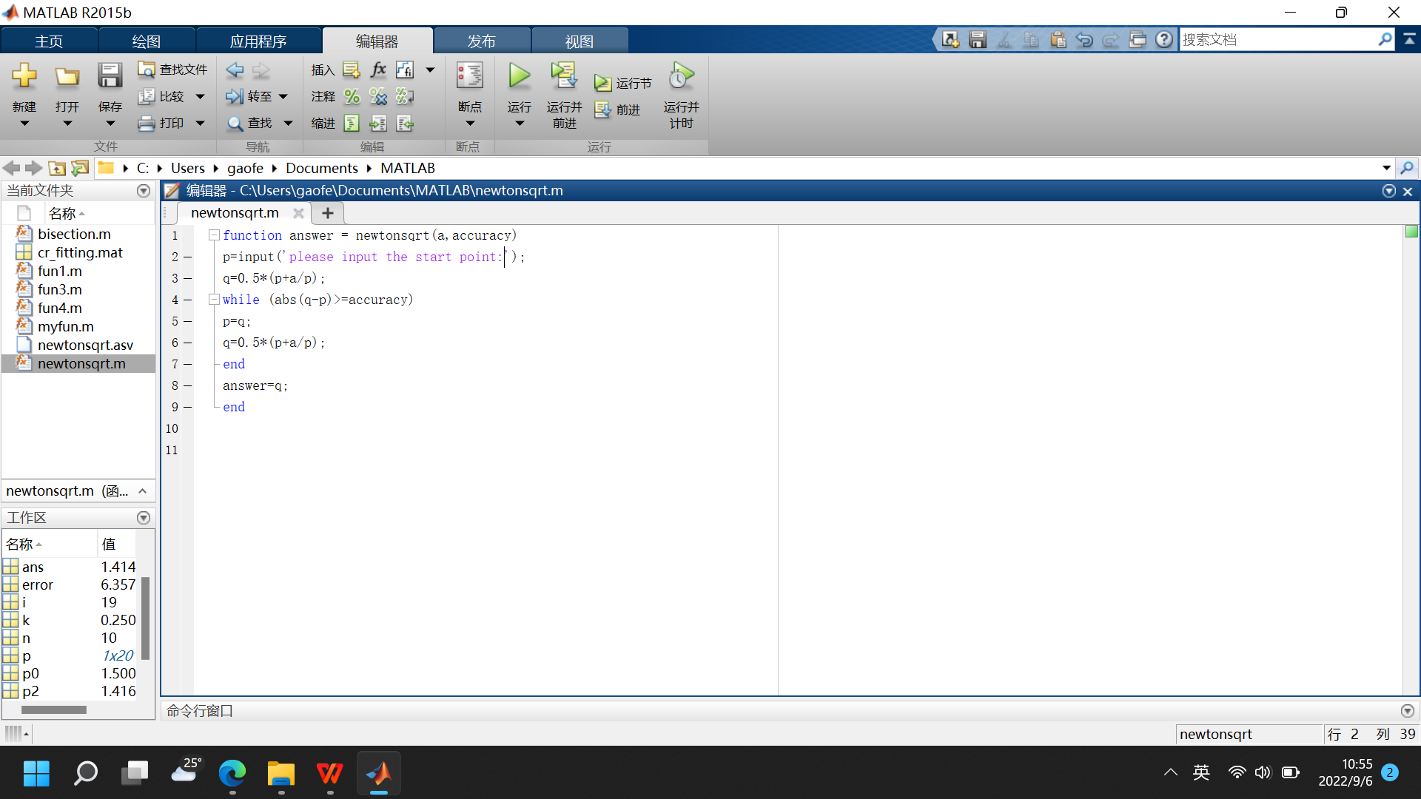

newtonsqrt.m

function answer = newtonsqrt(a,accuracy)
p=input(‘please input the start point:’);
q=0.5*(p+a/p);

while (abs(q-p)>=accuracy)
p=q;
q=0.5*(p+a/p);
end
answer=q;
end
>> newtonsqrt(2,0.0001)
please input the start point: 1.6

ans =

1.414213562962298
See the illustration of Newton method by clicking the below link,
https://blog.csdn.net/qq_31442743/article/details/80590640

作业拓展：
Consider to solve the following problem
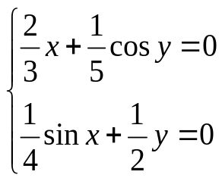

Q(1,1)=1/3*P(1,1)-1/5*cos(P(2,1));
Q(2,1)=1/4*sin(P(1,1))-1/5*P(2,1);
Q =

0.225272872159705
0.010367746201974

Q =

-0.124898293693585
0.053769537758492

Q =

-0.241343717895611
-0.041897362546850

Q =

-0.280272392743117
-0.051372431405279

Q =

-0.293160276279999
-0.058879869427823

Q =

-0.297373508337482
-0.060468802990318

Q =

-0.298758966567222
-0.061158741128516

Q =

-0.299212399600642
-0.061351845491387

Q =

-0.299361179691419
-0.061421553821987

Q =

-0.299409917759549
-0.061443153748713

Q =

-0.299425898562284
-0.061450476287391

Q =

-0.299431135563812
-0.061452829227258

Q =

-0.299432852330776
-0.061453609634856

-0.299433686198920
-0.061453986501797

Consider to solve the following equation by using fixed point iteration method and Newton method.
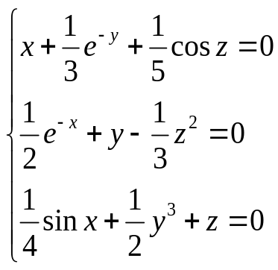

Gaussian Elimination Method
Solve the linear system AX=b

>> A=[4,2,1;3,6,2;1,2,8]

A =

4 2 1
3 6 2
1 2 8
>> b=[1;2;3]

b =

1
2
3
>> X=A\b
X =0.075757575757576
0.189393939393939
0.318181818181818

Command :
>>
for i=2:3
b(i)=b(i)-b(1)/a(1,1)*a(i,1);
for j=2:3
a(i,j)=a(i,j)-a(1,j)/a(1,1)*a(i,1);
end
end
a(2,1)=0;
a(3,1)=0;

b(3)=b(3)-b(2)/a(2,2)*a(3,2);
a(3,3)=a(3,3)-a(2,3)/a(2,2)*a(3,2);
a(3,2)=0

>> a
a = 4.0000 2.0000 1.0000
0 4.5000 1.2500
0 0 7.3333
>> b
b = 1.0000
1.2500
2.3333

