Malthusian model (马尔萨斯模型来自于英国经济学家托马斯·罗伯特·马尔萨斯于 1798 年发表的《人口原理》)
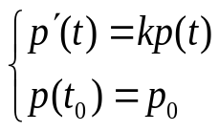
Analytic Solution：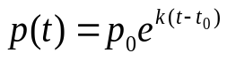
Logistic model
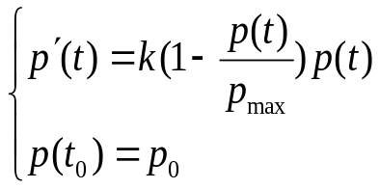
Let k=1, p_{max}=20,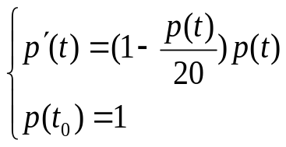
Find the analytic solution to the logistic model by using Matlab
>>syms t;
dsolve('Dp=(1-p/20)*p','p(0)=1','t')
ans =20/(exp(log(19) - t) + 1)
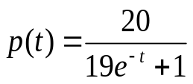

Graph for analytic solution:
>>p=dsolve('Dp=(1-p/20)*p','p(0)=1','t') #Matlab ODE solver
>> ezplot(p,[0,20]) #Graph for analytic solution

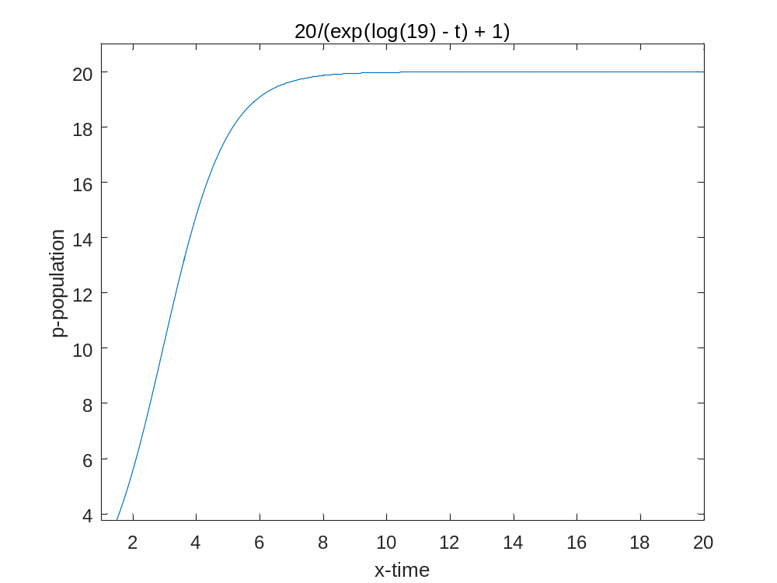
Find the numerical solution by using Euler method:
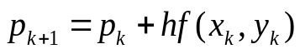
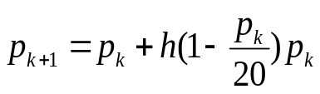
>> t=0:1:20
p=t; p(1)=1;
for i=2:20
p(i)=p(i-1)+h*(1-p(i-1)/20)*p(i-1);
end
plot(t,p,’^’) # 绘图
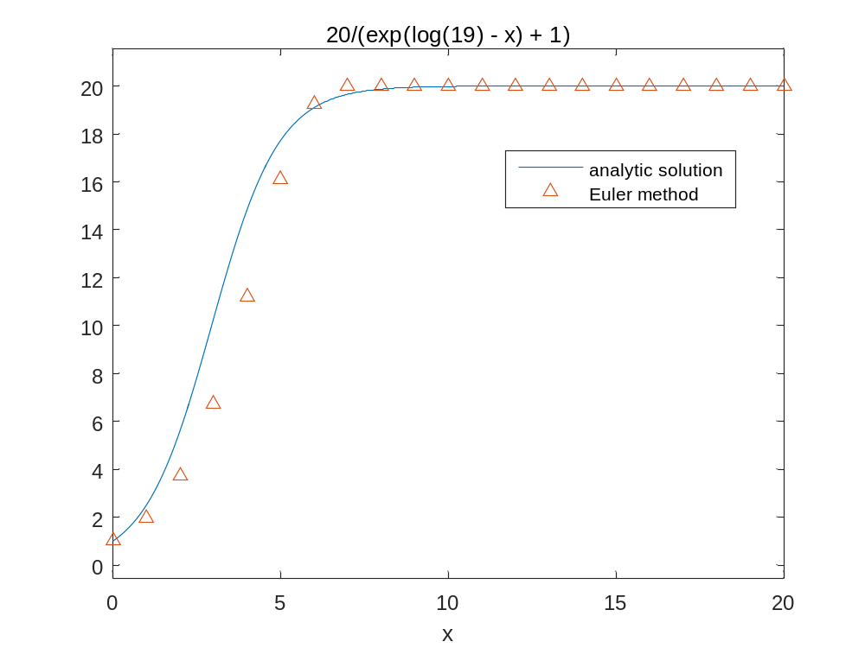
Find the numerical solution by using Modified Euler Method
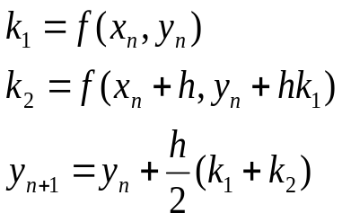
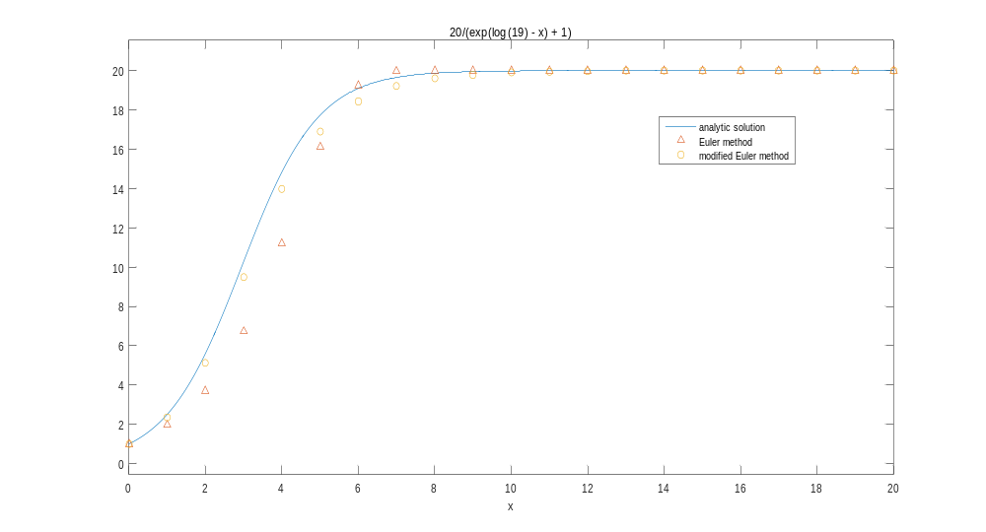
Please notice the local error for Euler Method and Modified Euler Method are
O(h²) and O(h³) respectively.

Find the numerical solution by using 4-th Runge-Kutta method

* Runge-Kutta method,especially 4-th Runge-Kutta method is the mostly used method for numerically solving ODE in engineering fields.
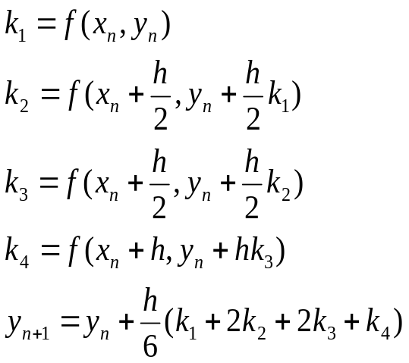
Refer to Runge4.m for the detail.
function y=runge4(h,x0,y0)
k1=odefun(x0,y0);
k2=odefun(x0+h/2,y0+h/2*k1);
k3=odefun(x0+h/2,y0+h/2*k2);
k4=odefun(x0+h,y0+h*k3);
y=y0+h*(k1+2*k2+2*k3+k4)/6;
end

function val = odefun(t,p)
val=(1-p/20)*p;
end

odefun=inline('(1-p/20)*p','t'); #也可以用内联函数定义
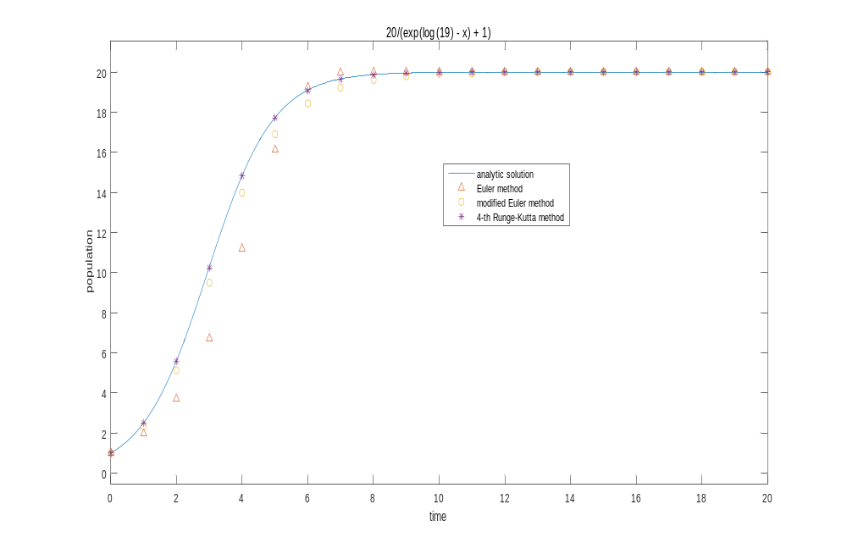

Numerical solution of Boundary value problem

I.V.P. initial value problem
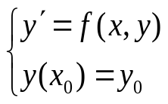
2-th order I.V.P. initial value problem
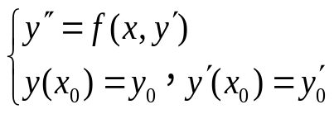
Typical Boundary value problem:
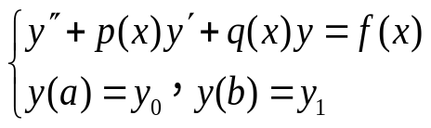
简谐振动：Simple harmonic vibration
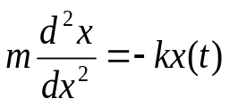
带阻尼项的简谐振动：Simple harmonic vibration with damping term
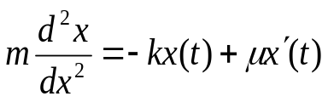
Solve the following boundary value problem （B.V.P) by using finite difference algorithm:
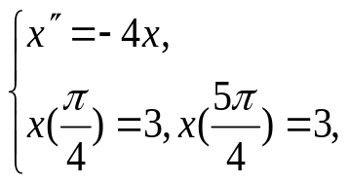
How to construct the numerical algorithm?

>>h=pi/10; #设定步长

A=ones(9,9)
for i=1:9
A(i,i)=4*h^2-2;
end
>> for i=1:9
for k=1:9
if abs(i-k)>1
A(i,k)=0;
end
end
end

>>b=zeros(9,1);
b(1)=-3
b(9)=-3
>> x=A\b
x=[3,x',3];
t=ones(1,11);
画动点图：
for k=1:10
for i=1:11
plot(x(i),t(i),'Ob','LineWidth',5);axis([-pi pi 0 2])
pause(0.2)
end
end

Find the analytic solution by suing Matlab ODE solver
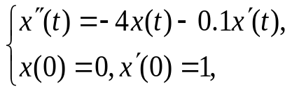
>>syms t

>> dsolve('D2x=-4*x-0.1*Dx','x(0)=0','Dx(0)=1','t')

ans =

(20*1599^(1/2)*exp(-t/20)*sin((1599^(1/2)*t)/20))/1599

>> t=100

t =

100

>> (20*1599^(1/2)*exp(-t/20)*sin((1599^(1/2)*t)/20))/1599

ans =

-0.0030

>>x=dsolve('D2x=-4*x-0.1*Dx','x(0)=0','Dx(0)=1','t')
>> ezplot(x,[0,300]) #graph for analytic solution
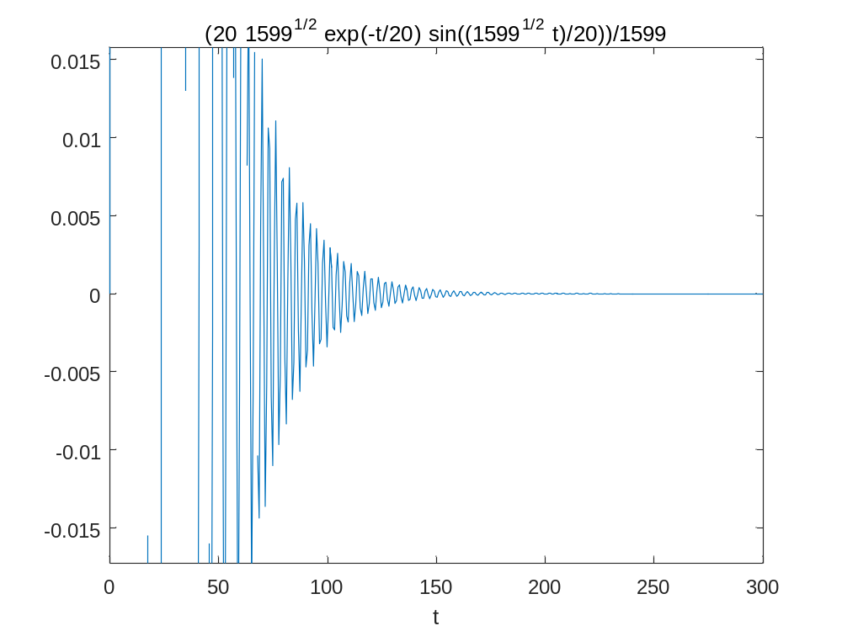
Find the numerical soluton by using Matlab function(直接调用4阶龙格库塔法：)
Ex1:
testfun.m
function dy=testfun(t,y)
dy=(1-y/20)*y;
end

[t,y]=ode45(@testfun,[0,20],1) #步长自适应
plot(t,y,'*')

Can be transformed to the 1-th ODE system

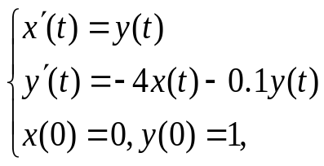
And this system can solved by ODE45:

function df=testfun1(t,f)
df=[y;
-4*x-0.1*y]
end
[t,f]=ode45(@testfun1,[0,20],[0,1]) #步长自适应
plot(t,f(:,1),'*')

