**新项目部署事项**

1. 安装pgsql
2. 下载yum源 <https://yum.postgresql.org/repopackages.php>
3. 安装yum源

#yum install yum源包名字

1. 安装

#yum install postgresql10-server.x86_64 (需要安装10版本)

先不要初始化，修改/etc/rc.d/init.d/postgresql-10

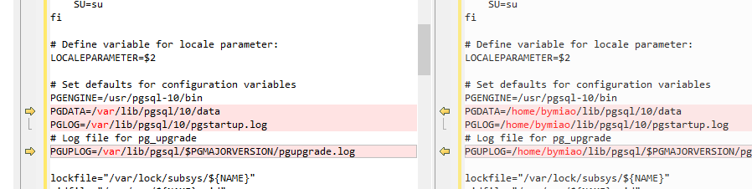

1. 初始化db

# service postgresql-10 initdb

1. 启动服务

# service postgresql-10 start

二．安装pqsql的python扩展 (不安装的话，dev库导入会少函数等)

# yum install postgresql10-plpython.x86_64

s

1. 数据库操作
2. 设置pgsql密码并新建库

#sudo su - postgres 进入到-bash

# psql 进入到pgsql命令行

#\password 设置pgsql密码 管理员账号是postgres

1. 新建数据库并授权给postgres

# CREATE DATABASE bcex_dev OWNER postgres;

# GRANT ALL PRIVILEGES ON DATABASE bcex_dev TO postgres;

# CREATE DATABASE dev OWNER postgres;

# GRANT ALL PRIVILEGES ON DATABASE dev TO postgres;

# CREATE DATABASE user_auth OWNER postgres;

# GRANT ALL PRIVILEGES ON DATABASE user_auth TO postgres;

修改配置文件pg_hba.conf postgresql.conf 需要开放访问权限和监听端口

配置文件路径 /var/lib/pgsql/10/data

pg_hba.conf修改内容：

# "local" is for Unix domain socket connections only

local all all trust

# IPv4 local connections:

host all all 127.0.0.1/32 ident

# IPv6 local connections:

host all all ::1/128 ident

# Allow replication connections from localhost, by a user with the

# replication privilege.

local replication all md5

host replication all 127.0.0.1/32 md5

host all all 0.0.0.0/0 trust

host replication all ::1/128 md5

postgresql.conf修改内容：listen_addresses = '*'

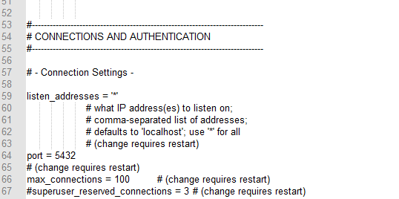

datestyle = 'iso, ymd'

#intervalstyle = 'postgres'

timezone = 'PRC'

#timezone_abbreviations = 'Default' # Select the set of available time zone

# abbreviations. Currently, there are

# Default

# Australia (historical usage)

# India

# You can create your own file in

# share/timezonesets/.

#extra_float_digits = 0 # min -15, max 3

#client_encoding = sql_ascii # actually, defaults to database

# encoding

# These settings are initialized by initdb, but they can be changed.

lc_messages = 'zh_CN.UTF-8' # locale for system error message

# strings

lc_monetary = 'zh_CN.UTF-8' # locale for monetary formatting

lc_numeric = 'zh_CN.UTF-8' # locale for number formatting

lc_time = 'zh_CN.UTF-8' # locale for time formatting

# default configuration for text search

default_text_search_config = 'pg_catalog.simple'

1. 其它命令：

（需要cd 到/usr/pgsql-10/bin/执行）

备份数据库

#./pg_dump -h 172.21.251.63 -p 5432 -U postgres -W -F c -b -v -f user_auth.backup user_auth

./pg_dump -h 192.168.1.52 -p 5432 -U postgres -W -F c -b -v -f dev.backup dev

还原数据库

./pg_restore -j4 -Fc -h 172.21.251.63 -d kernel -U postgres -p 5432 user_auth.backup

./bitcoind --datadir=/home/bitcoin/data/ --daemon

nohup ./geth --datadir /home/Wallet/ethereum/data/ --fast --rpc --rpcapi db,eth,net,web3,personal,miner,admin,debug --rpcaddr "172.21.251.56" &

#Bitcoin常用命令（莱特币，比特币现金，dash-cor都类似）：

1.注册账号并生成地址

./bitcoin-cli -datadir=/home//home/Wallet/bitcoin/data/ -regtest getnewaddress

1. 查看当前区块信息

./bitcoin-cli --datadir=/home/Wallet/bitcoin/data/ -getinfo

1. 列出所有账号及余额

./bitcoin-cli -datadir=/home/Wallet/bitcoin/data/ listaccounts

1. 交易详情

./bitcoin-cli -datadir=/home/Wallet/bitcoin/data/ listsinceblock

线上环境

BTC:

Btc 3JniWzEEgDtJjsXBptKts1tdgVZELPNwGM