Employee Management System Using MySQL and Power BI

Summary Report – Yein Flener

1. Introduction

This report provides insights from an employee management system using MySQL Workbench for

data extraction and Power BI for visualization. It focuses on key aspects such as

attendance, compensation, and departmental activities.

2. Limitations

Fictional data consists of 30 rows of employees’ information for analytical demonstration only.

3. Objectives

* Extract insights from employee data
* Integrate SQL queries with Power BI for effective reporting
* Support data-driven decision-making

4. Query and Visualization Sections

Query 1: Get the attendance status of employees on a specific date (“2023-01-11”)

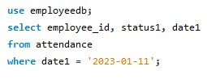

Query Result:

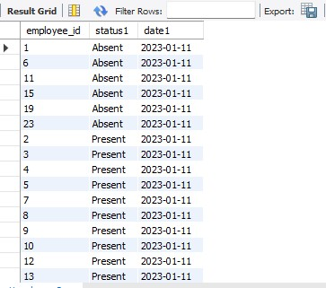

Visualization:

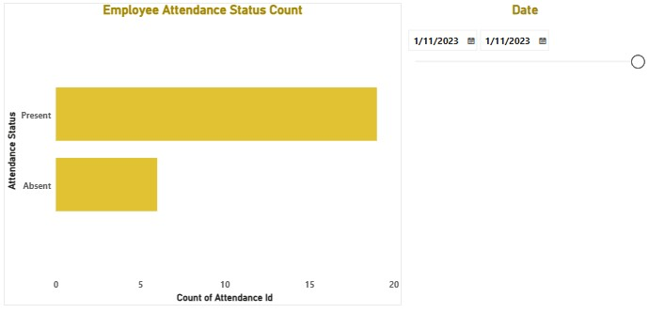

Query 2: List all projects and their associated department names



Query result:

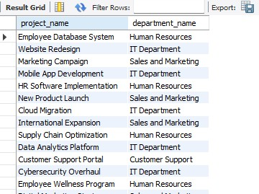

Visualization:

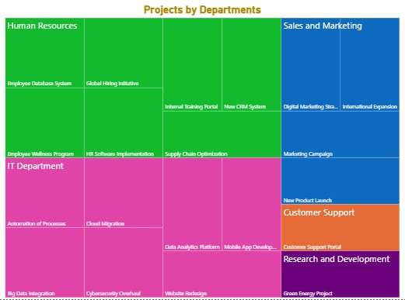

Query 3: Get salary details of employees along with their bonuses

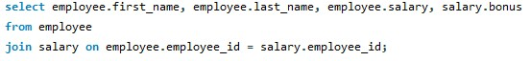

Query result:

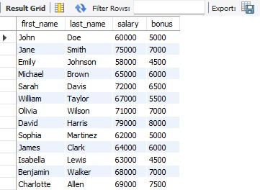

Visualization:

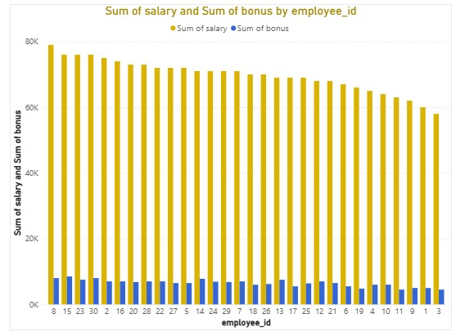

Query 4: Get number of employees in each department



Query result:

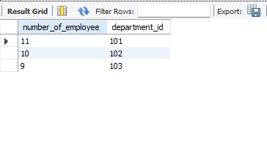

Visualization:

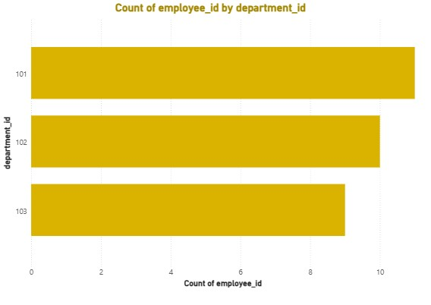

Query 5: Calculate the net salary of all employees after bonuses and deductions, and list those whose net salary exceeds a certain threshold.(60000/-)

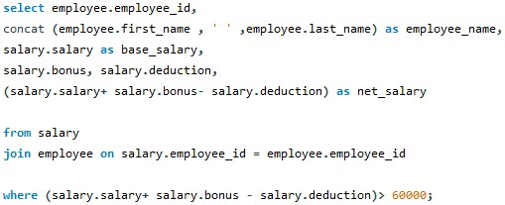

Query result:

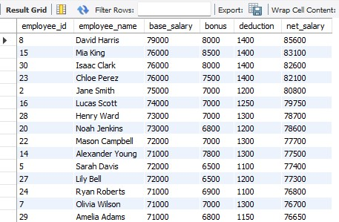

Visualization:

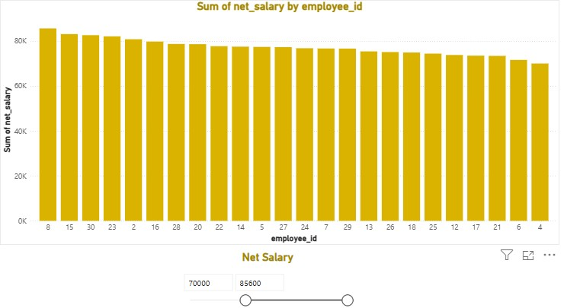

5. Summary

The analysis provides insights on attendance, workforce allocation, and pay structures. Additional data needs to be captured for in-depth analysis of the following areas:

* Monitor and address absenteeism
* Improve budgeting with compensation data
* Optimize staffing based on department and project needs

6. Conclusion

This project demonstrates how SQL and Power BI together can transform raw data into clear and useful insights to drive better decision-making.