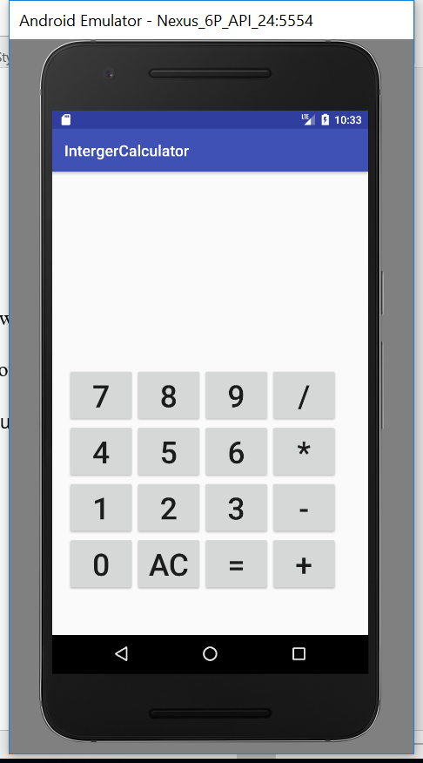

Figure1. Integer Calculator App showing in Nexus 6P Android Emulator

There four different test showcases video in the folder:

1. SequenceCalculation show the calculation of 39 + 48 = - 10 + 5 - 98= , and the result screen will display 39, 48, 87, 10, 77,5, 82,98, -16 in sequence.
2. devidedByZeroTest shows if the user devide a number by zero, the calculator will show ERROR!
3. overflowTest shows if the result is bigger than 9999999, the calculator will show OVERFLOW!
4. roundingTest shows the rouding result of -5 / 2, the calculator will give the result -3