Econ 4010 Homework 6

RyanYip

## Question 1

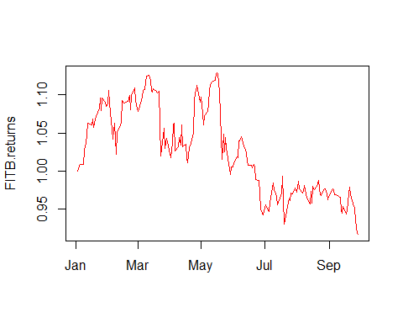

## Question 2

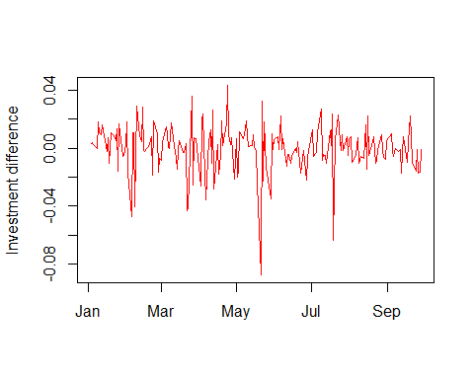

## Question 3

## FITB.Open FITB.High FITB.Low FITB.Close FITB.Volume   
## 1.836475e+00 1.878659e+00 1.811297e+00 1.723536e+00 2.709416e+06   
## FITB.Adjusted   
## 1.586929e+00

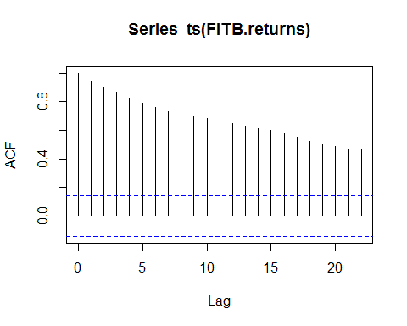

##   
## Phillips-Perron Unit Root Test  
##   
## data: ts(FITB.returns)  
## Dickey-Fuller Z(alpha) = -21.023, Truncation lag parameter = 4,  
## p-value = 0.05039  
## alternative hypothesis: stationary

According to the ACF plot,The above ACF is “decaying”, or decreasing, very slowly, and remains well above the significance range (dotted blue lines). This is indicative of a non-stationary series.And the ** Phillips–Perron Unit Root Test ** also tells us that ,the p-value of test is greater 0.05,which indicates that it is not significant.So,we can conclude that,this variable is not stationary.

## Question 4

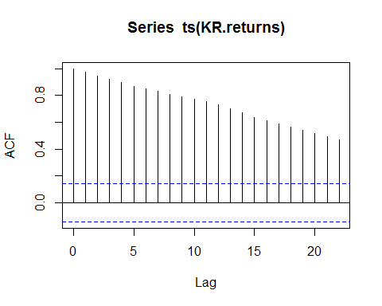

##   
## Phillips-Perron Unit Root Test  
##   
## data: ts(KR.returns)  
## Dickey-Fuller Z(alpha) = -6.4206, Truncation lag parameter = 4,  
## p-value = 0.7476  
## alternative hypothesis: stationary

According to the result got from above analysis,the analysis process and result is same as Question 3.So this variable is not stationary.

#### Plot the difference of KR returns

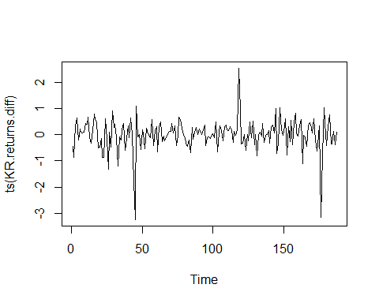

## [1] "pp test on difference of KR returns \n"

## Warning in pp.test(ts(KR.returns.diff)): p-value smaller than printed p-  
## value

##   
## Phillips-Perron Unit Root Test  
##   
## data: ts(KR.returns.diff)  
## Dickey-Fuller Z(alpha) = -160.76, Truncation lag parameter = 4,  
## p-value = 0.01  
## alternative hypothesis: stationary

The plot and pp test shows that the difference of KR returns is stationary.

## Question 5

##   
## Call:  
## lm(formula = KR.diff ~ KR.lag_1 + KR.lag_2 + FITB.lag_1 + FITB.lag_2,   
## data = Data)  
##   
## Residuals:  
## Min 1Q Median 3Q Max   
## -1.051e-16 -3.002e-18 3.490e-19 2.646e-18 2.068e-16   
##   
## Coefficients: (2 not defined because of singularities)  
## Estimate Std. Error t value Pr(>|t|)   
## (Intercept) -1.015e-18 1.484e-18 -6.840e-01 0.4951   
## KR.lag_1 1.000e+00 2.562e-18 3.903e+17 <2e-16 ***  
## KR.lag_2 NA NA NA NA   
## FITB.lag_1 -1.926e-16 9.190e-17 -2.096e+00 0.0374 *   
## FITB.lag_2 NA NA NA NA   
## ---  
## Signif. codes: 0 '***' 0.001 '**' 0.01 '*' 0.05 '.' 0.1 ' ' 1  
##   
## Residual standard error: 2.029e-17 on 184 degrees of freedom  
## Multiple R-squared: 1, Adjusted R-squared: 1   
## F-statistic: 7.9e+34 on 2 and 184 DF, p-value: < 2.2e-16

According to the summary of regression model,the coefficient of lag 1 on difference of returns to FITB if significant,which indicates that lag 1 on FITB affect the difference of returns to Kroger stock.

## Question 6

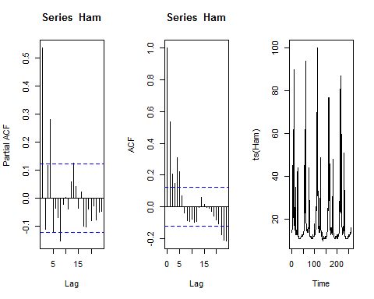

## Warning in adf.test(Ham, alternative = "stationary"): p-value smaller than  
## printed p-value

##   
## Augmented Dickey-Fuller Test  
##   
## data: Ham  
## Dickey-Fuller = -5.0358, Lag order = 6, p-value = 0.01  
## alternative hypothesis: stationary

The graph show us that,the acf ,pacf decay quikly,and ts plot has not obvious trend. we also call the ADF test on the Ham series data to check for stationarity. The p-value of 0.01 from the ADF test tells us that the series Ham is stationary

## Question 7

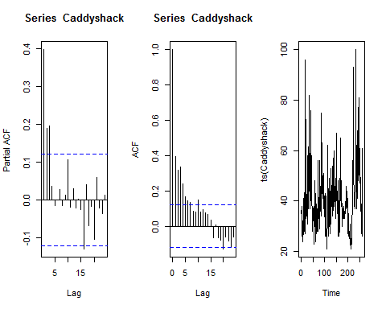

## Warning in adf.test(Caddyshack, alternative = "stationary"): p-value  
## smaller than printed p-value

##   
## Augmented Dickey-Fuller Test  
##   
## data: Caddyshack  
## Dickey-Fuller = -4.3608, Lag order = 6, p-value = 0.01  
## alternative hypothesis: stationary

The result is same as the question 6(Ham variable).And we get the same conclusion.So variable Caddyshack is stationary

## Question 8

### Fit Autoregressive Models on Caddyshack

##   
## Call:  
## ar(x = Caddyshack, aic = TRUE, order.max = 5)  
##   
## Coefficients:  
## 1 2 3   
## 0.2848 0.1266 0.1950   
##   
## Order selected 3 sigma^2 estimated as 129.7

According to the result above,the model best lag is 3

## Question 9

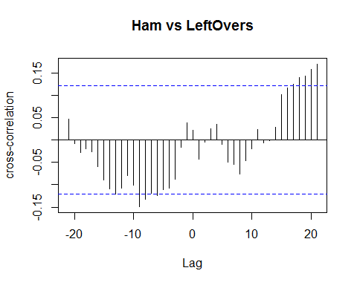 According to the CCF graph acrross variable Ham and LeftOvers ,It has strong correlation for lags -3 to 0 with tapering in both directions.

#### Run linear regression

Formula: c(Leftovers_lag_1,Leftovers_lag_2) ~ Ham_lag_1+Ham_lag_2+Ham_lag_3

Data=data.frame(LeftOvers_lag_1=lag(LeftOvers,-1),  
 LeftOvers_lag_2=lag(LeftOvers,-2),  
 Ham_lag_1=lag(Ham,-1),  
 Ham_lag_2=lag(Ham,-2),  
 Ham_lag_3=lag(Ham,-3))

## Response LeftOvers_lag_1 :  
##   
## Call:  
## lm(formula = LeftOvers_lag_1 ~ 0 + Ham_lag_1 + Ham_lag_2 + Ham_lag_3,   
## data = Data)  
##   
## Residuals:  
## Min 1Q Median 3Q Max   
## -22.440 -0.385 0.929 3.929 96.555   
##   
## Coefficients: (2 not defined because of singularities)  
## Estimate Std. Error t value Pr(>|t|)   
## Ham_lag_1 0.31319 0.03208 9.764 <2e-16 ***  
## Ham_lag_2 NA NA NA NA   
## Ham_lag_3 NA NA NA NA   
## ---  
## Signif. codes: 0 '***' 0.001 '**' 0.01 '*' 0.05 '.' 0.1 ' ' 1  
##   
## Residual standard error: 12.8 on 260 degrees of freedom  
## Multiple R-squared: 0.2683, Adjusted R-squared: 0.2655   
## F-statistic: 95.34 on 1 and 260 DF, p-value: < 2.2e-16  
##   
##   
## Response LeftOvers_lag_2 :  
##   
## Call:  
## lm(formula = LeftOvers_lag_2 ~ 0 + Ham_lag_1 + Ham_lag_2 + Ham_lag_3,   
## data = Data)  
##   
## Residuals:  
## Min 1Q Median 3Q Max   
## -22.440 -0.385 0.929 3.929 96.555   
##   
## Coefficients: (2 not defined because of singularities)  
## Estimate Std. Error t value Pr(>|t|)   
## Ham_lag_1 0.31319 0.03208 9.764 <2e-16 ***  
## Ham_lag_2 NA NA NA NA   
## Ham_lag_3 NA NA NA NA   
## ---  
## Signif. codes: 0 '***' 0.001 '**' 0.01 '*' 0.05 '.' 0.1 ' ' 1  
##   
## Residual standard error: 12.8 on 260 degrees of freedom  
## Multiple R-squared: 0.2683, Adjusted R-squared: 0.2655   
## F-statistic: 95.34 on 1 and 260 DF, p-value: < 2.2e-16

According to summary of the regression model, the coefficients of the Ham lag 1 is significant,which indicates that the lag 1 of Ham has strong correlation accross LeftOvers_lag_1 and LeftOvers_lag_2. So I have reason to believe searches for “Ham” affect the number of searches for “Leftovers”.

## Question 10

* H0: remove variable Ham from regression model with responce Leftovers
* H1: not remove variable Ham from regression model with responce Leftovers

#### stationary test

adf.test(df$Ham)

## Warning in adf.test(df$Ham): p-value smaller than printed p-value

##   
## Augmented Dickey-Fuller Test  
##   
## data: df$Ham  
## Dickey-Fuller = -5.0358, Lag order = 6, p-value = 0.01  
## alternative hypothesis: stationary

According to the adf.test,Ham is stationary

#### Granger causality test

## Granger causality test  
##   
## Model 1: Leftovers ~ Lags(Leftovers, 1:3) + Lags(Ham, 1:3)  
## Model 2: Leftovers ~ Lags(Leftovers, 1:3)  
## Res.Df Df F Pr(>F)  
## 1 251   
## 2 254 -3 1.6726 0.1734

The p-value of the above result is 0.1734,which tells us that we can not reject the H0.According to the test,we can not conclude that whether this variable can use to be a predictor for Leftovers.