CH1:
PPT: adventage of DBMS

CH2: (PPT CAN BE IGNORE. ONLY KNOW TUTORIAL)
TURORIAL 1 :EXERCISE 1. HOW TO DRAW ER-DIAGREAM
EXERCISE 2~5 DRAW

CH3(NOT METIONED)

CH4: PPT PAGE14(ONLY NEED TO KNOW THE FOLLOWING PROBLEM)
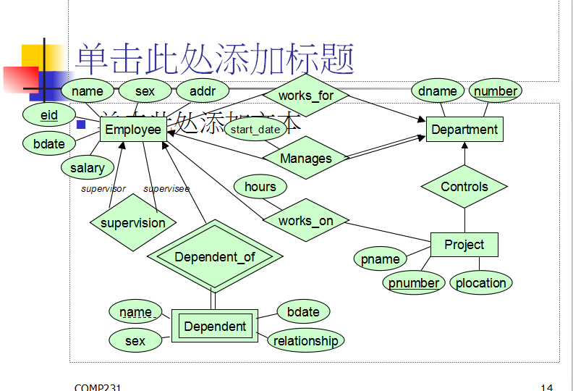

atleast one qustion : from figure to table or from table to figure

CH5(IGNORE PPT . ONLY KNOW TUTORIAL)
tutorial2:
convert E-R diagram to table
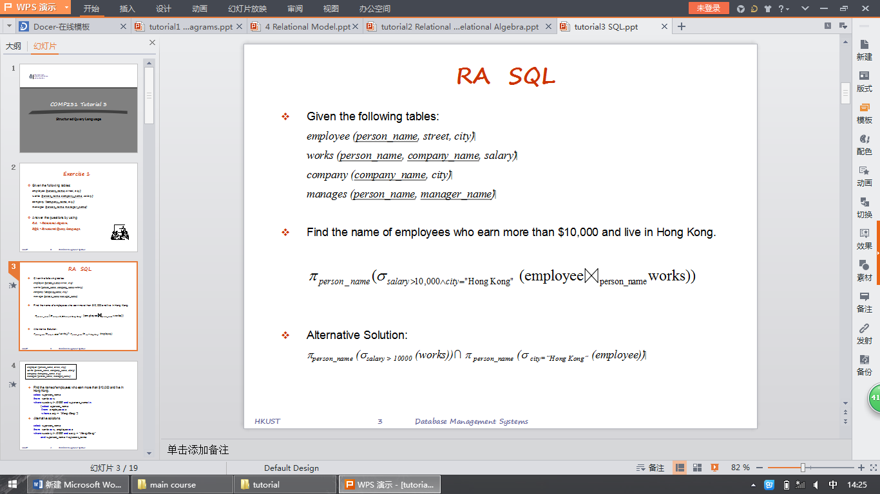
answer using algeber and SQL
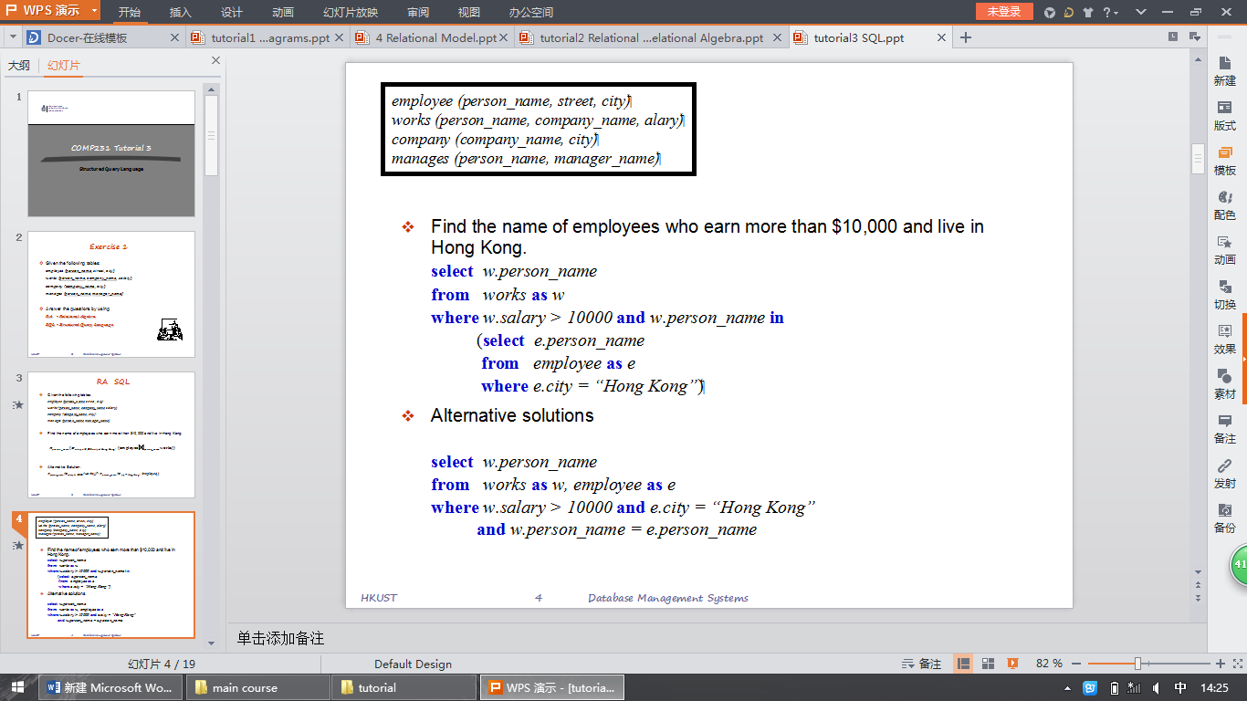

QUSTION 3

CH6 (ONLY NEED TO KNOW SUBLING)

CH7(NOT METIONED )

CH8 :
EXAM QUESTION
LIKE : (PPT PAGE 2)
3. Boyce Codd normal form (BCNF)(DOES IT SATISFT B/3-CNF,,CONVERTION..IN TUTORIAL 5)
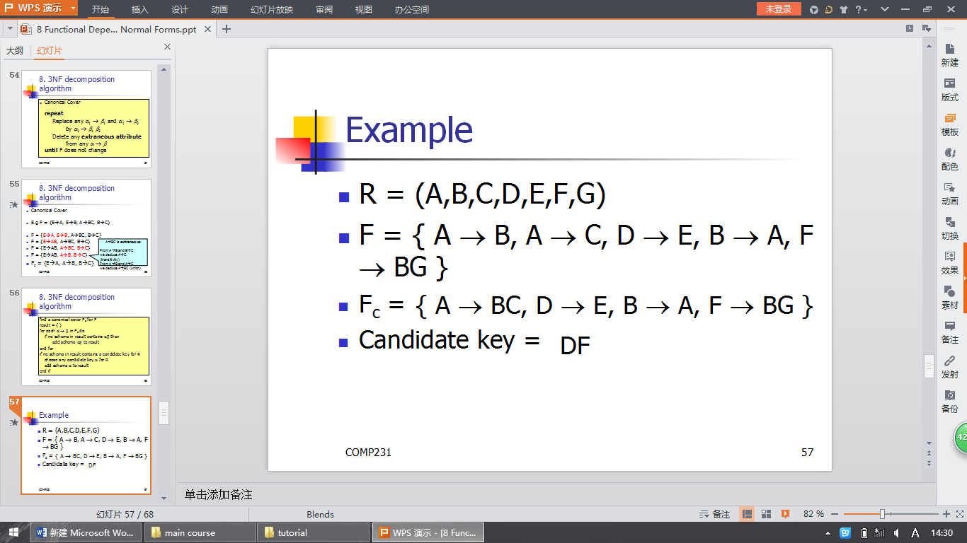7.BCNF decomposition algorithm
8.3NF decomposition algorithm
(DECOMPOSITION)
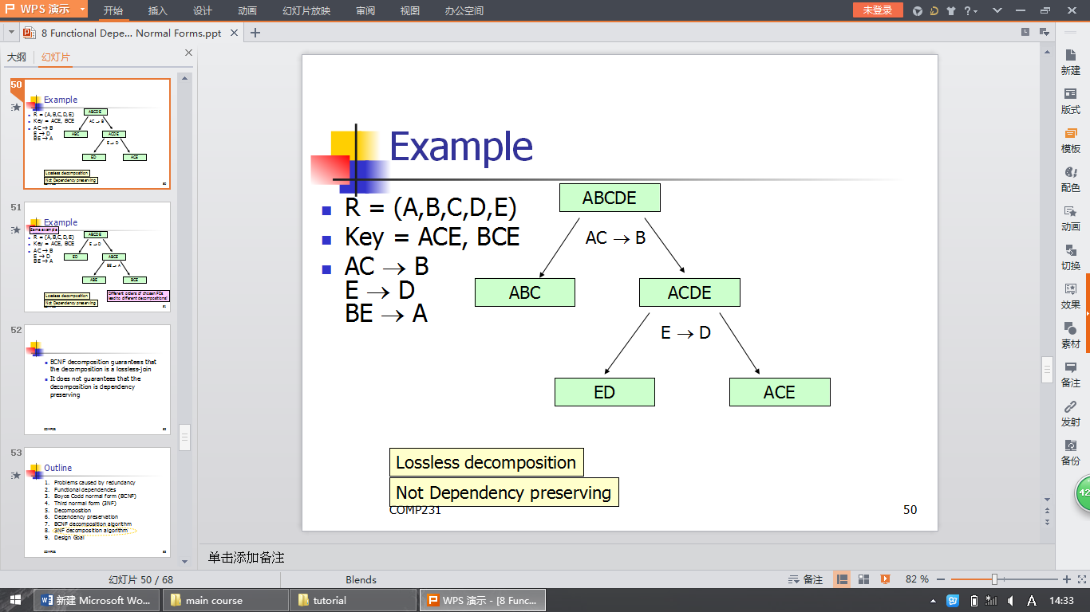

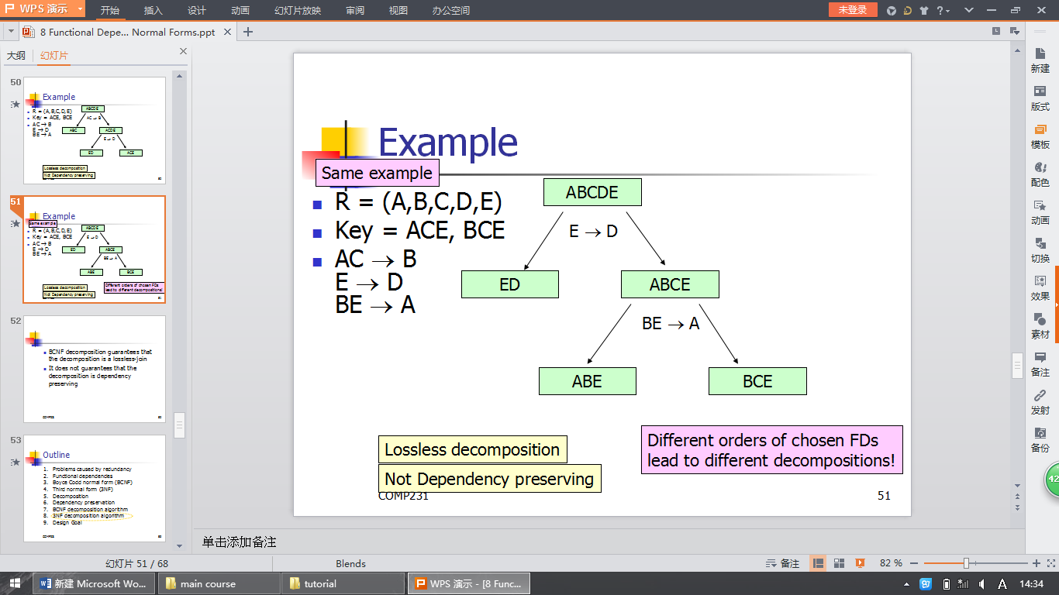

TUTORAIL 6: EXE3 EXE4 EXE5 REQUIRED
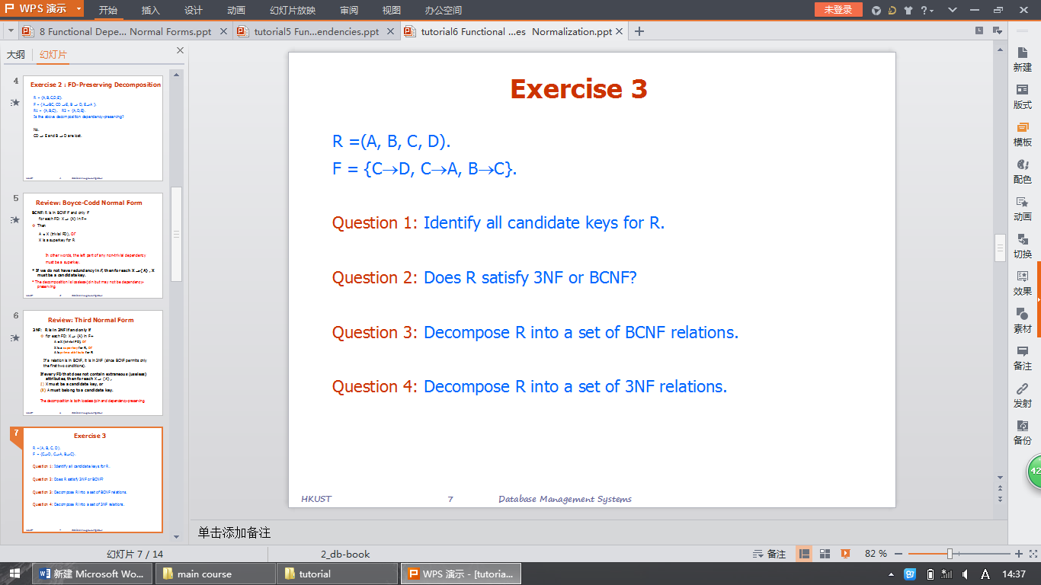

TUTORIAL 7 CAN BE IGNORED

CH9(IGNORE)

CH10(ONE QUESTION IN CH10)
WHAT IS B+ TREE.CONCEPT
HOW TO PERFORM INSERTION, DELETION, (ONLY NEED TO KNOW HOW TO DRAW THIS FIGURE)

CH11(IGNORE)

CH12(COMBINE WITH CH13 , HAVE ONT BIG QUESTION)
CH13()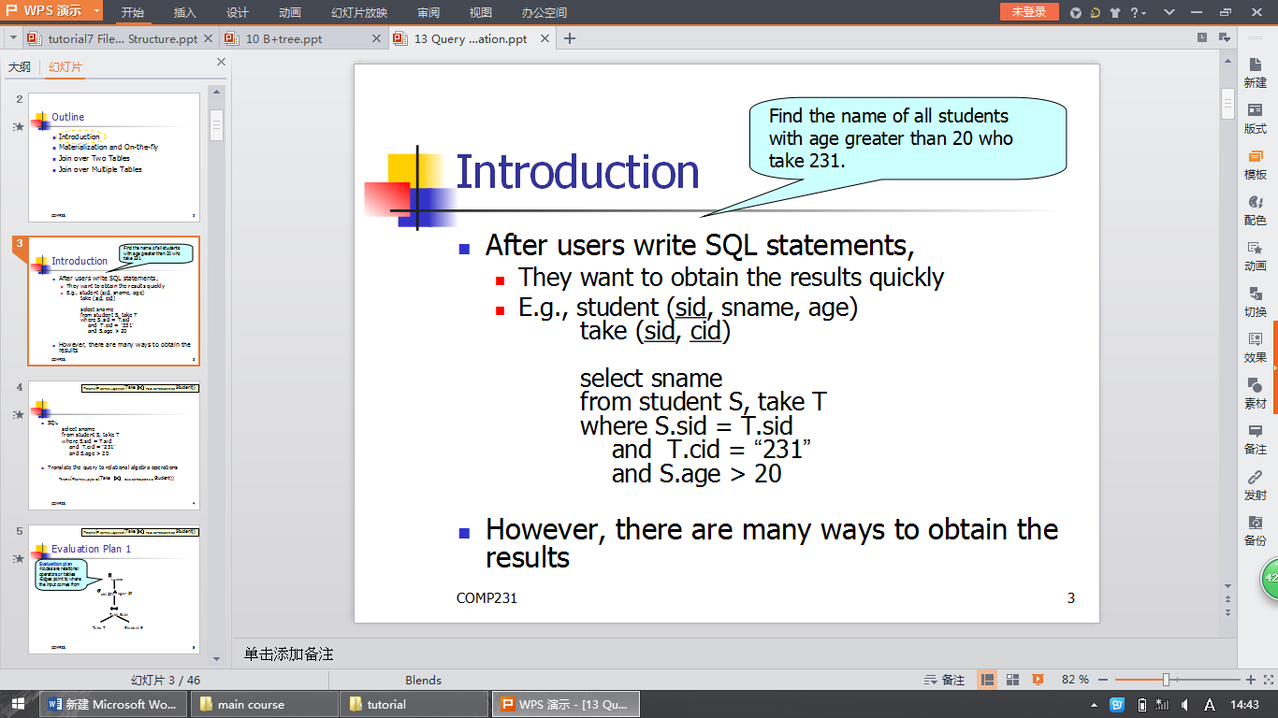
CALCULATE THE COST OF JION ALGORITHM
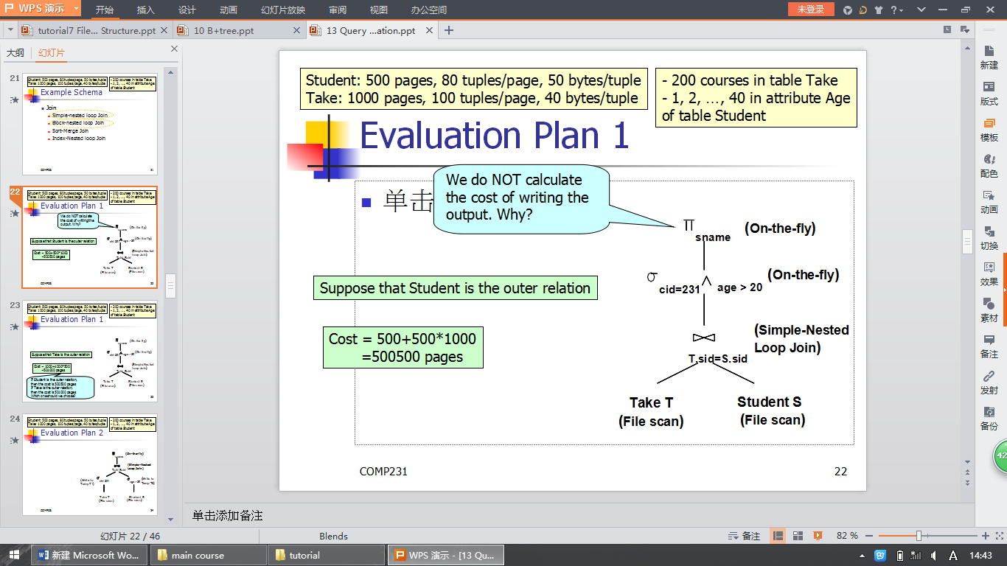
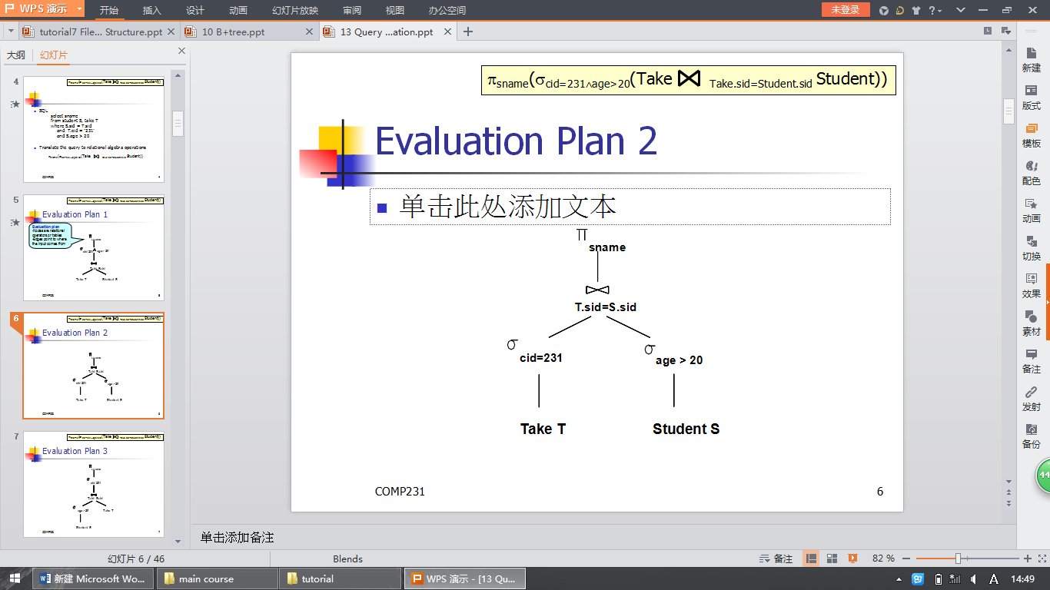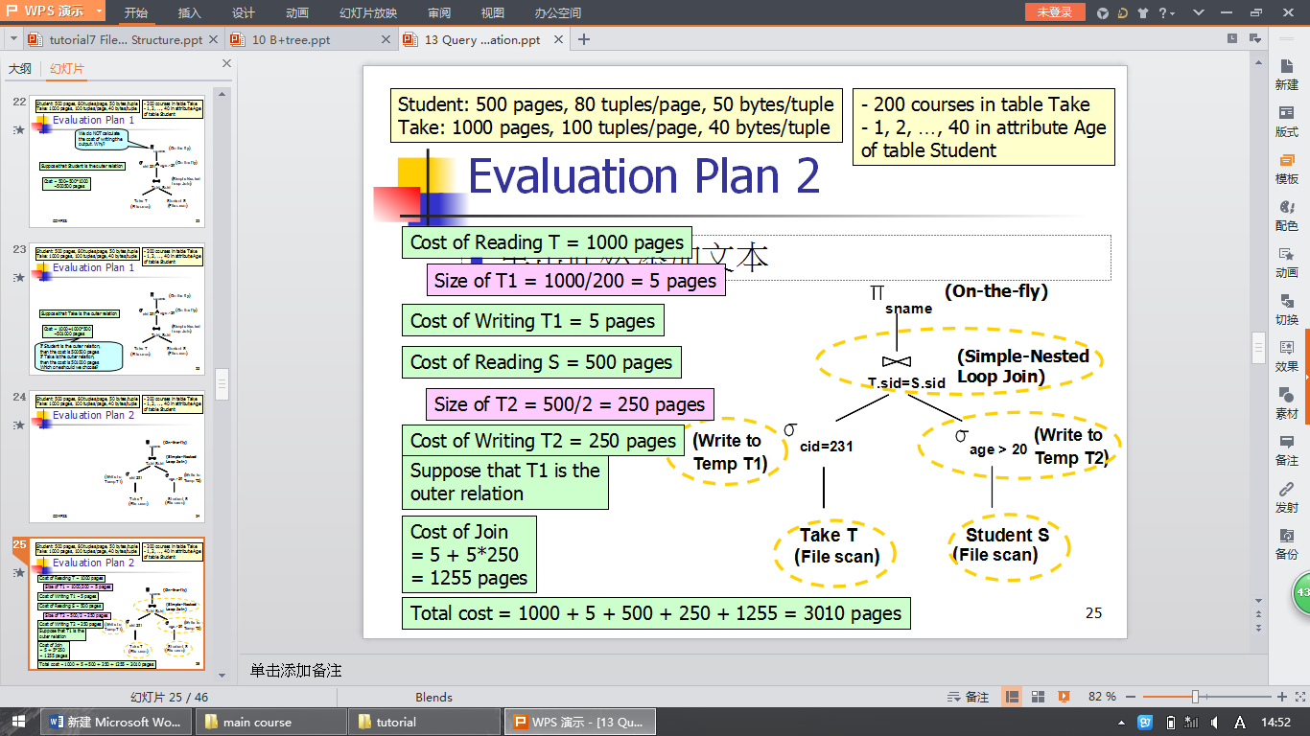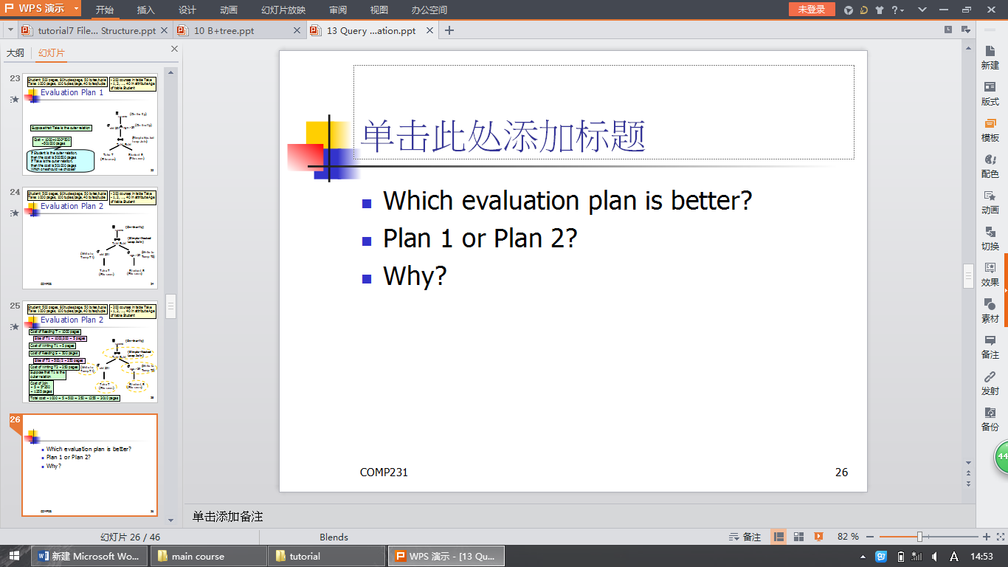
PLAN2
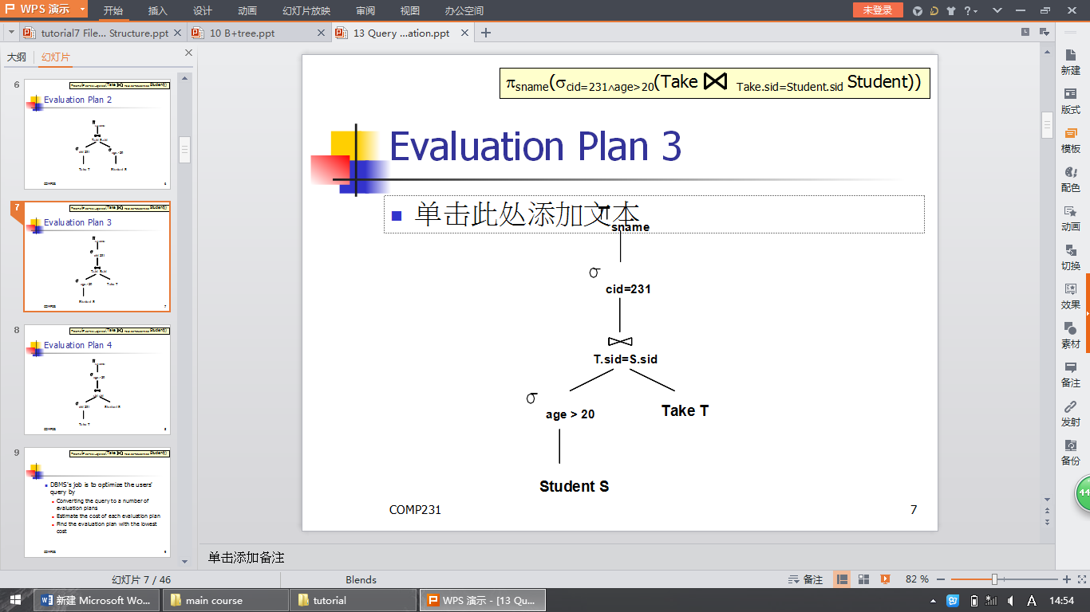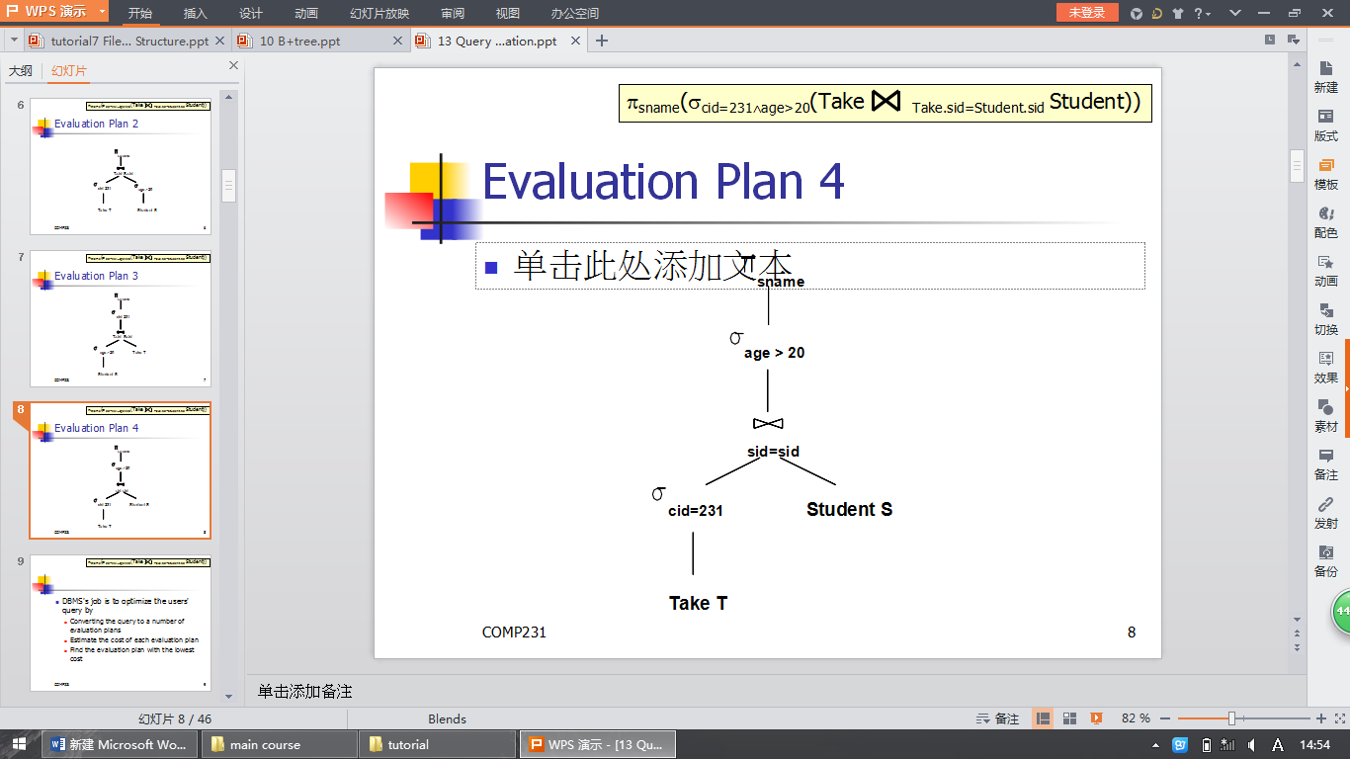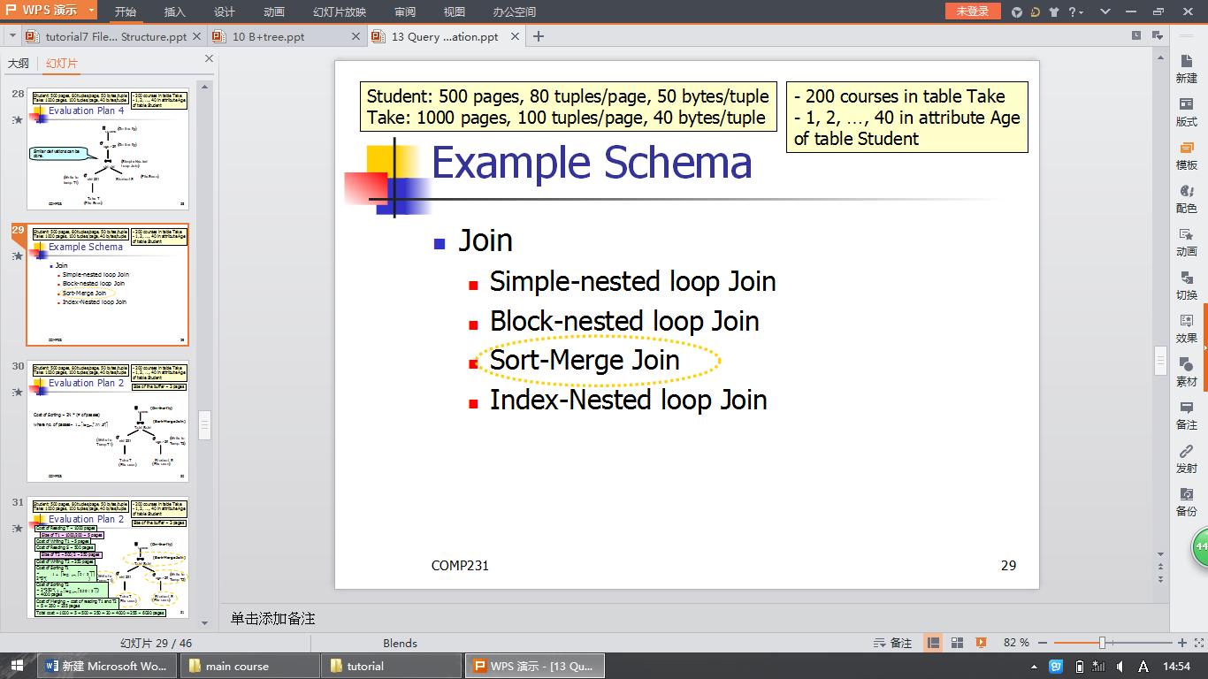
IF YOU HAVE TIME , SEE SORT-MERGE JOIN

TUTORIAL 8(ONLY NEED TO KNOW THE B+ TREE)

TUTORIAL9()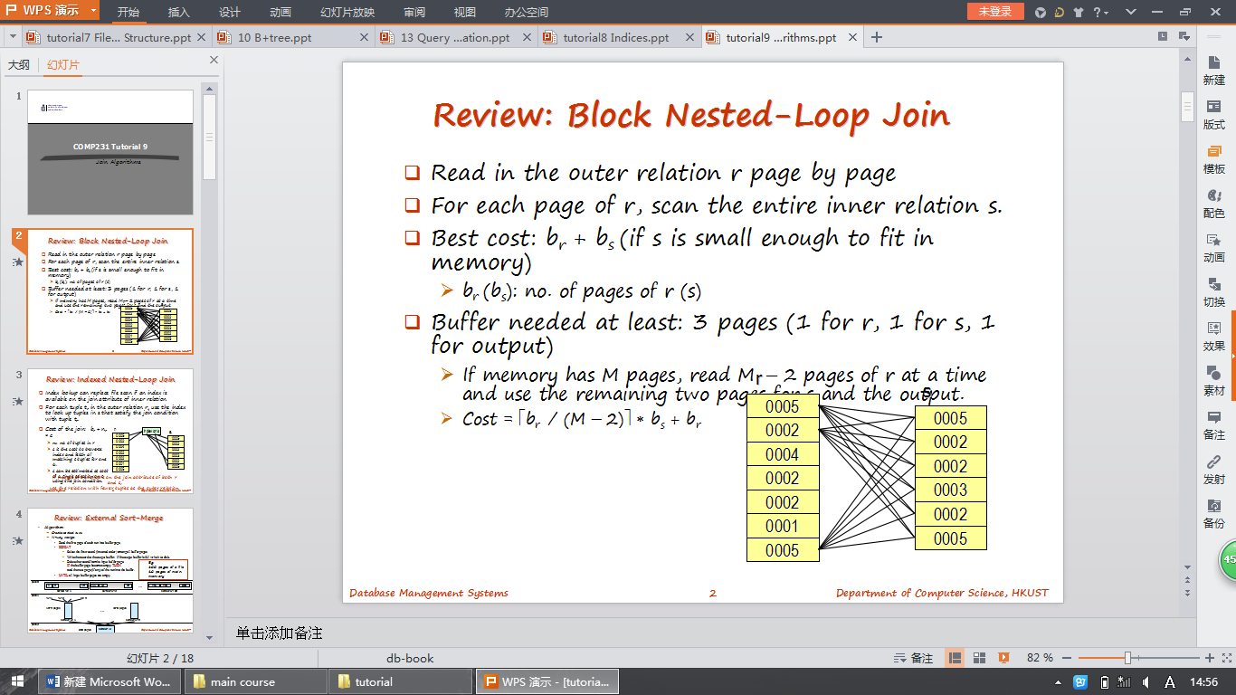
TUTORIAL 10(ONLY NEED TO KNOW CH13 PPT. THIS CAN BE IGNORED),
TUTORIAL 11 REQUIRED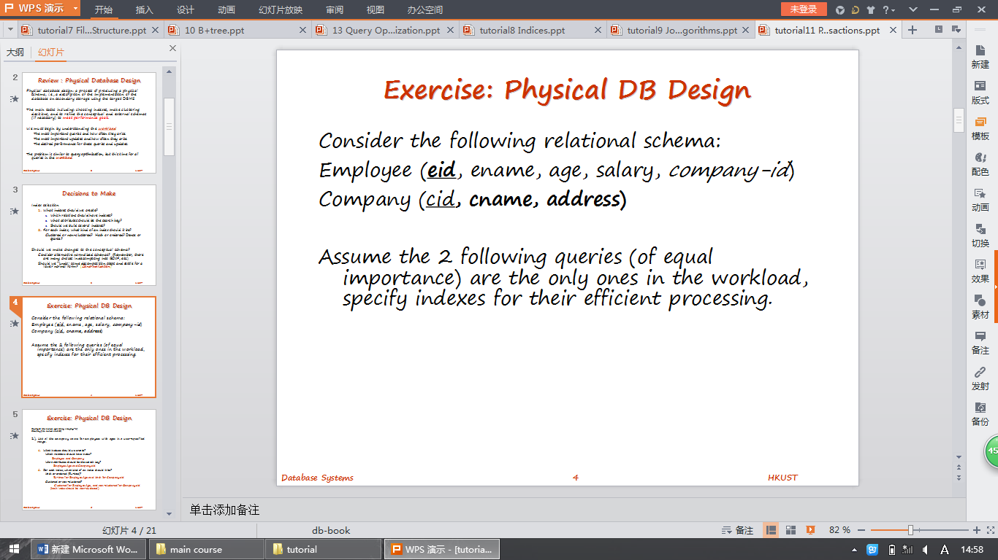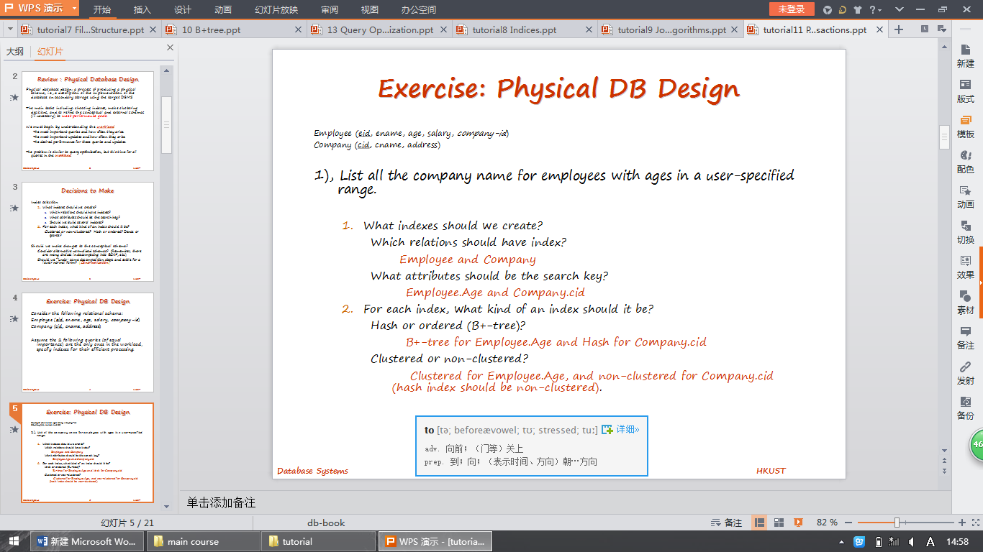
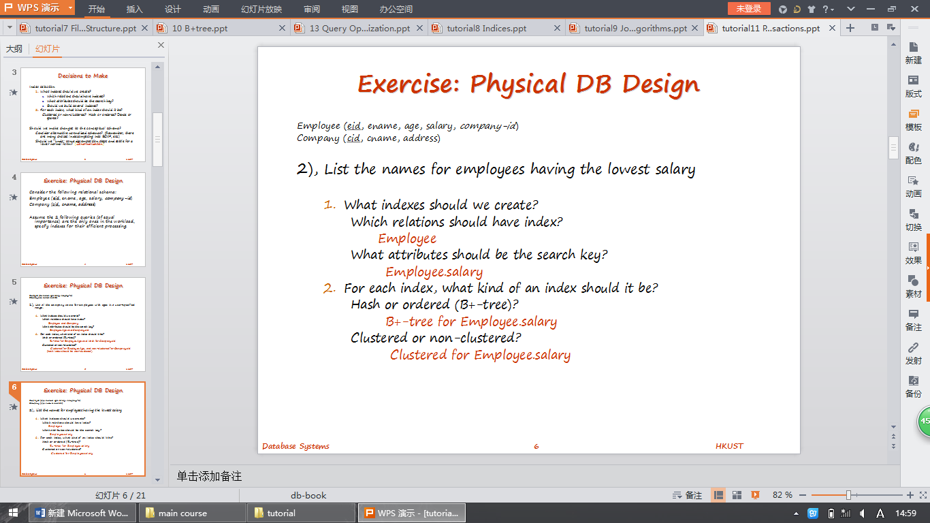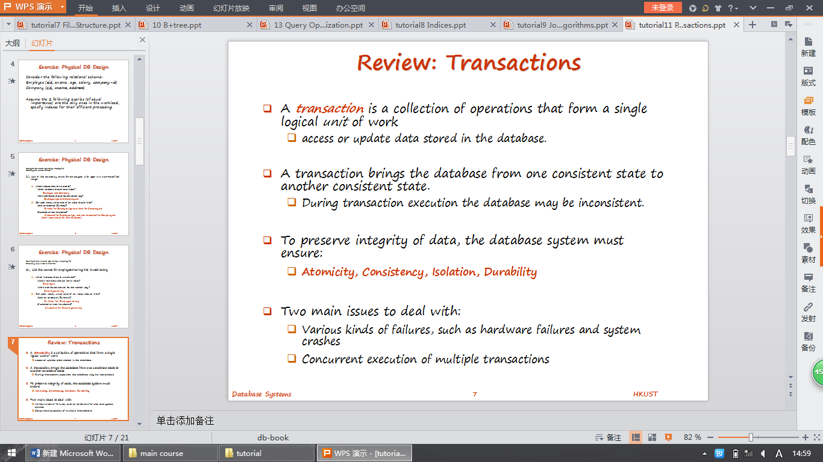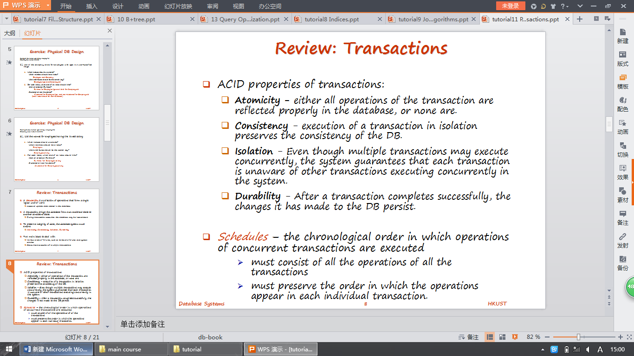

EXAMPLE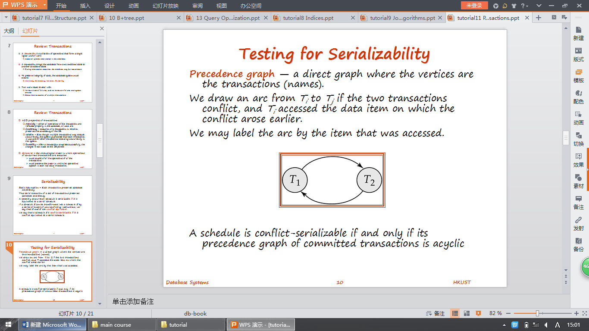

SHOULD KNOW HOW TO DRAW THIS GRAPH t1-t2-t3-t4
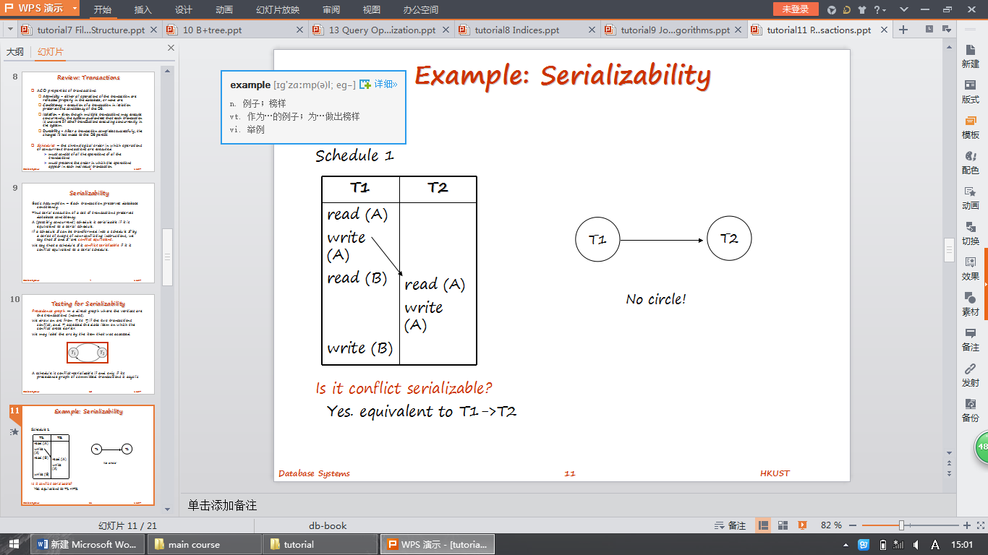
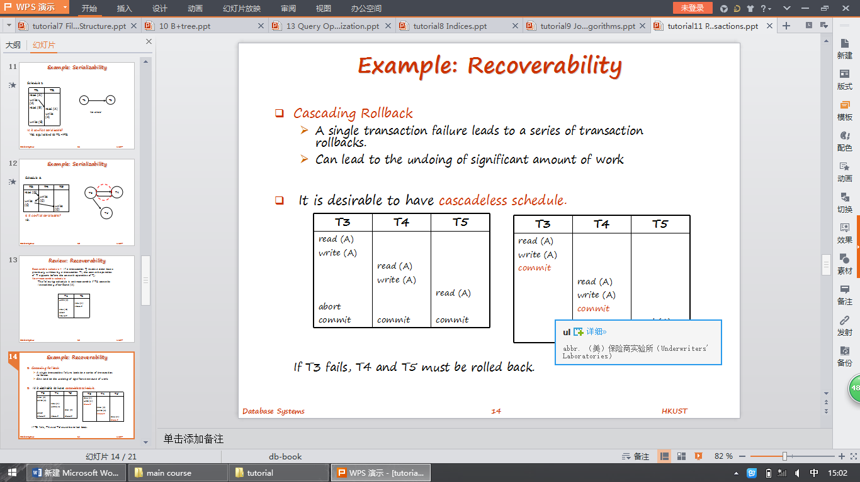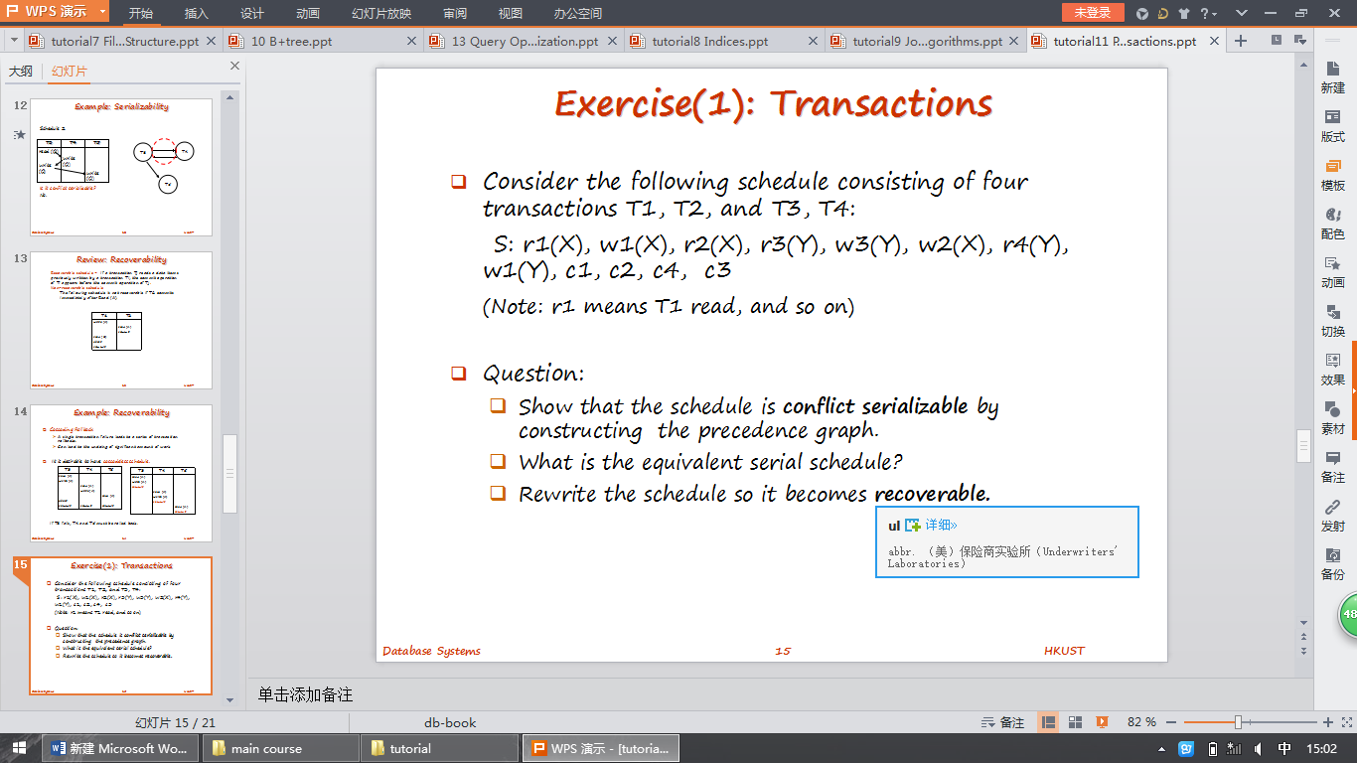

tuturial 11 show be understand 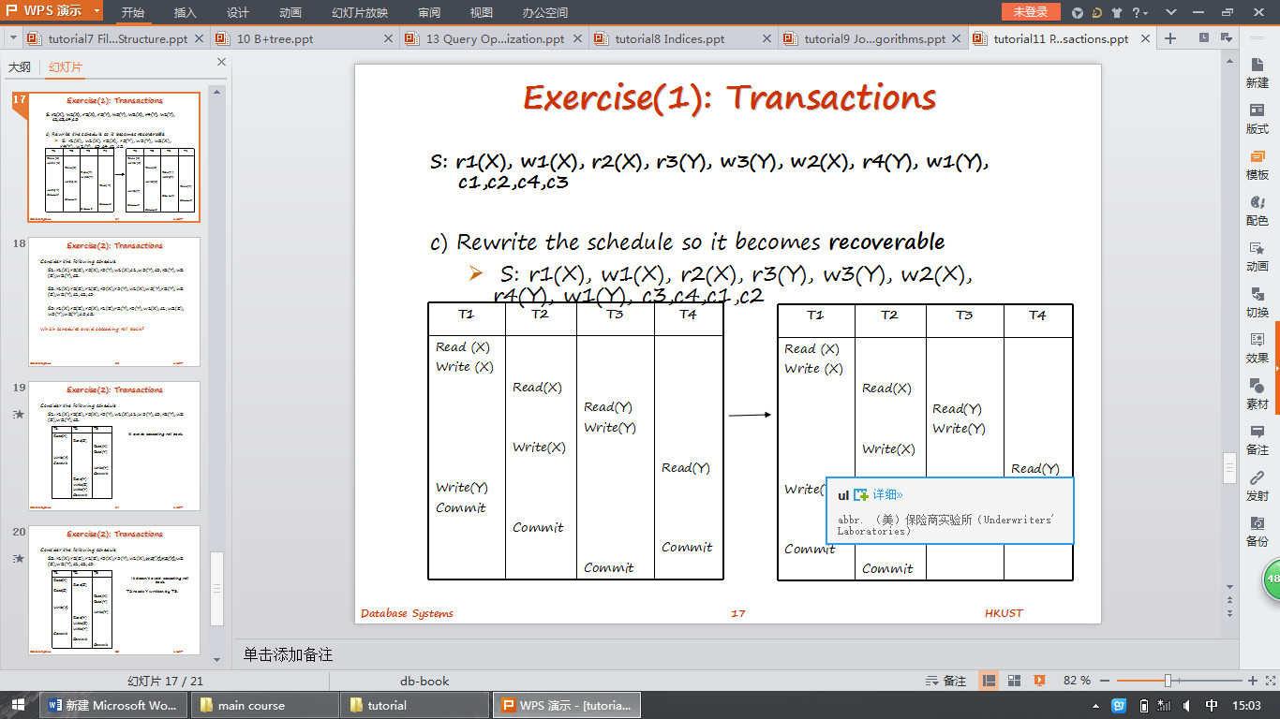

CH14~16(INGORE) (ONLY NEED TO KNOW TUTORIAL)

CH17()
CH18()
ONLY NEED TO KNOW 2 PAGES

WHAT IS DATA MINING ,OBJECTIVE
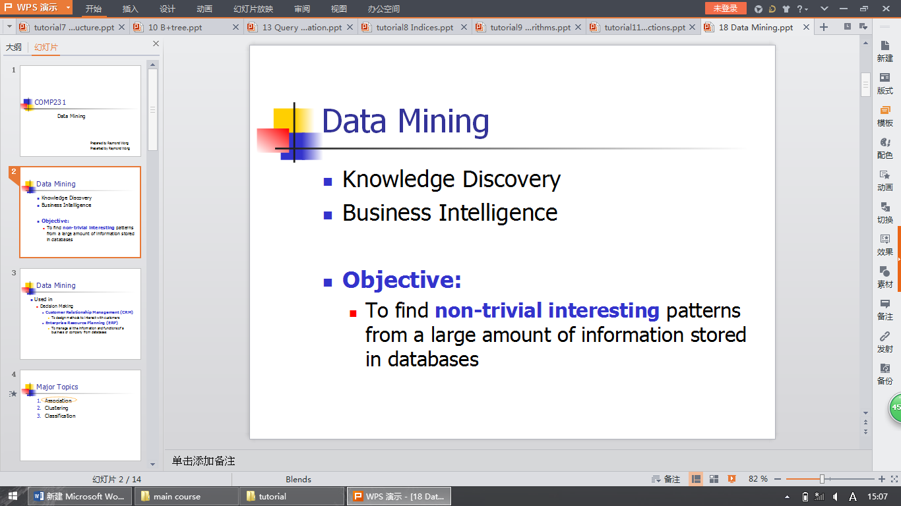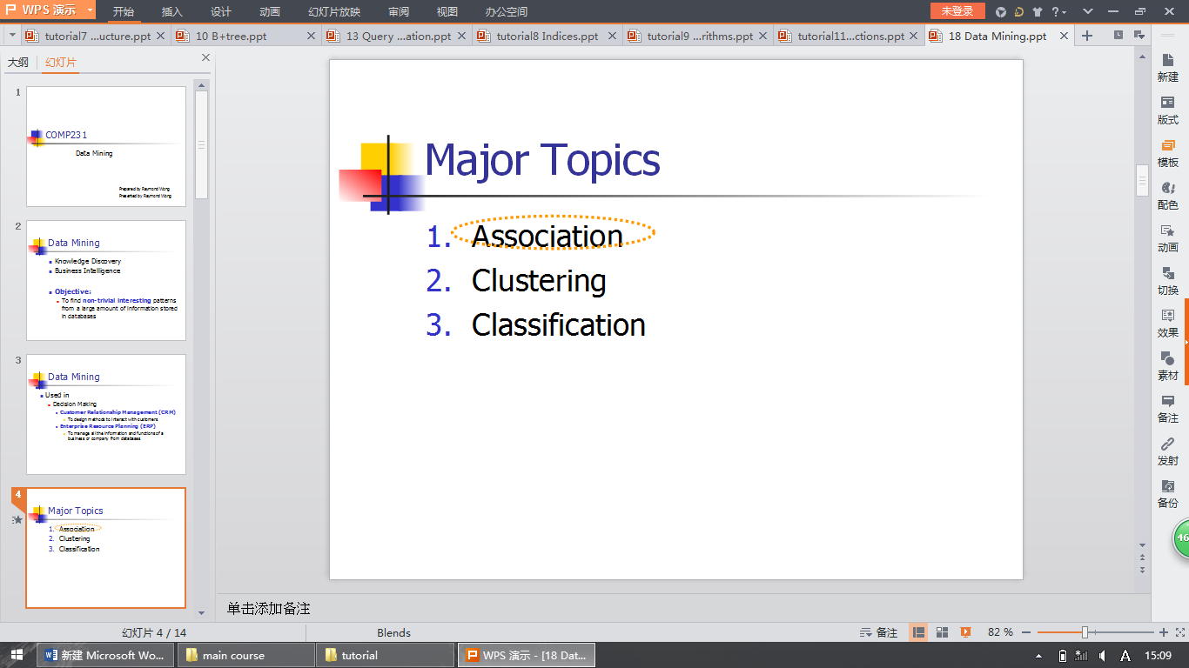

考试前几周完成实验
（某个周六下午验收 ）

