# Module 2 On Behavior

陈80 叶劲亨

课程注解第二单元40

## Lesson 1 Module Guide

1.fable (n.)

a [short](https://dictionary.cambridge.org/dictionary/english/short" \o "short) [story](https://dictionary.cambridge.org/dictionary/english/story" \o "story) that [tells](https://dictionary.cambridge.org/dictionary/english/tell" \o "tells) a [general](https://dictionary.cambridge.org/dictionary/english/general" \o "general) [truth](https://dictionary.cambridge.org/dictionary/english/truth" \o "truth) or is only [partly](https://dictionary.cambridge.org/dictionary/english/part" \o "partly) [based](https://dictionary.cambridge.org/dictionary/english/based" \o "based) on [fact](https://dictionary.cambridge.org/dictionary/english/fact" \o "fact), or [literature](https://dictionary.cambridge.org/dictionary/english/literature" \o "literature) of this [type](https://dictionary.cambridge.org/dictionary/english/type" \o "type)

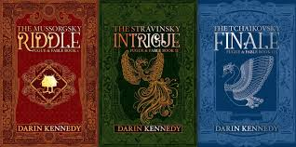

## Lesson 2 On Taking Stock

2.ceremonial (adj.)

marked by, involved in, or belonging to [ceremony](https://www.merriam-webster.com/dictionary/ceremony) **:**stressing careful attention to form and detail

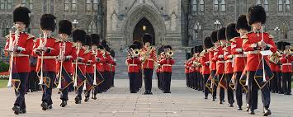

3.Duke Ling of Wei (n.)

Duke Ling of Wei (c. 534 — 492 BC) was the 28th ruler of the ancient Chinese state of [Wey](https://en.wikipedia.org/wiki/Wey_(state)" \o "Wey (state)), the son of [Duke Xiang of Wey](https://en.wikipedia.org/w/index.php?title=Duke_Xiang_of_Wey&action=edit&redlink=1" \o "Duke Xiang of Wey (page does not exist)). He was the subject of Chapter 15 of the [Analects](https://en.wikipedia.org/wiki/Analects" \o "Analects) of [Confucius](https://en.wikipedia.org/wiki/Confucius" \o "Confucius). His given name was Yuan.

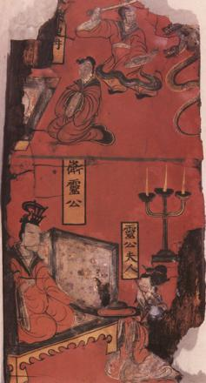

4.Encounter (v.)

a [meeting](https://dictionary.cambridge.org/dictionary/english/meeting" \o "meeting), [especially](https://dictionary.cambridge.org/dictionary/english/especially" \o "especially) one that [happens](https://dictionary.cambridge.org/dictionary/english/happen" \o "happens) by [chance](https://dictionary.cambridge.org/dictionary/english/chance" \o "chance)



5.mantis (n.)

any of an order or suborder (Mantodea and especially family Mantidae) of large usually green insects that feed on other insects and clasp their prey in forelimbs held up as if in prayer.

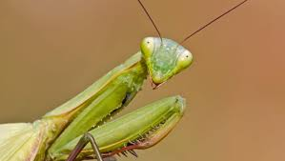

6.nobility (n.)

the quality or state of being noble in character, quality, or rank.

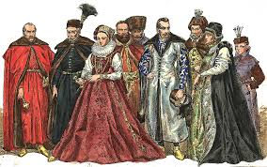

7.overestimate (v.)

to [estimate](https://www.merriam-webster.com/dictionary/estimate" \l "h1) or value (someone or something) too highly.

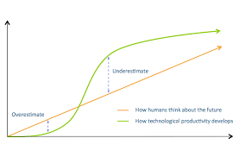

8.Qu Boyu (n.)

Qu 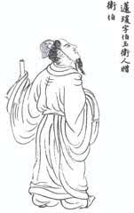Boyu (585 - 484 years ago), Ji's surname, Jia's surname, Ying's name, the word Boyu, Dr. Wei Guo at the end of the Spring and Autumn Period. He is generous, diligent in correcting, able to advance and retreat, not inconsistent with the times, strict self-discipline, lenient to others. At the age of 50, he can understand the mistakes he committed in the past 49 years. Prince Wu Jizha went to Wei for sightseeing and praised him as a "gentleman". Confucius also admired him for his ambition to be outnumbered. He had lodged in his home when he was passing the guard. In the twenty-seventh year of Kaiyuan in the Tang Dynasty, it was presented to Weber. As his deeds were praised by Confucius, nowadays most of them are worshiped in Confucian temples.

9.tattoo (n./v.)

noun

1: an indelible mark or figure fixed upon the body by insertion of pigment under the skin or by production of scars

2: the act of [tattooing](https://www.merriam-webster.com/dictionary/tattooing) : the fact of being [tattooed](https://www.merriam-webster.com/dictionary/tattooed)

verb

3: to mark the skin with (a tattoo)tattooed a flag on his chest

4: to mark or color (the skin) with [tattoos](https://www.merriam-webster.com/dictionary/tattoos)



10.Yan Hui (n.)

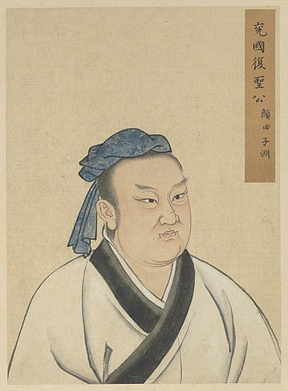Yan Hui (521 BC-481 BC), Ziyuan, also known as Yan Zi and Yan Yuan. In order to avoid Li Yuan's name and taboo, the Tang Dynasty changed its character to Ziquan. The people of the first of seventy-two disciples. Confucius is one of the ten philosophies of virtue. Being regarded as the most proud disciple of Confucius, he ranked first in the Confucius Gate. Yan Hui is 30 years younger than Confucius. Poor family, but able to live in poverty and happiness; smart, eager to learn, Wen Yizhi; superior conduct, Confucius praised his virtue, is the direct disciple of Confucius'mind law inheritance. Unfortunately, he died at the age of 40, and later generations called him "Rehabilitation".

## Lesson 3 On Courage

11.besiege (v.)

to surround with armed forces The army had besieged the castle.

12.bias (n./v.)

1.noun

an inclination of [temperament](https://www.merriam-webster.com/dictionary/temperament) or outlook.

2.Verb

to give a settled and often prejudiced outlook to.



13.born with silver spoon

born into a very wealthy family.



14.Confucius (n.)

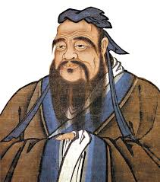Confucius (28 September 551-11 April 479), Zi surname, Confucius family name, Ming Qiu, word Zhongni, descendants honor Confucius or Confucius. Born in Piyi, Lu State, with a Song ancestor, educator and philosopher of Lu State in the late Spring and Autumn Period of the Eastern Zhou Dynasty, he served as an important official post in Lu State. Confucius was the founder of Confucianism. His theory of virtue and five elements (benevolence, righteousness, courtesy, wisdom and faith) had a far-reaching impact on neighboring areas, such as Korea Peninsula, Ryukyu, Japan, Vietnam, Southeast Asia and so on. These areas were also called Confucian cultural circles.

15.curse(n./v.)

1.noun

a prayer or invocation for harm or injury to come upon one.

2.verb

to use profanely insolent language against.

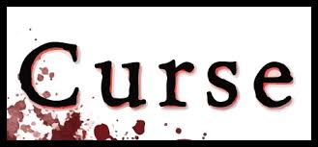

16.disciple (n.)

one who accepts and assists in spreading the [doctrines](https://www.merriam-webster.com/dictionary/doctrine) of another.

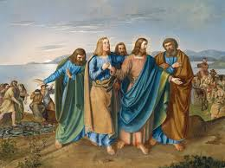

17.Jie (n.)

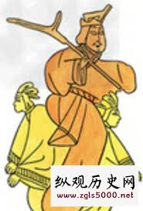

Jie [1] (about 1564 - about 1600 years ago), Yong's surname, name and performance, the seventeenth monarch of the Xia Dynasty in China, is also the last monarch. Son of hair.

Traditional history books describe Jie as a tyrant: he is indifferent to politics, addicted to women, and also practices tyranny.

18.sage (n.)

1.wise through reflection and experience.

2.one (such as a profound philosopher) distinguished for wisdom.

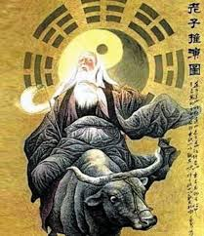

19.State of Wei (n.)

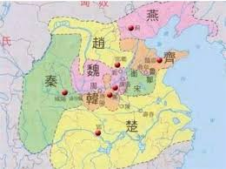The State of Wei, which was divided by Zhou Chengwang in the early Western Zhou Dynasty, was a country of counts and princes with the surname of Ji. It was enclosed in the north of Ruicheng County, Shanxi Province, and the emperor of the State was Wei with the surname of Ji. In 661 B.C. (16th year of Jin Xiangong), the State of Wei was conquered by Jin Xiangong and bestowed on Bi Wan, the descendant of Bi Guo (the ancestor of the King of Wei in the Warring States Period, the fifteenth son of King Wen of Zhou, Bi Gonggao).

20.State of Yue (n.)

State of Yue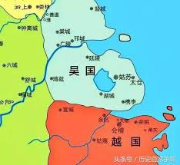, also known as Mao, was a kingdom of princes that rose in the Spring and Autumn Period and Warring States Period in Chinese history. Legend has it that the Shao Kang Shuzi after Xia Dynasty was no better than the Huiji area. From the late Spring and Autumn Period when Goujian annexed Wu State to the early Warring States Period, Vietnam was always the hegemony of the Spring and Autumn Period and Warring States.

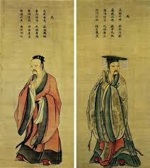21.Yao and Shun (n.)

Yao and Shun are the joint names of Tang Yao and Yu Shun, the leaders of the tribal alliance of the Central Plains in ancient China.

Its development of the Yellow River Basin was the first time in Chinese history to govern the world. Later generations called Tangyu Zhizhi or Tangyu era.

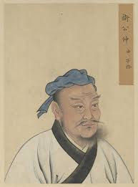22.Zi Lu (n.)

Zhongyou (542-480 years ago), Zilu, or Jilu, is a famous disciple of Confucius, one of the ten philosophies of Confucius, and also the protagonist in "Twenty-four Filial Piety". Young Confucius was nine years old. He was also the oldest disciple to serve Confucius. The guard Zhuanggong and his son Zhuangwei went out of the public contest and hijacked Kong Qi. Zilu was his family minister at that time. In order to save Kong Qi, he fought with the guard Zhuanggong's family ministers and died in battle. The corpse was sacrificed.

23.Zi Yu (n.)

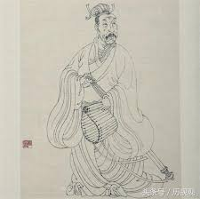Dantai Mingming (512 years ago)? According to the Confucius Family Talk, born in the first 502 years, Fuxing Dantai, Mingming, Ziyu, Wucheng of the State of Lu (Pingyi County, Shandong Province, today), Wucheng County, and Datan Village, Old Town County (Old Dantaizi Temple) are also people. He was a disciple of Confucius, one of the seventy-two sages.

24.zither (n.)

a stringed instrument having usually 30 to 40 strings over a shallow horizontal soundboard and played with pick and fingers.

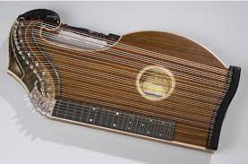

## Lesson 4 On Contentment

25.abdicate (v.)

to renounce a throne, high office, dignity, or function.

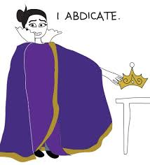

26.bellyful (adj.)

an excessive amount.

27.dispensation (n.)

a general state or ordering of things.

an exemption from a law or from an impediment, vow, or oath.



28.emperor (n.)

the sovereign or supreme male monarch of an empire.

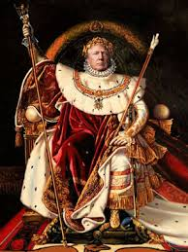

29.eternal (adj.)

lasting forever **:**having no beginning and no end.



30.exile (n./v.)

1.none

the state or a period of forced absence from one's country or home.

2.verb

to banish or expel from one's own country or home.

31.flee (v.)

to run away often from danger or evil.



32.interpretation (n.)

the act or the result of [interpreting](https://www.merriam-webster.com/dictionary/interpreting).



33.King Zhao of Chu (n.)

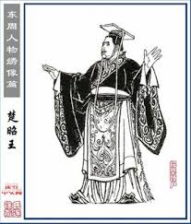King Zhao of Chu (523 years ago - 489 years ago), unearthed documents of the State of Chu also write Mao Wang [1], Yi surname, Xiong's family name, Mingzhen, a book, the son of King Ping of Chu and Princess Meng Fu of Qin.

King Chuping built his wife for his son Prince in the Qin Dynasty, but Mengfu was very beautiful, so King Chuping was provoked by Fei Wuji. He accepted himself as a concubine and gave birth to his son, that is, King Chuzhao. In the first 516 years, King Chuping died, and the prince, who was under 10 years old, succeeded him and renamed Xiong Du (Zhenzhen) as King Zhao.

34.legendary (n.)

of, relating to, or characteristic of [legend](https://www.merriam-webster.com/dictionary/legend) or a legend.

35.mu (n.)

Mu surname is one of the Chinese surnames, ranking 98th in Baijia surname.

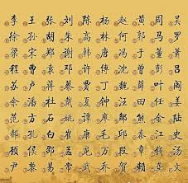

36.philosophical (adj.)

of or relating to [philosophers](https://www.merriam-webster.com/dictionary/philosophers) or [philosophy](https://www.merriam-webster.com/dictionary/philosophy).

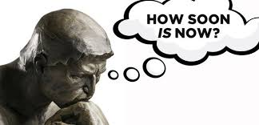

37.practitioner (n.)

one who practices a profession.



38.priest (n.)

one authorized to perform the sacred rites of a religion especially as a mediatory agent between humans and God.



39.righteous (adj.)

acting in accord with [divine](https://www.merriam-webster.com/dictionary/divine" \l "h1) or [moral](https://www.merriam-webster.com/dictionary/moral" \l "h1) law **:**free from guilt or sin.

40.sacrificial (adj.)

of, relating to, of the nature of, or involving [sacrifice](https://www.merriam-webster.com/dictionary/sacrifice).



41.throne (n.)

the chair of state of a sovereign or high dignitary (such as a bishop).

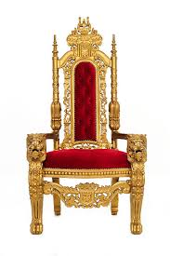

42.torch (n.)

a burning stick of resinous wood or twist of tow used to give light and usually carried in the hand.



## Lesson 5 On Modesty

43.borderline (n.)

being in an intermediate position or state : not fully classifiable as one thing or its opposite.



44.decay (n./v.)

1.noun

gradual decline in strength, soundness, or prosperity or in degree of excellence or perfection.

2.verb

to decline from a sound or prosperous condition.

45.deem (v.)

to come to think or judge.

46.Fables of Aesop (n.)

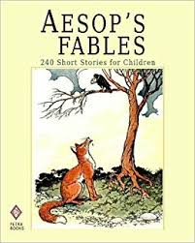Aesop's Fables is a series of fables originating from ancient Greece. It is said that Aesop created them and later generations assembled them into books. Others believe that there is no Aesop, but the ancients used their names to assemble some folk stories into books. "Aesop's Fables" is very popular and has a great influence on the fable literature in Europe. Lafondane's famous "Fables" is based on "Aesop's Fables".

47.gnat (n.)

any of various small usually biting dipteran flies.

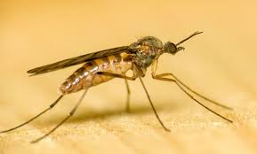

48.Grand Duke Ren (n.)

People in the Spring and Autumn Period. Confucius was trapped between Chen and cai and did not eat on fire for seven days. Tai Gong Ren went to console Confucius, who praised Confucius for his kindness.

49.paw (n.)

the foot of a quadruped (such as a lion or dog) that has claws.



50.swagger (v.)

to conduct oneself in an arrogant or superciliously [pompous](https://www.merriam-webster.com/dictionary/pompous) manner.

51.wane (n./v.)

1.verb

to decrease in size, extent, or degree.

2.noun

the act or process of waning.

52.majesty (n.)

sovereign power, authority, or dignity.

