诚信应考,考试作弊将带来严重后果！
_____________ ________
…

姓名 学号
学院 专业 座位号
( 密 封 线 内 不 答 题 )
……………………………………………………密………………………………………………封………………………………………线……………………………………线………………………………………

华南理工大学期末考试
《电路与电子技术》（双语）试卷 考试时间：240 minutes
注意事项：1. 考前请将密封线内填写清楚；
2. 所有答案请直接答在答题纸上；
3．考试形式：开卷；
4. 本试卷共 20题，满分200分， 考试时间240分钟。
题 号 | 1 | 2 | 3 | 4 | 5 | 6 | 7 | 8 |  |  |  | 总分
得 分
评卷人

1. Summarizes the fundamental laws of the circuit, voltage reference polarity and current reference direction Summarizes the analysis methods of the circuit. the relationship between voltage and current about Inductance and capacitance, the inductance capacitance equivalent calculation.
2. Summarize the formation process and the characteristics of the PN junction, of the structures and principles of the diode and BJT, the structures and principles of the NMOSFET and PMOSFET, the characteristics and linear analysis basis of the ideal operational amplifier, voltage comparator.
总结PN结的形成过程和特点，二极管和晶体管的结构和原理， NMOSFET和PMOSFET的结构和原理，以及理想运算放大器的线性分析的基础特性，电压比较器。
3.Use Ohm’s and Kirchhoff’s laws on the circuit of Fig.1 to find (a) v _{x}; (b) i_{in}; (c) I_{s}; (d) the power provided by the dependent source.
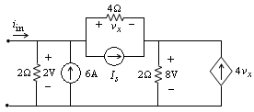
Figure 1
4. Find the Thévenin equivalent of the two-terminal network shown in Fig.2
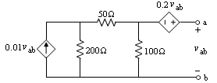
Figure 2
5，Use nodal analysis to find v4 in the circuit shown in Fig. 3

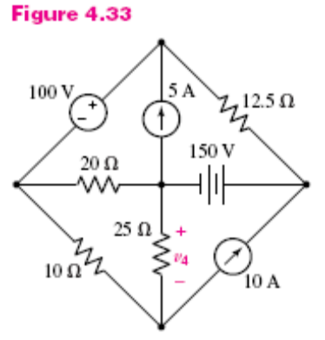
Figure 3
6. Replace the right-most 7-V source of Fig. 4 with a 3-A source, and assume value of 0.3 Ώ for the resistor marked X. Compute the three mesh currents for the new circuit.
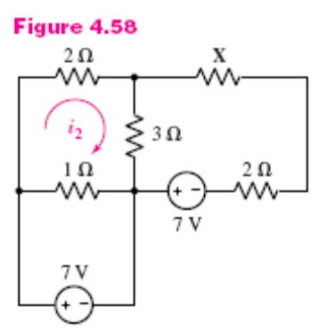
Figure 4
7. With sources iA and vB on in the circuit of Fig.5 and v_{C} = 0, i_{x} = 20 A; with i_{A} and v_{C} on and vB = 0, ix = −5 A; and finally, with all three sources on, ix = 12 A. Find ix if the only source operating is (a) iA; (b) vB; (c) vC. (d) Find ix if iA and vC are doubled in amplitude and vB is reversed.
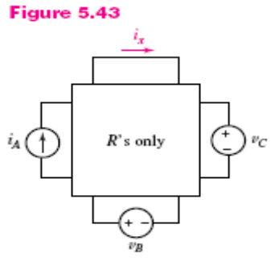
Figure 5

8. Determine I1 using source transformation to first simplify the circuit of Fig.6
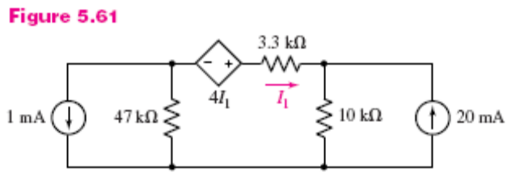
Figure 6
9. Reduce the network of Fig. 7 to a single equivalent inductance as seen looking into terminals a and b.
Figure 7
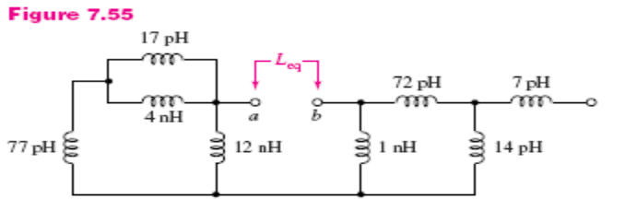
10. The network of Fig. 8 stores 534.8 μJ of energy when a voltage of 2.5 V is connected to terminals a and b, what is the value of Cx?
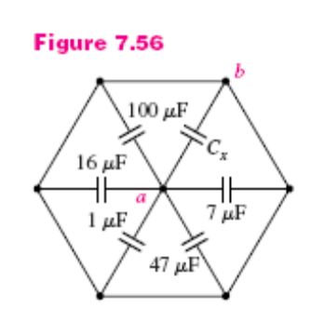
Figure 8
11. (a) Find the power factor at which the source in the circuit of Fig.9 is operating. (b) Find the average power being supplied by the source.
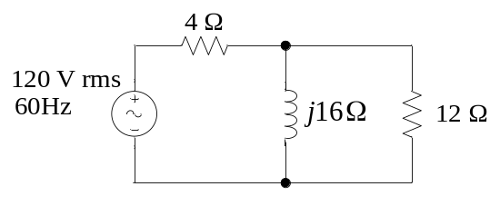
Figure 9
12. Find the time-domain node voltages v₁(t) and v₂(t) in the circuit shown in Fig.10
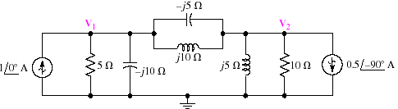

Figure 10

13. Consider the common-source amplifier illustrated in Figure 11，(1) plot small signal equivalent circuit; (2) Compute the voltage gain, input resistance, and output resistance..
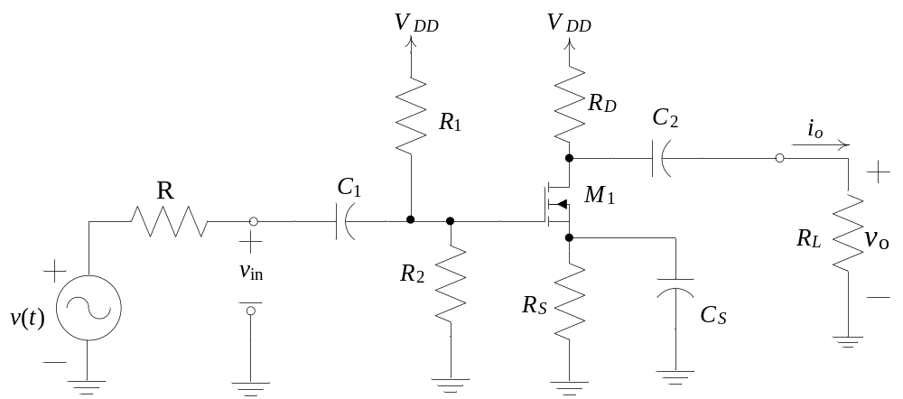
Figure 11
14. Calculation of Common-Emitter Amplifier Performance
(a) Find the values of I_{C} and V_{CE} in the circuit of Figure 12 for β=100 and β=300. V_{BE} =0.7V.
(b) Find A_{v}, A_{vo}, Z_{in}, A_{i}, G, and Z_{O} .
(c) Then, if v_{S} (t) =0.001sin (ωt)V, find an expression for v_{O} (t).
(d) Finally, repeat part (a) if the emitter resistor R_{E} is split into R_{E1}=100Ω and R_{E2}=900Ω, with the bypass capacitor in parallel with R_{E2}.
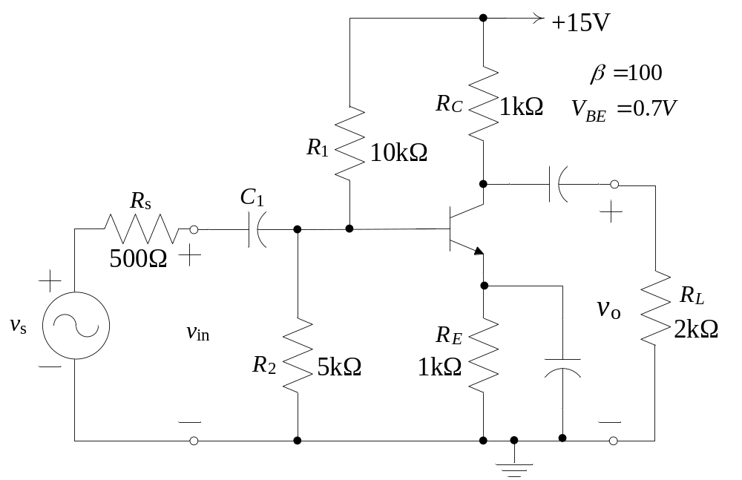
Figure 12 Common-emitter amplifier

15 Analyze the emitter follower
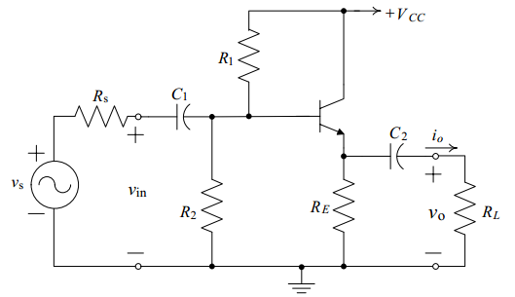

16 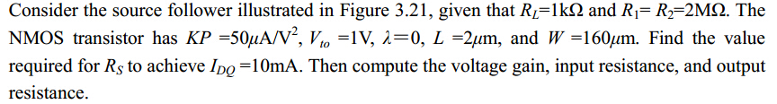
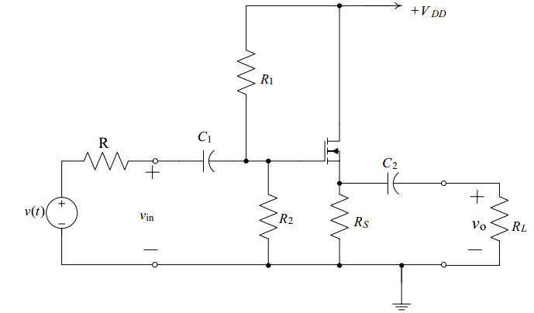

17Analyze the circuit
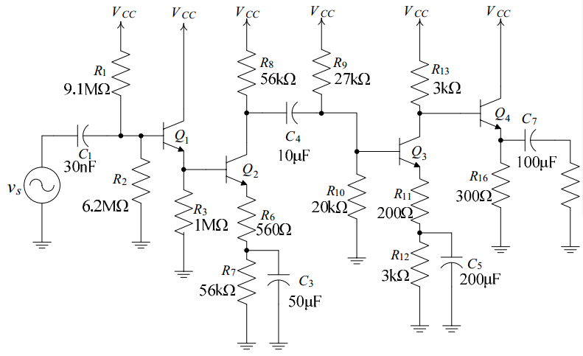

- Find an expression for the output voltage of the circuit shown in Figure 18.
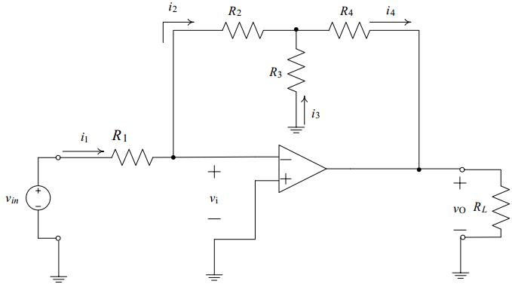

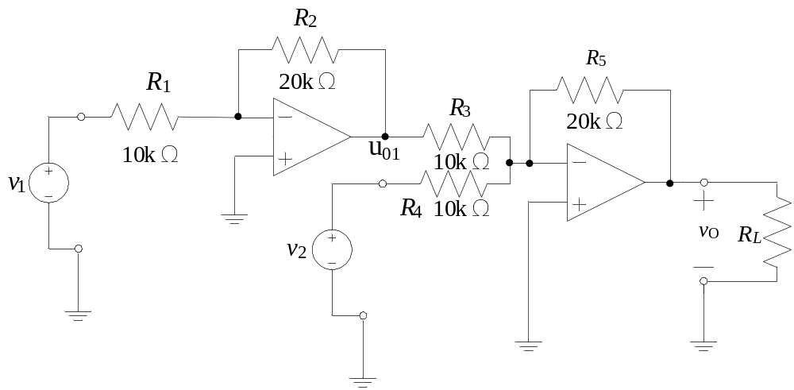
Figure 18.

19. 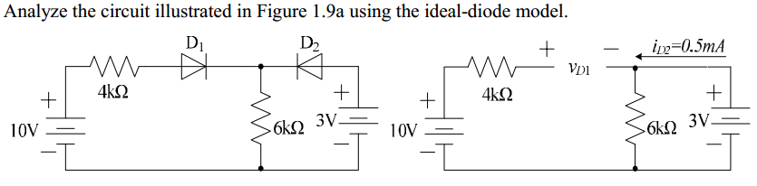
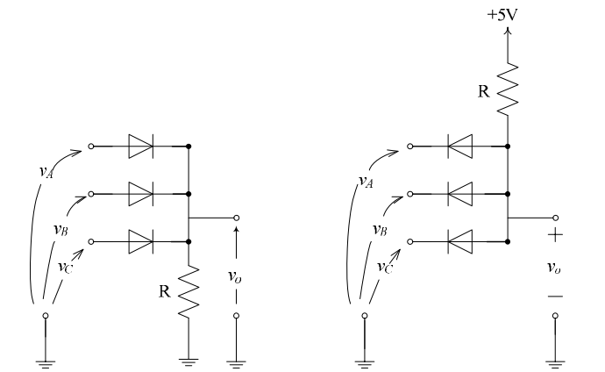
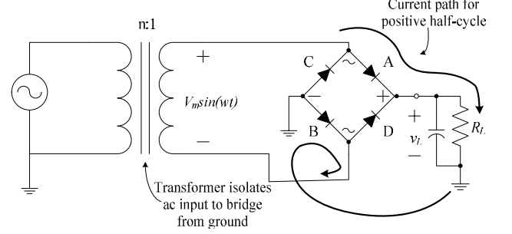

20. Analyze the circuit

