1 Introduction

The project was done with IBM UK. We developed an AI racing agent running on the TORCS open-source simulator and we utilized the IBM Granite large language model to determine high-level strategy selection. Direct car control was not performed by Granite. It would indicate whether the car should attack, defend, or go into the pit and low-level controllers would take care of the driving. Before Granite responded, the race state might have changed. The model could also fail to provide a valid or appropriate strategy so the safety measure had to be implemented independently.

Our preliminary research indicated that the response time of Granite was inappropriate to directly steer vehicles. We have developed a multi-layer structure to isolate the choice of strategy and control of driving. Low-level controllers were responsible by moving the car in real time. Granite got the overview of the race and chose the high-level strategy. Prior to the strategy getting to the controllers, a safety layer based on rules determined if the strategy was appropriate to the current situation.

In the development process, we initially integrated telemetry processing to be able to use raw TORCS data with the rest of the modules. Integration with granite and the safety regulations were introduced afterwards. Manual tests in TORCS were employed to identify issues in the overall system. The latest version will occasionally send a report of the recent telemetry information to Granite, and this will select a strategy based on the existing race conditions.

2 Project Management from Personal Perspective

2.1 Project Structure and Task Allocation

As soon as the project began, we separated the work into seven modules including SCR state parsing, control-command serialization, the SCR client handshake, low-level controllers, the safety layer, Granite policy invocation and main-loop integration. It provided us with a preliminary development sequence. My teammates got the modules of low-level control and communication based on our first estimation of the workload. I should have been more focused on Granite integration, testing and subsequently on bettering the strategy.

The initial plan of task allocation was altered when development began. Certain modules involved much more work than we had initially thought, and the completion of one module sometimes depended on modifications made to another. I consequently assisted in the partial safety control and integration of strategy. I also participated in the testing of the AI Bot in TORCS.

2.2 Task Planning and Prioritisation

It was not possible to have everything starting immediately. The low level controller and the Granite strategy module only came into play when the prerequisite environment (TORCS, Granite) and programs (state parser of the SCR) were present. We then focused on state parser and command serialization to ensure that future development would not be hindered. We also developed pure-logic modules and did not require either the TORCS simulator or LM Studio. It meant that every team member could move forward without having to wait to hear from another team mate or the environment.

Early implementation of getting the state parser and command serialization allowed subsequent modules to obtain their input and output interfaces. And because this section was completely logical, we were able to check its correctness shortly by building strings in the form of SCR protocols, where there was no necessity to have a running simulator.

Based on the current SCR client, I have corrected a bug where abnormal status packets were being confused with the end of the race and I have participated in checking the stability of connections in an actual TORCS environment. Following this, I changed my interest to the driving behavior of the AI Bot, safety control, integration of the Granite policy and testing and evaluation.
The modules were under development, and as of that time, I considered the aspect of reliability, particularly in relation to the safety layer and the Granite strategy. Prior to coding, I divided the integration of the safety layer with the Granite strategy into these subtasks that could have been tested separately.
- Adopt and examine local safety regulations. In case of the fuel level being less than 10 L and the car is under the pit region, the system will force a move to PIT; upon the damage value being 9500 or more, the safety layer will implement DEFEND.
It will be necessary to implement the policy confirmation mechanism. In our initial design, we needed to have Granite repeat the same suggestion two times consecutively before switching strategies. This was found to make the car respond slow during vehicle tests and peer feedback, thus, we lowered the confirmation number to one but maintained the regulation that local safety regulations take precedence over the model when in a high-risk state. It came up during our weekly review, which should be the type of early correction the Scrum framework is intended to identify.

2.3 Team Communication and Coordination
The AI Bot branch was only developed by my colleague and me. Since it was a summer job, we didn’t have synchronized schedules. Our different schedules were divided into four phases per week. On Monday, after the group meeting, we would have a brief planning discussion, which is comparable to Sprint Planning, and would decide on the tasks to be completed during the week. On Wednesday we conducted a mid-sprint check-in at a sufficiently early time when the problem could still be addressed. In between, we both worked within our own time slots and no real-time cooperation was necessary. On Sunday we conducted a review and retrospective, to see if the work done during the week was in line with expectations and whether there were some challenges regarding the cooperation and schedule. The outcome was used to prepare the next week.
It was necessary to organize cooperation with the rest of the group as well, although not by means of scheduled meetings, but primarily during particular issues related to development. When the Bot required a new SCR status field, or when I had to verify the meaning of some particular field, I would first note down my assumptions about the matter, the inputs I require, and the observations I have made regarding tests, and then consult the persons in charge of that module. In order to eliminate repetitive communication, we attempted to offer a reproducible example to any given problem. After identifying the cause of a problem, we determined who should implement a change. We subsequently came up with ways to test the change and ensure that it did not interfere with other modules.

3 Undertaken Tasks

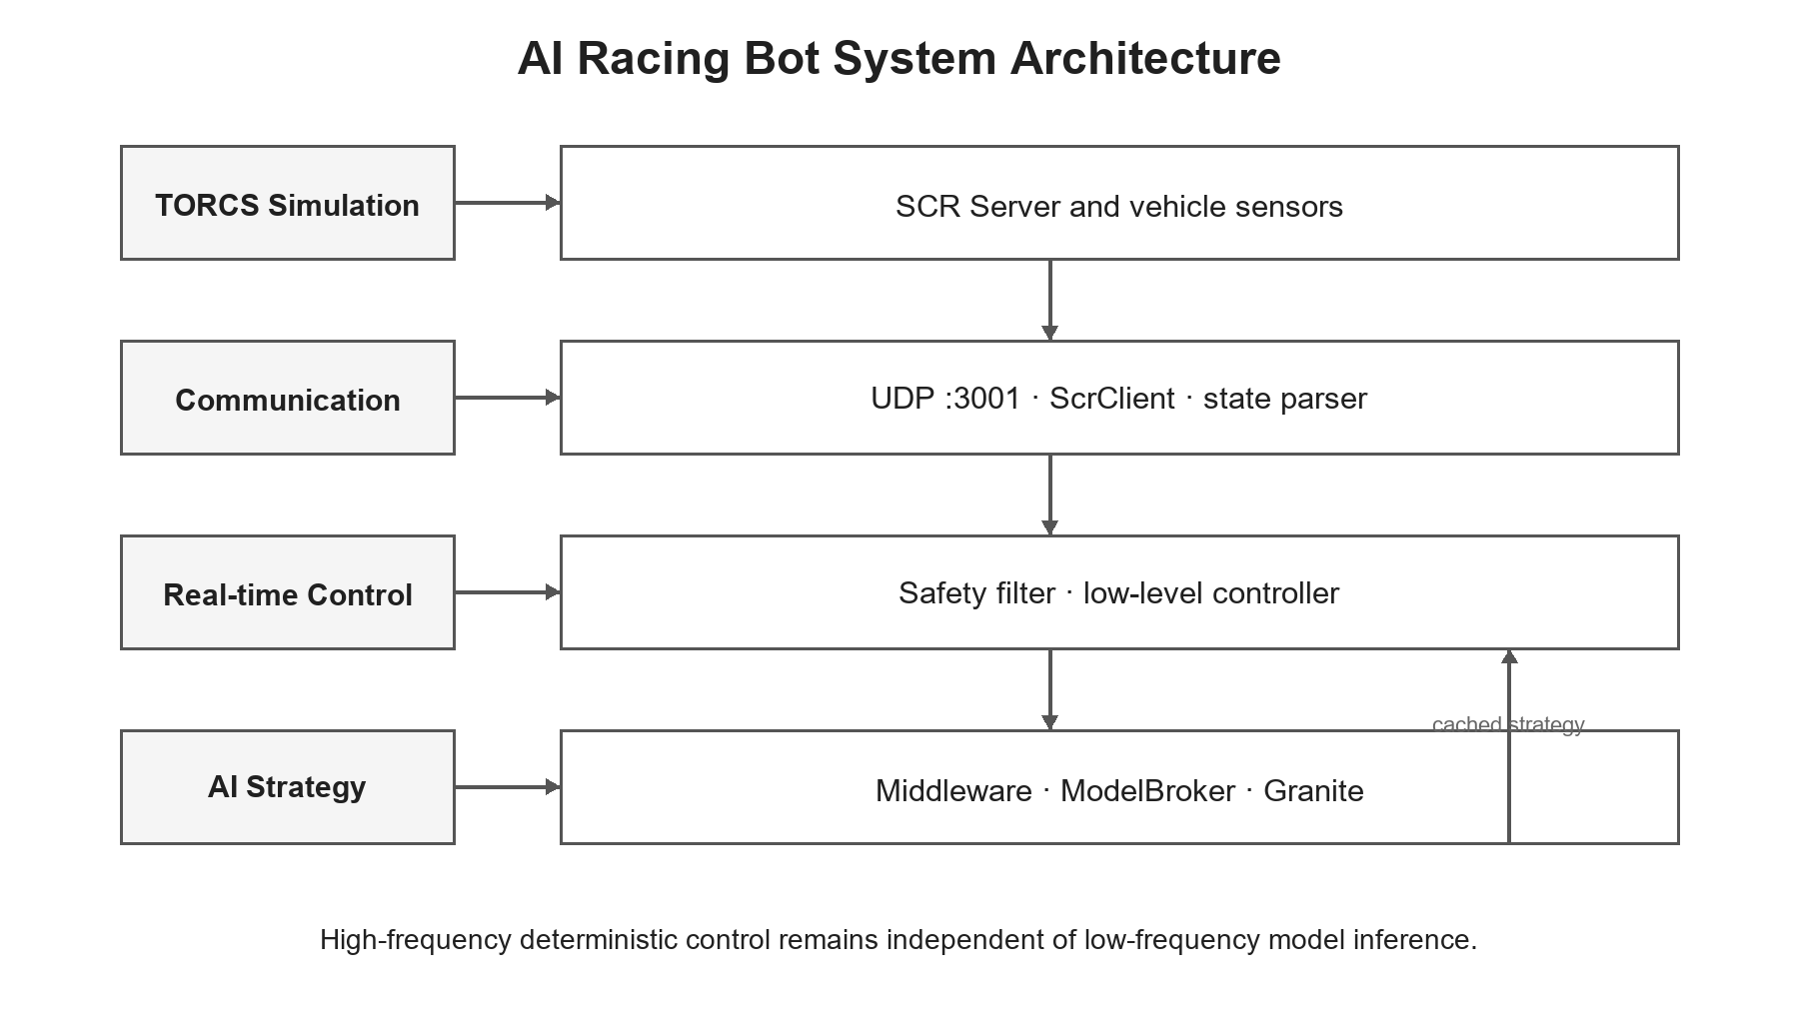

Figure 3.1: AI Racing Bot System Architecture

3.1 SCR State Parser
TORCS broadcasts text status data at about 50Hz using UDP, which includes speed, engine RPM, gear position, fuel level, damage, pose, track-edge sensor readings, opponent sensor data, and pit-lane information. This raw stream is not field ordered or field consistent, and may even miss some fields, so it cannot be utilized in its raw form as a consistent controller input as well as safety layer or policy layer. Then my first task was the state parser, which would convert this raw text into structured data that could be used by the rest of the system.
parse_scr_state() initially extracts tag-value pairs of the message and subsequently maps the TORCS fields to standardized names by using a lookup table. We began with a data class, but later on, we decided to use regular dictionaries, and they were easier; the callers simply read values with .get () and supply any value that was missing with a default. In case the protocol is added or altered, we would require merely updating the mapping table. When there are multi-value fields like opponents, track and wheelSpinVel, the parser divides the information and fills up the rest of the information to a fixed length. When a message lacks a very important element like speedX, fuel, gear or track, the parser returns None instead of forwarding an incomplete state on downwards.
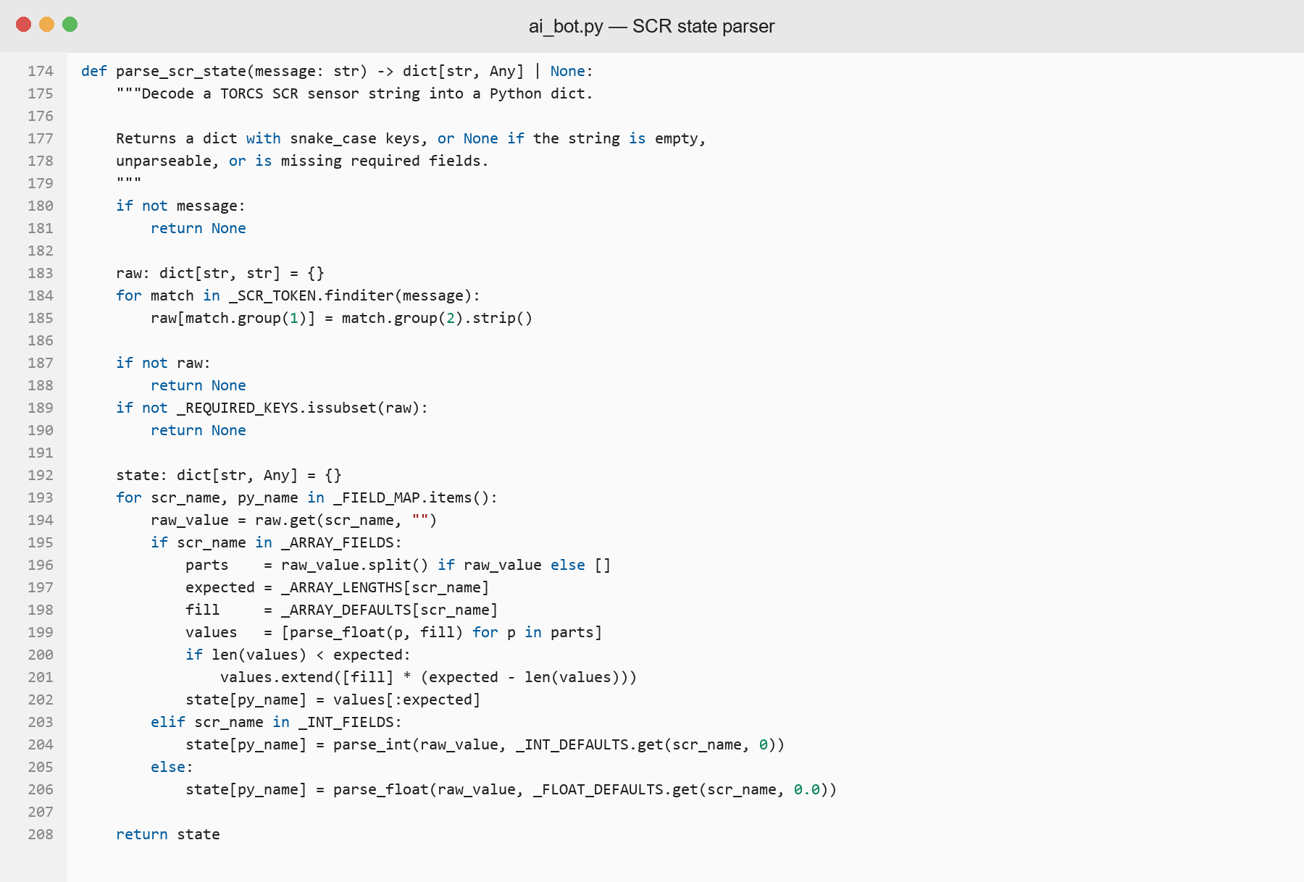

Figure 3.2: Implementation of the SCR State Parser
Since this component is a pure function and does not have any I/O, it can be tested by not running TORCS. We developed 13 test cases that included normal parsing, missing required fields, multi-value padding and several other situations. A drawback of our current approach is the lack of detection of abnormal value ranges, and adding tests that will check obviously distorted telemetry values is of course the next step forward.

3.2 SCR Client Handshake
SCRC protocol is based on UDP, and it does not provide establishing a permanent connection (Postel, 1980). The client must send an initialisation packet to the server, consisting of 19 track sensor angles and after the server has acknowledged this, the client may start to receive telemetry data. I have organized two mechanisms around this. In case of failure, the client waits five seconds and tries again automatically, five times. And another guard ensures that two Bot instances do not take control of the same car slot to avoid interference between two groups of control commands.
We tested three types of issues in the network tests: successfully completed handshakes, unresponsive server and port conflicts, and whether or not the error messages were understandable. Also, I corrected the bug which considered abnormal status packets as end of the race. The start-up phase became reliable, but while racing, there is no individual reconnection process. In case the connection fails, the main loop should be able to catch the exception and initiate a full reinitialization. This was what I thought of as one of the most critical limitations of the connection layer.

3.3 Safety Layer

3.3.1 Rule-based Safety Filtering
Language models may produce false or unsound information (Ji et al., 2023). Our system operates such that Granite is responsible for making the high-level strategy decision, but it does not always imply that its output needs not to be checked. It may even time out, give an incorrect format or offer anything evidently inappropriate when entering a high-risk condition. When an untested model result was put directly into the execution level, a single wrong decision would influence the behavior of the car. I inserted a rules-based safety layer between the model and the controllers, as part of the runtime-assurance design pattern of separating the mechanism that controls a learning-enabled entity (Cofer et al., 2020).
The safety_filter() method uses the model recommendation and the existing vehicle state to yield the ultimate strategy. The principles are tested by the level of risk priority: the fall-back in case of an illegal or unsuccessful response is NORMAL; when the pit-entry conditions are satisfied, PIT is applied; when the damage level is 9500, DEFEND is applied; and when the damage level is 8000 and the model suggests ATTACK, NORMAL is applied. The first applicable rule becomes effective immediately, such that only the most important rule is in effect at any given time.
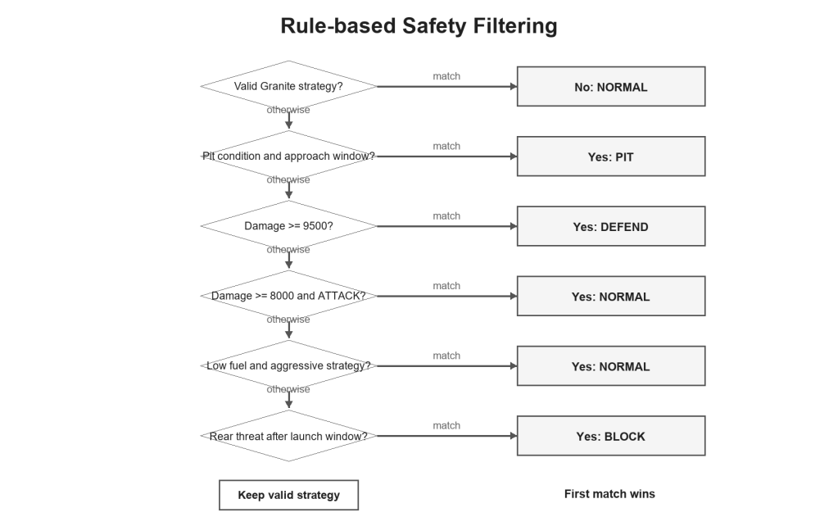

Figure 3.3: Priority-based Safety Filtering

3.3.2 Pit Strategy and Execution
The pit-entry functionality has been designed by us but we could not identify a proper interface that would allow us to implement it physically. I further developed the strategy-triggering logic. At last we divided PIT into two layers: selecting the time when the pit stop should be triggered and performing it literally. There was no specific strategy to be applied during the pit stop in the initial design; Granite just began to produce conservative strategies once the fuel level went down. This strategy layer will now consider a fixed fuel threshold as well as a dynamic prediction depending on remaining laps as well as past fuel consumption. It is only when the fuel level is low and the vehicle is within the approximately 150 meter zone before the pit-lane entry that the safety layer will lock the strategy to PIT.
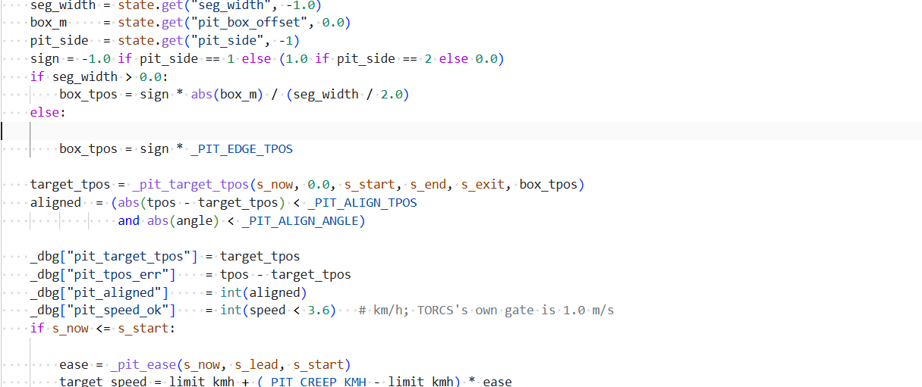

Figure 3.4: Pit Alignment and Capture Conditions

3.4 Granite Strategy Integration
The output of granite never gives any feedback on braking or steering. It just chooses a high-level strategy based on ATTACK, NORMAL, DEFEND and PIT, and all strategies are subsequently associated with predetermined control parameters.
The system packages speed, fuel level, damage, lateral position, gear, rank, distance travelled, predicted fuel consumption, remaining laps, and track and opponent information of each request in JSON and sends it to Granite.
{
"strategy": "ATTACK",
reason: There are not many more laps left and enough fuel, therefore the car has the capability to push to reduce the distance between itself and the car in front of it.
}

The system prompt is instructing Granite that it should only output JSON with a strategy name and short reason. When the low-level controller fails to parse the response or the strategy value is illegal, the system reverts to NORMAL.
The request is run in the background in order to prevent model inference blocking the main control loop. The main loop continues to use the last confirmed strategy and does not replace until a new result is valid. Should the previous request have not ended, we will not queue any additional request. The polling of the system is approximately 15 seconds and one request has to wait for no more than 180 seconds. It keeps the control loop continuous, however, large timeouts can make the strategy stale and a real-time system only functions when tasks complete within their time frame (Stankovic, 1988). We ought to note the time taken by each Granite request in future tests.

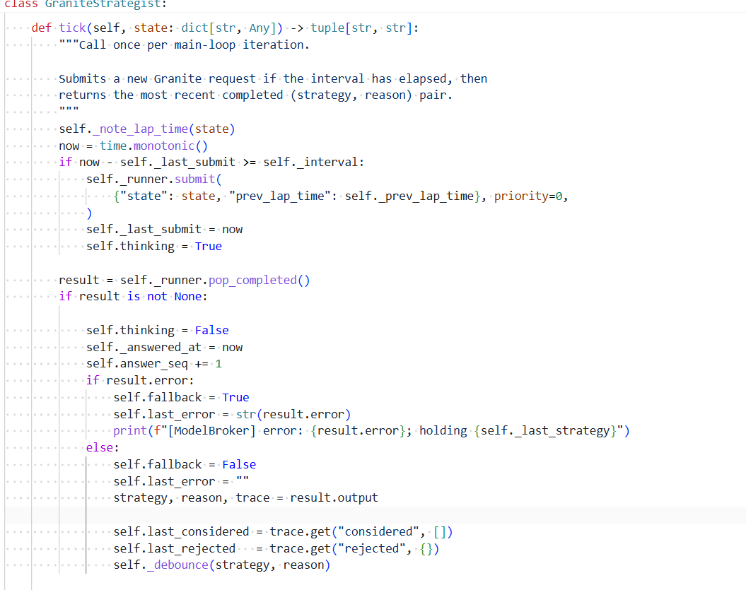

Figure 3.5: Asynchronous Granite Strategy Update

3.5 Additional Contribution: Overtaking Logic
Afterwards, during the performance-tuning stage of the project, I was also involved in solving the overtaking trigger logic. The initial logic considered only the distance between the cars in front: after it dropped a certain level, the car would start readying itself to overtake. What happened here is that the steady pace of following another vehicle also kept its distance low, which was erroneously interpreted as closing up. I have introduced additional constraints, whereby the overtaking logic is engaged only when there is an actual change in the distance ahead and the speed differential between the two vehicles.
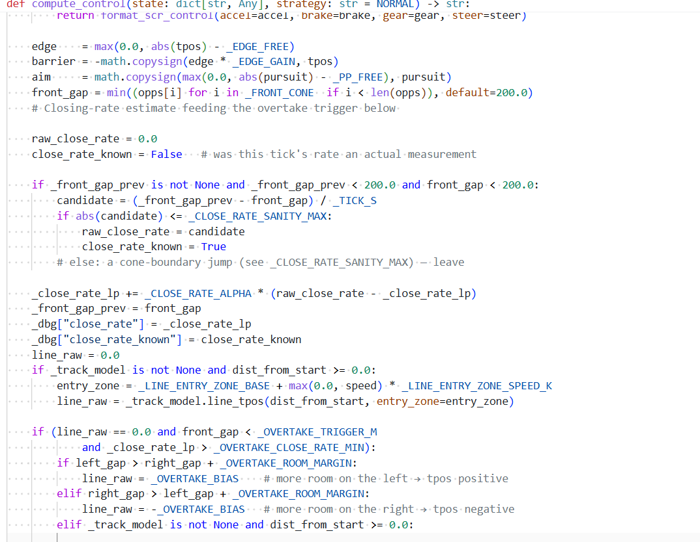

Figure 3.6: Closing-rate Estimation and Overtaking Trigger

4 Critical Evaluation

4.1 Communication and Coordination
There were a number of constraints on the project. The record of task allocation was not revised when the scope of the project was altered. Alterations like adding the BLOCK rule and other alterations that impacted the integration of Granite were discussed over private messages and not documented on time. We should have kept a brief list of interfaces and accountable persons, and changes made, assignees and verification requirements during weekly reviews, and thus the documented scope was equal to what we were actually implementing.

4.2 Design
The stratified architecture isolated Granite and low-level controller and limited risks associated with the model. The model never controlled the vehicle directly and the timeout or invalid output had deterministic fallbacks. However, it complicated cross-layer coordination. In a case like BLOCK, the safety layer was needed to assess the trigger conditions, and the steering bias was applied by the controller, whereas in a case like PIT, the strategy layer and execution layer were needed to cleanly pass each other at the appropriate spot. This separation of the various levels of system behaviour is an application of the idea of layered control as proposed by Brooks (1986), which in our system increased verifiability at the expense of having more interfaces and state transitions.

4.3 Testing
The majority of our tests were aimed at testing individual functions, as proposed by the test-pyramid concept that involves more low-level tests than wide integration tests (Fowler, 2018). The state parser, safety layer, recovery state machine and overtaking logic were tested individually. With these parts operating independently, the entire flow between Granite response to final strategy was then tested. It demonstrated if there was an invalid model output that could bypass the safety layer. Certain driving behavior could not be recreated with manually created data and thus we also ran the full AI bot on TORCS.

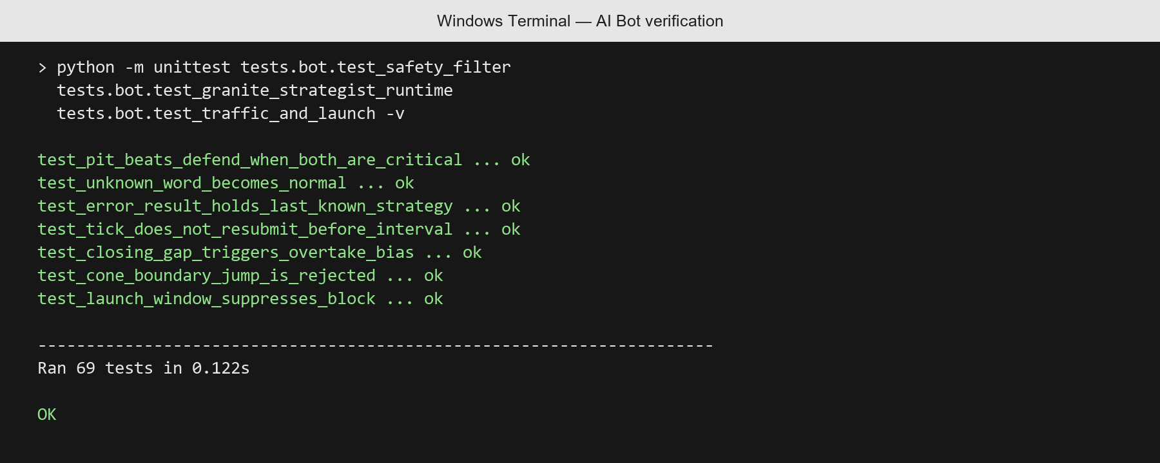

Figure 4.1: Targeted AI Bot Test Execution

References
Brooks, R.A. (1986) 'A robust layered control system for a mobile robot', IEEE Journal on Robotics and Automation, 2(1), pp. 14-23. Available at: https://doi.org/10.1109/JRA.1986.1087032 (Accessed: 22 August 2026).
Cofer, D., Gacek, A., Miller, S.P., Whalen, M.W., LaValley, B. and Heimdahl, M.P.E. (2020) 'Run-time assurance for learning-enabled systems', NASA Formal Methods, pp. 361-368. Available at: https://doi.org/10.1007/978-3-030-53291-8_19 (Accessed: 21 August 2026).
Dijkstra, E.W. (1972) 'On the reliability of programs', EWD303. Available at: https://www.cs.utexas.edu/~EWD/transcriptions/EWD03xx/EWD303.html (Accessed: 21 August 2026).
Fowler, M. (2018) 'The practical test pyramid'. Available at: https://martinfowler.com/articles/practical-test-pyramid.html (Accessed: 21 August 2026).
Ji, Z., Lee, N., Frieske, R., Yu, T., Su, D., Xu, Y., Ishii, E., Bang, Y.J., Madotto, A. and Fung, P. (2023) 'Survey of hallucination in natural language generation', ACM Computing Surveys, 55(12), pp. 1-38. Available at: https://doi.org/10.1145/3571730 (Accessed: 21 August 2026).
Postel, J. (1980) User Datagram Protocol. RFC 768. Available at: https://doi.org/10.17487/RFC0768 (Accessed: 21 August 2026).
Schwaber, K. and Sutherland, J. (2020) The Scrum Guide: The Definitive Guide to Scrum: The Rules of the Game. Available at: https://scrumguides.org/scrum-guide.html (Accessed: 21 August 2026).
Stankovic, J.A. (1988) 'Misconceptions about real-time computing: A serious problem for next-generation systems', Computer, 21(10), pp. 10-19. Available at: https://doi.org/10.1109/2.7053 (Accessed: 21 August 2026).

