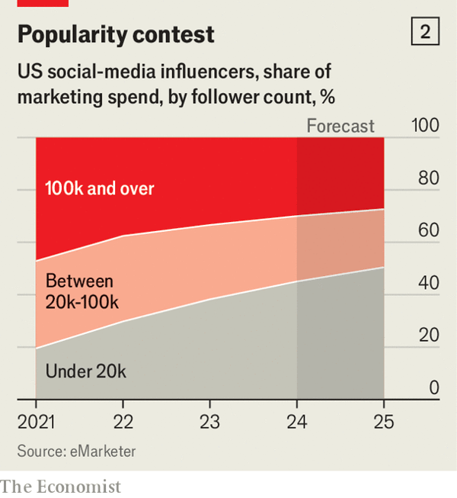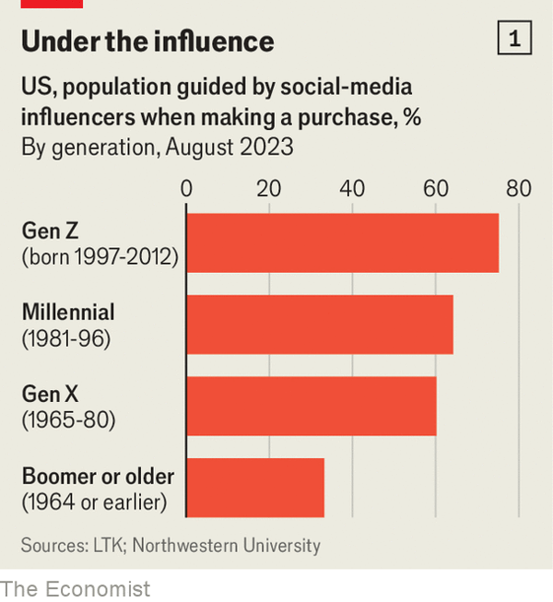

# Too many people want to be social-media influencers

1. ASK A YOUNG person what they would like to do with their life and increasingly often the answer will be to find fame and fortune online. Fully 57% of Gen Zs in America would like to be a social-media influencer, according to Morning Consult, a pollster; 53% describe it as a “reputable career choice”. Those dreams may be understandable: examples a_______ of social-media superstars, from fashionistas and comedians to gamers, making tens of thousands of dollars for a post promoting the wares of some brand. As consumers spend more of their lives on social media, the amount of money companies are paying influencers is r_______.
2. Yet as the industry has grown, it has also changed. Spoiled for choice, companies have shifted their attention towards influencers creating content for narrower audiences, such as fashion tips for the over 60s or gardening advice for inner-city dwellers, to better target those consumers. Cultivating a small fan base in a n_______ area may earn hobbyists some extra cash, but it will rarely be enough for them to quit their day job. Those who fantasise about making a living as a social-media star may thus be heading for disappointment.
3. Companies have been increasing the share of their marketing budgets they hand over to influencers. Over the past five years, American firms have roughly tripled their spending on influencer marketing, to $7bn, according to eMarketer, a research firm. In a survey by the Influencer Marketing Hub, another research group, 86% of brands globally said they plan to spend on influencer marketing this year, up from 37% in 2017, when the survey was first conducted. Nearly a quarter intend to spend over 40% of their marketing budget on influencer campaigns.
4. Companies realise that influencers—or “creators”, as many prefer to be called—have become i_______ to how consumers shop. According to research by Northwestern University and LTK, a platform that connects influencers with brands, nearly three-quarters of Gen Zs in America have relied on influencers to help them choose products to buy. More surprisingly, so h_______ a third of consumers who are boomers or older.
5. Influencers are part of every big campaign nowadays. Walmart, a giant American retailer, has worked with TikTok stars Charli and Dixie D’Amelio. BOSS, a fancy clothing brand, has collaborated with Khaby Lame, a comedian with more followers than anyone else on TikTok. Louis Vuitton, *a luxury* ***stalwart***, has run campaigns with Emma Chamberlain, a YouTuber. For the past few years influencers have even starred in Super Bowl ads alongside Hollywood royalty and ***chart-topping*** *pop stars*. The biggest influencers now hire legions of staff to help them create eye-catching posts, while agencies and other middlemen help them ***land and manage*** *brand deals*.
6. Such stories have l_______ a growing number of people to ***try their hand at*** *being an influencer*. Goldman Sachs, a bank, estimates that as of last year there were more than 50m influencers globally, and reckons their ranks are s_______ by between 10% and 20% annually.
7. The surging supply of influencers has been a boon for companies that use them to sell their products. Celebrity influencers may be helpful for building awareness of a brand or altering how it is perceived by shoppers, but when it comes to persuading people to buy something, *marketers look to* ***the long tail of*** *creators* with small but engaged groups of followers.
8. Since 2021 the share of spending on influencer marketing in America taken by creators with more than 1m followers has fallen from 15% to 8%; the share taken by those with fewer than 20,000 followers has surged from 20% to 45%. Marketing agencies help companies manage contracts with many such influencers, sometimes using artificial intelligence (AI) to s_______ out those whose audiences best match their needs.
9. For those hoping to make a career out of their social-media presence, however, the proliferation of social-media influencers should be a cause for c_______. Only 4% of creators earn $100,000 a year or more from the work, according to Goldman Sachs. AI could worsen the situation, as *“virtual influencers” begin to* ***crowd social-media feeds***: Aitana López, a gamer and fitness guru with pink hair and a face so symmetrical it could only have been generated by a computer, has 330,000 followers on Instagram.
10. The glut of influencers is also making online fame yet more fickle. Even if a post goes viral, that doesn’t mean an influencer’s career is s_______, says Joe Gagliese, co-founder of Viral Nation, a marketing agency. “If they’re not careful to make the most of that, there is another creator right behind them,” he says. “This industry is extremely volatile,” points out Vanessa Chen, a fashion influencer better known by her Instagram name Vivacious Honey. To diversify her income, she recently launched her own clothing line. Many others have done something similar.
11. There is another problem with the flood of influencers online: *consumers are growing weary of all those ads* ***dressed up as entertainment***. In a survey last year McKinsey, a consultancy, found that 68% of fashion consumers globally were unhappy with the amount of sponsored content on social media.
12. *Influencers* ***first took off***because consumers thought of them as “people they could trust”, says Anita Balchandani of McKinsey. To remain influential they need to strike a balance between getting paid and convincing followers they are still “authentic”, one of the industry’s favourite buzzwords. Being popular, it seems, is harder than ever.
13. abound
14. rising / rocketing
15. niche
16. intrinsic
17. have
18. lured
19. soaring / swelling
20. scout
21. concern
22. set

太多人想成为社交媒体网红

若问年轻人未来想从事什么职业，越来越多的答案会是在网上追逐名利。根据民调机构Morning Consult的数据，57%的美国Z世代希望成为社交媒体网红，53%认为这是"体面的职业选择"。这种梦想或许可以理解：社交媒体超级明星的案例比比皆是——从时尚达人、喜剧演员到游戏主播，他们为品牌推广产品的一条帖子就能赚取数万美元。随着消费者在社交媒体上花费更多时间，企业支付给网红的资金正在增长。

但随着行业发展，格局已悄然改变。企业拥有更多选择后，已将注意力转向服务细分受众的网红，例如针对60岁以上人群的时尚建议或面向市中心居民的园艺指导，以便更精准触达消费者。在小众领域（niche）培养少量粉丝或许能让爱好者赚些外快，但很少能支撑他们辞去主业。那些幻想靠社交媒体成名谋生的人，恐怕终将失望。

企业不断增加营销预算中分配给网红的比例。研究机构eMarketer数据显示，过去五年美国公司在网红营销上的支出增长近两倍，达到70亿美元。另一研究机构Influencer Marketing Hub的调查显示，86%的全球品牌计划今年进行网红营销（2017年首次调查时仅为37%）。近四分之一品牌打算将40%以上的营销预算用于网红推广。

企业意识到，网红 —— 或者如许多人更愿意被称呼的 “创作者”—— 已成为影响消费者购物方式的重要因素。美国西北大学与连接网红和品牌的平台 LTK 所做的研究显示，美国近四分之三的 Z 世代依赖网红来帮助自己挑选购买的产品。更令人惊讶的是，三分之一的婴儿潮一代及更年长的消费者也是如此。

如今每个大型营销活动都少不了网红。美国零售巨头沃尔玛与TikTok明星Charli和Dixie D'Amelio合作，高端服装品牌BOSS与TikTok粉丝数第一的喜剧演员Khaby Lame联手，奢侈品牌路易威登邀请YouTuber Emma Chamberlain推广。过去几年，网红甚至开始与好莱坞巨星和顶流歌手共同出演超级碗广告。（Super Bowl 即 “超级碗”，是美国国家橄榄球联盟（NFL）的年度冠军赛，美国人非常重视的赛事）顶级网红如今雇佣大批团队制作吸睛内容，经纪公司等中间商则协助其对接和管理品牌合作。

这些成功案例吸引越来越多人尝试成为网红。高盛估计，截至去年全球已有超5000万网红，且其规模每年扩张10%-20%。

网红供给激增对品牌方是福音。名人网红或许有助于提升品牌知名度或改变消费者认知，但真要说服人们购买产品，营销者更看重那些粉丝量小但互动率高的"长尾创作者"。

自2021年以来，美国网红营销预算中分配给百万粉以上创作者的比例从15%降至8%，而粉丝数低于2万的创作者份额从20%飙升至45%。营销机构帮助企业管理大量中小网红合作，有时甚至用人工智能（AI）筛选出受众最匹配需求的账号。

但对想以社交媒体为业的人而言，网红泛滥应引起警惕。高盛数据显示，仅4%的创作者年收入超10万美元。随着"虚拟网红"开始充斥社交媒体，AI可能让情况更糟：粉发电竞健身博主Aitana López（其完美对称的面容显然由电脑生成）在Instagram已拥有33万粉丝。

网红过剩还使网络名气更不稳定。营销机构Viral Nation联合创始人Joe Gagliese指出，即使某条内容爆红，也不意味网红生涯就此稳固："若不趁机巩固地位，立刻会有新人取代你。"时尚网红Vanessa Chen（Ins账号Vivacious Honey）坦言："这行业极度动荡。"为分散风险，她最近推出了自有服装品牌，许多同行也采取了类似策略。

网红泛滥还存在另一问题：消费者越来越厌倦伪装成娱乐内容的广告。麦肯锡（咨询公司）去年调查发现，68%的全球时尚消费者对社交媒体过量植入广告感到不满。

麦肯锡分析师Anita Balchandani指出，网红最初兴起是因为消费者视其为"可信赖的普通人"。要保持影响力，他们必须在赚钱与维持"真实人设"（行业最爱标榜的标签）间找到平衡。在这个时代，维持人气似乎比以往任何时候都更难。