hw1
1602019 김예지
A<-data.frame(X1=c(51,27,37,42,27,43,41,38,36,26,29),X2=c(36,20,22,36,18,32,22,21,23,31,20),X3=c(50,26,41,32,33,43,36,31,27,31,25),X4=c(35,17,37,43,14,35,25,20,25,32,26),X5=c(42,27,30,27,29,40,38,16,28,36,25))
A
## X1 X2 X3 X4 X5
## 1 51 36 50 35 42
## 2 27 20 26 17 27
## 3 37 22 41 37 30
## 4 42 36 32 43 27
## 5 27 18 33 14 29
## 6 43 32 43 35 40
## 7 41 22 36 25 38
## 8 38 21 31 20 16
## 9 36 23 27 25 28
## 10 26 31 31 32 36
## 11 29 20 25 26 25
# 1. 산점도행렬
pairs(A[,-5])
library(GGally)
## Warning: package 'GGally' was built under R version 3.5.3
## Loading required package: ggplot2
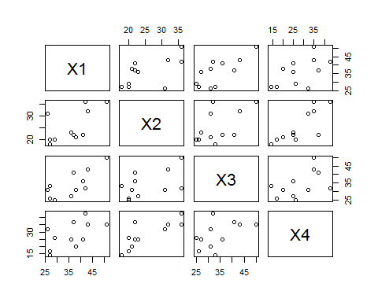
ggpairs(A[,-5])
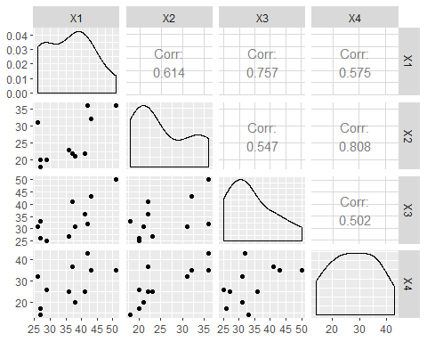
점이 11개 밖에 되지 않아서 행렬의 패턴을 잘 볼 수 없다.
어디 한곳이 몰려 있지 않고 잘 퍼져 있는 것을 알 수 있다.
그래도 몇몇 아웃 라이어들을 빼 주고 점의 수가 늘어난다면 비교적 선형 관계라고 볼 수도 있겠다. 가로축 숫자가 커질수록 세로축 숫자 작은 점들은 별로 없다.

# 2. 평행그림
library(lattice)
## Warning: package 'lattice' was built under R version 3.5.3
parallelplot(A,horizontal.axis=FALSE)
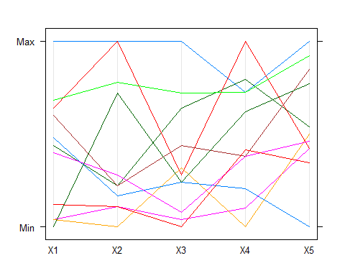
ggparcoord(A)
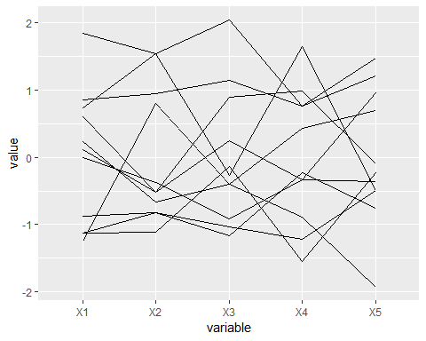
# 3. 표본평균벡터
colMeans(A)
## X1 X2 X3 X4 X5
## 36.09091 25.54545 34.09091 28.09091 30.72727
# 3. 표본분산공분산행렬
var(A)
## X1 X2 X3 X4 X5
## X1 65.09091 33.64545 47.59091 42.09091 25.42727
## X2 33.64545 46.07273 28.94545 49.74545 28.36364
## X3 47.59091 28.94545 60.69091 35.49091 41.12727
## X4 42.09091 49.74545 35.49091 82.29091 28.32727
## X5 25.42727 28.36364 41.12727 28.32727 58.21818
# 4. 표본상관행렬
cor(A)
## X1 X2 X3 X4 X5
## X1 1.0000000 0.6143902 0.7571850 0.5751117 0.4130573
## X2 0.6143902 1.0000000 0.5473897 0.8078961 0.5476595
## X3 0.7571850 0.5473897 1.0000000 0.5022031 0.6918927
## X4 0.5751117 0.8078961 0.5022031 1.0000000 0.4092602
## X5 0.4130573 0.5476595 0.6918927 0.4092602 1.0000000
# 5. 1번학생과10번학생간의 유클리드거리
x1<-t(A[1,,drop=FALSE])
x2<-t(A[10,,drop=FALSE])
x1
## 1
## X1 51
## X2 36
## X3 50
## X4 35
## X5 42
x2
## 10
## X1 26
## X2 31
## X3 31
## X4 32
## X5 36
sqrt(sum((x1-x2)^2))
## [1] 32.49615
dist(A[1:10,],method = "euclidean")
## 1 2 3 4 5 6 7
## 2 44.237993
## 3 24.919872 27.166155
## 4 26.343880 34.539832 18.627936
## 5 42.414620 8.124038 26.645825 37.349699
## 6 11.532563 34.380227 15.620499 19.261360 33.376639
## 7 24.657656 22.022716 15.779734 25.651511 20.566964 16.031220
## 8 40.693980 16.643317 24.228083 29.866369 18.411953 33.030289 23.323808
## 9 34.914181 12.489996 18.601075 23.558438 16.248077 25.099801 14.387495
## 10 32.496154 21.283797 19.052559 22.000000 23.388031 21.424285 19.595918
## 8 9
## 2
## 3
## 4
## 5
## 6
## 7
## 8
## 9 13.892444
## 10 28.071338 17.117243
노란색 보면 같음을 알 수 있음
# 6. 1번과 10번학생간의 표준화거리
S<-var(A)
D<-diag(diag(S))
D
## [,1] [,2] [,3] [,4] [,5]
## [1,] 65.09091 0.00000 0.00000 0.00000 0.00000
## [2,] 0.00000 46.07273 0.00000 0.00000 0.00000
## [3,] 0.00000 0.00000 60.69091 0.00000 0.00000
## [4,] 0.00000 0.00000 0.00000 82.29091 0.00000
## [5,] 0.00000 0.00000 0.00000 0.00000 58.21818
sqrt(t(x1-x2)%*%solve(D)%*%(x1-x2))
## 1
## 1 4.101278
# 7. 1번과 10번학생간의 마할노비스거리
sqrt(t(x1-x2)%*%solve(S)%*%(x1-x2))
## 1
## 1 3.625891
# 8. A. 고유값과 고유벡터
A1<-var(A)
A1
## X1 X2 X3 X4 X5
## X1 65.09091 33.64545 47.59091 42.09091 25.42727
## X2 33.64545 46.07273 28.94545 49.74545 28.36364
## X3 47.59091 28.94545 60.69091 35.49091 41.12727
## X4 42.09091 49.74545 35.49091 82.29091 28.32727
## X5 25.42727 28.36364 41.12727 28.32727 58.21818
eigen(A1)
## eigen() decomposition
## $values
## [1] 209.14089 49.33038 34.74413 11.94653 7.20171
##
## $vectors
## [,1] [,2] [,3] [,4] [,5]
## [1,] 0.4638605 -0.1045418 0.6982908 0.3399260 0.4132128
## [2,] 0.4017334 0.2813695 -0.1957213 0.6310947 -0.5682025
## [3,] 0.4563333 -0.4692740 0.1866554 -0.5029592 -0.5326665
## [4,] 0.5231453 0.6540127 -0.1712795 -0.4578090 0.2442551
## [5,] 0.3761949 -0.5118120 -0.6402392 0.1536640 0.4037413
eigen(A1)$values
## [1] 209.14089 49.33038 34.74413 11.94653 7.20171
eigen(A1)$vectors
## [,1] [,2] [,3] [,4] [,5]
## [1,] 0.4638605 -0.1045418 0.6982908 0.3399260 0.4132128
## [2,] 0.4017334 0.2813695 -0.1957213 0.6310947 -0.5682025
## [3,] 0.4563333 -0.4692740 0.1866554 -0.5029592 -0.5326665
## [4,] 0.5231453 0.6540127 -0.1712795 -0.4578090 0.2442551
## [5,] 0.3761949 -0.5118120 -0.6402392 0.1536640 0.4037413
# 8. B.역행렬
solve(A1)
## X1 X2 X3 X4 X5
## X1 0.048665834 -0.01828352 -0.039115974 -0.002679933 0.016589253
## X2 -0.018283517 0.08164789 0.012605279 -0.037755718 -0.022326965
## X3 -0.039115974 0.01260528 0.067035713 -0.004792132 -0.034081570
## X4 -0.002679933 -0.03775572 -0.004792132 0.036651891 0.005116478
## X5 0.016589253 -0.02232697 -0.034081570 0.005116478 0.042395701
# 8. c. trace
sum(diag(A1))
## [1] 312.3636
# 8. D. determinant
det(A1)
## [1] 30839842
# 8. E. Rank
sum(round(eigen(t(A1)%*%A1)$values,10)!=0)
## [1] 5
# 8. F. Spectral decomposition
E<-eigen(A1)$vectors
lambda<-diag(eigen(A1)$values)
E%*%lambda%*%t(E)
## [,1] [,2] [,3] [,4] [,5]
## [1,] 65.09091 33.64545 47.59091 42.09091 25.42727
## [2,] 33.64545 46.07273 28.94545 49.74545 28.36364
## [3,] 47.59091 28.94545 60.69091 35.49091 41.12727
## [4,] 42.09091 49.74545 35.49091 82.29091 28.32727
## [5,] 25.42727 28.36364 41.12727 28.32727 58.21818
part1<-lambda[1,1]*E[,1,drop=FALSE]%*%t(E[,1,drop=FALSE])
part2<-lambda[2,2]*E[,2,drop=FALSE]%*%t(E[,2,drop=FALSE])
part1
## [,1] [,2] [,3] [,4] [,5]
## [1,] 45.00012 38.97304 44.26989 50.75148 36.49549
## [2,] 38.97304 33.75319 38.34061 43.95409 31.60747
## [3,] 44.26989 38.34061 43.55152 49.92792 35.90327
## [4,] 50.75148 43.95409 49.92792 57.23790 41.15989
## [5,] 36.49549 31.60747 35.90327 41.15989 29.59816
part2
## [,1] [,2] [,3] [,4] [,5]
## [1,] 0.5391316 -1.451048 2.420088 -3.372802 2.639460
## [2,] -1.4510475 3.905427 -6.513553 9.077738 -7.103983
## [3,] 2.4200878 -6.513553 10.863442 -15.140044 11.848173
## [4,] -3.3728017 9.077738 -15.140044 21.100212 -16.512433
## [5,] 2.6394598 -7.103983 11.848173 -16.512433 12.922166
part1+part2
## [,1] [,2] [,3] [,4] [,5]
## [1,] 45.53925 37.52199 46.68998 47.37868 39.13495
## [2,] 37.52199 37.65862 31.82706 53.03183 24.50349
## [3,] 46.68998 31.82706 54.41496 34.78788 47.75144
## [4,] 47.37868 53.03183 34.78788 78.33811 24.64746
## [5,] 39.13495 24.50349 47.75144 24.64746 42.52033
# 8. G. 표본 분산공분행렬의 제곱근
E%*%sqrt(lambda)%*%t(E)
## [,1] [,2] [,3] [,4] [,5]
## [1,] 6.9202047 1.794126 2.992419 2.057138 0.8924112
## [2,] 1.7941263 5.358832 1.223578 3.158346 1.6323188
## [3,] 2.9924194 1.223578 6.399364 1.555077 2.6208908
## [4,] 2.0571376 3.158346 1.555077 8.019546 1.1629978
## [5,] 0.8924112 1.632319 2.620891 1.162998 6.8217070

