hw2
library("ggplot2")
## Warning: package 'ggplot2' was built under R version 3.5.3
data2<-read.csv("c:/Users/HW2.csv")
# 4.a)
colMeans(data2[,-1])
## X1 X2
## 22.34737 51.03158
var(data2[,-1])
## X1 X2
## X1 61.44708 55.6562
## X2 55.65620 251.7967
# 4.b) X1
attach(data2)
summary(data2)

## type X1 X2
## 건설업 : 1 Min. :13.00 Min. :14.00
## 경공업(제조업) : 1 1st Qu.:17.50 1st Qu.:44.05
## 광업 : 1 Median :20.40 Median :51.50
## 내수기업(제조업): 1 Mean :22.35 Mean :51.03
## 도매및소매업 : 1 3rd Qu.:26.10 3rd Qu.:55.85
## 부동산및임대업 : 1 Max. :47.80 Max. :82.10
## (Other) :13
n<-nrow(data2)
t<-seq(1:n)
edf<-(t-0.5)/n
q<-qnorm(edf,0,1)
norm.sample<-data.frame(X1=sd(X1)*rnorm(100)+mean(X1))
ggplot(data2,aes(x=X1))+stat_ecdf(geom="Step")+stat_ecdf(data=norm.sample,geom="Step",color="red")
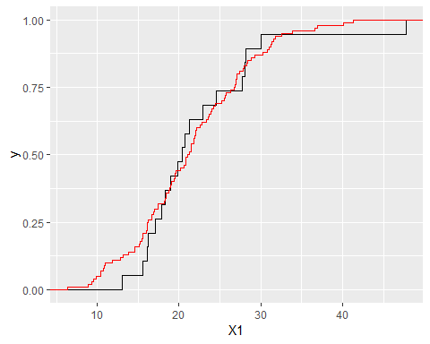
ggplot(data2,aes(sample=X1))+stat_qq()+stat_qq_line(color="red")
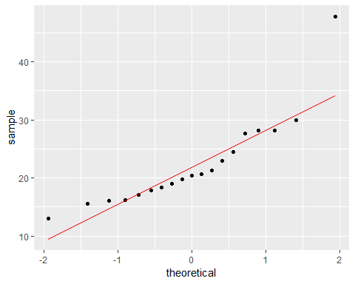
cor(X1,q)
## [1] 0.01790849
shapiro.test(X1)
##
## Shapiro-Wilk normality test
##
## data: X1
## W = 0.81955, p-value = 0.002229
ks.test(X1,"pnorm",mean=mean(X1),sd=sd(X1))
##
## One-sample Kolmogorov-Smirnov test
##
## data: X1
## D = 0.18472, p-value = 0.4797
## alternative hypothesis: two-sided
p-value를 보았을 때 정규분포를 따른다고 할 수 있다.
# 4.b) X2
norm.sample<-data.frame(X2=sd(X2)*rnorm(100)+mean(X2))
ggplot(data2,aes(x=X2))+stat_ecdf(geom="Step")+stat_ecdf(data=norm.sample,geom="Step",color="red")
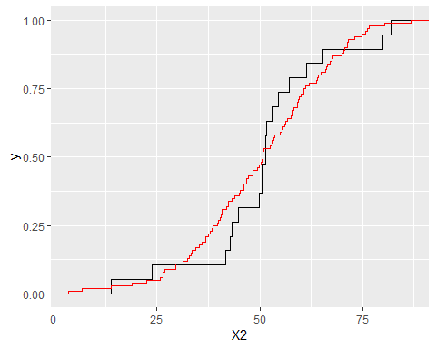
ggplot(data2,aes(sample=X2))+stat_qq()+stat_qq_line(color="red")
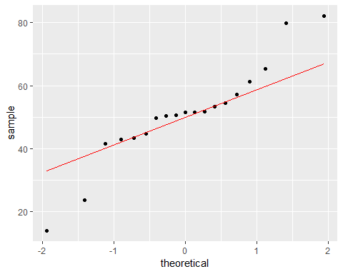
cor(X2,q)
## [1] -0.1048802
shapiro.test(X2)
##
## Shapiro-Wilk normality test
##
## data: X2
## W = 0.92315, p-value = 0.1294
ks.test(X1,"pnorm",mean=mean(X2),sd=sd(X2))
##
## One-sample Kolmogorov-Smirnov test
##
## data: X1
## D = 0.85485, p-value = 2.22e-16
## alternative hypothesis: two-sided
두 실험의 p-value를 봤을 때 정규분포를 따른다고 하기 어렵다.
# 4.c)
X<-as.matrix(data2[,-1])
p<-ncol(X)
mean.X<-matrix(colMeans(X),ncol=1)
one<-matrix(rep(1,nrow(X)),ncol=1)
var.X<-var(X)
diag((X-one%*%t(mean.X))%*%solve(var.X)%*%t(X-one%*%t(mean.X)))
## [1] 0.67996790 1.16768424 0.24318997 5.48828354 4.28572225
## [6] 0.59404682 1.81834136 1.81342408 5.76478876 0.29601688
## [11] 10.71087718 0.66554203 0.91994016 0.04975022 0.38260074
## [16] 0.04870840 0.23855962 0.35763507 0.47492079
data<-data.frame(d2=mahalanobis(data2[,-1],mean.X,var.X))
ggplot(data,aes(sample=d2))+stat_qq(distribution=qchisq,dparams=p)+stat_qq_line(distribution=qchisq,dparams=p,color="red")
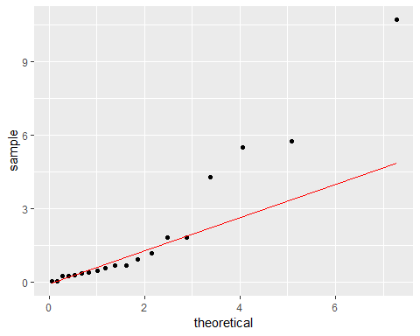
detach(data2)
숫자가 작을때는 비슷해 보이나 중간부터 검은 점과 빨간 선의 차이가 너무 크다. 정규성을 따른다고 하기 어렵다.

