XML

[HW1]

컴퓨터공학부

20143079 오예진

1. **XML Schema**

▶Code

<?xml version="1.0" encoding="UTF-8"?>

<!-- edited with XMLSpy v2019 (x64) (http://www.altova.com) by yejin (kookmin univ) -->

<schema xmlns="http://www.w3.org/2001/XMLSchema" xmlns:vc="http://www.w3.org/2007/XMLSchema-versioning" xmlns:oh="urn:kmu:cs:4:yejinoh" targetNamespace="urn:kmu:cs:4:yejinoh" elementFormDefault="qualified" attributeFormDefault="unqualified" vc:minVersion="1.1">

<element name="Vehicle" type="oh:VehicleType"/>

<complexType name="VehicleType">

<sequence>

<!-- Body, DriveTrain등 Vehicle을 구성하는 element는 한번씩 등장한다 -->

<element name="Body" type="string" minOccurs="1" maxOccurs="1" />

<element name="DriveTrain" type="oh:DriveTrainType" minOccurs="1" maxOccurs="1"/>

</sequence>

</complexType>

<complexType name="DriveTrainType">

<sequence>

<element name="Engine" type="string" minOccurs="1" maxOccurs="1"/>

<element name="Transmission" type="string" minOccurs="1" maxOccurs="1"/>

</sequence>

</complexType>

<complexType name="AutomobileType">

<complexContent>

<extension base="oh:VehicleType">

<sequence>

<element name="Trunk" type="string" minOccurs="1" maxOccurs="1"/>

</sequence>

</extension>

</complexContent>

</complexType>

<complexType name="SedanType">

<complexContent>

<extension base="oh:AutomobileType"/>

</complexContent>

</complexType>

<complexType name="ConvertibleType">

<complexContent>

<extension base="oh:AutomobileType">

<sequence>

<!-- OperatingRoof는 필수적이지 않기 때문에 minOccurs="0"으로 한다 -->

<element name="OperatingRoof" type="string" minOccurs="0" maxOccurs="1"/>

</sequence>

</extension>

</complexContent>

</complexType>

<complexType name="TruckType">

<complexContent>

<extension base="oh:VehicleType">

<sequence>

<element name="Compartment" type="string" minOccurs="1" maxOccurs="1"/>

</sequence>

</extension>

</complexContent>

</complexType>

<element name="Vehicles">

<complexType>

<sequence>

<!-- element Vehicle은 최소 한번부터 제한없이 등장할 수 있다. -->

<element ref="oh:Vehicle" minOccurs="1" maxOccurs="unbounded"/>

</sequence>

</complexType>

</element>

</schema>

▶시각화

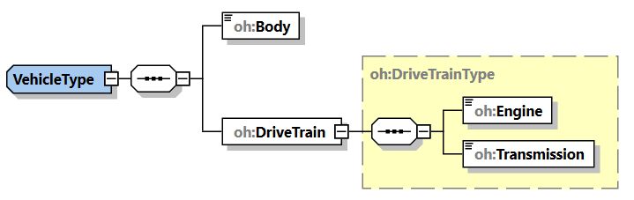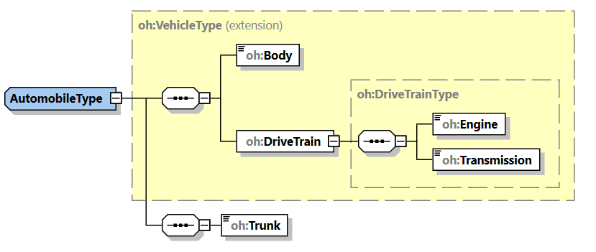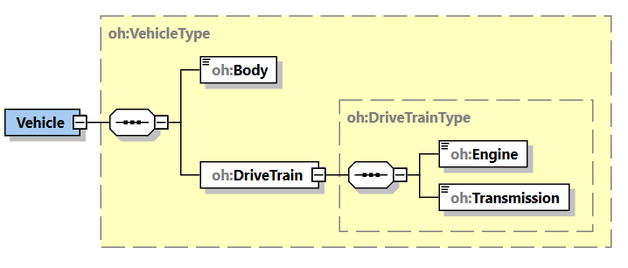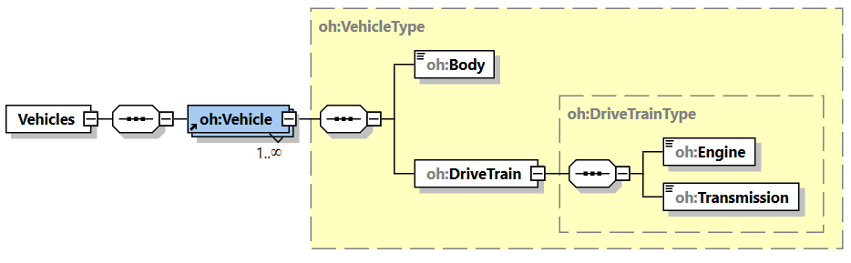

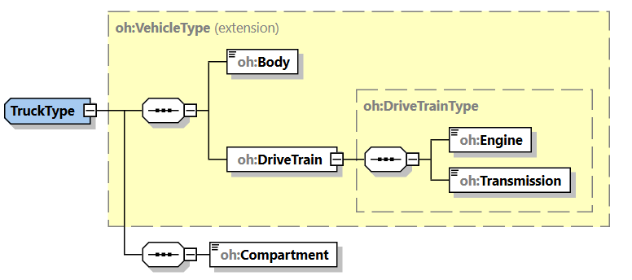

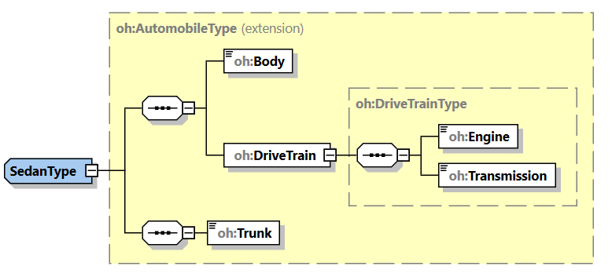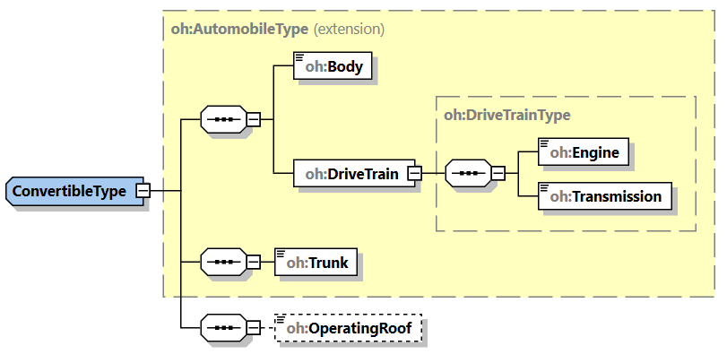

▶Screenshot

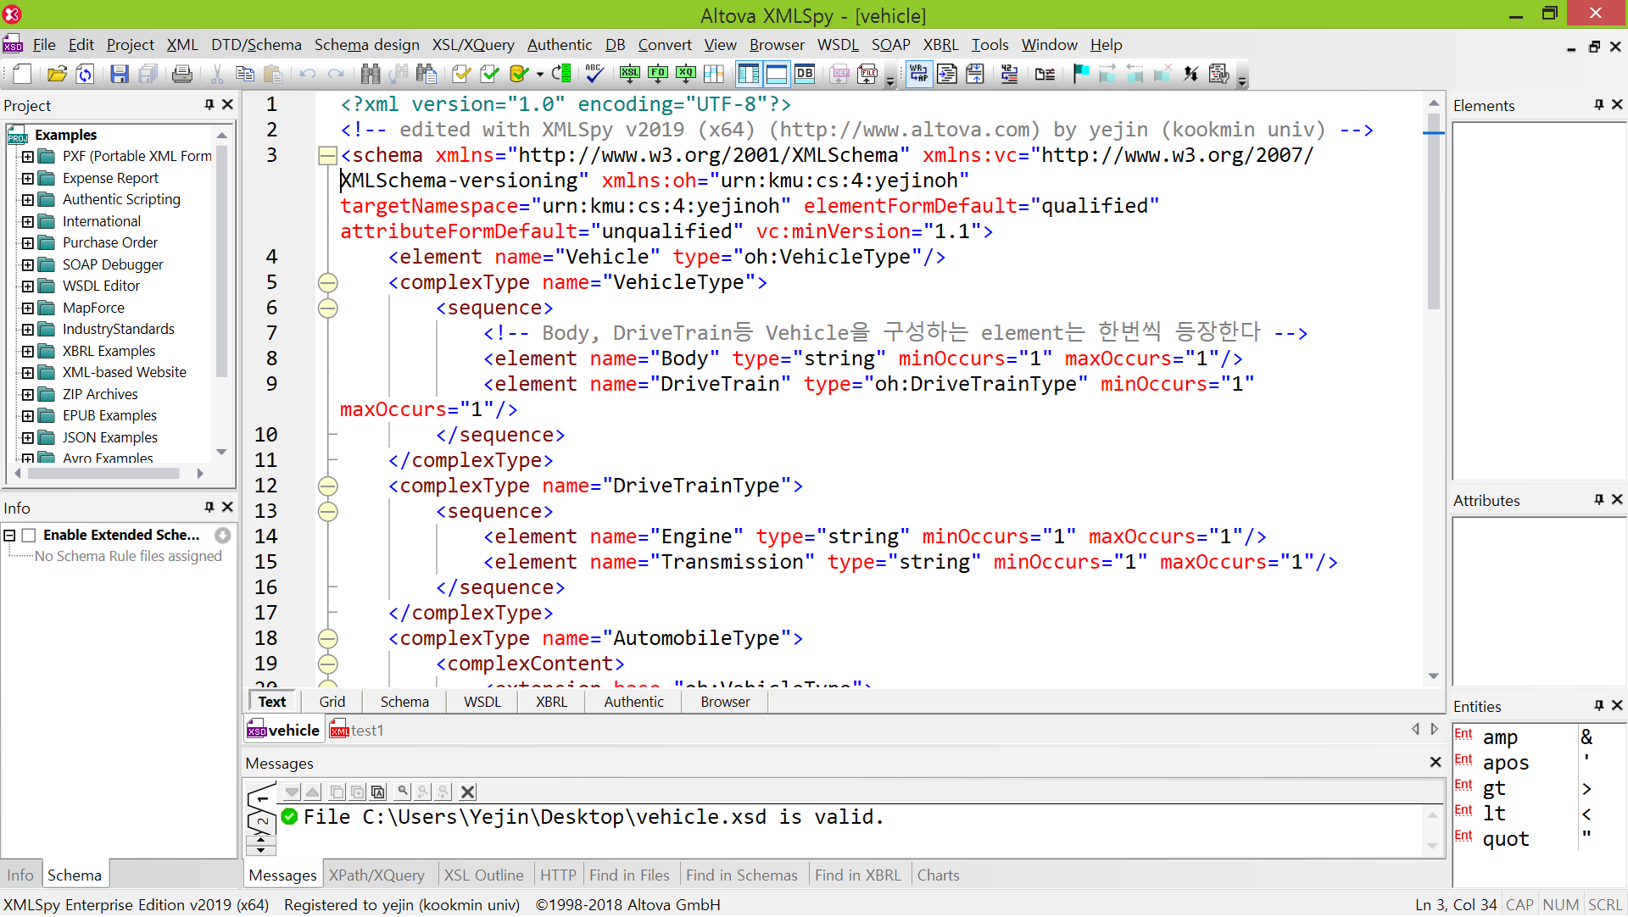

▶간단한 설명 및 짧은 소견

▷xmlns="http://www.w3.org/2001/XMLSchema"🡪default. xmlns:oh="urn:kmu:cs:4:yejinoh"🡪Prefix : oh, targetNamespace="urn:kmu:cs:4:yejinoh" 로 하였다.

▷각 Type은 name을 부여하였기 때문에 anonymous type이 아니다. 따라서 계속 재사용(binding) 가능하다.

▷각 type이 inherit한 후 element를 추가하는 방식이므로 <extension>을 사용하였고, attribute가 아닌 element를 추가하는 방식이기 때문에 <complexContent>를 사용하였다.

▷element를 extension할 때에는 compositor가 필요하기 때문에 <sequence>를 사용하였다.

▷처음 작성해보는 xsd여서 조금 헤맬 뻔 했지만 교수님께서 처음 설명을 잘 해주셔서 비교적 수월하게 작성할 수 있었다.

1. **XML Instance**

▶Code

<?xml version="1.0" encoding="UTF-8"?>

<Vehicles xmlns="urn:kmu:cs:4:yejinoh" xmlns:xsi="http://www.w3.org/2001/XMLSchema-instance" xsi:schemaLocation="urn:kmu:cs:4:yejinoh file:///C:/Users/Yejin/Desktop/vehicle.xsd">

<Vehicle xsi:type="VehicleType">

<Body>

Vehicle body

</Body>

<DriveTrain>

<Engine>

Vehicle engine

</Engine>

<Transmission>

Vehicle transmission

</Transmission>

</DriveTrain>

</Vehicle>

<Vehicle xsi:type="AutomobileType">

<Body>

Automobile body

</Body>

<DriveTrain>

<Engine>

Automobile engine

</Engine>

<Transmission>

Automobile transmission

</Transmission>

</DriveTrain>

<Trunk>

Automobile trunk

</Trunk>

</Vehicle>

<Vehicle xsi:type="SedanType">

<Body>

Sedan body

</Body>

<DriveTrain>

<Engine>

Sedan engine

</Engine>

<Transmission>

Sedan transmission

</Transmission>

</DriveTrain>

<Trunk>

Sedan trunk

</Trunk>

</Vehicle>

<Vehicle xsi:type="ConvertibleType">

<Body>

Convertible body

</Body>

<DriveTrain>

<Engine>

Convertible engine

</Engine>

<Transmission>

Convertible transmission

</Transmission>

</DriveTrain>

<Trunk>

Convertible trunk

</Trunk>

<!-- OperatingRoof는 없어도 error가 발생하지 않는다 -->

<OperatingRoof>

Convertible operatingroof

</OperatingRoof>

</Vehicle>

<Vehicle xsi:type="TruckType">

<Body>

Truck body

</Body>

<DriveTrain>

<Engine>

Truck engine

</Engine>

<Transmission>

Truck transmission

</Transmission>

</DriveTrain>

<Compartment>

Truck compartment

</Compartment>

</Vehicle>

</Vehicles>

▶Screenshot

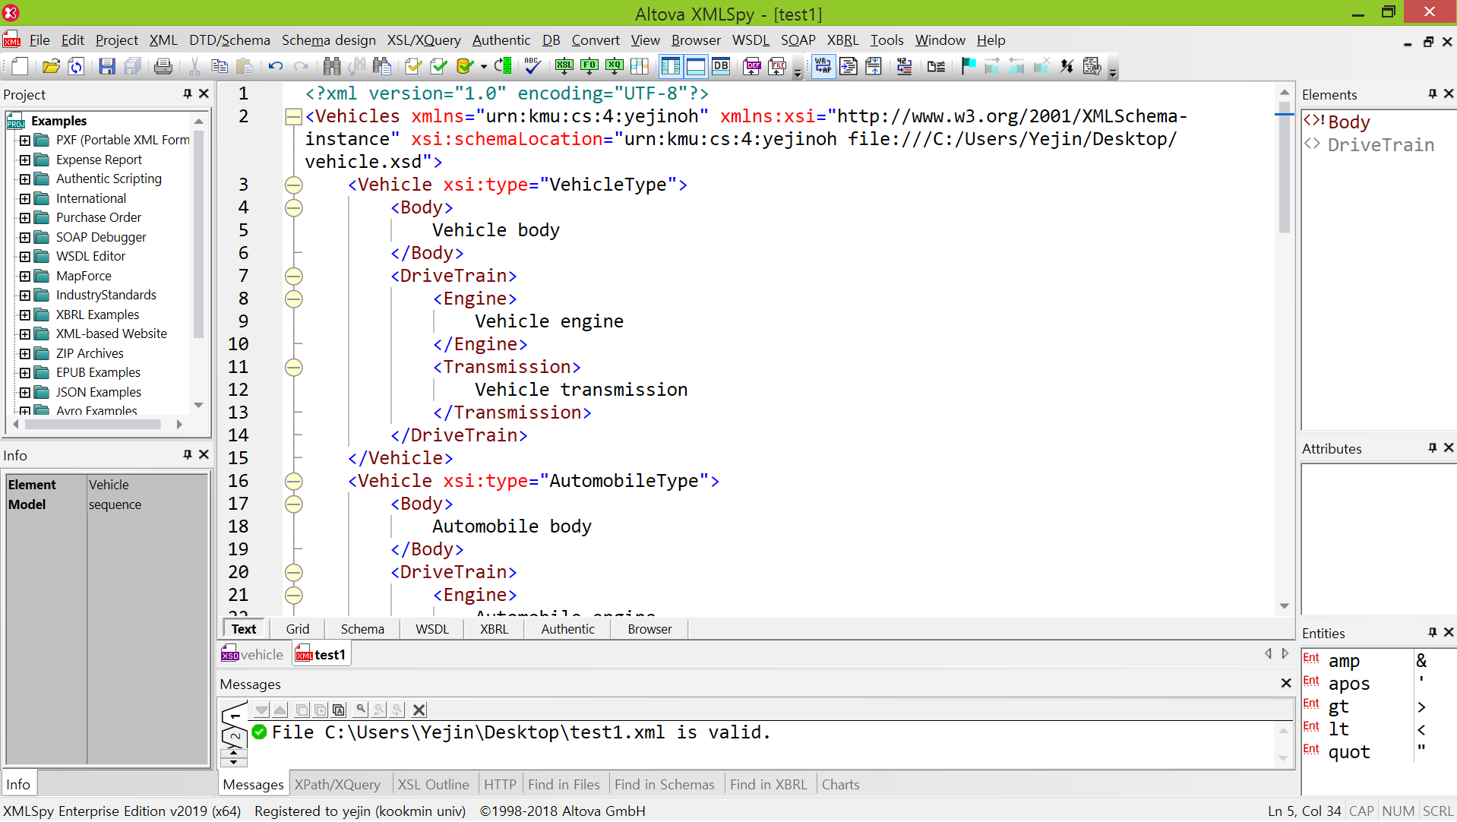

▶간단한 설명 및 짧은 소견

▷Vehicle.xsd를 토대로 test1.xml을 생성하였다.

▷type="string"로 하였기 때문에,

<Vehicle xsi:type="VehicleType">

<Body>Vehicle body</Body>

<DriveTrain>

<Engine>Vehicle engine</Engine>

<Transmission>Vehicle transmission</Transmission>

</DriveTrain>

</Vehicle> 의 Vehicle body, Vehicle engine, Vehicle transmission과 같이 string으로 내용을 채웠다.

▷element Vehicles에서 minOccurs="1" maxOccurs="unbounded"로 하였기 때문에, element Vehicle의 수는 최소 하나부터 최대 여러 개가 등장할 수 있다.

▷xmlspy를 통해 내가 작성한 xsd를 기반으로 하는 xml파일을 수월하게 작성할 수 있었다.