Chapter 8. Graphical Representations of Stress Transformations

8.1. Graphical Review for Stress

A German engineer, Otto Mohr, combined the previous theories of stress and strain transformations in order to form a comprehensive pictorial method to solve for these forces. Since the late 1800s, this model has been used extensively in order to solve these types of problems.

The stresses acting on a differential element of a body can be represented as shown in Figure 8.1.1.
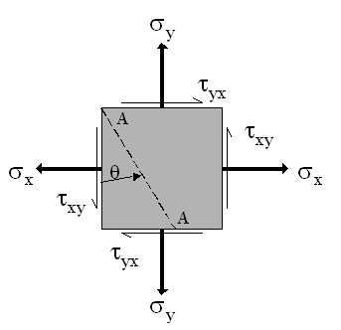

Figure 8.1.1 Normal and shear stresses acting on a two-dimensional differential element.

The roots of Mohr's circle for plane stress lie in the following equations

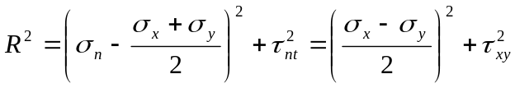

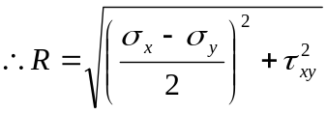
These expressions are shown graphically in the Mohr's circle diagram in Figure 8.1.2 where we assume that 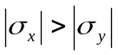 and we adopt the convention that the shear stress pointing clockwise (counterclockwise) on the element is positive (negative.)
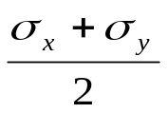
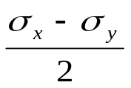
O
S
C
T
V'
F'
P₁
F
Y(σ_{y}, τ_{yx})

P₂

Figure 8.1.2 Mohr circle representation of stresses acting on a differential element.

8.2. Graphical Review for Strain

The roots of Mohr's circle for plane strain lie in the following equations:

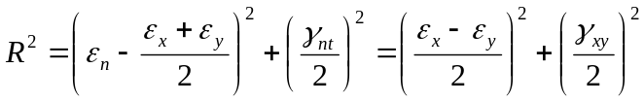

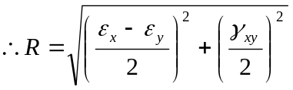

Following the same assumption and convention as for stress, but noting that shear strains appear as 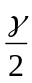, the graphical representation of these equations can be seen in Figure 8.2.1.

When the Mohr's circles for plane stresses and plane strains are combined, a powerful tool for finding principal stresses and strains is formed. Alternatively, one can transform either stresses or strains and then employ the constitutive law to find the transformed strains or stresses, respectively.

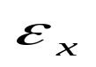
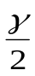
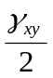
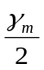
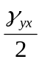
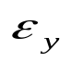
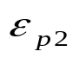
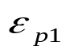
2θ
ε
O
Y
X

Figure 8.2.1 Mohr circle representation of strains acting on a differential element.

Example 8.2.1 A plane element is subject to the stresses as shown in the Figure 8.2.2. Determine the principal stresses and their directions. Also determine the maximum shearing stresses and the directions of the planes in which they occur.

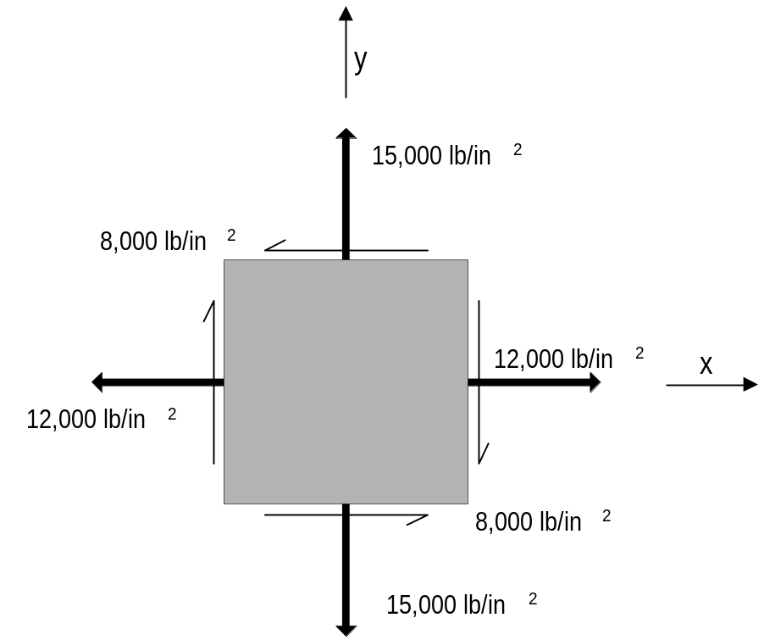
Figure 8.2.2 Stresses acting on a plane element.

Based on the convention that clockwise rotation is viewed as "positive" and counterclockwise rotation is viewed as "negative", the shear forces on the vertical faces are positive in this example while those on the horizontal faces are negative.

Therefore, the stress on the vertical faces can be represented as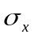= 12,000 lb/in²,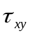= 8000 lb/in² (point X). The stress on the horizontal faces can be represented as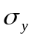= 15,000 lb/in²,= -8000 lb/in² (point Y).

Graphical solution using Mohr’s circle

Figure 8.2.3 shows the Mohr circle construction for given stresses acting on the element. When the two points are plotted and connected, they form the diameter of the Mohr's circle. The center of the circle (point C) is located where the diameter crosses the normal stress axis. The principal stresses are the maximum/minimum points located where the Mohr's circle intersects the normal stress axis, the line of zero shear stress (which is a characteristic of a principal stress). Points P₁ and P₂ in Figure 8.2.3 represent the maximum and minimum principal stresses respectively.

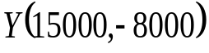
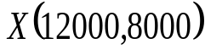
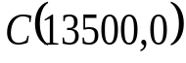
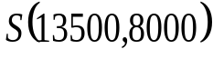
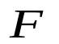
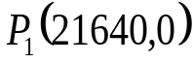
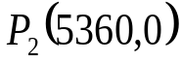
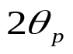
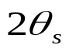
O
Normal stress
Shear
stress

Figure 8.2.3 Two dimensional Mohr circle solution for Example 8.2.1

The points P₁ and P₂ can be determined mathematically by finding out the location of the center of the circle and the radius of the Mohr’s circle. The center of the circle, C is located at the average of the two normal stress values while the radius corresponds to the distance of center from either of the two points X or Y.

We have 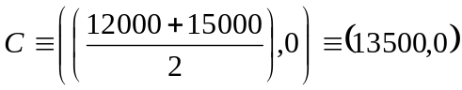lbs/in².
Using CF (= 15000-13500 = 1500 lbs/in²) and FY (= -8000 lbs/in²), we get the radius of the Mohr’s circle as R (= CX = CY) = 8140 lbs/in².

The minimum and maximum principal stresses are given by,

lbs/in²
lbs/in²

The angle through which the element must be rotated to achieve the principal stress state (i.e. no shear stress acting on the element) is denoted in Figure 8.2.3 as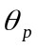. From the Mohr’s circle diagram, we have
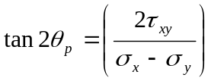or= 39.7°.
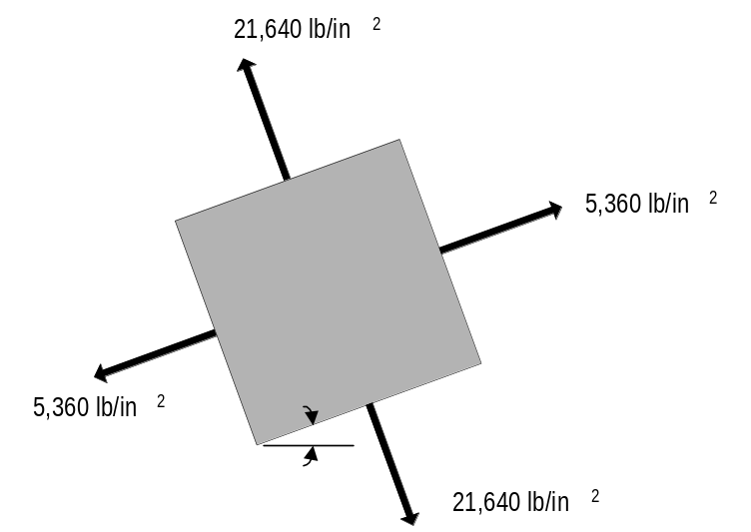
The above results when applied to the element as shown in Figure 8.2.4 represents the principle stress state of the element inclined at angle where the only stresses acting on the element faces are the maximum and minimum principal stresses. No shear stress acts on the element in this state.
39.7°
Figure 8.2.4 Principal stress state for element in Example 8.2.1

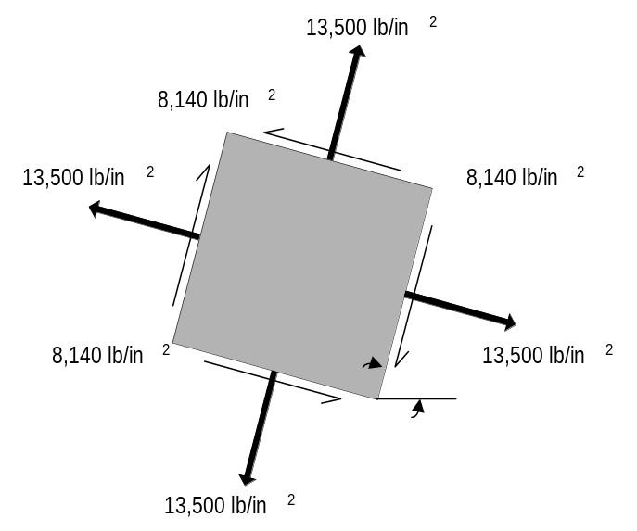
Point S in Figure 8.2.3 represents the maximum shear stress acting on the element. In this case, the maximum shear stress is equal to 8140 lb/in². The orientation of the element to achieve maximum shear stress state is denoted by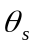, where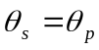+ 45° = 84.7°. The shear stress in this direction is positive and tends to twist the element in a clockwise direction. It can also be determined from Mohr's circle that the normal stress in both directions is equal to 13,500 lb/in² when the element is under the maximum shear stress as shown in Figure 8.2.5.
84.7°

Figure 8.2.5 Maximum shear stress state for element in Example 8.2.1

While a good visual method of transforming stress components, the Mohr’s circle graphical method of stress transformation to the principal planes is applicable only to two-dimensional stress state and hence used for plane problems only. For the three-dimensional stress transformation problem we need to use the matrix method described in the next section.

8.3. Theory of Matrix Method for Stress Calculations in 2-D

From the rotational transformation (Equation 7.11), we obtain the following:

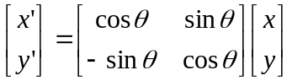 or 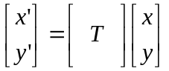 (8.3.1)

Inversely,
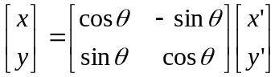 or 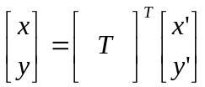 (8.3.2)

where the notation for the transformation is now 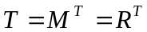.

Furthermore,
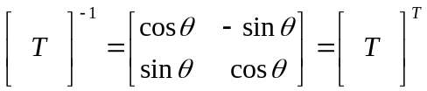 (8.3.3)

so that the second set can be obtained from the first:
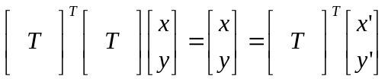

The use of the inverse or transpose of the rotational transformation matrix will be used below. These matrices will play a vital role in the calculations of the stress states in an element.

Figure 8.3.1 represents the convention for the positive directions the stress components acting on a two-dimensional differential element.

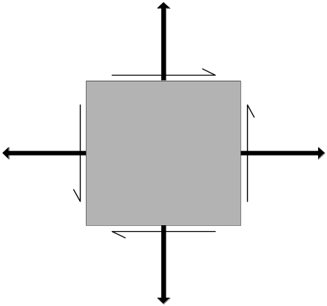
τ_{xy}

σ_{x}
τ_{yx}

σ_{x}
σ_{y}

τ_{yx}

τ_{xy}

σ_{y}

Figure 8.3.1 Positive stresses acting on a two-dimensional differential element.

If theorcomponents are directed towards the element or the components are oriented in the opposing directions, they should be given negative values following this convention.
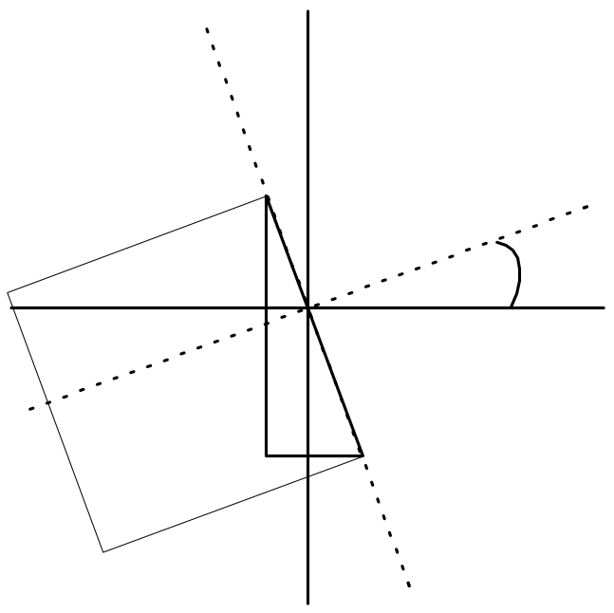
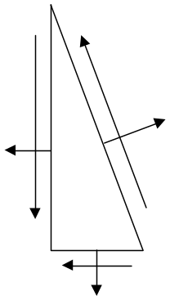
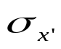
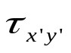
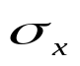
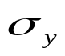
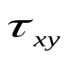
The matrix representation for this stress state is given by: 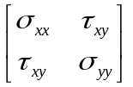
X
θ
Y
Y'
X'
AC = Area A
AB = A cos θ
BC = A sin θ
A
B
C
θ
θ

Figure 8.3.2 Stress transformation along x' axis.
The stress transformations along the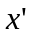- axis can be derived for the element shown in Figure 8.3.2 using matrix manipulation and the fact that equilibrium requires that the sum of the forces be equal to zero.

Force transformations from x-, y- axes to -, 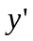- axes are as follows:

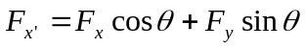
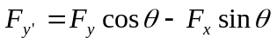

Using 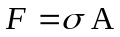 and force equilibrium equation,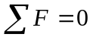 we obtain expressions for stress transformations as follows:

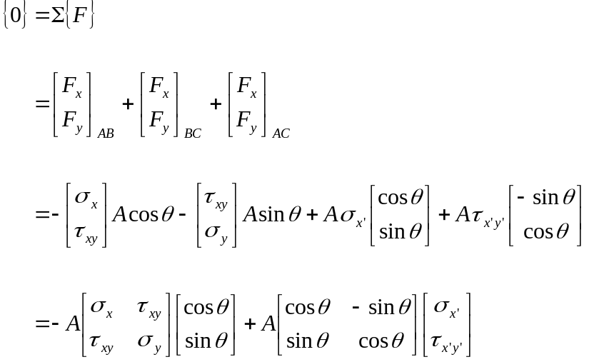

Canceling area A out and pre-multiplying by transformation T, we have

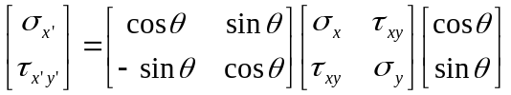 (8.3.4)

where 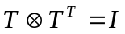, the identity matrix. The order of the matrix multiplication does matter in the final outcome.

The same logic can be used for the stresses on the y' face as illustrated in Figure 8.3.3.

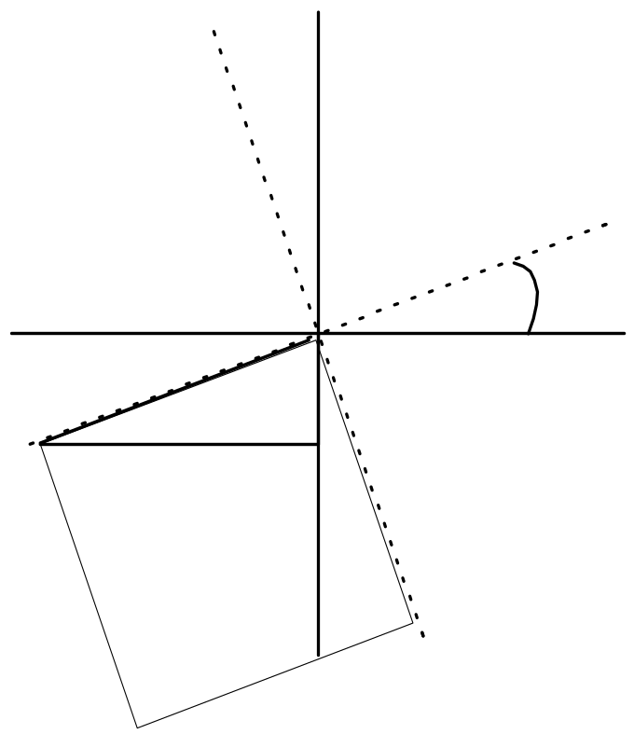
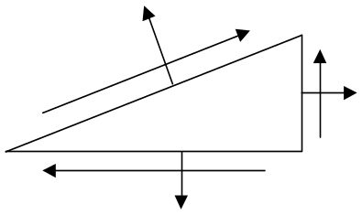
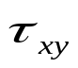
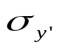
Figure 8.3.3 Stress transformation along y' axis.
Y
Y'
X
X'
θ
θ
B
C
D
BD = Area A
BC = A cos θ
CD = A sin θ
θ

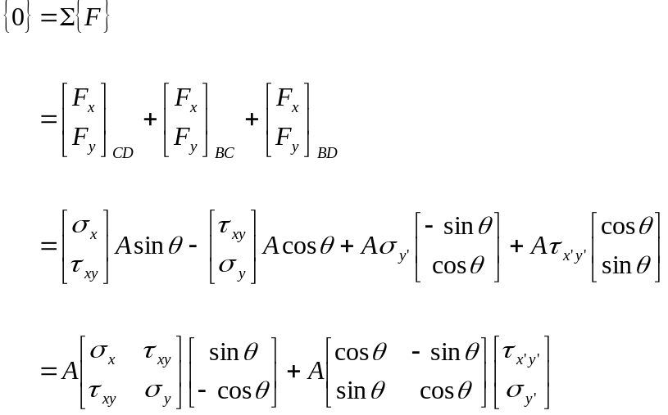

Canceling area A out and pre-multiplying by transformation T, we have

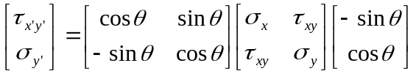 (8.3.5)

Combining expressions (8.3.4) and (8.3.5) we get the following expression for stress transformations as:
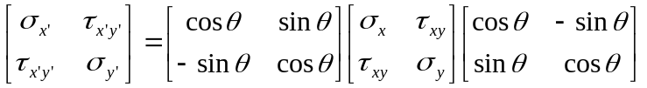 (8.3.6)

or 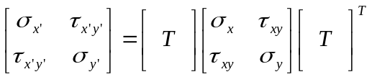

Problems involving different stress states can be calculated quickly and efficiently using
MATLAB to solve the above equation.

8.4. Principal Stress State using the Matrix method

As stressed earlier, the Mohr’s circle graphical solution to determine the principal stress state can be applied only to a plane stress problem in two-dimensions. For the principal stress problem in three-dimensions, we need to use the matrix method of stress transformations explained in the previous section.

Consider a three-dimensional element in the form of a tetrahedron as shown in Figure 8.4.1 where the inclined face ABC has only normal stress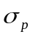 acting on it (Shear stress on inclined face,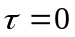). The stresses acting on the normal faces are as shown in the Figure.
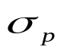
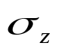
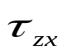
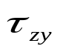
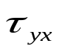
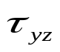
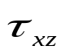
y
x
z
A
B
C
D

Figure 8.4.1 Principal stress state for a differential element in a three-dimensional stress state

Let 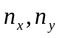 and 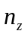be the direction cosines of the normal vector to surface ABC with respect to x, y, and z directions respectively. Hence we have if, Area (ABC) = A, then
Area (BCD) = 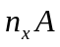, Area (ACD) = 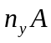, and Area (ABD) = 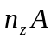.

Using and force equilibrium equations for each direction, we obtain expressions for stress transformations to the principal stress state as follows:

Canceling the areas A and combining the terms with same direction cosines allows us to rewrite the above equations in the matrix form as follows:

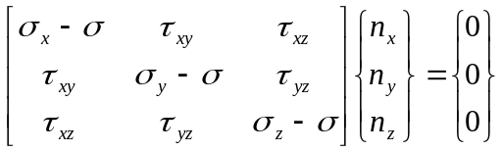 (8.4.1)
The trivial solution for equation 8.4.1, 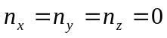 is not possible since the direction cosines satisfy the relation,
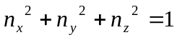 (8.4.2)

Hence the solution for the principal stresses and their directions can be found from the solution of the standard eigenvalue problem represented by equations 8.4.1 and 8.4.2. The three eigenvalues correspond to the three principal stresses,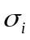, =1, 2, 3. For each there corresponds an eigenvector, namely the direction cosines 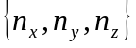 that define the orientation of the principal plane. Standard mathematical software such as MATLAB or Mathematica can be used to solve the eigenvalue problem.

Example 8.4.1. Solve example 8.2.1 using Matrix method and eigenvalue problem

function prin_stress_example

sigmax=12000; sigmay=15000; tauxy=8000;
original_stress=[sigmax tauxy; tauxy sigmay];

[Vectors, Principal] = eig (original_stress); %Eigen value function in MATLAB

principal_stress = Principal %Principal stresses
Value = Vectors (2,1)/Vectors (1,1); % Slope of eigenvector is a ratio of its (y/x)-components
RadianOrientation = atan (Value);
PrincipalOrientation = RadianOrientation * (180/pi) %Principal stress orientation in degrees

ShearTheta = RadianOrientation - (pi/4);
MaxShearOrientation = ShearTheta*(180/pi) %Maximum shear stress orientation in degrees

T=[cos (ShearTheta) sin (ShearTheta); sin (ShearTheta) cos (ShearTheta)]; % Transformation matrix

Maxshear = T*original_stress*transpose (T) % Calculating Maximum shear using Matrix method

Answers:

Principal_stress = 1.0e+004 * 0.5361 0
0 2.1639

PrincipalOrientation = -39.6902

MaxShearOrientation = -84.6902

Maxshear = 1.0e+004 * 1.3500 0.5512
0.5512 1.0551

Directions for Stress Transformations in MATLAB

NOTE: MATLAB variables are case sensitive.

1. Enter the stress matrix with the following syntax:

OrigStress = [σ_{xx}, τ_{xy}; τ_{xy}, σ_{yy}]

2. Find the eigenvalues and eigenvectors of the corresponding matrix to find the principal stresses.

[Vectors, Principal] = eig(OrigStress)

3. Divide Vectors(2,1) by Vectors(1,1) and take the arctan of the result. Note: the vector in column 1 is associated with the (1,1) principal stress.

Value = Vectors(2,1)/Vectors(1,1)

RadianOrientation = atan(Value)

4. The result of the previous calculations will provide the orientation in radians. To convert this value to degrees, multiply by 180/π.

PrincipalOrientation = RadianOrientation * 180 / pi

5. The maximum shear occurs 45 degrees from the principal state.

MaxShearOrientation = PrincipalOrientation - 45°

ShearTheta = MaxShearOrientation * pi / 180

6. The transformation matrix to calculate the maximum shear is:

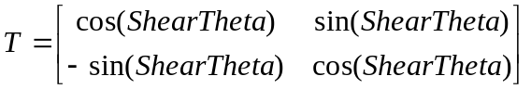

7. The value of the maximum shear stress can be found by multiplying the following matrices:

The value that appears twice in the resulting matrix is the value of the maximum shear stress oriented in the direction found in the previous step.

Example done in MATLAB

EDU» OrigStress = [-10,35;35,50]

OrigStress =

-10 35
35 50

EDU» [Vectors,Principal]=eig(OrigStress)

Vectors =

0.9085 0.4179
-0.4179 0.9085

Principal =

-26.0977 0
0 66.0977

EDU» Value=Vectors(2,1)/Vectors(1,1)

Value =

-0.4599

EDU» RadianOrientation=atan(Value)

RadianOrientation =

-0.4311

EDU» PrincipalOrientation=RadianOrientation*180/pi

PrincipalOrientation =

-24.6994

EDU» MaxShearOrientation=PrincipalOrientation-45

MaxShearOrientation =

-69.6994

EDU» ShearTheta=MaxShearOrientation*pi/180

ShearTheta =

-1.2165

EDU» T=[cos(ShearTheta),sin(ShearTheta);-sin(ShearTheta),cos(ShearTheta)]

T =

0.3469 -0.9379
0.9379 0.3469

EDU» Ttrans=[cos(ShearTheta),-sin(ShearTheta);sin(ShearTheta),cos(ShearTheta)]

Ttrans =

0.3469 0.9379
-0.9379 0.3469

EDU» MaxShear = T*OrigStress*Ttrans

MaxShear =

20.0000 -46.0977
-46.0977 20.0000

EDU» Principal

Principal =

-26.0977 0
0 66.0977

EDU» PrincipalOrientation

PrincipalOrientation =

-24.6994

EDU» MaxShear

MaxShear =

20.0000 -46.0977
-46.0977 20.0000

EDU» ShearTheta

ShearTheta =

-1.2165

