Code
package test2;
import com.mongodb.client.*;
import com.mongodb.client.model.Filters;
import com.mongodb.client.model.Updates;
import org.bson.Document;
public class MongoCRUDExample {
public static void main(String[] args) {
// Connect to MongoDB
MongoClient mongoClient = MongoClients.create("mongodb://localhost:27017");
// Access database
MongoDatabase database = mongoClient.getDatabase("CollegeDB");
// Access collection
MongoCollection<Document> collection =
database.getCollection("Students");
// ==========================
// CREATE (Insert)
// ==========================
Document student = new Document("id", 101)
.append("name", "John")
.append("department", "CSE")
.append("cgpa", 8.7);
collection.insertOne(student);
System.out.println("Document Inserted Successfully");
// ==========================
// READ (Find)
// ==========================
System.out.println("\nStudent Records:");
FindIterable<Document> students = collection.find();
for (Document doc : students) {
System.out.println(doc.toJson());
}
// ==========================
// UPDATE
// ==========================
collection.updateOne(
Filters.eq("id", 101),
Updates.set("cgpa", 9.2)
);
System.out.println("\nDocument Updated Successfully");
// ==========================
// READ Updated Record
// ==========================
Document updatedStudent =
collection.find(Filters.eq("id", 101)).first();
System.out.println("\nUpdated Record:");
System.out.println(updatedStudent.toJson());
// ==========================
// DELETE
// ==========================
collection.deleteOne(Filters.eq("id", 101));
System.out.println("\nDocument Deleted Successfully");
// Close connection
mongoClient.close();
}
}
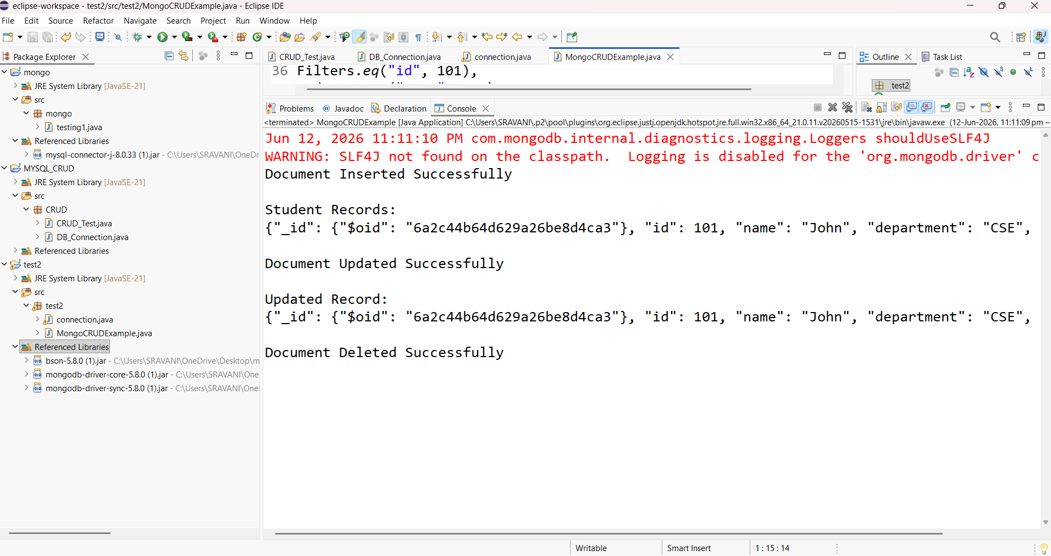

package test2;
import com.mongodb.client.*;
import com.mongodb.client.model.Filters;
import com.mongodb.client.model.Updates;
import org.bson.Document;
public class MongoCRUDExample {
public static void main(String[] args) {
// Connect to MongoDB
MongoClient mongoClient = MongoClients.create("mongodb://localhost:27017");
// Access database
MongoDatabase database = mongoClient.getDatabase("CollegeDB");
// Access collection
MongoCollection<Document> collection =
database.getCollection("Students");
// ==========================
// CREATE (Insert)
// ==========================
Document student = new Document("id", 101)
.append("name", "John")
.append("department", "CSE")
.append("cgpa", 8.7);
collection.insertOne(student);
System.out.println("Document Inserted Successfully");
// ==========================
//CREATE (INSERT Many)

collection.insertMany(java.util.Arrays.asList(

new Document("id", 111).append("name", "kyathi").append("department", "ece"),

new Document("id", 112).append("name", "sravani").append("department", "cse"),

new Document("id", 113).append("name", "arav").append("department", "eee")

));
// READ (Find)
// ==========================
System.out.println("\nStudent Records:");
FindIterable<Document> students = collection.find();
for (Document doc : students) {
System.out.println(doc.toJson());
}
// ==========================
// UPDATE
// ==========================
collection.updateOne(
Filters.eq("id", 101),
Updates.set("cgpa", 9.2)
);
System.out.println("\nDocument Updated Successfully");
// ==========================
// READ Updated Record
// ==========================
Document updatedStudent =
collection.find(Filters.eq("id", 101)).first();
System.out.println("\nUpdated Record:");
System.out.println(updatedStudent.toJson());
// ==========================
// DELETE
// ==========================
collection.deleteOne(Filters.eq("id", 101));
System.out.println("\nDocument Deleted Successfully");
// Close connection
mongoClient.close();
}
}

