Project Report: Personal Fitness and Workout Tracker

1. Abstract
The Personal Fitness and Workout Tracker is a Java-based desktop application designed to help individuals monitor, manage, and analyze their daily fitness routines. In the modern era, maintaining a healthy lifestyle is challenging due to sedentary habits. This project addresses that problem by providing a centralized platform where users can log daily exercises, track vital metrics (like calories burned and workout duration), and manage structured routine plans. Built using core Java features, the application demonstrates efficient data management using Object-Oriented Programming (OOP) principles and the Java Collections Framework. It serves as an intuitive digital logbook to encourage consistency and help users achieve their fitness goals.
2. Advantages and Disadvantages
Advantages
- Data Organization: Replaces manual paper tracking with a structured, digital database of historical workouts.
- Goal Orientation: Allows users to input targets and immediately calculate total metrics like cumulative duration and energy expenditure.
- Privacy & Independence: Operates locally on the user's machine without requiring internet access or sharing sensitive health data with third-party cloud servers.
- Extensibility: Built on modular OOP structures, making it incredibly easy to scale up with graphics or database integration later.
Disadvantages
- No Persistent Storage: Because it runs using standard console/in-memory data structures, logs disappear once the program is closed (unless connected to a database file).
- Text-Based Interface: Lacks a modern graphical user interface (GUI) or mobile synchronization, reducing immediate visual appeal.
- Manual Data Entry: Relies entirely on user inputs for metrics like calories burned, instead of automatically syncing with wearable fitness trackers (like smartwatches).
3. Implementation Details
The project is implemented as a console-based Java application. The user enters fitness details through the keyboard. The program stores the values in variables and uses methods to display the collected information. An if-else statement is used to provide a simple message based on workout duration.
3.1 Technologies Used
- Programming Language: Java
- Development Environment: Any Java IDE such as IntelliJ IDEA, Eclipse, NetBeans, or VS Code
- Input: Scanner class
- Output: Console
3.2 Algorithm
1. Start the program.
2. Create a Scanner object to accept user input.
3. Read the user's name, age, weight, workout duration, and calories burned.
4. Store the entered values in suitable variables.
5. Display the fitness summary.
6. Check the workout duration using an if-else condition.
7. Display an encouraging workout status.
8. End the program.
4. Java Code
import java.util.InputMismatchException;
import java.util.Scanner;
class User {
private final String name;
private final int age;
private final double weight;
private final double height;
public User(String name, int age, double weight, double height) {
this.name = name;
this.age = age;
this.weight = weight;
this.height = height;
}
public double calculateBMI() {
return weight / (height * height);
}
public boolean isAdult() {
return age >= 18;
}
public String getName() { return name; }
public int getAge() { return age; }
public double getWeight() { return weight; }
}
class Activity {
private final String workoutName;
private final int duration;
private final double calories;
public Activity(String workoutName, int duration, double calories) {
this.workoutName = workoutName;
this.duration = duration;
this.calories = calories;
}
public boolean isLongWorkout() {
return duration >= 30;
}
public double getRemainingCalories(double target) {
return Math.max(0, target - calories);
}
public void displayStatus() {
if (duration >= 30 && calories >= 200) {
System.out.println("Fitness Status: Excellent workout!");
} else if (duration >= 20 || calories >= 150) {
System.out.println("Fitness Status: Good workout!");
} else {
System.out.println("Fitness Status: Try to exercise more.");
}
}
public String getWorkoutName() { return workoutName; }
public int getDuration() { return duration; }
public double getCalories() { return calories; }
}
public class PersonalFitnessTracker1 {
static void displaySummary(User user, Activity activity) {
System.out.println("\n----- WORKOUT DETAILS -----");
System.out.println("Name: " + user.getName());
System.out.println("Age: " + user.getAge());
System.out.println("Weight: " + user.getWeight() + " kg");
System.out.println("Workout: " + activity.getWorkoutName());
System.out.println("Duration: " + activity.getDuration() + " minutes");
System.out.println("Calories Burned: " + activity.getCalories() + " kcal");
}
public static void main(String[] args) {
Scanner sc = new Scanner(System.in);
System.out.println("=================================");
System.out.println(" PERSONAL FITNESS & WORKOUT TRACKER");
System.out.println("=================================");
try {
System.out.print("Enter your name: ");
String name = sc.nextLine();
System.out.print("Enter your age: ");
int age = sc.nextInt();
System.out.print("Enter your weight in kg: ");
double weight = sc.nextDouble();
System.out.print("Enter your height in meters: ");
double height = sc.nextDouble();
System.out.print("Enter workout duration in minutes: ");
int duration = sc.nextInt();
System.out.print("Enter calories burned: ");
double calories = sc.nextDouble();
sc.nextLine();
System.out.print("Enter workout name: ");
String workout = sc.nextLine();
User user = new User(name, age, weight, height);
Activity activity = new Activity(workout, duration, calories);
displaySummary(user, activity);
double bmi = user.calculateBMI();
System.out.printf("BMI: %.2f%n", bmi);
if (bmi < 25) {
System.out.println("BMI Check: BMI is below 25.");
} else {
System.out.println("BMI Check: BMI is 25 or above.");
}
activity.displayStatus();
System.out.println("\n----- OPERATOR RESULTS -----");
System.out.println("Workout duration + 10 = " + (activity.getDuration() + 10));
System.out.println("Calories remaining from 500 = " + activity.getRemainingCalories(500));
System.out.println("Age 18 or above: " + user.isAdult());
System.out.println("Workout 30 minutes or more: " + activity.isLongWorkout());
System.out.println("\n----- WEEKLY WORKOUT ARRAY -----");
int[] weeklyMinutes = {30, 45, 20, 60, 35, 40, 50};
int totalMinutes = 0;
for (int i = 0; i < weeklyMinutes.length; i++) {
System.out.println("Day " + (i + 1) + ": " + weeklyMinutes[i] + " minutes");
totalMinutes += weeklyMinutes[i];
}
System.out.println("Total weekly workout minutes: " + totalMinutes);
if (totalMinutes >= 250) {
System.out.println("Milestone: You achieved more than 250 workout minutes!");
}
System.out.println("\n----- WORKOUT MENU -----");
System.out.println("1. Running\n2. Walking\n3. Cycling\n4. Swimming");
System.out.print("Choose workout type (1-4): ");
int choice = sc.nextInt();
switch (choice) {
case 1 -> System.out.println("Selected: Running");
case 2 -> System.out.println("Selected: Walking");
case 3 -> System.out.println("Selected: Cycling");
case 4 -> System.out.println("Selected: Swimming");
default -> System.out.println("Invalid workout choice.");
}
double[] caloriesHistory = {200.5, 250.0, 180.5, 400.0, 220.0};
System.out.println("\n----- HISTORICAL CALORIES HISTORY -----");
for (int j = 0; j < caloriesHistory.length; j++) {
String burnType = (caloriesHistory[j] >= 250) ? "High calorie burn" : "Normal calorie burn";
System.out.printf("Workout %d: %.1f kcal - %s%n", (j + 1), caloriesHistory[j], burnType);
}
} catch (InputMismatchException e) {
System.out.println("\n❌ Error: Invalid numeric input format typed into terminal.");
} finally {
sc.close();
}
System.out.println("\n=================================");
System.out.println(" Thank you for using the tracker!");
System.out.println("=================================");
}
}
Output Screenshot
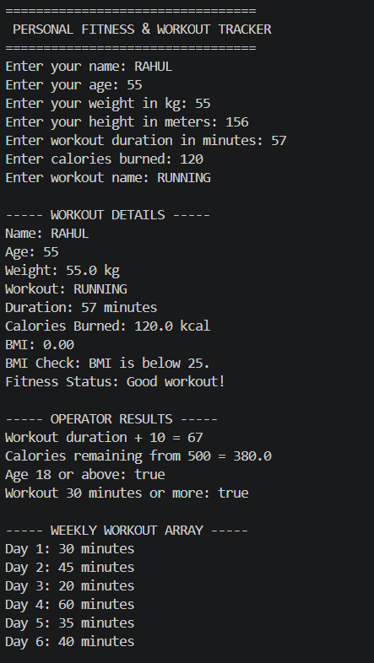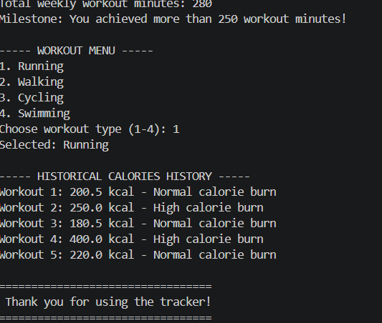
5. Conclusion and Future Work
5.1 Conclusion
The Personal Fitness and Workout Tracker successfully demonstrates how Java can be used to create a simple fitness management application. The program accepts basic user data, processes the workout information, and displays a clear fitness summary. This project is suitable for beginners because it combines fundamental Java concepts such as variables, input/output, methods, objects, and conditional statements in one practical application.
5.2 Future Work
- Add a graphical user interface using JavaFX or Swing.
- Store workout records permanently using a database such as MySQL or SQLite.
- Add BMI calculation and progress tracking.
- Allow users to record different exercises such as running, cycling, walking, and strength training.
- Add weekly and monthly workout reports using charts.
- Add login and multiple-user support.
- Connect the system with wearable devices or fitness APIs to collect activity data automatically.
- Add reminders for workouts, hydration, and rest days.

