**Part 1: PREDICTIVE ANALYSIS RFM**

**TASK 2**

*a. Define PVA97NK as a data source in SAS Enterprise Miner. Use the Advanced Metadata Advisor*

*options to customize the following:*

• Change the Class Levels Count Threshold from 20 to 5.

• Change the Reject Levels Count Threshold from 20 to 80.

• Reject the variable TargetD.

*b. Create a new diagram and transform the R, F, and M variables as described previously to create four*

*bins of each variable. Concatenate them to create an RFM variable.*

Variable GiftTimeLast_Rev = -1*GiftTimeLast

Create a new variable for Monetary value. Variable TotalGiftAmount = GiftAvgAll*GiftCntAll

BinRFM variables

RFM

*c. Explore the data and perform graphical RFM analysis using a grouped pie chart and a stacked bar*

*chart.*

The inner ring of the pie represents non-responders to target gift flag , and the outer ring shows responders to target gift flag. The area of each slice demonstrates the relative proportion of responders and non-responders to gift flag in each RFM group.

The grouped bar chart shows the number of observations in each RFM group as the height of the bar,

with the upper portion representing the portion of response. The lower portion of the bar is

the proportion of non-responders to the target gift flag.

The 26th bar from the left has a relatively high proportion of responders and this makes sense because it’s in the group 04 (Recency)04(Frequency)04(Monetary Value).

*d) Calculate response rate for 040404 and 030303 group?*

There are 359 responders in group 040404.

There are 188 non- responders in group 040404.

The response rate for the 040404 group is 359 / (188+359) = 65.63%.

There are 224 responders in group 030303.

There are 219 non- responders in group 030303.

The response rate for the 030303 group is 224 / (219+224) = 50.56%.

*e. Each promotional mailing (request for a gift) costs $2.3, and the average donation is about $21 What*

*is the break-even response rate for this promotion? Do any RFM cells exceed this response rate?*

*Remember to account for the fact that in the population, 95% of mailings are not responded to, while*

*this sample is oversampled to 50% responders and 50% non-responders.*

The break-even response rate for this promotion is 10.95%. Many RFM cells exceed this response rate such as 030303 and 040404.

**Part 2: PREDICTIVE MODLING**

**TASK 3: ORGANICS DATASET**

*1. Set the roles for the analysis variables as shown above.*

*2. Examine the distribution of the target variable.*

The proportion of individuals who purchased organic products is 24.7716%

*3. The variable DemClusterGroup contains collapsed levels of the variable DemCluster. Presume that, based on previous experience, you believe that DemClusterGroup is sufficient for this type of modeling effort. Set the model role for DemCluster to Rejected.*

*4. As noted above, only* ***TargetBuy*** *is used for this analysis, and it should have a role of* ***Target****.*

*Can* ***TargetAmt*** *be used as an input for a model that is used to predict* ***TargetBuy****? Why or*

*why not?*

No, because **TargetAmt** implies a buy, therefore, it cannot be used to predict **TargetBuy.** Adding this variable to the model will cause a perfect collinearity between **TargetAmt** variable and **TargetBuy** target variable.

*c. Add the* ***ORGANICS*** *data source to the Organics diagram workspace.*

d*. Add a* ***Data Partition*** *node to the diagram and connect it to the* ***Data Source*** *node. Assign 65%*

*of the data for training and 35% for validation.*

*e. Add a* ***Decision Tree*** *node to the workspace and connect it to the* ***Data Partition*** *node.*

*f. Create a* ***decision tree*** *model autonomously. Use* ***Misclassification*** *as the model assessment*

*statistic.*

1. How many leaves are in the optimal tree? 14 leaves

*2. Which variables were used for the first split?*

Age variable is used for the first split. Age < 44.5 and Age >= 44.5 or Missing

*What were the competing splits for this first split?*

Affluence Grade (importance = 0.7806) and Gender (importance = 0.5184)

*3. Which variables were used for the second split for all branches from first split?*

Affluence Grade was used for the second split for all branches from the first split. The cutoff value for affluence grade for the left node is affluence grade < 9.5 and >= 9.5 or Missing. The cutoff vale for the right node is affluence grade < 12.5 or Missing or >= 12.5.

*4. Discuss the results and provide your insights*

This is a complex tree with 51 nodes in total and nodes are reused to split as needed. Affluence grade variable also was also used multiple times (node 2,3,7,9,10,20), with different cutoff values to split the nodes.

***g.*** *Add a second* ***Decision Tree*** *node to the diagram and connect it to the* ***Data Partition*** *node.*

*1. In the Properties panel of the new Decision Tree node, change the maximum number of*

*branches from a node to 3 to allow for three-way splits.*

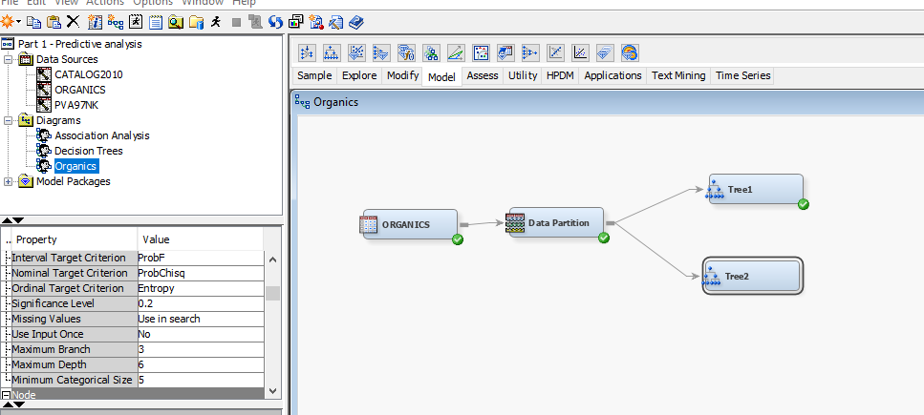

*2. Create a decision tree model using* ***Misclassification*** *as the model assessment statistic.*

*3. How many leaves are in the optimal tree?*

16 leaves in tree2

***h.*** *Based on* ***Misclassification rate****, which of the decision tree models appears to be better?*

Tree2 has a slightly higher Misclassification rate than Tree1 0.18858 compared to 0.18380.

**Part 3: PREDICTIVE MODELING USING LOGISTIC REGRESSION**

Review the **CATALOG2010** data set.

Cluster variables according to their similarities.

Run the **Variable Clustering** node. View the results.

Summary of the final cluster solution

Estimate a logistic regression model.

Standard output for Logistics regression

The output below shows the results of the final model

The assessment statistics for the validation data set for the 5th percentile, the10th percentile, and so on.

View model performance across the fitted models.

View the misclassification rate.

Run the Model Comparison node and view the results.

