The University of North Carolina at Charlotte



**THE GOLFER´S LINK**

**Group Case Study**

Course: Supply Chain Analytics

Authors:

Ezi Tsogli, Luis Mendez, Lenka Raslova, Yawo Eklou

Charlotte, 2022

**Question 1: Create a spreadsheet model for this problem and solve it. What is the optimum solution?**

The model described in the problem has following variables:

$TM$ number of men's golf sets produced in Tempe,

$TW$ number of women's golf sets produced in Tempe,

$TJ$ number of juniors’ golf sets produced in Tempe,

$DM$ number of men's golf sets produced in Daytona,

$DW$ number of women's golf sets produced in Daytona,

$MW$ number of women's golf sets produced in Memphis,

$MJ$ number of juniors’ golf sets produced in Memphis,

$M_{ij} for i ∈1,2,3 for j ∈1,2,3$ number of men's golf sets delivered from production place *j* (Tempe, Daytona, Memphis) to subscriber *i* (Sacramento, Denver, Pittsburgh),

$W_{ij} for i ∈1,2,3 for j ∈1,2,3$ number of women's golf sets delivered from production place *j* (Tempe, Daytona, Memphis) to subscriber *i* (Sacramento, Denver, Pittsburgh),

$J_{ij} for i ∈1,2,3 for j ∈1,2,3$ number of juniors´ golf sets delivered from production place *j* (Tempe, Daytona, Memphis) to subscriber *i* (Sacramento, Denver, Pittsburgh),

$CM_{ij} for i ∈1,2,3 for j ∈1,2,3$ costs for delivering of men's golf sets between production place *j* (Tempe, Daytona, Memphis) and subscriber *I* (Sacramento, Denver, Pittsburgh),

$CW_{ij} for i ∈1,2,3 for j ∈1,2,3$ costs for delivering of women's golf sets between production place *j* (Tempe, Daytona, Memphis) and subscriber *i* (Sacramento, Denver, Pittsburgh),

$CJ_{ij} for i ∈1,2,3 for j ∈1,2,3$ costs for delivering of juniors´ golf sets between production place *j* (Tempe, Daytona, Memphis) and subscriber *i* (Sacramento, Denver, Pittsburgh),

The linear formulation of model that is described in the case study has following form:

MAX: profit = total revenue-total costs

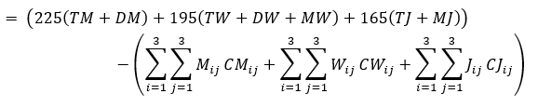

Subjected to:

Production Tempe

$2.9TM+2.7TW+2.5TJ≤14500$

$4.5TM+4TW+5TW≤19000$

$5.4TM+5TW+4.8TW≤18000$

Production Daytona

$2.9DM+2.7DW≤4500$

$4.5DM+4DW≤6000$

$5.4DM+5DW≤9500$

Production Memphis

$2.7MW+2.5MJ≤8500$

$4MW+5MW≤12000$

$5MW+4.8MW≤16000$

Transportation Men

$M_{11}+M_{12}+M_{13}≤700$

$M_{11}+M_{12}+M_{13}≥630$

$M_{21}+M_{22}+M_{23}≤550$

$M_{21}+M_{22}+M_{23}≥495$

$M_{31}+M_{32}+M_{33}≤900$

$M_{31}+M_{32}+M_{33}≥810$

$M_{11}+M_{21}+M_{31}=TM$

$M_{12}+M_{22}+M_{32}=DM$

$M_{13}+M_{23}+M_{33}=0$

Transportation Women

$W_{11}+W_{12}+W_{13}≤900$

$W_{11}+W_{12}+W_{13}≥810$

$W_{21}+W_{22}+W_{23}≤1000$

$W_{21}+W_{22}+W_{23}≥900$

$W_{31}+W_{32}+W_{33}≤1200$

$W_{31}+W_{32}+W_{33}≥1080$

$W_{11}+W_{21}+W_{31}=TW$

$W_{12}+W_{22}+W_{32}=DW$

$W_{13}+W_{23}+W_{33}=MW$

Transportation Juniors

$J_{11}+J_{12}+J_{13}≤900$

$J_{11}+J_{12}+J_{13}≥810$

$J_{21}+J_{22}+J_{23}≤1500$

$J_{21}+J_{22}+J_{23}≥1350$

$J_{31}+J_{32}+J_{33}≤1100$

$J_{31}+J_{32}+J_{33}≥990$

$J_{11}+J_{21}+J_{31}=TJ$

$J_{12}+J_{22}+J_{32}=0$

$J_{13}+J_{23}+J_{33}=MJ$

Table of $CM_{ij}$

|  | Tempe | Daytona | Memphis |
| --- | --- | --- | --- |
| Sacramento | 10 | 51 | 1000000 |
| Denver | 43 | 28 | 1000000 |
| Pittsburg | 56 | 36 | 1000000 |

Table of $CW_{ij}$

|  | Tempe | Daytona | Memphis |
| --- | --- | --- | --- |
| Sacramento | 9 | 49 | 33 |
| Denver | 42 | 27 | 22 |
| Pittsburg | 54 | 34 | 13 |

Table of $CJ_{ij}$

|  | Tempe | Daytona | Memphis |
| --- | --- | --- | --- |
| Sacramento | 8 | 1000000 | 31 |
| Denver | 40 | 1000000 | 21 |
| Pittsburg | 52 | 1000000 | 12 |

If Rick Eldridge decides to apply the optimum solution, then the company will produce 630 men's golf sets, 350.6897 women´s and 2675.948 juniors´ sets in Tempe; 1305 men´s and 31.875 women's sets in Daytona; and 2407.435 women´s and 474.0517 juniors´ sets in Memphis. The distribution between suppliers and subscribers for golf sets is in the tables below:

| **MEN** | Tempe | Daytona | Memphis |
| --- | --- | --- | --- |
| Sacramento | 630 | 0 | 0 |
| Denver | 0 | 495 | 0 |
| Pittsburg | 0 | 810 | 0 |
| **WOMEN** | Tempe | Daytona | Memphis |
| Sacramento | 350.6897 | 0 | 459.3103 |
| Denver | 0 | 31.875 | 868.125 |
| Pittsburg | 0 | 0 | 1080 |
| **JUNIOR** | Tempe | Daytona | Memphis |
| Sacramento | 810 | 0 | 0 |
| Denver | 1350 | 0 | 0 |
| Pittsburg | 515.9483 | 0 | 474.0517 |

The total revenue is $ 1,499,175, the total costs for transportation $ 194,630.8. The optimal profit of this solution will be **$ 1,304,544.246**. If you wish to see the solution in the excel sheet, please open the attached excel file.

**Question 2: If Rick wanted to improve this solution, what additional resources would be needed, and where would they be needed? Explain.**

For Rick to improve this solution he needs to increase the amounts of raw materials. He needs to increase the amount of aluminum at Memphis and Daytona. For Rock Maple, additional resources would be needed at Tempe. For example, aluminum as shown below is showing a constraint for Daytona at 6000, additional resources in aluminum can overcome this constraint. A similar case is shown at Memphis with aluminum, if Rick can provide additional resources of aluminum, Rick can overcome the constraint at Memphis.

**Aluminum**

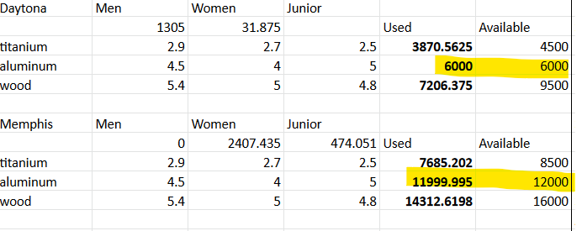

**Rock Maple**

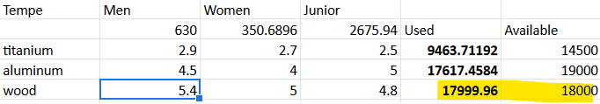

**Question 3: What would TGL’s optimal profit be if they were not required to supply at least 90 % of each distributor’s order?**

If the company was not required to supply at least 90% of each distributor’s order, these constraints (Lower bound production constraints) must be removed from the solver. Therefore the transportation constraints become:

*Transportation Men*

$M_{11}+M_{12}+M_{13}≤700$

$M_{21}+M_{22}+M_{23}≤550$

$M_{31}+M_{32}+M_{33}≤900$

$M_{11}+M_{21}+M_{31}=TM$

$M_{12}+M_{22}+M_{32}=DM$

$M_{13}+M_{23}+M_{33}=0$

*Transportation Women*

$W_{11}+W_{12}+W_{13}≤900$

$W_{21}+W_{22}+W_{23}≤1000$

$W_{31}+W_{32}+W_{33}≤1200$

$W_{11}+W_{21}+W_{31}=TW$

$W_{12}+W_{22}+W_{32}=DW$

$W_{13}+W_{23}+W_{33}=MW$

*Transportation Juniors*

$J_{11}+J_{12}+J_{13}≤900$

$J_{21}+J_{22}+J_{23}≤1500$

$J_{31}+J_{32}+J_{33}≤1100$

$J_{11}+J_{21}+J_{31}=TJ$

$J_{12}+J_{22}+J_{32}=0$

$J_{13}+J_{23}+J_{33}=MJ$

The production is in the below table.

|  | **Production** | | |
| --- | --- | --- | --- |
|  | Men | Women | Junior |
| **Daytone** | 1333.3 | 0 | 0 |
| **Memphis** | 0 | 2200 | 640 |
| **Tempe** | 816.7 | 900 | 1893.8 |

With this production and all the associated cost of transportation, the optimal profit is

**$ 1,349,438.75.**

Details can be found in the excel spreadsheet.

|  |
| --- |

**4. Supposedly, TGL’s agreement included the option of paying a $10,000 penalty if the company cannot supply at least 90% of each distributor’s order, but instead supply at least 80% of each distributor’s order.**

At least 80% of the demand(Number of Club set ordered). Our new constraints for transportation have the following structure (conditions higligeted in the blue color are for 80 %):

Transportation Men

$M_{11}+M_{12}+M_{13}≤700$

$M_{11}+M_{12}+M_{13}≥560$

$M_{21}+M_{22}+M_{23}≤550$

$M_{21}+M_{22}+M_{23}≥440$

$M_{31}+M_{32}+M_{33}≤900$

$M_{31}+M_{32}+M_{33}≥720$

$M_{11}+M_{21}+M_{31}=TM$

$M_{12}+M_{22}+M_{32}=DM$

$M_{13}+M_{23}+M_{33}=0$

Transportation Women

$W_{11}+W_{12}+W_{13}≤900$

$W_{11}+W_{12}+W_{13}≥720$

$W_{21}+W_{22}+W_{23}≤1000$

$W_{21}+W_{22}+W_{23}≥800$

$W_{31}+W_{32}+W_{33}≤1200$

$W_{31}+W_{32}+W_{33}≥960$

$W_{11}+W_{21}+W_{31}=TW$

$W_{12}+W_{22}+W_{32}=DW$

$W_{13}+W_{23}+W_{33}=MW$

Transportation Juniors

$J_{11}+J_{12}+J_{13}≤900$

$J_{11}+J_{12}+J_{13}≥720$

$J_{21}+J_{22}+J_{23}≤1500$

$J_{21}+J_{22}+J_{23}≥1200$

$J_{31}+J_{32}+J_{33}≤1100$

$J_{31}+J_{32}+J_{33}≥880$

$J_{11}+J_{21}+J_{31}=TJ$

$J_{12}+J_{22}+J_{32}=0$

$J_{13}+J_{23}+J_{33}=MJ$

**Profit if TGL applies “meet at least 80% of the demand) strategy**

An additional constraint (binary variable) is created to represent the penalty TGL will have to pay if the any of demands is less than 90%. The penalty is applied only once (even if more places are not able to send at least 90 %).

If (production men < 90% of the demand then penalty)

If (production women < 90% of the demand then penalty)

If (production junior <90% of the demand then penalty)

Objective Function: MAX Profit = revenue - total cost - (10 000*yes/no).

*yes and no is a binary variable (yes = 1, no = 0). If any demand is less than 90 % then this variable value is 1 (we apply the penalty) otherwise 0 (we do not apply the penalty). This variable is added to the objective function:

**All these constraints can be viewed in the excel spreadsheet.**

Number of Club sets Ordered by Sacramento, Denver and Pittsburgh

|  | Men | Women | Junior | Total |
| --- | --- | --- | --- | --- |
| Sacramento | 700 | 900 | 900 | 2500 |
| Denver | 550 | 1000 | 1500 | 3050 |
| Pittsburgh | 900 | 1200 | 1100 | 3200 |

| **Constraints** | **Production Upper Bound(100%)** | **Penalty Applied(<90%)** |
| --- | --- | --- |
| Sacramento | 2500 | **< 2250** |
| Denver | 3050 | **< 2745** |
| Pittsburgh | 3200 | **< 2880** |

The tables below show how many golf sets are distributed from different production places to different customer locations.

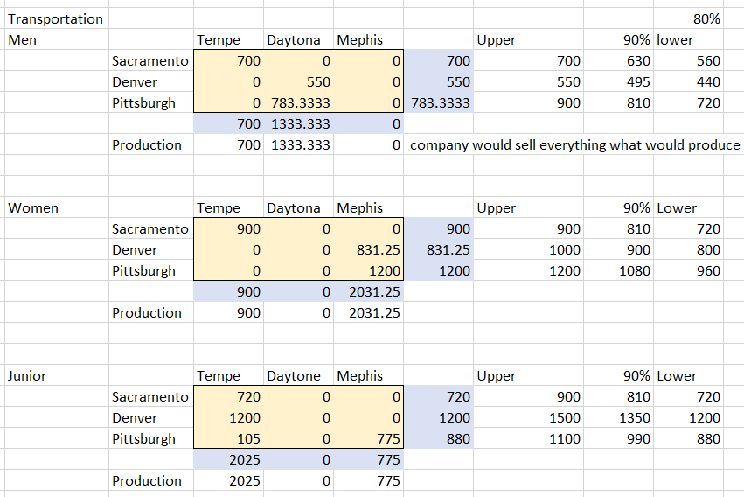

**Pros of this option for TGL:**

The TGL company can make an extra profit of **($1,319,986.25 - $1,304,544.246 = $15442)** when it negotiates the lower bound of the production to 80% compared to 90% production lower bound option. Even if TGL pays the penalty, the profit still increases by **$15442**.

**Cons of this option for TGL:**

The TGL company is not capable of meeting the terms in the contract with its partners which state a penalty payment of $10,000. Therefore, the TGL company will be subject to the payment of an amount of $ 10,000 to its clients. In addition, the TGL company can potentially lose clients; if TGL will not be able to supply at least 90 % of order golf sets (the minimum amount that customers are willing to accept) its clients can cancel contracts in the aid of its competitors.