Analysis Of Amazon Cell Phone Reviews

**Team.no: 337**

**Members:**

**CHUNDURI VENKATA SURENDRA**

**YEKOLLU SUJITH REDDY**

**YALARTHI JAYA RAM KRISHNA**

**MANDALAPU JAI SRINIVAS KHOWSHIK**

1. **INTRODUCTION:**

***1.1 OVERVIEW: -***

As more and more people shop online, customer reviews have become an essential part of the decision-making process. Cell phones are a popular item to purchase online, and Amazon is a leading marketplace for cell phones. With millions of customer reviews available on Amazon, it is possible to gain valuable insights into the satisfaction levels, features, and performance of different cell phone models.

By analysing Amazon cell phone reviews, we can gain a comprehensive understanding of consumers' experiences, preferences, and concerns. By examining the feedback provided by a large number of users, we can identify patterns, trends, and common themes. This information can help potential buyers make informed decisions about which cell phone to purchase. The analysis can also uncover information about various aspects of cell phones, such as design, functionality, performance, battery life, camera quality, and durability.

***1.2 PURPOSE: -***

The analysis of Amazon cell phone reviews can be used to identify the most important features that influence customer sentiment, the most common problems that customers have with cell phones, and the most influential reviewers. This information can be used by cell phone manufacturers to improve their products and by consumers to make informed decisions about which cell phone to purchase.

The results of the analysis of Amazon cell phone reviews can be used to improve the products of cell phone manufacturers, help consumers make informed decisions about which cell phone to purchase, and identify new opportunities for marketing and sales.

Here are some of the benefits of conducting an analysis of Amazon cell phone reviews:

* It helps to understand the sentiment of customer reviews, which can give you valuable insights into how customers feel about your products.
* It can help identify the most important features that influence customer sentiment, which can help you improve your products.
* It can help you identify the most influential reviewers, who can help you spread the word about your products.

1. **LITERATURE SURVEY: -**

***2.1 EXISTING SOLUTION: -***

**Sentiment analysis** is a common approach to analysing Amazon cell phone reviews. This approach involves identifying the sentiment of each review (positive, negative, or neutral) and then summarizing the overall sentiment of the reviews for a particular cell phone model. Sentiment analysis can be used to identify the features of cell phones that are most important to consumers, as well as the problems that consumers have with cell phones.

**Topic modelling** is another approach to analysing Amazon cell phone reviews. This approach involves identifying the topics that are discussed in the reviews and then summarizing the frequency of each topic. Topic modelling can be used to identify the most important features of cell phones, as well as the problems that consumers have with cell phones.

**Entity extraction** is a third approach to analysing Amazon cell phone reviews. This approach involves identifying the entities that are mentioned in the reviews (e.g., cell phone brands, features, and problems). Entity extraction can be used to identify the features of cell phones that are most important to consumers, as well as the problems that consumers have with cell phones.

**Machine learning** can be used to train models that can predict the sentiment of reviews, the topics that are discussed in reviews, or the entities that are mentioned in reviews. This can be helpful for identifying the features of cell phones that are most important to consumers, as well as the problems that consumers have with cell phones.

Machine learning can also be used to identify the most influential reviewers. This can be helpful for identifying reviewers who are likely to have a high impact on the decision-making process of other consumers. Machine learning can be used to identify patterns and trends in the data. This can help to improve the accuracy of the analysis and to identify new insights.

**Social network analysis** can be used to identify the relationships between reviewers. This can be helpful for identifying reviewers who are likely to have a high impact on the decision-making process of other consumers. Social network analysis can also be used to identify communities of reviewers. This can be helpful for identifying groups of reviewers who are likely to have similar opinions about cell phones.

***2.2 PROPOSED SOLUTION: -***

**Visualization: -**

* Visualization can be used to create visualizations of the data that can help to identify patterns and trends. For example, a bar chart could be used to visualize the frequency of different topics in the reviews. A pie chart could be used to visualize the percentage of positive, negative, and neutral reviews.
* Visualization can help to make the data more understandable and accessible to a wider audience. This is important because Amazon cell phone reviews are often used by consumers to make informed decisions about which cell phone to purchase.
* Visualization can help to identify patterns and trends that would be difficult to identify by simply looking at the data. This can help to improve the accuracy of the analysis and to identify new insights.
* Visualization can help to communicate the results of the analysis to a wider audience. This is important because Amazon cell phone reviews are often used by consumers to make informed decisions about which cell phone to purchase. By creating visualizations of the data, it is possible to make the results of the analysis more accessible and understandable to a wider audience.

1. **THEORITICAL ANALYSIS: -**

***3.1 BLOCK DIAGRAM: -***

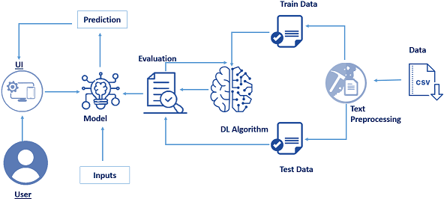

***3.2 SOFTWARE USED: -***

**Tableau** is a data visualization software platform. It allows users to create interactive dashboards and visualizations from data sources. It is a popular tool for business intelligence and analytics, and it is used by a wide range of organizations. Tableau is easy to use, even for beginners. It is powerful and versatile, and it can be used to create interactive visualizations that can be shared easily.

1. **EXPERIMENTAL INVESTIGATIONS: -**

* Identify the most important features of cell phones to consumers. This could be done by using sentiment analysis to identify the words and phrases that are most commonly used in positive and negative reviews. This information could then be used to identify the features of cell phones that are most important to consumers.
* Identify the problems that consumers have with cell phones. This could be done by using sentiment analysis to identify the words and phrases that are most commonly used in negative reviews. This information could then be used to identify the problems that consumers have with cell phones and to prioritize the development of new features and improvements.
* Identify the most influential reviewers. This could be done by using social network analysis to identify the reviewers who have the most connections and who are most likely to have a high impact on the decision-making process of other consumers. This information could then be used to target these reviewers with marketing campaigns or to solicit their opinions about new cell phone models.
* Identify the spread of information about cell phones. This could be done by using social network analysis to identify how information about cell phones spreads through the Amazon review community. This information could then be used to track the effectiveness of marketing campaigns or to identify potential problems with new cell phone models.

1. **FLOW CHART**

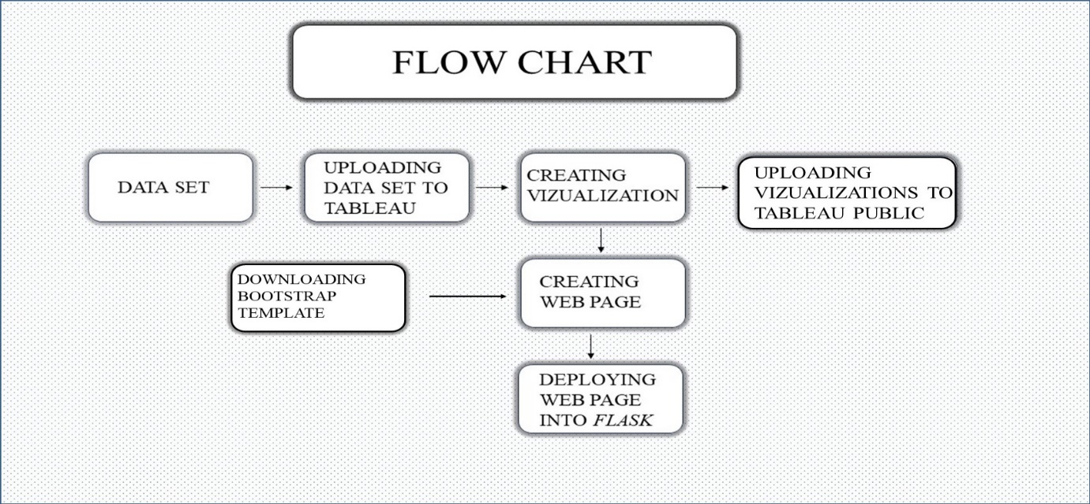

1. **RESULTS:**

**Dashboards:**

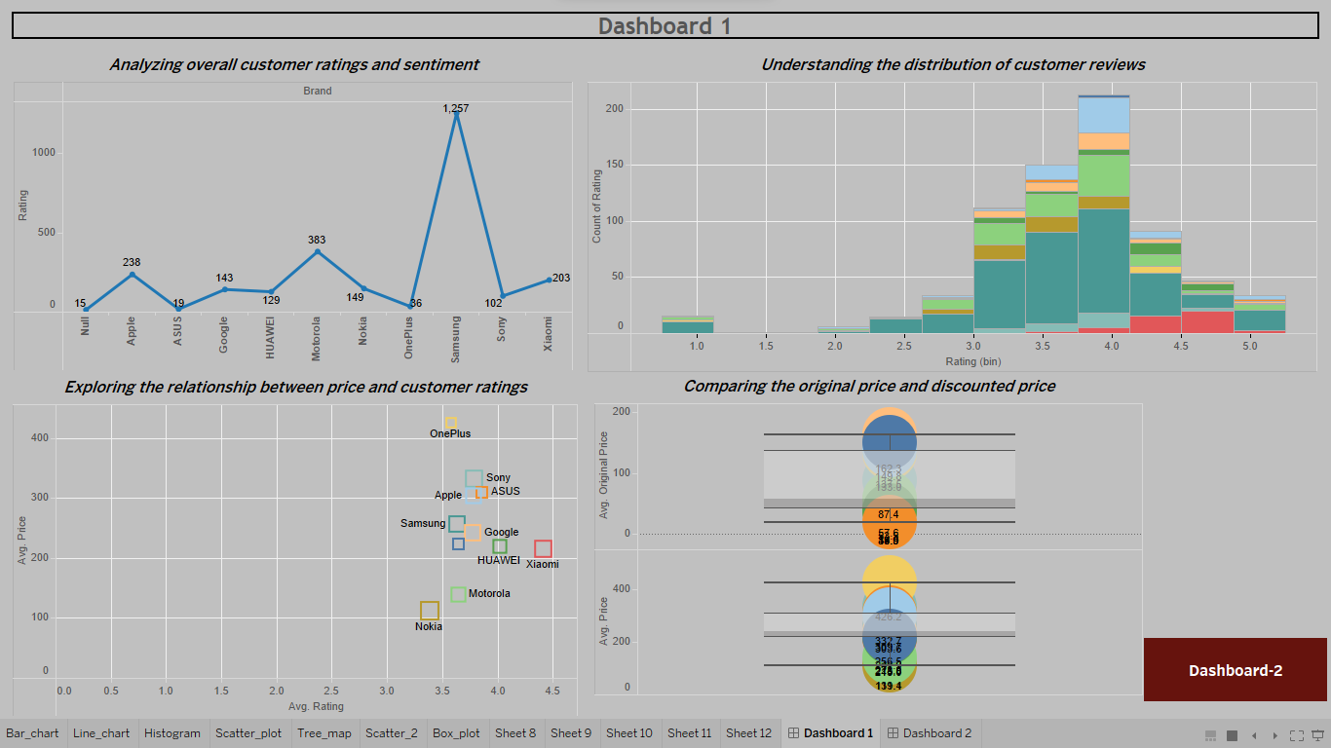

1) Overall Customer Rating vs. Brand (Line Chart):

* Samsung received the highest number of ratings among all the brands analysed.

2) Distribution of Customer Ratings by Brand (Histogram):

* The distribution of customer ratings for Samsung showed that 93 reviewers gave a rating of 3.8.

3) Relationship Between Price and Customer Ratings (Scatter Plot):

* The scatter plot revealed that Xiaomi had the maximum ratings compared to other brands while having a relatively lower price.

4) Comparison of Original Price and Discounted Price (BOX Plot):

* A visualization was created to compare the original price and discounted price of the cell phones.

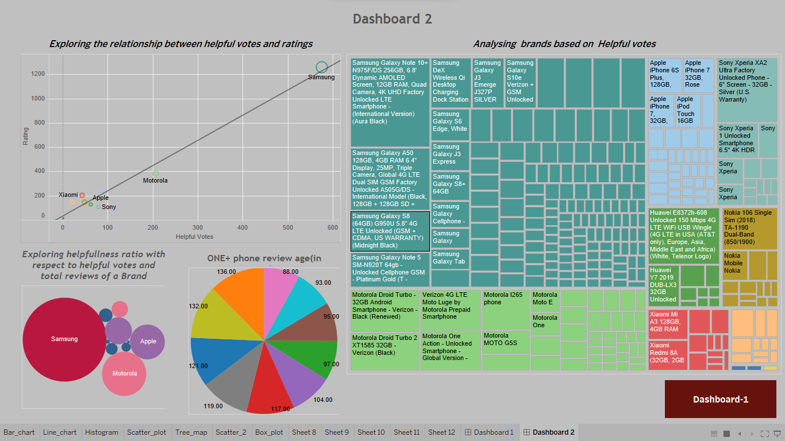

5) Helpful Votes by Brand (Tree Map):

* The tree map visualized the number of helpful votes given by users for each brand. Google had the least number of helpful votes, while Samsung had the highest.

6) Relationship Between Helpful Votes and Ratings (Scatter Plot):

* Another scatter plot was created to examine the relationship between helpful votes and ratings, providing further insights into the data.

7) Review Helpfulness Ratio (Packed Bubble):

* The packed bubble chart illustrated the review helpfulness ratio, which was calculated as the ratio of helpful votes to total reviews.

8) Age of Reviews (Pie Chart):

* A pie chart depicted the age of reviews for the OnePlus brand in months.

**Story:**

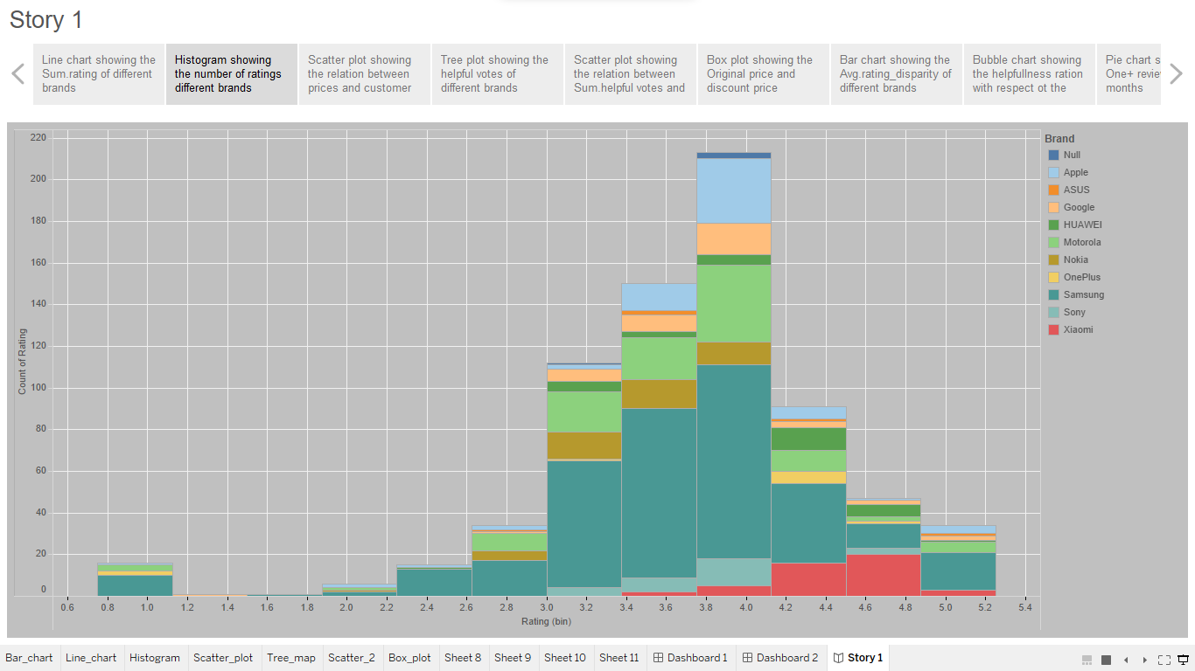

**Application Results (Flask):**

* **Home Page**

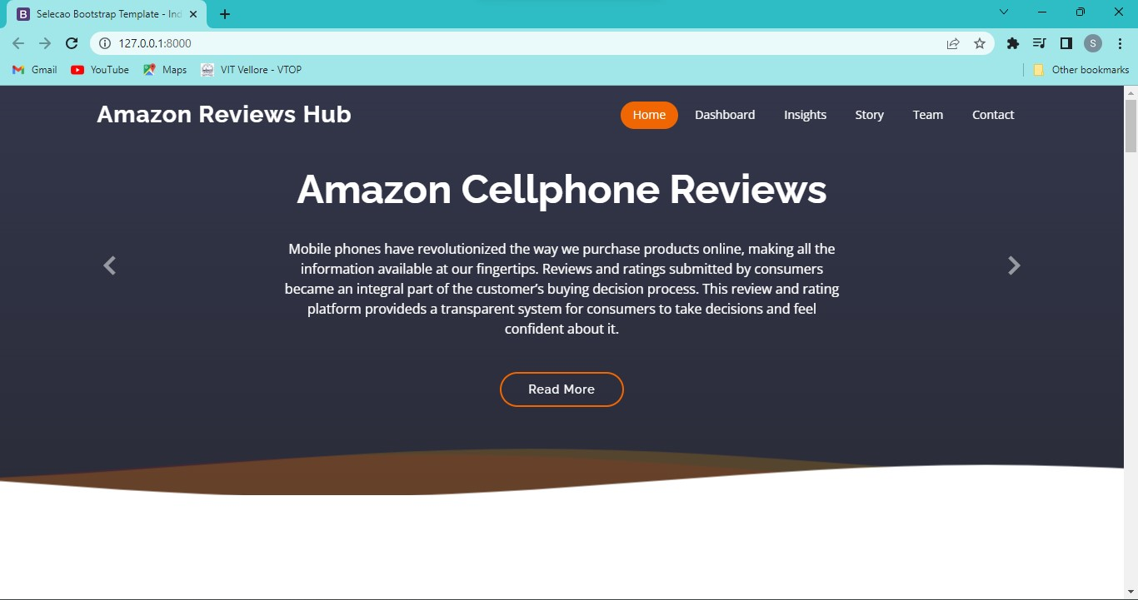

* **Dashboard page**

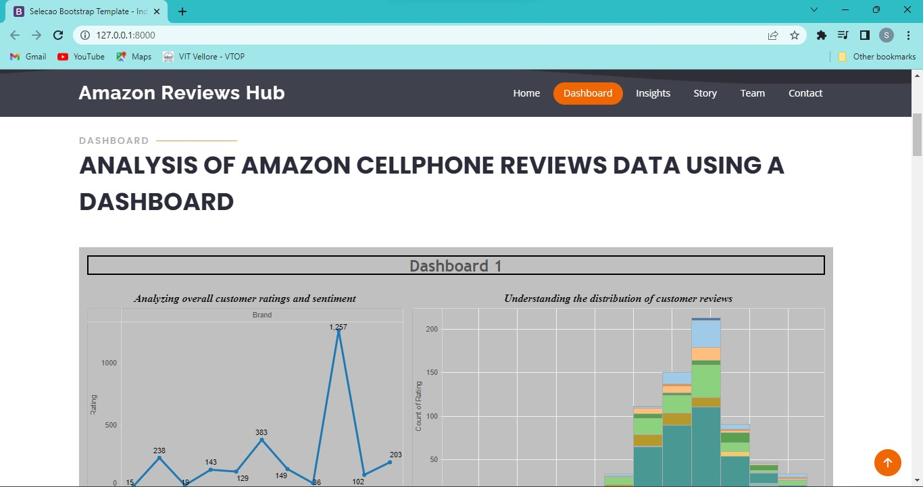

* **Insights page**

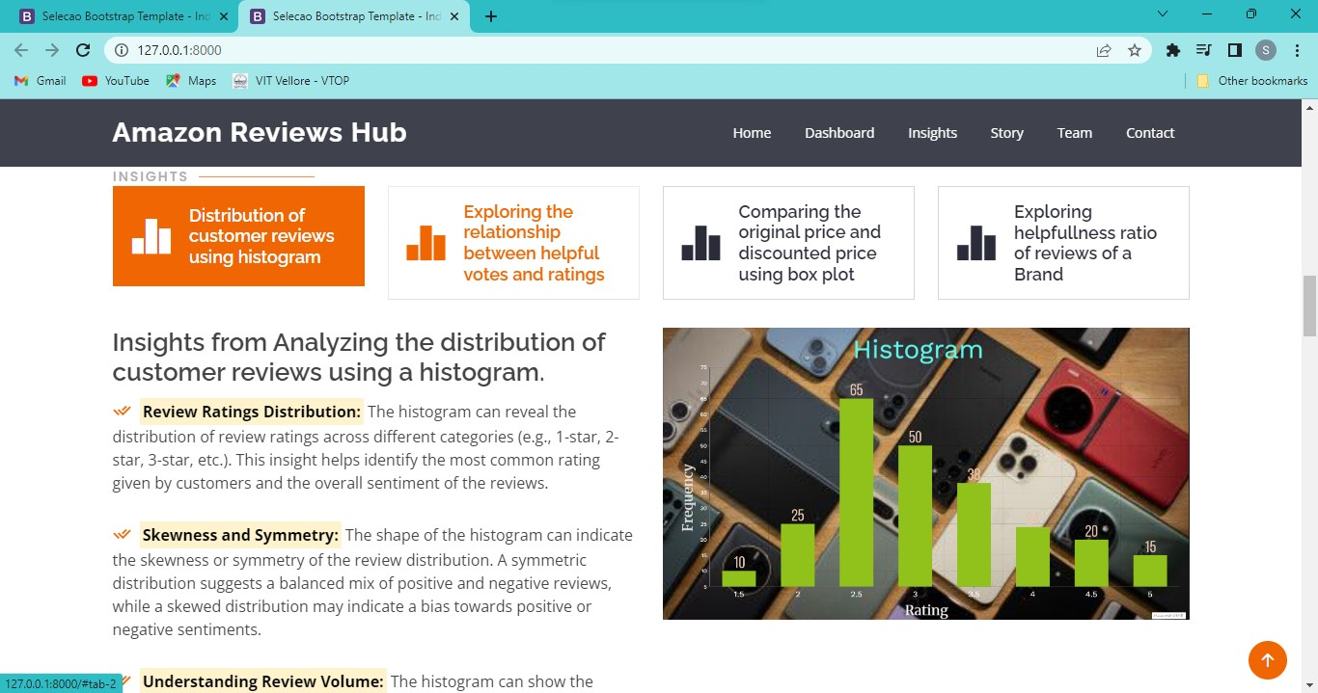

* **Story page**

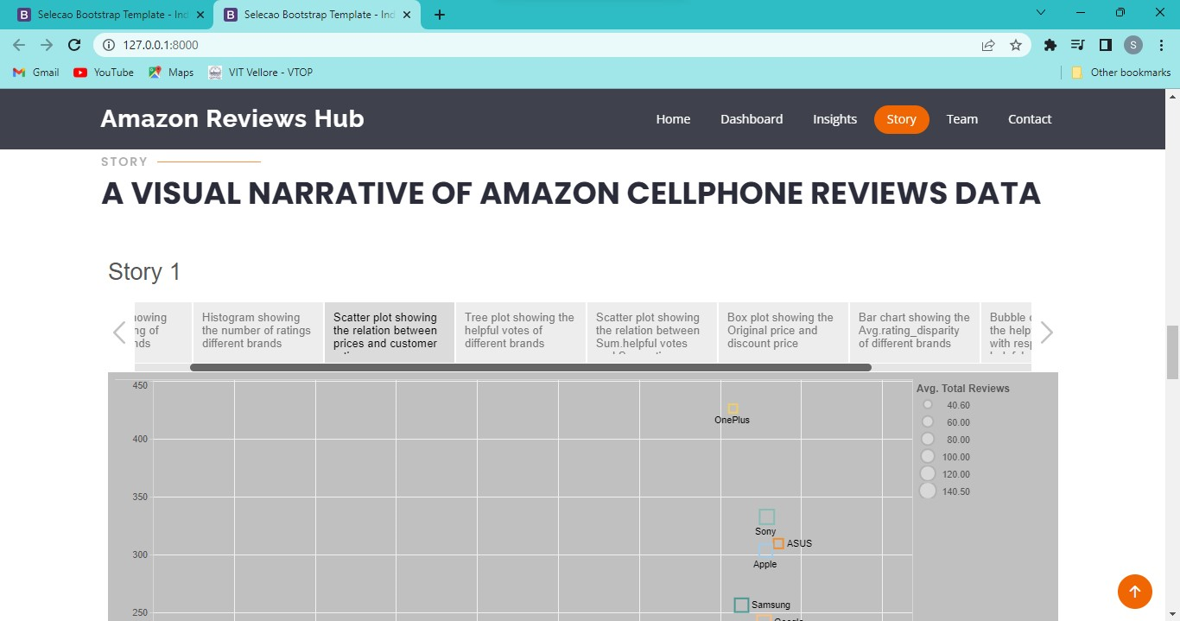

* **FAQ’s page**

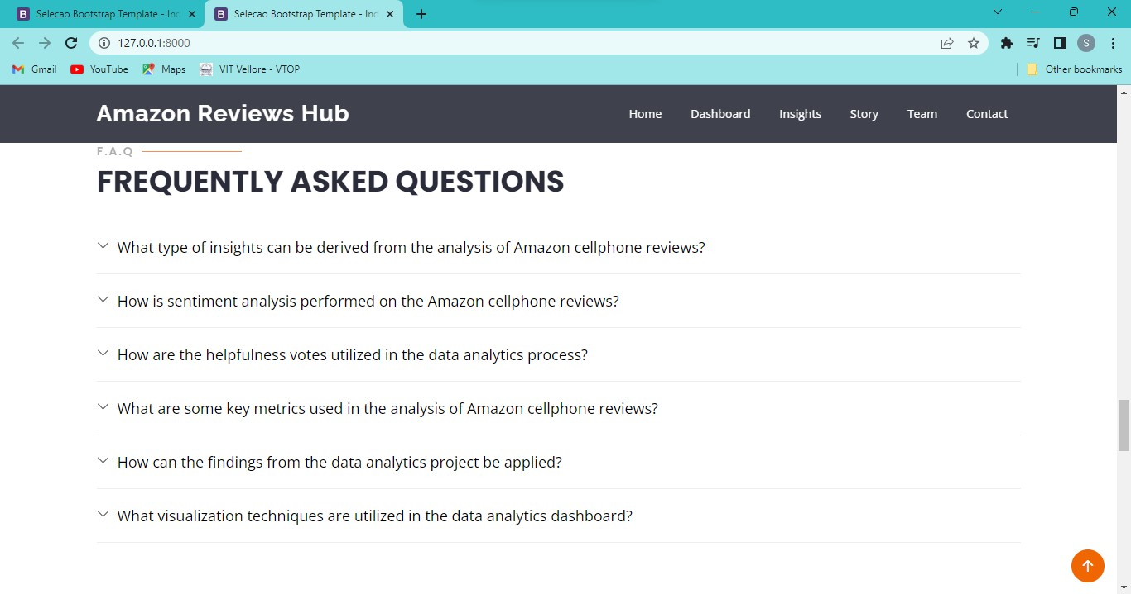

In summary, the project analysed various aspects of Amazon cell phone reviews, including overall ratings, price vs. ratings, helpful votes, review helpfulness ratio, and reviewer demographics. The visualizations in Tableau helped provide insights into the data and facilitate a comprehensive analysis of the customer reviews for different cell phone brands on Amazon.

1. **ADVANTAGES & DISADVANTAGES**

***ADVANTAGES: -***

* Help to identify patterns and trends in the data. This can be difficult to do with raw data, but visualizations can make it easier to see patterns and trends. For example, a visualization could show the percentage of positive and negative reviews for each cell phone model. This could help to identify the most popular and least popular cell phone models
* Communicate the results of the analysis to a wider audience. This is important because Amazon cell phone reviews are often used by consumers to make informed decisions about which cell phone to purchase. By creating visualizations of the data, it is possible to make the results of the analysis more accessible and understandable to a wider audience. This can help to ensure that the results of the analysis are used to make informed decisions about the development and marketing of cell phones.
* Identifies outliers in the data. Outliers are data points that are significantly different from the rest of the data. They can be important to identify because they can indicate problems or errors in the data. For example, a visualization could show the distribution of prices for cell phones. If there is a data point that is significantly higher or lower than the rest of the data, this could indicate that there is a problem with the price of that cell phone model.
* Tells a story about the data. By using different types of visualizations, it is possible to tell a story about the data. This can be helpful for understanding the results of the analysis and for communicating the results of the analysis to others. For example, a visualization could show the evolution of the battery life of cell phones over time. This could help to tell a story about how battery life has improved over time.
* These are Engaging and Memorable. People are more likely to remember information that is presented in a visually appealing way. This means that visualizations can be a helpful way to communicate the results of the analysis and to ensure that the results of the analysis are remembered.

***DISADVANTAGES: -***

* If a visualization is not created carefully, it can be misleading. For example, a visualization that shows the percentage of positive and negative reviews for each cell phone model could be misleading if the number of reviews for each cell phone model is not equal.
* Some visualizations can be complex and difficult to understand. This can make it difficult to communicate the results of the analysis to a wider audience.
* Visualizations can be time-consuming to create. Creating visualizations can be time-consuming, especially if the data is complex. This can be a disadvantage if the analysis needs to be done quickly.

1. **APPLICATIONS**

* Product Development and Enhancement: Analysing cell phone reviews on Amazon can provide valuable insights for manufacturers and product developers. By identifying common complaints, feature requests, or positive feedback from customers, companies can make informed decisions to improve their products. This analysis can guide future product development cycles, prioritize specific enhancements, and ensure that the next iterations meet customer expectations.
* Quality Control and Issue Identification: By analysing Amazon cell phone reviews, companies can identify potential quality control issues or manufacturing defects. Patterns in negative reviews can highlight recurring problems, allowing manufacturers to address them promptly. This analysis helps ensure that the quality of cell phones meets customer standards and helps prevent reputational damage due to faulty products.
* Market Research and Competitive Analysis: It helps companies understand customer preferences, feature demands, and emerging trends. By comparing reviews of different cell phone models, companies can gain insights into their competitors' strengths and weaknesses. This information can guide market positioning, product differentiations, and pricing strategies.

1. **CONCLUSION**

Amazon cell phone reviews are a valuable source of information for consumers and businesses alike. By analysing these reviews, businesses can gain insights into customer sentiment and identify areas where there is room for improvement.There are many different ways to analyze Amazon cell phone reviews. One common approach is to use visualizations to track the distribution of star ratings, the percentage of positive, negative, and neutral reviews, and the most common words in the reviews. Visualizations can also be used to identify trends over time, compare different phones side-by-side, and understand the customer journey.The insights gained from analysing Amazon cell phone reviews can be used to improve product development, marketing strategies, and customer service. By understanding what customers are saying about their products, businesses can make better decisions that will lead to increased customer satisfaction and loyalty.In conclusion, analysing Amazon cell phone reviews is a valuable way for businesses to gain insights into customer sentiment and improve their products and services. By using visualizations and other analytical techniques, businesses can identify areas where there is room for improvement and make better decisions that will lead to increased customer satisfaction.

Here are some additional thoughts on the importance of analysing Amazon cell phone reviews:Reviews are a form of social proof: When potential customers see that other people are happy with a product, they are more likely to be interested in buying it themselves. Reviews can help you identify potential problems: If you see a lot of negative reviews about a particular product, it's a good indication that there may be some problems with it. This can help you avoid making a bad purchase.Reviews can help you improve your products: By reading through reviews, you can learn what customers like and dislike about your products. This information can be used to improve your products and make them more appealing to customers.

1. **FUTURE SCOPE**

The future scope of analysing Amazon cell phone reviews is quite promising, given the increasing popularity of online shopping and the significant role that customer reviews play in purchase decisions. Analysing Amazon cell phone reviews can provide valuable insights to various stakeholders, including customers, manufacturers, and marketers. Here are some aspects to consider regarding the future scope of analysing Amazon cell phone reviews:

1. Customer Insights: Analysing reviews can help customers make informed decisions about purchasing cell phones on Amazon. Natural Language Processing (NLP) techniques can be employed to extract sentiment, identify key features, and uncover common pain points or preferences among customers. This analysis can help potential buyers understand the strengths and weaknesses of different cell phone models, enabling them to choose the most suitable option.
2. Product Development and Enhancement: Manufacturers and product developers can gain valuable feedback by analysing Amazon cell phone reviews. By understanding customer sentiments and identifying recurring issues or complaints, they can improve their products, address specific problems, and enhance user experiences. This feedback loop can lead to iterative improvements and more customer-centric offerings.
3. Competitor Analysis: Analysing reviews can provide insights into competitors' products. By understanding customer opinions and comparing them with similar products, manufacturers can identify their competitive advantages and disadvantages. This information can guide marketing strategies, pricing decisions, and product differentiations to stay ahead in the market.
4. Market Research: Analysing large volumes of Amazon cell phone reviews can provide valuable market research data. By examining customer preferences, trending features, and emerging needs, companies can identify market gaps, anticipate future demands, and develop innovative products or features to cater to evolving consumer expectations.
5. Sentiment Analysis and Review Summarization: As the volume of Amazon cell phone reviews grows, it becomes essential to automate the analysis process. NLP techniques, such as sentiment analysis and review summarization, can be employed to categorize reviews into positive, negative, or neutral sentiments. Review summarization can extract key information and opinions, providing a concise overview for users who want quick insights without reading every review.
6. AI-powered Customer Support: Analysing Amazon cell phone reviews can contribute to the development of AI-powered customer support systems. By understanding common customer issues, AI chatbots or virtual assistants can provide more effective and personalized solutions, reducing the need for human intervention and improving overall customer satisfaction.

It's important to note that as technology advances, new techniques and approaches for analysing Amazon cell phone reviews will continue to emerge. These developments will further enhance the scope and effectiveness of leveraging customer reviews to make data-driven decisions and deliver improved products and services.

1. **APPENDIX**

**Project Documents Link:**

<https://drive.google.com/drive/folders/1ROI80cGhMfjykS9EF1u2IFKVvXKqe4a7?usp=drive_link>



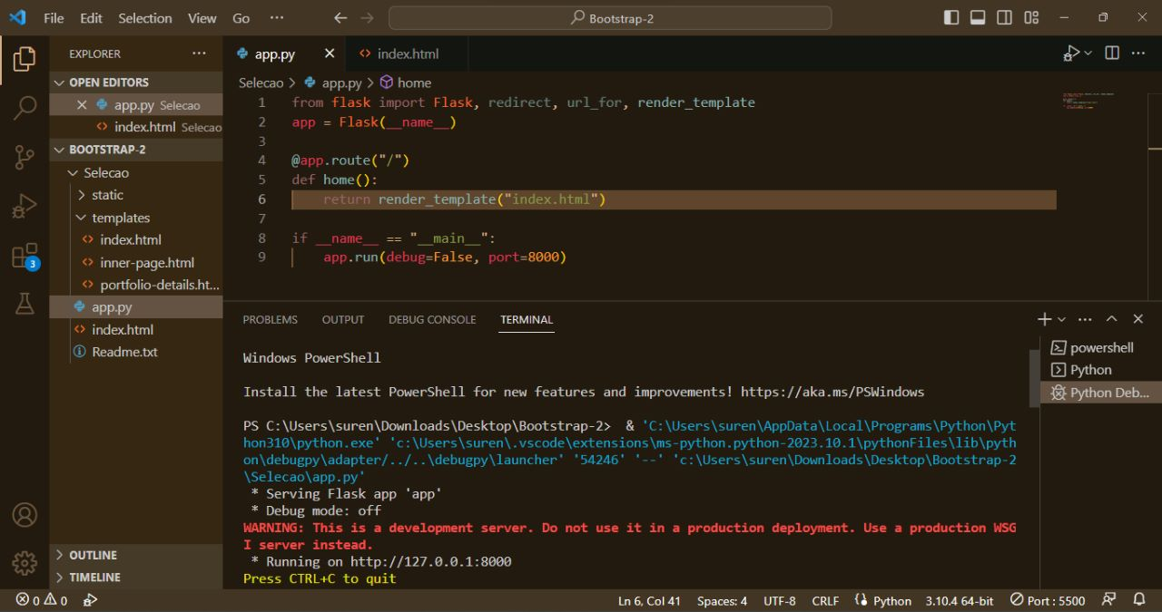

**VIDEO Link: -**

[**https://drive.google.com/drive/folders/1sIZ8K7q6rBr91i47gMrw2_dqJOZiqGcx?usp=drive_link**](https://drive.google.com/drive/folders/1sIZ8K7q6rBr91i47gMrw2_dqJOZiqGcx?usp=drive_link)