**Introduction**

The function of an inverter is to convert DC signal into AC signal. It takes DC power from a constant DC source and converts it into an AC power. For example, the household inverter takes DC power from a 12 V or 24 V battery and converts it into 220 V AC power with desirable frequency of 50/60 Hz. These DC-AC inverters have been widely used for industrial applications such as uninterruptible power supply (UPS), AC motor drives etc. The inverters also play an important role in various renewable energy applications as these are used for grid connection of Wind Energy System or Photovoltaic System.

The DC-AC inverters usually operate on Pulse Width Modulation (PWM) technique. The PWM is a very useful technique in which width of the Gate pulses are controlled by various mechanisms. The PWM signal controls the switches of a certain topology which do the main work of conversion. In this project H-bridge switching topology has been used along with SPWM (Sinusoidal Pulse Width Modulated) signal.

**Working Principle**

H-bridge is a standard topology that is widely used in inverters. It consists of 4 MOSFETS connected in the way shown in Figure 1. The MOSFETS work as controlled switch here. To function as an inverter the MOSFETS should be controlled by appropriate gate signals. In this project we have used SPWM signal to control the MOSFETS. To easily understand the working principle of H-bridge easily, it’s better to explain the switching using square pulse. The result for SPWM follows the output for square pulse.

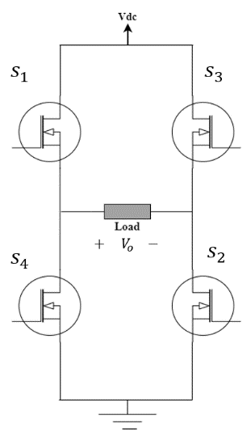

**Figure 1**: H-bridge Topology

As shown in the Figure 2, the MOSFET S1 & S2 are controlled by the same square wave. The S3 & S4 MOSFETS are controlled by a square wave which is 180­­­0 phase shifted version of the signal used for S1 & S2. Due to this sort of control signal, S1 and S4 are never on simultaneously. Same observation goes for S2 and S3 MOSFETS.

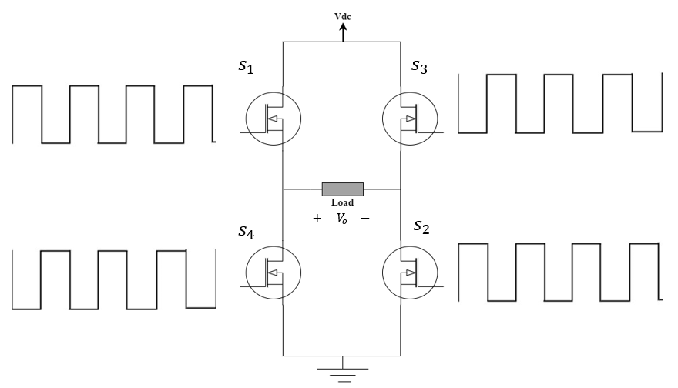

**Figure 2**: Pulse Signal for Controlling H-bridge

To understand this clearly, let’s look at the figure 3(a). For the first half cycle S1 and S2 are on while S3 and S4 are off. Hence from Figure 3(b) it’s clear that current through the load flows from left to right and $Vo=+V_{dc}$

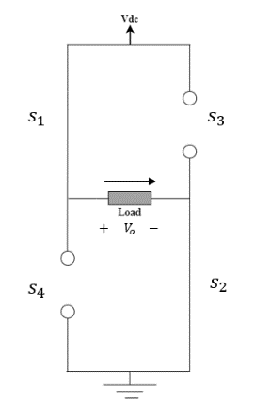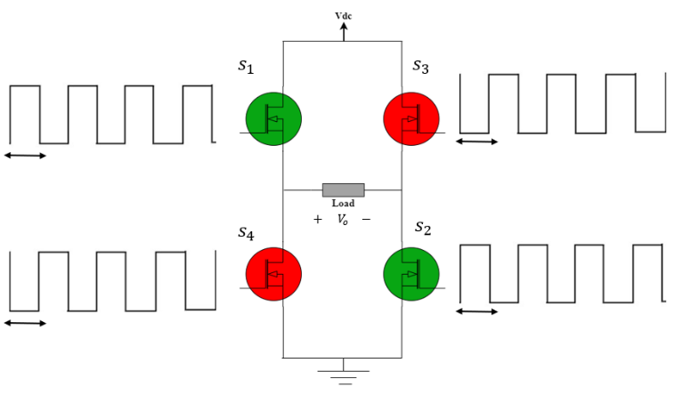

(a) (b)

**Figure 3**: (a) Switching for First Half Cyle (b) Circuit for First Half Cycle

Similarly for second half cycle, from figure 4(a) and 4(b) we can see that S3 and S4 are on but S1 and S2 are off. Consequently, current through the load flows from right to left and $Vo=-V_{dc}$.

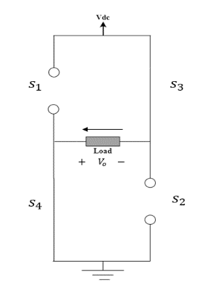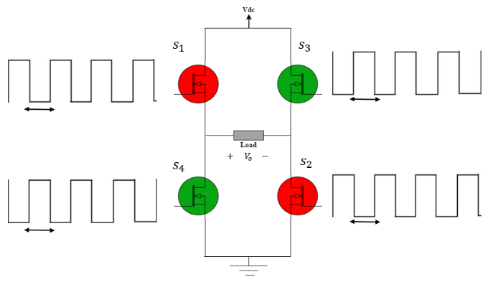

(a) (b)

**Figure 4**: (a) Switching for Second Half Cyle (b) Circuit for Second Half Cycle

So, for the pair of gate signals shown in figure 5(a) the output across the load is like that shown in figure 5(b). The output is alternating square signal with peak amplitude Vdc.

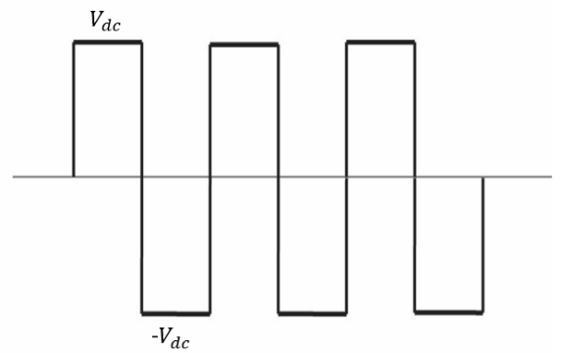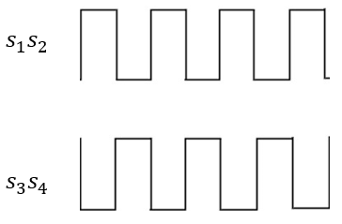

(a) (b)

**Figure 5**: (a) Gate Signals applied to H-bridge (b) Output

This alternating square wave has high THD and DF (Distortion Factor). Due to high DF, it gets difficult to filter out higher order harmonics. Therefore, this square wave is not perfect for pure sine wave generation. SPWM (Sinusoidal Pulse Width Modulated) signal offers lower DF and it’s pretty easy to generate SPWM signal. One just needs to compare a triangular signal with a sine wave. So, using SPWM instead of square wave gives the output like that in figure 6(b).

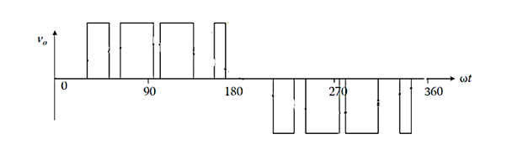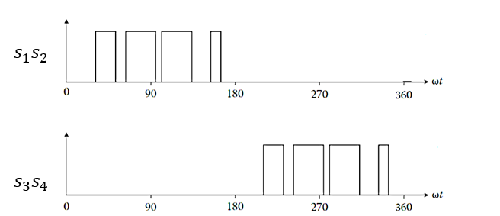

(a) (b)

**Figure 6**: (a) SPWM Gate Signals (b) Output for SPWM Gate Signal

The output across the load for SPWM gate signal is the filtered using an LC filter. The LC filter removes the higher order harmonics and gives a sinusoidal output. The sinusoidal output has low amplitude. A step-up transformer is used to step up the output of LC filter to finally produce a sine wave of required amplitude and frequency. This sub-sequent procedure is shown as in figure 7.

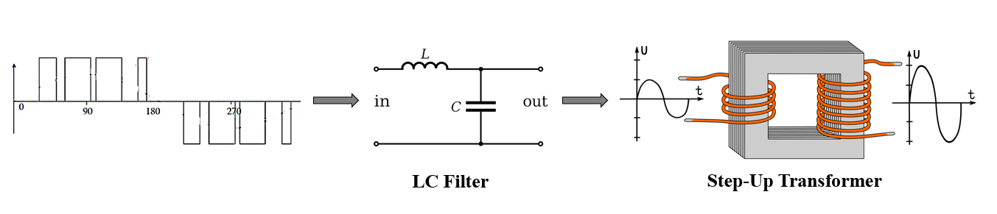

**Figure 7**: Filtering and Stepping Up