Name: Rasik Gaire

Program: BCA Third Semester

Submitted to: Dipendra Silwal

## Site Map

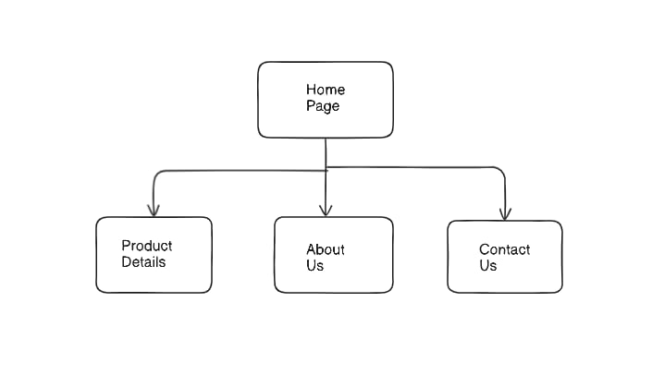

## Reference

Image from: Free Stock Images

Site: W3schools